Evaluation and study on different configuration of cold formed steel sections in steel structures based on ductility and energy absorption capacity

Sajad Pouraman Moshtaghin
MSc, Civil Engineering, Islamic Azad University, Tehran, Iran

Abstract
The popularity of CFS structures has recently grown dramatically in recent years, due to its lightweight materials, significant absorption capacity, seismic performance, time efficiency and cost-effectiveness. Due to the low weight of these structures, their seismic performance is desirable and considered in high seismic areas as the main option for industrial construction. Also, these types of structures have the proper function as the option of building fast houses after the earthquake. In this thesis, an analytical study of various configurations of cold sections formed in steel structures in terms of the degree of plasticity and energy absorption capacity has been investigated. For this purpose, different sections of cold rolled steel have been used to make frame and modeling in the SAP software environment. Based on the results of the comparison, the final frame capacity for the various states of the cross-sectional shape of the CFS column has been observed, which is the highest final frame capacity of the C-shaped back-to-back frame. The second round of the C model has been orthogonal, however, with the C-shaped back-to-back model showing up to 5% higher results. Also, the smallest capacity level is related to the C-shaped single and U-shaped models. Based on the results of the energy absorption of the frame for different states of the shape of the cross section of the CFS column, the highest energy absorption of the C-shaped back-to-back model has been observed. According to the direct relationship between ductility and energy absorption, it can be concluded that this model Has a higher ductility. The second order of the C-shaped model is orthogonal. The U-shaped model also has the lowest energy absorption. Finally, the C-shaped orthogonal model is proposed as the preferred cross section for use in the Wall Post Corner.

Keywords:
Cold formed steel, steel structure, flexibility, energy absorbance, CFS
1. Introduction

Cold-formed steel (CFS) structures have been considered as an efficient solution for rapidly growing construction demand particularly for low-rise and mid-rise buildings. Especially with the publication of various editions of “Specifications for the Design of Cold-Formed Steel Structural Members” by American Steel and Iron Institute (AISI) [1].
the popularity of CFS structures has started to spread all over the world including North and South America, Great Britain, Germany and so forth. However, some downsides such as vulnerability to instability problems arising from large width-to-thickness ratio always kept the researchers erring on the side of caution and conduct further experimental and analytical studies.
Regarding the experimental and analytical studies conducted by researchers, Miller and Pekoz [2–3] proposed studies which include tests of CFS shear walls under axial loading and they conducted experiments of CFS frames sheathed with gypsum wallboard (GWB), Serette and Ogunfunmi [4] proposed a research including test results of CFS specimens coated with GWB, flat strap X-bracing and combination of these two systems, Serette et al. [5] conducted a research in order to investigate the impact of board type and screw spacing on the behavior of shear panels, Fülöp and Dubina [6–7] have conducted an interactive study observing performance of wall-stud cold-formed steel shear panels undermonotonic and cyclic loading, Rogers et al. [8] implemented an experimental study to investigate the effect of the dimensions of the CFS shear panels on the behavior, Corte et al. [9] have conducted a study in order to investigate seismic behavior of sheathed cold-formed steel structures, Landolfo et al. [10] have conducted an experimental study to investigate the seismic behavior of CFS stud shear walls sheathed with GWB and OSB, Xu and Martinez [11] presented a research involving an interactive study between experiments under monotonic loading and development of an analytical model representing the experimental behavior, Fiorino et al. [12] observed the lateral response of sheathed cold-formed steel shear walls with an analytical approach, Fiorino et al. [13] have conducted tests on typical screw connections for CFS housing, Yu et al. [14,18] conducted twophase full-scale tests of steel sheet coated shear walls to provide a
wide range of data referring to the nominal strength of different wall configurations, Simsir and Jain [15] proposed a study about nonlinear analysis of wood-frame shear walls using SAP2000 software, Dubina [16] conducted a research on behavior and performance of cold-formed steel-framed houses under seismic action, Fiorino et al. [17] and Landolfo et al. [19] proposed a research based on two successive phases of a study ending up with acquisition of design nomographs to be used for design purposes of cold-formed steel structures, Rogers et al. [20] conducted a research on experiments of typical weld and screw-connected single-story diagonal strap braced cold-formed steel frame configurations, Yu [21] performed monotonic and cyclic tests on CFS shear walls with different thickness of steel sheets measuring their nominal shear strength under wind and seismic loads. He concluded his work with a comparison of reduction factor between code and practice, Rossi et al. [22] conducted full-scale tests on CFS structural sections subjected to concentric compression in order to observe the effect of combined distortional and global flexural-torsional buckling, Schafer et al. [23] proposed a study about computational modeling of cold-formed steel intending to see the effect of choice of element andmesh type during modeling process, Fiorino et al. [24] presented an article about seismic analysis of sheathing-braced cold-formed steel structures, Vieria and Schafer [25] conducted an experimental and analytical study so as to analyze the local stiffness of small-scale stud-fastener-sheathing assemblies.
Besides, they developed a simplified conservative analytical model backed up by more detailed finite element modeling providing the local stiffness when experimental work is not possible. They also worked on a simplified analytical model supplying translational stiffness induced by the sheathing diaphragm action. Liu, Peterman and Schafer [26] conducted a series of monotonic and cyclic experiments onwood sheathed CFS shearwalls investigating the impact of geometry,
type of sheathing, use of ledger and location of sheathing seams on the nonlinear structural response of the shear walls. The ultimate motivation of this study was to assess current design procedures utilizing AISI-S213–07 and to develop nonlinear (hysteretic) models for global performance assessment, Baran and Alica [27] carried out an experimental study on OSB sheathed CFS shear panels representing construction practices in Turkey so as to evaluate the performance of these panels as well as to observe different deformation modes, Yanagi and Yu [28] presented a design model (Effective Strip Model) anticipating the nominal strength of CFS shear walls sheathed with steel sheet. The experimental results were also used to verify the model which yielded a good match with the actual test results, Peterman and Schafer [29] tested CFS stud-fastener-sheathing assemblies under in-plane cyclic loads and they characterized hysteretic behavior of each sheathing-toframe fastener by using either radially symmetric linear or non-linear spring elements. When it comes to nonlinear analysis, they used Pinching4 model to enlighten the hysteretic behavior accurately, Afshan et al. [30] and Rossi et al. [31] proposed studies backed up withmaterial testing which emphasize increase of strength in CFS structural sections due to manufacturing process (plastic deformations) and development of predictive models anticipating these strength enhancements, Peterman et al. [32] proposed a paper about hysteretic characterization of cold-formed steel stud-to-sheathing connections, Peterman and
Schafer [33] conducted a study relevant to sheathed CFS studs under axial and lateral load to characterize the system behavior, Zeynalian and Ronagh [34] worked on seismic performance parameters of currently used fiber-cement board sheathed CFS shear panels aiming to compare the results of a new configuration type and current practices, Buonopane et al. [35] developed a computational model of a CFS shear wall representing the nonlinear behavior of each fastener by a nonlinear, radially-symmetric spring element. The analytical model is composed of a softening backbone curve, pinching, loading and unloading parameters. Physical tests on sheathing-to-stud fasteners have also been performed for backing up the analytical material model. The researchers
eventually cameupwith an efficient overlap between computational approach and actual lateral behavior of the walls.
As a result of the observations on the conducted research relevant to CFS systems, it has been proven that they have satisfactory resistance against lateral loading, thus their use has been expanded to seismicprone regions taking full benefit from energy absorption capacity (i.e.
ductility). The main advantages of CFS systems can be listed as follows:
• Low seismic forces due to lightness of the material
• Practicability in the field (easy erection)
• Dimensional superiority
• High level of ductility and energy absorption capacity
• Environmental issues
In the scope of this research, displacement-controlled cyclic tests have been implemented on dissimilar configuration of CFS shear panels in order to observe the effect of different factors on the performance parameters.
In case the experiments were conducted multiple times, namely two or three times for some of the specimens, the average of results has been used to represent the system for more accuracy (as long as the difference between two successive experimental results does not exceed 10%). Shear strength per unit length and strength reduction factors (R) of cold-formed steel shear panels have been obtained and presented in the content of this paper. The main motivation of this study was to perform cyclic loading tests on different configuration of CFS shear panels so as to examine the contribution of effects such as board type, steel thickness, screw spacing and axial loads on the seismic performance of shear panels as well as to obtain analytical models of shear panels to be used for 3-D structural analysis and seismic performance assessment. Ultimately, it was intended to utilize the nonlinear parameters that are obtained from the experimental results of large series of CFS shear panels, and to assess the global performance of a typical one-story structure. It was also aimed to determine the strength and ductility parameters of different configurations of CFS shear panels in order to embed the results in the new Turkish Seismic Code 2016 considering that the strength results may be different in Turkey due to manufacturing process.

2. CFS shear panels
Lateral loading is resisted by CFS shear panels which are composed of CFS bare frame and sheathing board. For the structural level, it is desired to transfer the lateral loads to the shear panels by roof and floor diaphragms.
The fundamental aim is to transfer the lateral load eventually to the foundation. In the first stage, lateral load is taken by the top track of the shear panel and then transferred to the sheathing panel via sheathing- to-frame fasteners. Therefore, it can be clearly deduced that board type, steel thickness and screw spacing take up a really significant role in assuring the satisfactory structural performance of a CFS shear panel.
The lateral load is transferred to the bottom track and then to the foundation by hold-down and shear anchors. The forces transferred from panel to studs via screws result in axial load on studs. To sum up the main picture relevant to the load carrying mechanism of a CFS framed structure, overturning moment and shear forces are two main forces acting on a CFS shear wall when a lateral load is applied to the top track (Fig. 1). Overturning moment is compensated with a force
couple in the hold-down anchors on the tension side and the chord studs on the compression side whereas in-plane shear forces are resisted by the sheathing, sheathing to frame fasteners and ultimately by shear anchorage at the foundation.

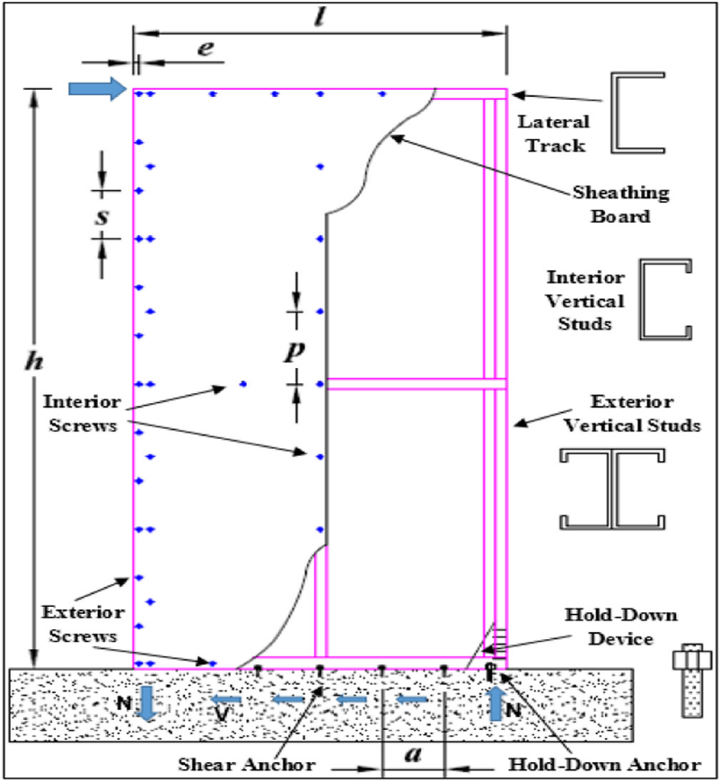
Figure 1 Components of a typical CFS shear panel.

3. Verification
To carry out verification, Karabulut and et.al Paper (2017) have been used. A two-dimensional frame with cold-rolled steel sections (CFS) has been modeled. The chalkboard panels are twisted on the members. The model in the verification paper is as follows:
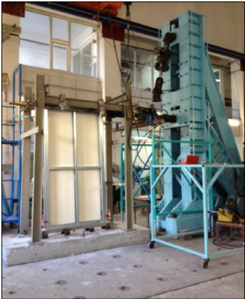
Figure 2 The model under review in the validation paper
The sections used in the model are as follows:
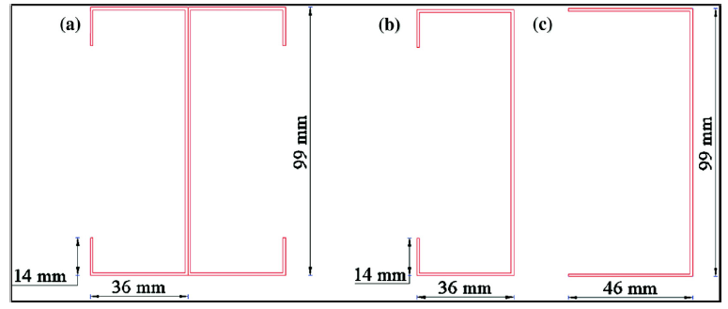
Figure 3 The sections used in the model
Finally, the modeling in SAP software is over and the final shape is as follows:
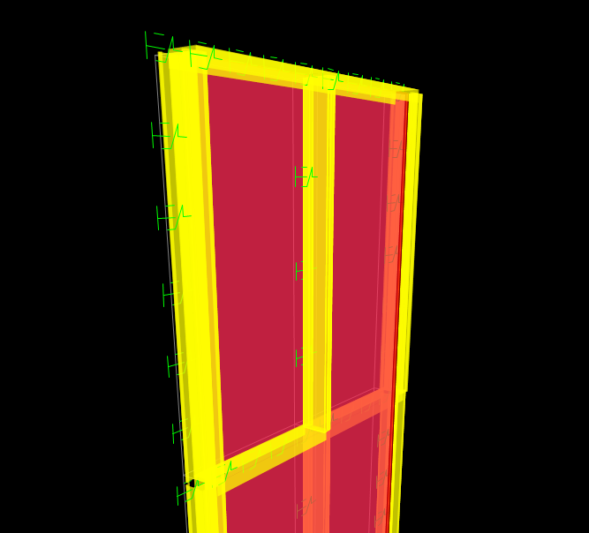
Figure 4 Final Validation Model in SAP
The final model in the validation paper is also as follows:
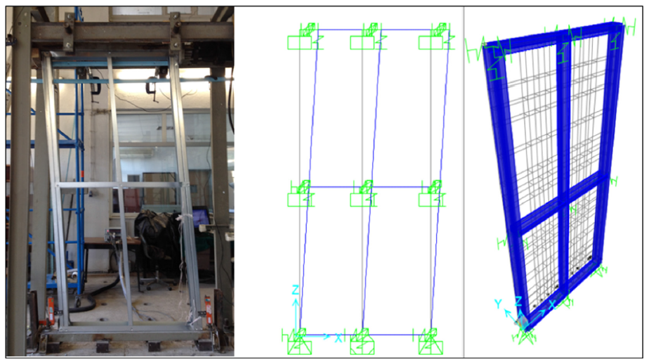
Figure 5 Final version of the verification paper
The results related to the output of the validation paper model are as follows:
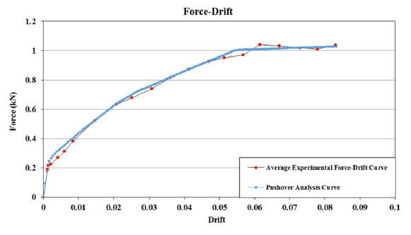
Figure 6 pushover Curve Modeling Laboratory and Numerical Model
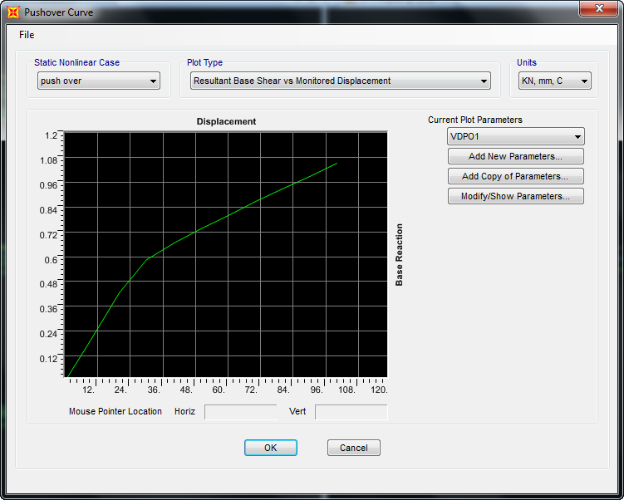
Figure 7 Pushover curve for verification model
Based on the results of the analysis of the model, we compared the Pushover curve for three modes of laboratory modeling: verification of the article, numerical modeling of the verification paper and, finally

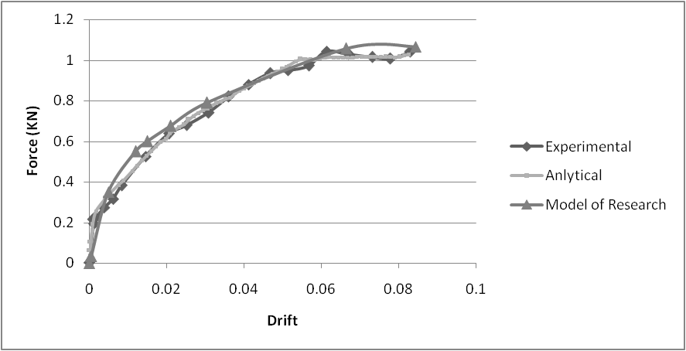
Figure 8 comparing results
Based on the comparison of the results of the curvilinear curve for the three modes of laboratory modeling, the verification of the article, numerical modeling of the verification paper, and ultimately numerical verification of the accuracy has been observed, with an error difference of 4.8%.
4. Introducing Models
The models studied in this study include different sections of the CFT columns, which are selected in 6 states and have been modeled in SAP software. These models are shown in the following figure:

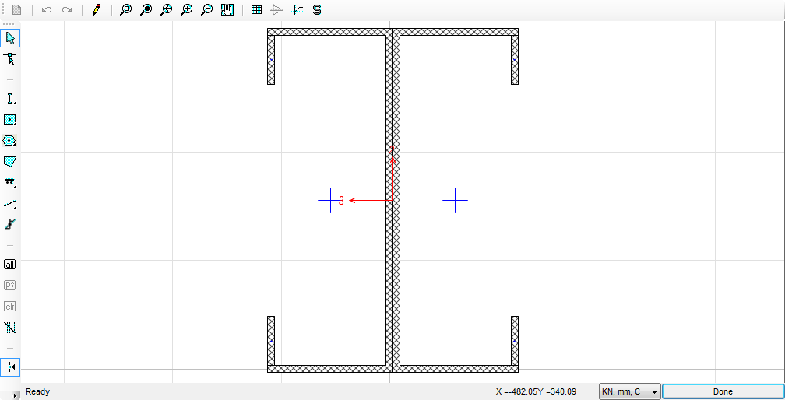 | 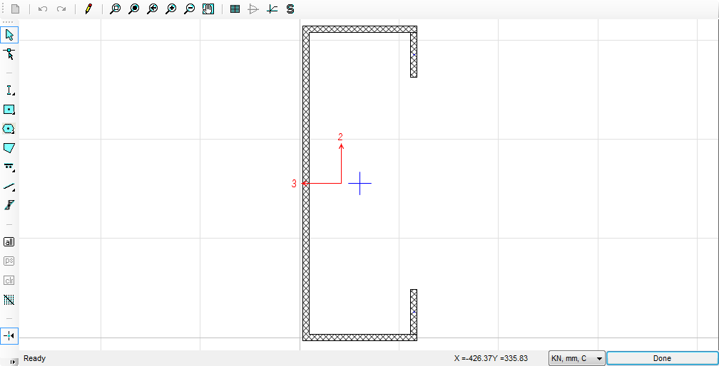
M1 Model | M2 Model

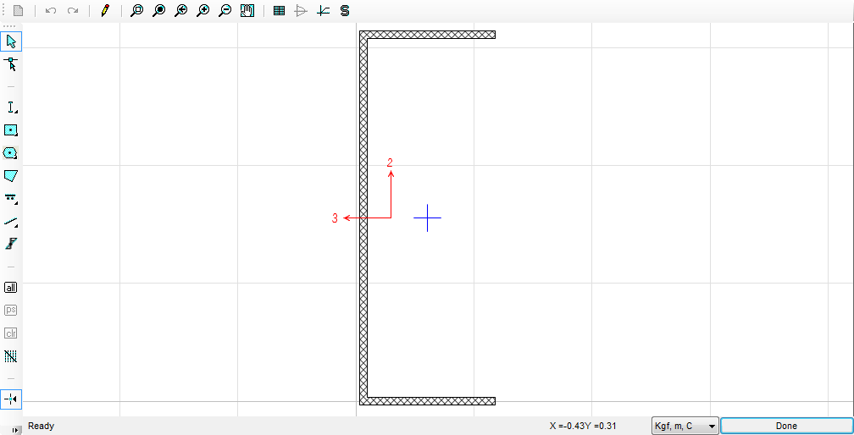 | 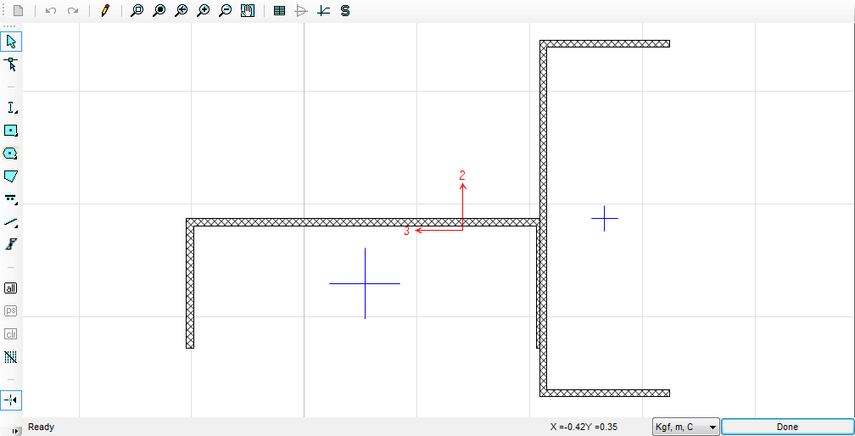
M3 Model | M4 Model
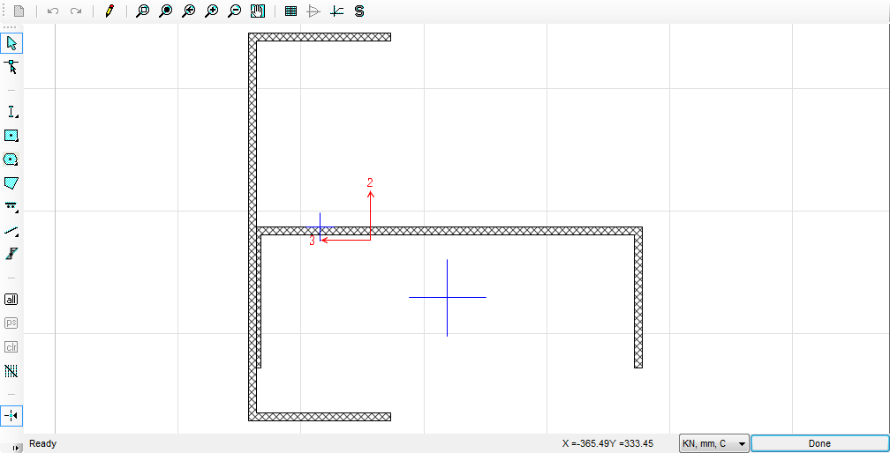 |  | 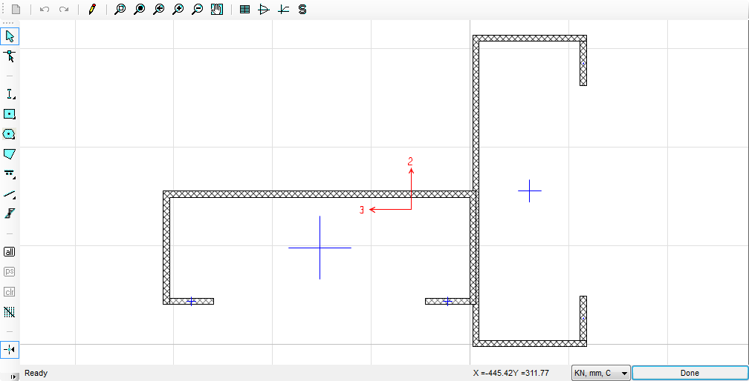
M5 Model |  | M6 Model
Figure 9 Study of research modeling

4.1. Model M6
The modeling performed in this case is based on the column cross section as follows:

Figure 10 Column section in M6 model
The final state of the structure and plastic joints has been as follows:

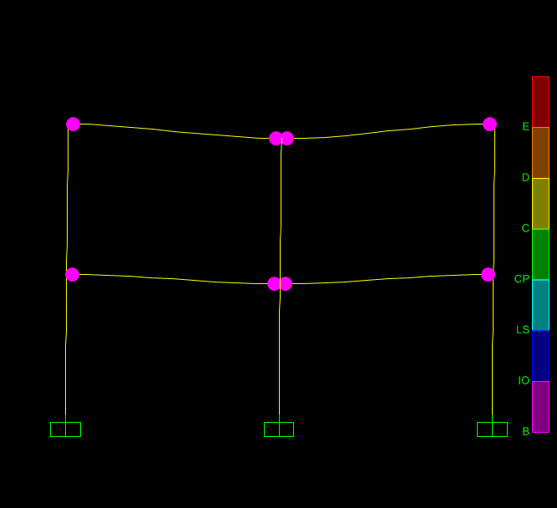
Figure 11 The initial condition of plastic structures and joints in the M6 model
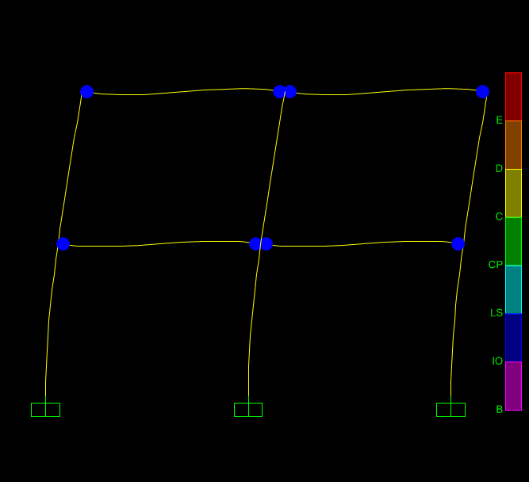

Figure 12 Final condition of plastic structures and joints in M6 model

Finally, the push over curve for these conditions is determined as follows:

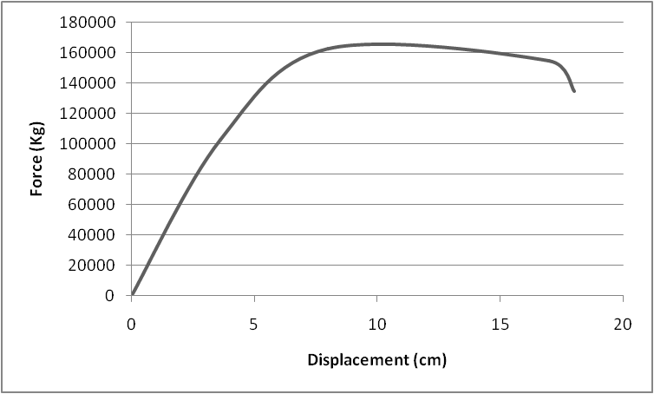
Figure 13 push over Curve in M6 Model
Based on the results of the push over curve in the M6 model, the maximum bearing capacity of the structure in this case was 138 tons. Also, based on the calculation of the following level, it has been observed that the energy absorption capacity of the model is equal to 8050 Jules.

5. Summary of results
The following is a summary of the results of the analysis:

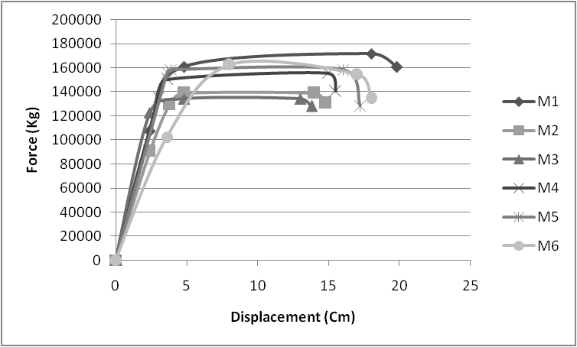
Figure 14 push over Curve Comparison in Different Models

Based on the results of the comparison of the push over curve in different models, the M1 curve is higher than other models.
In the following, we study the highest final capacity of the frame as well as energy absorption for various states of the shape of the CFS column.

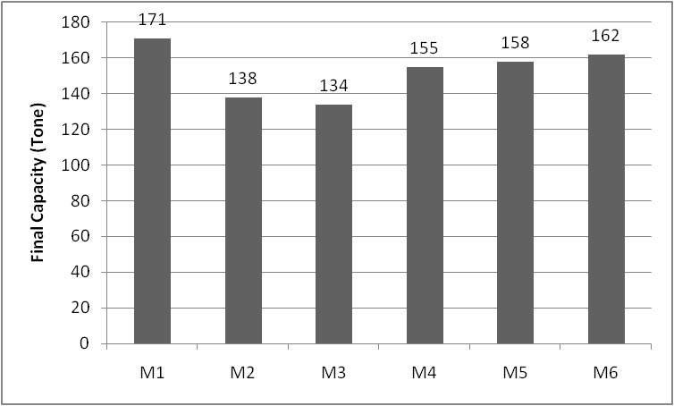

Figure 15 Comparison of the final frame capacity for various states of the cross section of the CFS column

Based on the results of the comparison, the final capacity of the frame for the various states of the cross section of the CFS column has been observed, which is the highest level of energy associated with the M3 model. The second-in-second was the M1, with the M3 showing 83% higher results. The M4 and M5 also have the lowest energy absorption, which is 66% lower than the maximum in the M3. The following section is shown in the M3 model:

Figure 16 Model M3

The comparison of the energy absorption of the frame for various states of the cross-section of the CFS column is given in the following figure:

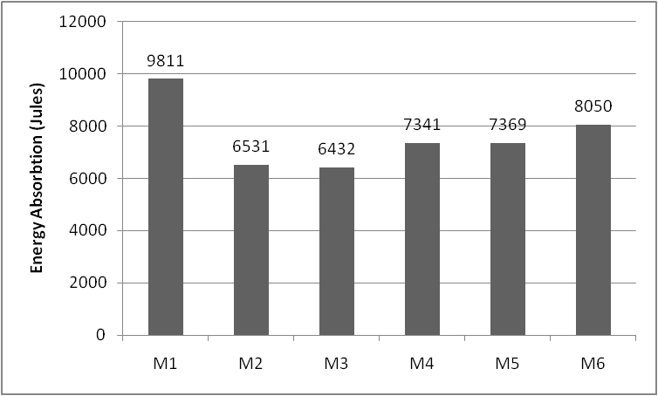

Figure 17 Comparison of the energy absorption of the frame for various states of the cross section of the CFS column
Based on the results of the energy absorption comparison, the frame energy for the various states of the shape of the CFS column has been observed, which is the highest level of energy associated with the M1 model. The second-in-one was the M2, but the M1 is showing a higher 10%. The M3 also has the lowest energy absorption, which is 34% lower than the maximum in the M1. The following figure shows the cross section in the M1 model:

Figure 18 Model M1

REFERENCES
[1] AISI-S213-07/S1-09, North American Standard for Cold-formed Steel Framing—Lateral Design, 2007 Edition With Supplement No. 1, American Iron and Steel Institute, Washington, D.C., 2012.
[2] T.H. Miller, T. Pekoz, Behavior of cold-formed steel wall stud assemblies, J. Struct. Eng. 119 (2) (1993) 641–651.
[3] T.H. Miller, T. Pekoz, Behavior of gypsum-sheathed cold-formed steel wall studs, J.Struct. Eng. 120 (5) (1994) 1644–1650.
[4] R. Serrette, K. Ogunfunmi, Shear resistance of gypsum-sheathed light-gauge steel stud walls, J. Struct. Eng. 122 (4) (1996) 383–389.
[5] R.L. Serrette, J. Encalada,M. Juadines, H. Nguyen, Static racking behavior of plywood, OSB, gypsum, and fiberbond walls with metal framing, J. Struct. Eng. 123 (8) (1997) 1079–1086.
[6] L.A. Fülöp, D. Dubina, Performance of wall-stud cold-formed shear panels under monotonic and cyclic loading part I: experimental research, Thin-Walled Struct. 42 (2004) 321–338.
[7] L.A. Fülöp, D. Dubina, Performance of wall-stud cold-formed shear panels under monotonic and cyclic loading part II: numerical modelling and performance analysis, Thin-Walled Struct. 42 (2004) 339–349.
[8] C.A. Rogers, A.E. Branston, F.A. Boudreault, C.Y. Chen, Steel frame/wood panel shear walls: preliminary design information for use with the 2005 NBCCProc 13th World Conf Earthq Eng, 2004.
[9] G.D. Corte, L. Fiorino, R. Landolfo, Seismic behavior of sheathed cold-formed structures: numerical study, J. Struct. Eng. 132 (4) (2006) 558–569.
[10] R. Landolfo, L. Fiorino, G.D. Corte, Seismic behavior of sheathed cold-formed structures: physical tests, J. Struct. Eng. 132 (4) (2006) 570–581.
[11] L. Xu, J. Martinez, Strength and stiffness determination of shear wall panels in coldformed steel framing, Thin-Walled Struct. 44 (2006) 1084–1095.
[12] L. Fiorino, G. Della Corte, R. Landolfo, Lateral response of sheathed cold-formed shear Walls: an analytical approachProc Eighteenth Int Spec Conf Cold-Formed Steel Struct 2006, pp. 603–620.
[13] L. Fiorino, G.D. Corte, R. Landolfo, Experimental tests on typical screw connections for cold-formed steel housing, Eng. Struct. 29 (2007) 1761–1773.
[14] C. Yu, Steel Sheet Sheathing Options for Cold-Formed Steel Framed Shear Wall Assemblies. Research Report RP07-3 submitted to American Iron and Steel Institute, 2007 (Washington, DC).
[15] C.C. Simsir, A. Jain, Nonlinear analysis of woodframe shear walls, 14 World Conf Earthq Engvol. 7, 2008, pp. 4–10.
[16] D. Dubina, Behavior and performance of cold-formed steel-framed houses under seismic action, J. Constr. Steel Res. 64 (2008) 896–913.
[17] L. Fiorino, O. Iuorio, R. Landolfo, Sheathed cold-formed steel housing: a seismic design procedure, Thin-Walled Struct. 47 (2009) 919–930.
[18] C. Yu, Y. Chen, Steel Sheet Sheathing Options for Cold-Formed Steel Framed Shear Wall Assemblies Providing Shear Resistance - Phase 2, Research Report. RP09-2, American Iron and Steel Institute, Washington, D.C., 2009.
[19] R. Landolfo, L. Fiorino, O. Iuorio, A specific procedure for seismic design of coldformed steel housing, Adv. Steel Constr. 6 (2010) 603–618.
[20] C.A. Rogers, K. Velchev, G. Comeau, N. Balh, Evaluation of the AISI S213 seismic design procedures through testing of strap braced cold formed steel walls, Thin- Walled Struct. 48 (2010) 846–856.
[21] C. Yu, Shear resistance of cold-formed steel framed shear walls with 0.686 mm, 0.762 mm, and 0.838 mm steel sheet sheathing, Eng. Struct. 32 (2010) 1522–1529, http://dx.doi.org/10.1016/j.engstruct.2010.01.029.
[22] B. Rossi, J.P. Jaspart, K.J.R. Rasmussen, Combined distortional and overall flexuraltorsional buckling of cold-formed stainless steel sections: experimental investigations, J. Struct. Eng. 136 (4) (2010) 354–360.
[23] B.W. Schafer, Z. Li, C.D. Moen, Computational modeling of cold-formed steel, Thin- Walled Struct. 48 (2010) 752–762.
[24] L. Fiorino, O. Iuorio, R. Landolfo, Seismic analysis of sheathing-braced cold-formed steel structures, Eng. Struct. 34 (2012) 538–547.
[25] L.C.M. Vieira, B.W. Schafer, Lateral stiffness and strength of sheathing braced coldformed steel stud walls, Eng. Struct. 37 (2012) 205–213, http://dx.doi.org/10. 1016/j.engstruct.2011.12.029.
[26] P. Liu, K.D. Peterman, B.W. Schafer, Test report on cold-formed steel shear walls. Research report, CFS-NEES RR03, http://www.ce.jhu.edu/cfsnees/publications.php 2012.
[27] E. Baran, C. Alica, Behavior of cold-formed steel wall panels under monotonic horizontal loading, J. Constr. Steel Res. 79 (2012) 1–8.
[28] N. Yanagi, C. Yu, Analyticalmodel for cold-formed steel framed shear wallwith steel sheet sheathingInternational Specialty Conference on Cold-Formed Steel Structures, August 24, 2012 (Paper 2 http://scholarsmine.mst.edu/isccss/21iccfss/21iccfss-session10/
[29] K.D. Peterman, B.W. Schafer, Hysteretic shear response of fasteners connecting sheathing to cold formed steel studs. CFS-NEES RR04, http://www.ce.jhu.edu/ cfsnees/publications.php 2013.
[30] S. Afshan, B. Rossi, L. Gardner, Strength enhancements in cold-formed structural sections – part 1: material testing, J. Constr. Steel Res. 83 (2013) 177–188.
[31] B. Rossi, S. Afshan, L. Gardner, Strength enhancements in cold-formed structural sections – part 2: predictive models, J. Constr. Steel Res. 83 (2013) 189–196.
[32] K.D. Peterman, N. Nakata, B.W. Schafer, Hysteretic characterization of cold-formed steel stud-to-sheathing connections, J. Constr. Steel Res. 101 (2014) 254–264.
[33] K.D. Peterman, B.W. Schafer, Sheathed cold-formed steel studs under axial and lateral load, J. Struct. Eng. 140 (10) (2014) 1–12, 04014074.
[34] M. Zeynalian, H.R. Ronagh, Seismic performance of cold formed steel walls sheathed by fibre-cement board panels, J. Constr. Steel Res. 107 (2015) 1–11.
[35] S.G. Buonopane, G. Bian, T.H. Tun, B.W. Schafer, Computationally efficient fastenerbased models of cold-formed steel shear walls with wood sheathing, J. Constr. Steel Res. 110 (2015) 137–148, http://dx.doi.org/10.1016/j.jcsr.2015.03.008.
[36] ASTM E2126, Standard test methods for cyclic (reversed) load test for shear resistance of vertical elements of the lateral force resisting systems for buildingsASTM International 2011; West Conshohocken, PA, 2006http://dx.doi.org/10.1520/ E2126-11 (www.astm.org).
[37] TEC, Specifications for Structures to be Built in Disaster Areas, Ministry of Public Works and Settlement, 2007.
[38] B. Karabulut, S. Soyoz, Experimental and analytical studies on different configurations of cold-formed steel structures, Journal of Constructional Steel Research 133 (2017) 535–546

