The Block Relevance (BR) analysis to interpret chromatographic data: application to IAM chromatography in permeability studies
Giulia Caron PhD, University of Torino, Torino, Italy Maura Vallaro, University of Torino, Torino, Italy Giuseppe Ermondi PhD, University of Torino, Torino, Italy

Abstract
Statement of the Problem: The Block Relevance (BR) analysis is a computational tool that can be conveniently used to characterize and compare chromatographic scales. Immobilised Artificial Membranes (IAM) chromatography is expected to predict drug membrane permeability, a pivotal molecular property in drug discovery processes. The purpose of this study is to extract by BR analysis the balance of intermolecular interactions governing IAM descriptors (log K_{w}^{IAM}, Δlog K_{w}^{IAM}) and verify their relationship with passive permeability. Methodology: Experimental: The RP-HPLC analyses were performed with 20 mM ammonium/acetate at pH 7.0 in water or in mixture with acetonitrile at various percentages. The stationary phase was IAM.PC.DD.2: its surface is formed by covalently bonding the membrane forming phospholipids to silica (Regis, 10cmx4.6cm 10um packing 300Å pore size). The flow rate was 1.0 ml/min. Computational: VolSurf+ (Vs+) software (version 1.0.7, http://www.moldiscovery.com) was used to generate PLS models with default settings and four probes (OH2, DRY, N1, and O probes that mimic, respectively, water, hydrophobic, HBA, and HBD properties of the environment). BR analysis was performed using an in-house software. Findings: BR analysis showed that successful prediction of permeability using log K_{w}^{IAM} alone is unlikely to occur but its combination with PSA can reasonably well predict PAMPA log P_{eff} of neutral and ionized compounds. Conversely, Δlog K_{w}^{IAM} is a polarity descriptor and thus plays a very relevant role in the prediction of cellular permeability Conclusion: IAM chromatography provides two descriptors (log K_{w}^{IAM} and Δlog K_{w}^{IAM}) of interest in the prediction of permeability, which is a crucial issue of any drug discovery project. Overall, this study highlights that, prior to their application to biological/toxicological topics, any chromatographic descriptor should be characterized for its information content using a tool like BR analysis.

Image
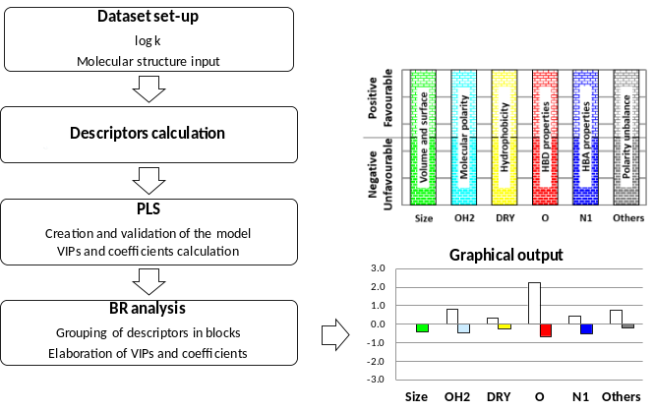
Recent Publications
- Ermondi G, Caron G (2018). Block relevance (BR) analysis and polarity descriptors in property-based drug design, ADMET and DMPK, doi: 10.5599/admet.532
- Ermondi G, Vallaro M, Caron G (2018). Learning how to use IAM chromatography for predicting permeability. European Journal of Pharmaceutical Sciences, 114: 385-390.
- Ermondi G, Vallaro M, Camacho Leal MP, Potter T, Visentin S, Caron G (2018). Charged cyclic hexapeptides: updating molecular descriptors for permeability purposes. European Journal of Pharmaceutical Sciences 122: 85-93.
- Goetz G, Shalaeva M, Caron G, Ermondi G, Philippe L (2017). Relating passive permeability to molecular polarity using Block Relevance analysis. Molecular Pharmaceutics 14: 386-393.
- Valko KL (2016). Lipophilicity and biomimetic properties measured by HPLC to support drug discovery. Journal of Pharmaceutical and Biomedical Analysis 130: 35–54.

Biography
Giulia Caron’s primary scientific activity was lipophilicity, then she moved to the design, experimental determination and computational prediction of physicochemical properties related to ADME properties and to permeability measurements. The integration of Intramolecular Hydrogen Bonding (IMHB) considerations in drug design and the development and application of a tool named Block Relevance (BR) analysis to provide a mechanistic interpretation of QSAR/QSPR models based on the PLS algorithm are two of her main field of interest. To fit new drug discovery exigences she is now focusing on defining a set of experimental and in silico tools for molecular properties evaluation in the bRo5 chemical space.
Email: giulia.caron@unito.it

Notes/Comments:

