Waterborne metabolites as indicators to the growth phases of macroalga Ulva (Chlorophyta) in aquacultures

Taghreed Alsufyani, Assistance Professor, Taif University, KSA
Thomas Wichard, Associated Professor, FSU, Germany

Abstract (300 word limit)
Field experiments usually give ecologically relevant results contributing to understand the ecosystem deeply. In marine research, aquacultures are one of the most popular procedures used to carry out field experiments (fig. a). In this study, the aquaculture of the green macroalga Ulva mutabilis was inoculated for the first time with freshly induced gametes (7-day old germlings) to culture large volume (200 L) with small axenic gametes. Two sets of aquaculture: defined community (inoculated with axenic gametes of U. mutabilis and two associated bacteria: Roseovarius sp. strain MS2. and Maribacter sp. strain MS6), and undefined community (inoculated of U. mutabilis axenic gametes only). In defined community U. mutabilis showed a healthy growth and development (fig. b) whereas in undefined community U. mutabilis lost its ability for growing and developing and formed only callus-like colonies (fig. c). Multivariate statistics of the GC/MS and LC/MS analyses along with acquisition of biological metadata revealed that the waterborne metabolites in defined community were affected qualitatively and quantitatively by the growth phases of U. mutabilis as was proven in previous study of bioreactor cultures (fig. d,e).
d: CAP of GC-MS analysis

Image
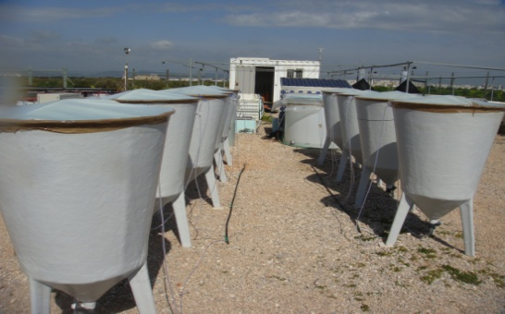
Figure a: Aquaculture set-up of 200 L in cylindrical and conical tanks, Ramalhete Station, Faro, Portugal.

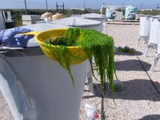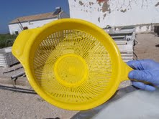
Figure b: U. mutabilis growth in defined community. Figure c: No growth in undefined community

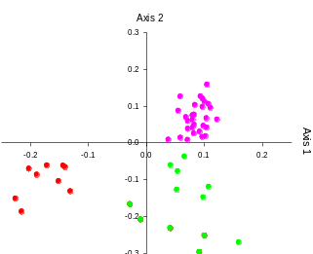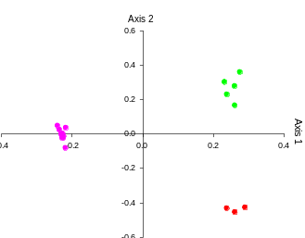
e: CAP of GC-MS analysis

Figure d,e: three separated groups based on the growth phases of U. mutabilis. red: non inducible phase, green: artificially inducible phase, Magenta: spontaneously inducible phase

Biography (150 word limit)
Taghreed Alsufyani, an Assistance Professor of Bioorganic Chemistry, Taif University, grew up in Kingdome of Saudi Arabia and received her Bachelor’s and Master’s degrees from King AbdulAziz University, Jeddah, KSA in 2006. After that, she joined Chemistry Department at Taif University where she got a scholarship to join PhD program at Friedrich Schiller University Jena, Germany, under the supervision of Dr. Thomas Wichard in Professor Georg Pohnert’s group. By the end of 2014, she got the PhD degree. In 2015, she went back to Taif University and was promoted to Assistance Professor. Since 2015, she has established The Algal Research Laboratory and began her investigation of algal chemical ecology as well as the applications of algae in biotechnology processes such as water treatment and bioenergy production.
Email: Taghreed.alsufyani@gmail.com

Notes/Comments:

I got an invitation for Oral presentation

