
Title: A novel toolbox for impurity pattern monitoring during inclusion body processing
Name: Vignesh Rajamanickam^{1,2}, Britta Eggenreich¹, Christoph Herwig^{1,2} and Oliver Spadiut^{1,2}*

¹Research Division Biochemical Engineering, Institute of Chemical Engineering, Vienna University of Technology, Vienna, Austria

² Christian Doppler Laboratory for Mechanistic and Physiological Methods for Improved Bioprocesses, Institute of Chemical Engineering, Vienna University of Technology, Vienna, Austria

Escherichia coli is a well-studied recombinant host organism extensively used for recombinant protein production. Albeit E. coli is attributed with high product titres and growth on inexpensive media, overexpression of heterologous proteins often leads to accumulation of target protein in water-insoluble, misfolded aggregates called inclusion bodies (IBs). In practice, IBs are washed, solubilized and refolded to recover the target protein in its active form. Empirical complex washing and solubilization protocols are diverse and product specific and often render poor product quality with different impurities, which negatively impact subsequent refolding. Thus, fast and precise monitoring tools are needed to follow the impurity pattern along IB processing to judge the efficiency of each Unit Operation. However, such reliable monitoring tools are still scarce to date.

In this study, we developed a novel toolbox using UV chromatogram fingerprints and chemometric techniques to monitor impurity pattern in IB washing and solubilization. Furthermore, we were not only able to monitor the process but also identify the optimal time point of transfer from one Unit Operation to the next. We are convinced that this toolbox will not only facilitate DSP monitoring, but will also allow enhanced process control in the future. The different unit operations where the novel toolbox was implemented is shown in Figure 1.

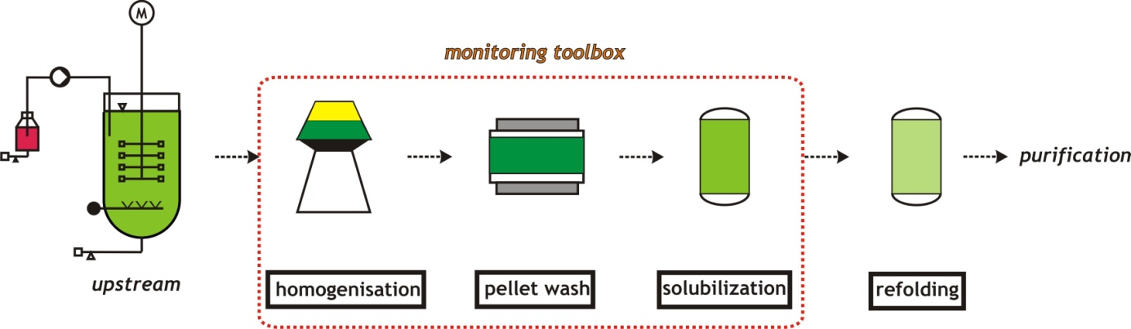
Figure 1. Implementation of novel toolbox for monitoring different unit operations involved in inclusion body processing
Keywords: process analytical technology, inclusion body processing, HPLC, process monitoring, Escherichia coli, chemometrics, chromatography

Presenting author details
Full name: Vignesh Rajamanickam
Contact number: +43(1)58801 – 166496
Twitter account: -n.a-
Linked In account: -n.a-
Session name/ number: -n.a-
Category: Oral Presentation

