Mapping of mothers' suffering and child mortality in Sub-Saharan Africa
Bayuh Asmamaw Hailu Master of Public Health in Epidemiology and Bio-statistics, Wollo University, Dessie, Ethiopia.

Abstract
Child death and mothers who suffer from child death are a public health concern in Sub-Saharan Africa. The location and associated factors of child death and mothers who suffer child death were not identified. To monitor and prioritize effective interventions, it is important to identify hotspots areas and associated factors. Data from nationally representative demographic and health survey and Multiple Indicator Cluster administrated in 42 Sub-Sahara Africa countries, which comprised a total of 398,574 mothers with 1,521,312 children. Spatial heterogeneity conducted hotspot regions identified. A mixed-effect regression model was run, and the adjusted ratio with corresponding 95% confidence intervals was estimated. The prevalence of mothers who suffer child death 27% and 45-49 year of age mother 48%. In Niger, 47% of mothers were suffering child death. Women being without HIV knowledge, stunted, wasted, uneducated, not household head, poor, from rural, and from subtropical significantly increased the odds of the case (P<0.05). The spatial analysis can support the design and prioritization of interventions. Multispectral interventions for mothers who suffer from child death are urgently needed, improve maternal health and it will reduce the future risk of cases.
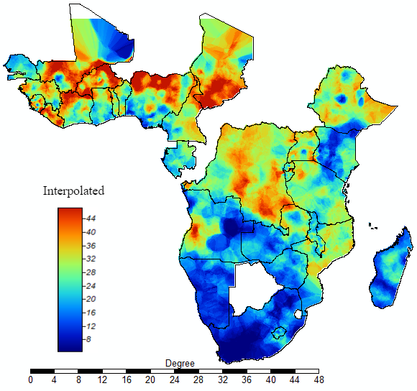
Figure 1. Interpolation of mothers who suffer at least one child death: the interpolated continuous images provided by the interpolation ordinary kriging. The colour through bold blue to bold red indicates an increase in the prevalence of mothers who suffer from child death. Tis analysis was carried out at SAGA GIS

The audience learn from my presentation is
- The burden of child death and mothers who suffer in child death can easily the specific area and the characteristics/group of such peoples
- Different models were implemented in this analysis (two factor and three in spatial) addition to simple prevalence, the audience can showed a single case in different model type is can implement.
- In this analysis used above four different tools. The audience can be see used such type of tools for health data analysis. For example SAGA GIS for interpolation is not familiar in the research world, may be in health research this attractive tools is the first time to implement because I cannot get from any research using this tools
- Almost all researchers work on SSA or low and middle income countries used systematic review or based on report of others. But in this work is from DHS directly the characteristics of individuals.
- These findings for decision maker, planer and any concerned body showed full information. First identify the burden of the problem in the study area, next the high risk group of peoples’ location and finally the characteristics or group of people from which type of house hold and community for periodization purpose and to decide the type of intervention

Biography
Bayuh Asmamaw Hailu is an Epidemiologist and Biostatistician at Woll University. He has expertise in evaluation and passion in improving the health and wellbeing. His open and contextual evaluation of geographical and non-geographical models based on responsive constructivists creates new pathways for improving health care. He has ample knowledge of different open sources GIS and other statistical soft wear. He used to link his soft wear ability with health and statistics background and experiences, and he can easily show health problems for planners and decision makers as well as any concerned body.

Details of presenting author
Name: Bayuh Asmamaw
Affiliation: Monitering and Evaluation, Wollo University, Dessie, Ethiopia
Country: Ethiopia
Other Details:
Presentation Category: Oral
Session Name: June 17-18, 2022
Email: bayuhasmamaw@gmail.com
Alternative email: bayedata@gmail.com
Contact Number: +251 91 3 58 4859
Facebook/LinkedIn/ WhatsApp: Bayuh Hailu/ bayuhasmamaw@gmail.com/+251913584859

