Parent Training for Early ADHD
Marie Louise Rimestad.
Centre for ADHD, Aarhus, Denmark

Parent training is a structured, manualized intervention for parents of children with behavioral difficulties and/or hyperactivity, impulsivity and impaired inattention. The Incredible Years ® is a well-documented parent training program developed by Carolyn Webster-Stratton, originally aiming at treating oppositional defiance conduct problems in children. It has been adapted and tested for children with ADHD difficulties as well.

Incredible Years ® Parent training as conducted in Center for ADHD, Aarhus, Denmark is group based. A group consists of two group leaders and parents of 6-7 children in the age range 3-8 years (BASIC) or 9-12 years (SCHOOL AGE). The parent training course runs for 20 session. Parents are trained in integrating play and positive labeling in their parental practices, along with structuring difficult everyday situations and establishing daily routines. Furthermore, parents are taught how to use behavioral contingency principles, primarily in the form of praise, encouragements and rewards to reinforce child concentration, self-regulation and collaboration. Sessions consist of video vignettes modeling effective and ineffective parental strategies, group discussions and hands-on exercises where parents practice new ways of managing their child’s difficulties. Extensive psychoeducation on child difficulties is implemented in the parent training, aiming at enhancing parent understanding and mentalization ability of child symptoms and difficulties.

The goal of IY Parent Training is to facilitate a more positive, successful parental management of child difficulties. By strengthening the relation between parent and child, the goal is to reduce child symptoms, prevent a negative, adverse developmental trajectory and to promote well-being for both parent and child.
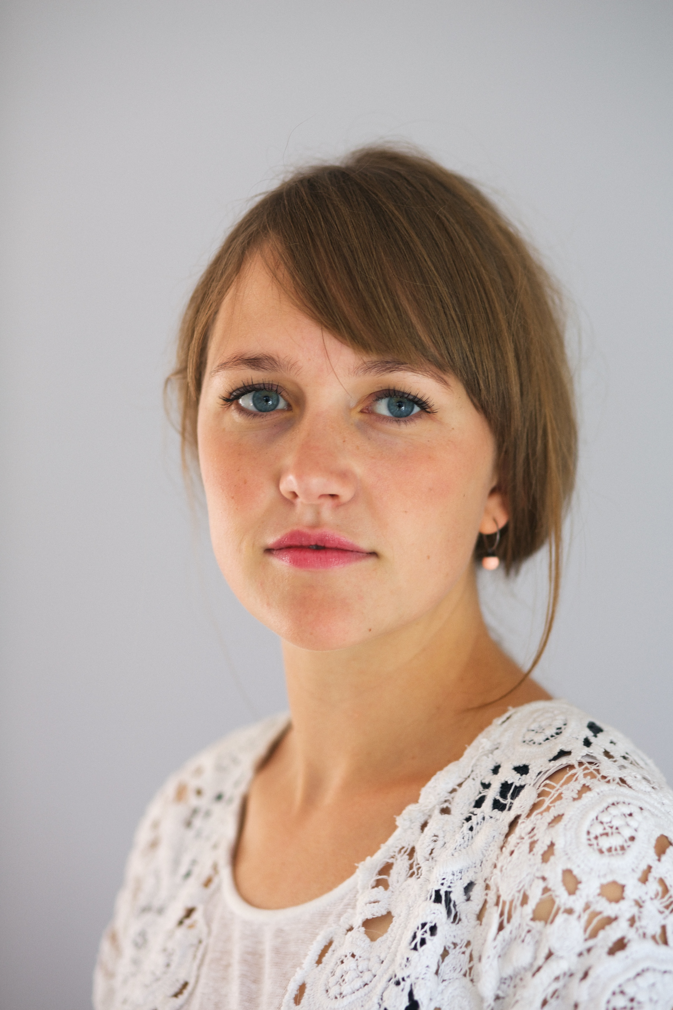

Biography

Marie Louise Rimestad is a clinical psychologist with a PhD degree in Parent Training for Early ADHD from Department of Psychology, Aarhus University, Denmark. Marie Louise is employed at Centre for ADHD, a private non-profit clinic in Aarhus, Denmark. Centre for ADHD specializes in early intervention for families of children with ADHD and professionals working with children. The core intervention in the Centre is parent training with Incredible Years®, adapted for ADHD difficulties.

Presenting author details
Marie Louise Rimestad
MLR@adhdcenter.dk
Tlf: +45 53 735 702

