Analysis of petroleum products spill effect (gasoline and diesel fuel) on soil fertility quality around pertamina Rewulu-Cilacap pipeline, Bantul, Yogyakarta
Thaifah Muthohharoh¹,Suherman², Suyanta³, Gadjah Mada University, Indonesia

Abstract
This paper is focused on analyzing of petroleum products spill effect (Gasoline and diesel fuel) on soil fertility quality around PERTAMINA Rewulu-Cilacap Pipeline, Bantul, Yogyakarta. The objective of this study was to analyzing soil fertility quality changes of the soil contaminated by gasoline and diesel fuel oil, compared to non-contaminated soil to serve as control. Soil samples were collected from around Pertamina Rewulu-Cilacap pipeline. Some physico-chemical properties that reflect soil fertility were determined using standard physico-chemical methods and Total Petroleum Hydrocarbon (TPH) using Gas Chromatography method. Soil samples were divided into three sample points based on places where they were taken, namely sample points I, II, and III . The research began with analysis physical and chemical properties of the soil, then petroleum products (gasoline and diesel) are added to the soil sample. Uncontaminated soil as control and contaminated soil then analyzed for fertility quality and TPH content. The results showed that petroleum product contamination increases N, P, and reduces K concentrations in the soil. The sample point III had the highest values of TPH concentration with without addition petroleum product. The soil samples points I, II, and III, after the addition of a dose of 13% gasoline, the concentration of tph increased by 0.036%, 0.08% and 0.008%. At the addition of 15% diesel dose, the tph concentration of soil samples 1,2, and 3 increased by 0.892 %, 1.198%, and 0.91%.

Image
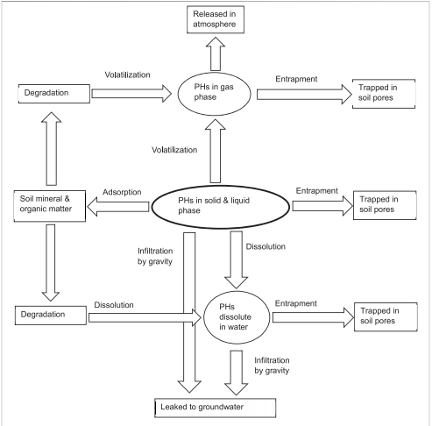
Recent Publications (minimum 5)
- Yue J l, Jiang P J (2006) Characteristics and Environmental Behavior of Petroleum Pollutants [J]. Petrochemical technology and application, 24(4):307-309.
- Chen H J (2000) Permeability and Degradation of Crude Oil in Soil [J]. Oil and Gas Field Environmental Protection 10(4):14-15.
- Cruz, J.M., Loрes, P.M., Montagnolli, N., Tamada, I.S. , Gsilva, N.M., Bidoia, E.D. (2013) Phytotoxicity Of Soil Contaminated With Petroleum Derivatives And Biodiesel. In Ecotoxicology And Environmental Contamination, 8(1): 49–54.
- Petrov, A.M. – Versioning, A.A. – Karimullin, L.K. – Akaikin, D.V. –Tarasov, O.Yu. (2016) Dynamics Of Ecological And Biological Characteristics of soddy-podzolic soils under long-term oil pollution. In Eurasian Soil Science, 49(7): 784 –791.
- Wyszkowski, M., & Wyszkowska, J. (2005) Effect of enzymatic
activity of diesel oil contaminated soil on the chemical composition of oat (Avena sativa L.) and maize (Zea mays L.).
Plant, Soil and Environment, 51(8): 360–367

Biography

Thaifah Mutohharoh, a graduate student in chemistry from the Faculty of Mathematics and Natural Sciences, Gadjah Mada University
Email: thaifah.muthohharoh@mail.ugm.ac.id

Notes/Comments:

Presenting author details
Full name: Thaifah Muthohharoh
Contact number: +6282180277200
Twitter account: -
Linked In account: -
Session name/ number:
Category: (Poster presentation)

