Unusual solvation of ESIPT probes in protic solvents
Nitin Chattopadhyay PhD, FASc, FNASc
Department of Chemistry, Jadavpur University,
Kolkata – 700 032, India.

Abstract
Unusually high fluorescence anisotropy (FA) of some ESIPT-prone molecular systems with emphasis on 3-hydroxyflavone (3HF) family in protic solvents, especially in water, has been reported for the first time.¹ Based on the experimental outcomes of steady-state and time-resolved FA experiments with 3HF and its methoxy analogue (3MF) we put forward our pioneering proposition that high FA is due to the formation of H-bonded cage-like structures of probes involving the protic solvents. This reveals an unusual pattern of solvation. Comparison of the solvation patterns of 3HF, 6HF and 7HF reveals that the position of hydroxyl group as well as the extended π-conjugation within the probe molecule dictates the extent of solvated cluster formation.² To establish the proposition, we adopt a strategy where H-bonding between the probe and water is intentionally broken in the presence of chaotropic agents or supramolecular assemblies like micelles and cyclodextrins.^{3,4} Contrary to the conventional increasing trend of FA, introduction of these entities results in lowering of the FA compared to that in aqueous medium. Disruption of the 3HF–water cluster through encapsulation of the probe within the assemblies is made responsible for the atypical behavior of FA of 3HF.^{3,4} To have a theoretical basis of the probe-water cluster formation, we undertook DFT based quantum chemical calculations as well as molecular dynamics (MD) simulation. The calculations validate our proposition by showing enhanced stability of the 3HF-water clusters with 4-5 water molecules.⁵ Essence of the whole scenario is perceived from Figure 1. We have further extended our study to another series of compounds to explore if observation of high FA prevails for other ESIPT probes as well.⁶ Here also the experimental findings led to a similar proposition of formation of H-bonded probe–water cage, justifying an unusual solvation of ESIPT probes in protic solvents.

Notes/Comments:

ESIPT: Excited state intramolecular proton transfer.
Image
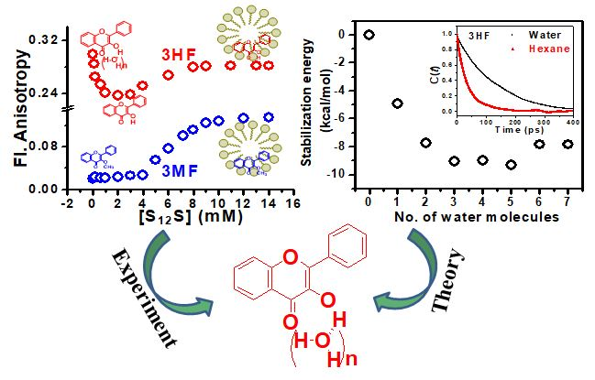
Figure 1: Formation of probe–water cluster established through experiment and theory.

Recent Publications
- Das S, Ghosh S, Chattopadhyay N (2016) Unprecedented high fluorescence anisotropy in protic solvents: Hydrogen bond induced solvent caging? Chem. Phys. Lett. 644: 284-287.
- Das S, Mukherjee S, Chakrabarty S, Chattopadhyay N (2021) Hydroxyl group directed solvation of ESIPT probes in water: A demonstration from the fluorescence anisotropy of hydroxyflavones. J. Phys. Chem. A 125: 57-64.
- Das S, Chattopadhyay N (2017) Unconventional modulation of fluorescence anisotropy of 3-hydroxyflavone in cationic micelles. Colloid Interface Sci. Commun. 16: 10-13.
- Das S, Chattopadhyay N (2017) Supramolecular inclusion assisted disruption of probe-solvent network. ChemistrySelect 2: 6078-6081.
- Das S, Chakrabarty S, Chattopadhyay N (2020) Origin of unusually high fluorescence anisotropy of 3-hydroxyflavone in water: Formation of probe-solvent cage-like cluster. J. Phys. Chem. B 124: 173-180.
- Das S, Chattopadhyay N (2018) Heteroatom controlled probe-water cluster formation of a series of ESIPT probes: An exploration with fluorescence anisotropy. Chem. Phys. Lett. 708: 37-41.


Biography (150 word limit)
Nitin Chattopadhyay, a Professor of Jadavpur University and Fellow of the Indian Academy of Sciences (FASc) and the National Academy of Sciences India (FNASc) is a well-recognized researcher and an inspirational educator/teacher. His diverse areas of research interest include photochemistry, biophysical chemistry, surface chemistry, fluorescence sensing, polymer photophysics, drug delivery / drug excretion, nanoparticle research, photo-processes in homogeneous and micro-heterogeneous environments etc. He has been engaged in developing various simple and useful strategies. Massive enhancement of the fluorosensing efficiency through introduction of micelles, synthesis of gold nanoparticles of desired dimension, delivery of drugs by endogenous/exogenous methods using suitable self-assembled binders, excretion of excess drugs from the cell membranes using cyclodextrins, are only a few of his notable contributions. He is also an adorable orator and an excellent teacher. His stimulating lectures make the subjects loveable to the students at all levels, starting from schools, motivating them towards chemistry/science.
Email: nitin.chattopadhyay@yahoo.com

