Synthesis and Characterization of two Dimensional MXene (30F-Ti₃C₂T_{x}) from MAX (Ti₃AlC₂) by Etching method
Amol Tambe, Sudhir Arbuj, Sunit Rane, Sulabha Kulkarni, Bharat B. Kale*
Centre for materials for Electronics Technology, off Pashan road, Panchwati, Pune -411008
Email: amoltambe338@gmail.com/bbkale1@gmail.com
Abstract
The family of 2D transition metal carbides, carbonitrides and nitrides (collectively referred to as MXene) has expanded rapidly since the discovery of MXene (30F-Ti₃C₂T_{x}) in 2011.The multilayered MXene (30F-Ti₃C₂T_{x}, X= -OH,-F) of two-dimensional materials is produced by etching of an ‘Al’ layer from a MAX phase of Ti₃AlC₂ three-dimensional materials. ‘Al’ layer is etched by different etchants such as HF, LiF/HCl, KF/HCl, LiBr/HCl, NH₄HF₂. MXene materials always have surface terminations of functional group/atoms such as hydroxyl, oxygen or fluorine, which impart hydrophobicity or hydrophilicity to their surfaces. The main properties and synthesis routes are reviewed here including solid state reaction methods, physical vapor deposition (PVD) techniques and molten salt processes. The MXene product is characterized by different techniques such as XRD, FESEM, UV, FTIR and Raman spectroscopy etc. Novel potential applications of MXene in supercapacitors, anodes in lithium-ion batteries, sodium ion batteries, photo catalysis and gas sensors are discussed. We will show some of our recent results on Ti₃C₂T_{x} MXene used as anode material in application for Li ion battery and hydrogen generation.
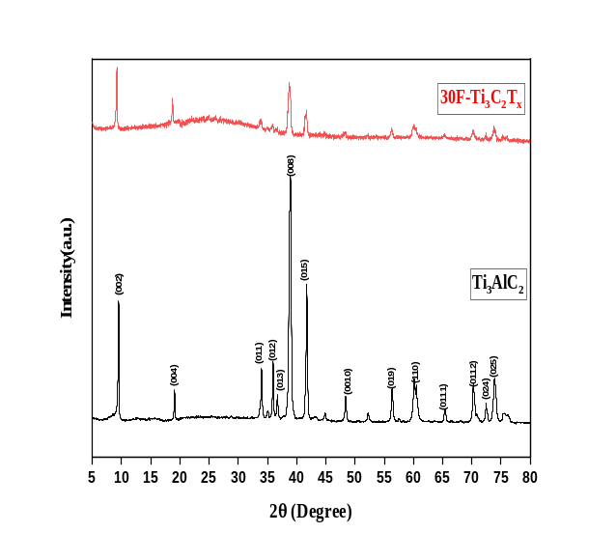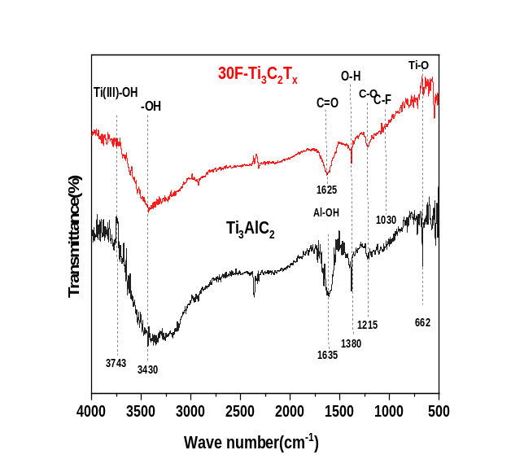Keywords: MAX, MXene, Etching, supercapacitor.
FESEM: Ti₃AlC₂ & 30F-Ti₃C₂T_{X}
XRD: Ti₃AlC₂ & 30F-Ti₃C₂T_{X}
FTIR: Ti₃AlC₂&30F-Ti₃C₂T_{X}
MAX (Ti₃AlC₂)
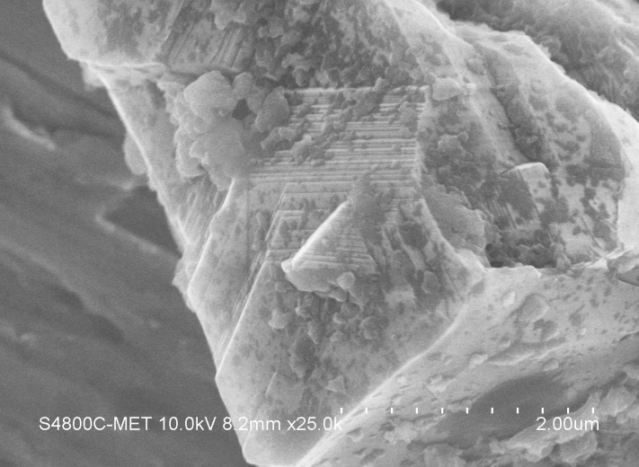MXene (30F-Ti₃C₂T_{x}) 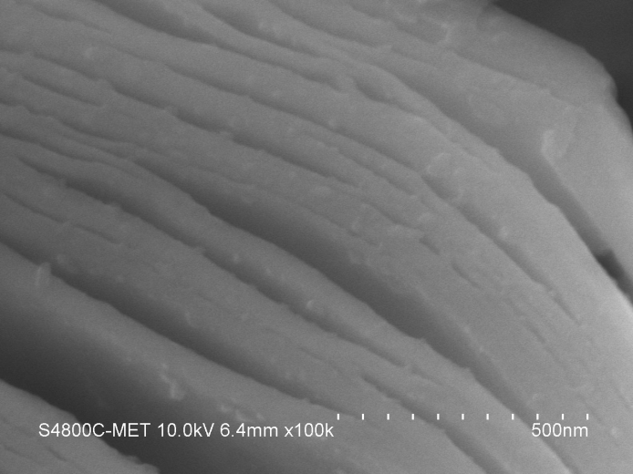

Reference
1. Barsoum, M. W. Wiley: Hoboken, NJ, 2013; p 436.
2. NaguibM, Gogotsi Y. Acc. Chem. Res. 2015, 48, 128−35.
3. Naguib M, Kurtoglu M. M, Hultman, L, Gogotsi, Y, Barsoum, M. W. Adv. Mater. 2011, 23, 42, 48−53.