Development and Characterization of Electrospun Curcumin-Loaded Antimicrobial Nanofibrous Membranes
Javeed A. Awan^{1,2}*, Saif Ur Rehman¹, Muhammad Kashif Bangash², Jean-Noël Jaubert³
javeed.icet@pu.edu.pk, kashif.tet@pu.edu.pk, saifrehman241200@gmail.com, jean-noel.jaubert@univ-lorraine.fr
¹ Institute of Chemical Engineering and Technology, University of the Punjab, Lahore, Pakistan.² Department of Textile Engineering and Technology, University of the Punjab, Lahore, Pakistan. ³ Laboratoire Réactions et Génie des Procédés (LRGP), Université de Lorraine, France.

Advances in Chemical Engineering & Technology, March 02-03, 2020 London, UK

Abstract
Curcumin is a naturally occurring hydrophobic polyphenol compound. It exhibits a wide range of biological activities such as antibacterial, anti-inflammatory, anti-carcinogenic, antifungal, anti-HIV, and antimicrobial activity. In this research work, antimicrobial curcumin nanofibrous membranes are produce by electrospinning technique using the Eudragit RS 100 (C₁₉H₃₄CINO₆) polymer solution and curcumin. The morphology and chemistry of the membrane are analyzed using Scanning Electron Microscopy (SEM) and Fourier-Transform Infrared (FTIR) Spectroscopy. Kirby Bauer disk diffusion tests are carried out to examine the antibacterial effectiveness of the membrane. Experimental results shows that the nanofibers produced are of uniform thickness morphology and curcumin is successfully incorporated into the nanofibrous mat while no chemical bonding was observed between curcumin and the polymer. The antimicrobial curcumin nanofibrous membranes can be effectively applied as antimicrobial barrier in a wide variety of medical applications such as wound healing, scaffolds and tissue engineering.
Key Words: Antimicrobial Nanofibrous Membrane, Curcumin, Electrospinning, SEM, FTIR, Kirby Bauer Disk Diffusion Test.

*Corresponding Author/s :- Dr. Javeed Ashraf Awan ( Associate Professor at ICET) Prof. Dr. Jean-Noël Jaubert ( Professor and Head) LRGP - Laboratoire Réactions et Génie des Procédés, Université de Lorraine, France. Email Address: jean-noel.jaubert@univ-lorraine.fr Phone: 00 33 3 72 74 37 70

Literature Review
Nanofibers are exciting new class of materials, useful for many applications due its very fine thickness (≤ 100 nm) and large surface-to-volume ratio [1]. Several techniques based on polymer type, attainable fiber assembly, production rate and cost are used to produce nanofibers such as electrospinning [2], melt-blowing [3], template synthesis [4], self-assembly [5], multi-component spinning [6], flash spinning [7], and nanolithography [8].
Among others [2–8], electrospinning is the most versatile fabrication process that can produce nanofibers from a wide range of polymeric materials at higher production rate and low cost. Electrospinning is a process of applying high voltage between a polymer solution contained in a syringe with a capillary tip and a collector. Electrospun fibers are collected at the collector during the fabrication process in the form of membranes. The properties of nanofibers can be customized by regulating the voltage, concentration and viscosity of polymer solution, and solvent composition [9]. Till the recent past, electrospinning of more than 100 varieties of natural and synthetic polymers, composites and ceramics into ultra-fine nanofibers have been demonstrated. Nanofibers can also be functionalized by mixing with functional additives or surface modification [10,11]. Electrospun nanofibrous membranes have found wide range of applications in health care, energy storage, environment engineering and biotechnology due to its relatively light weight, high surface area, and interconnected porous structure [10].
Recent developments in the field of nanostructures has opened up exciting opportunities for new materials design such as nanofibrous membranes with antimicrobial properties for medical applications such as wound dressings etc. [12,13]. The conventional wound dressings provide basic environments for wounds with regards to barrier to evaporation and protection from outside bodies. However, the biologically functional electrospun antimicrobial nanofibrous membranes encourage healing and also compensate the functions of conventional wound dressing [14]. Antimicrobial agents inhibits the growth of microorganism by bacteriostatic and bactericidal responses, however, the antimicrobial agents can also be harmful such as in case specific allergies etc. [15]. Compared to synthetic, natural antimicrobial agents are less harmful, biocompatible, economically viable and readily available. Natural antimicrobial agents are the major chemical constituents of some most common plants such as Turmeric, Aloe Vera, Basil and Neem etc. Turmeric was used in the ancient times to promote wound healing due to one of its major chemical component, Curcumin. Figure 1 shows the structure of the Curcumin molecule. Curcumin is an anti-oxidant, anti-inflammatory, anti-cancer, assists in reducing pain and accelerates the process of wound healing [16,17]. Curcumin dissolves in organic solvents like ethanol, acetone and Dimethyl Formaamide (DMF) and its anticoagulant property make it suitable for drug-eluting stents [18]. Several researchers has successfully incorporated curcumin into biomaterials and observed its medical efficacy. Nguyen et al. [16] produced curcumin loaded Poly-Lactic Acid (PLA) nanofibers and reported its potential antimicrobial effectiveness. Xie et al. [19] fabricated curcumin-loaded silk fibroin nanofibrous membranes and suggested that the drug-loaded nanofibrous membranes can be useful as biomaterials with antimicrobial and antitumor function.
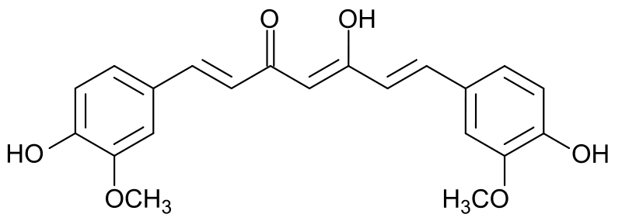
Figure 1 Curcumin (C₂₁H₂₀O₆) Structure
Wide range of natural (collagen, gelatin, chitosan, elastin, silk fibroin and alginate) and synthetic (PGA, PLGA, PCL, PLLA-CL, PEO and PVA) polymers are used to produce nanofibrous membranes for biomedical applications [20–22]. Natural polymers are biocompatible and biodegradable compare synthetic polymers display improved structural properties. However, natural polymers are sometimes mixed with synthetic polymers to enhance the properties of membrane [23].
In this research work, an economical and effective antimicrobial nanofibrous membranes are fabricated by using natural antimicrobial agent “Curcumin” utilizing electrospinning fabrication technique. Morphological and functional properties of the nanofibrous membrane are studied using SEM and FTIR. To evaluate application in the medical field, Kirby Bauer disk diffusion tests are carried out to examine the antibacterial effectiveness of the antimicrobial curcumin nanofibrous membranes.

Experimental Work

Materials
Eurdagit RS 100 (C₁₉H₃₄C_{l}NO₆) (ethyl prop-2-enoate; methyl 2-methylprop-2-enoate; trimethyl-(2-(2-methylprop-2-enoyloxy) ethyl) azanium) supplied by Sigma-Aldrich, Germany was used as electrospinning polymer. Ethanol and DMF, supplied by the institute of Chemical Engineering, University of the Punjab, Lahore were used as solvent. Curcumin was recovered from Turmeric powder of analytical grade, acquired from local (Abkari) market, Lahore, Pakistan.
The conductivity of solutions was measure using a conductivity meter. Ostwald Viscometer was used to determine viscosity of solutions. Stalagometer was used to measure the surface tension of solutions. To produce the nanofibrous membranes, sprocket disk needleless electrospinning setup in the lab facility of the College of Textile Engineering, Bahauddin Zakariya University was used. Figure 2 represents the schematic diagram of needleless electrospinning setup. The setup is composed of a Teflon bathtub, high voltage supply, a sprocket disk equipped with spinneret for fabrication of nanofibrous membrane and a collector surface to receive nanofibers and produce membrane.
Figure 2 Schematic diagram of needleless electrospinning setup.
Finite detail method was used to analyze the mechanism, profile and intensity of electric area across the spinneret of sprocket disk in needleless electrospinning setup. Geometry of bullet spinneret was produced using solid work software (2014 version) and COMSOL Multiphysics 5 software was used for modeling.
Inspect S50 Scanning Electron Microscopy (SEM) was used to examine the surface morphology of the fibers and Nicolet iS5 Fourier Transform Infrared Spectrometer (FTIR) was used to identify functional group in nanofibers in the institute of Chemical Engineering, University of the Punjab, Lahore. Mueller-Hinton agar plates in the lab facility of the College of Textile Engineering, Bahauddin Zakariya University were used to evaluate the response of curcumin nanofibrous membrane towards bacteria growth.

Methods

Curcumin Extraction
To extract the curcumin, Turmeric powder was mixed with ethanol (95%) in a ratio 1:5 for fifteen days at a room temperature with the help of magnetic stirrer. The main ingredients of turmeric are diffused into the solvent and by filtration and evaporation, an active substance called Curcumin is recovered.

Dope Preparation
The polymer solution for electrospinning of nanofibrous membrane without antimicrobial activity was prepared by adding 3.2 gm of Eurdagit RS 100 polymer to an 8% solution of HCON (CH₃)₂ containing 20 ml of ethyl alcohol and 20 ml of DMF. The polymer solution was stirred for 36 hours continuously to reach uniformity.
To produce antimicrobial nanofibrous membrane, curcumin was added to polymer solution to prepare polymer solution for electrospinning in three different concentrations. Each of the polymer solution was stirred for 36 hours continuously at room temperature to attain uniformity. The viscosity, conductivity and surface tension properties of the prepared polymer solutions were determined and the respective vales are reported in Table 1.

Table 1 Properties of the prepared dope solution for electrospinning of nanofibrous membranes.

S. No | Electrospinning Dope | Viscosity [cps] | Conductivity [mS] | Surface Tension  [dyne/cm]
1 | Polymer solution without Curcumin | 1415 | 0.75 | 87
2 | Polymer solution with 1% Curcumin | 1165 | 0.96 | 81
3 | Polymer solution with 5% Curcumin | 769.44 | 1.50 | 78
4 | Polymer solution with 9% Curcumin | 687 | 1.80 | 74

Nanofibrous Membranes Preparation
Sprocket disk needleless electrospinning setup was used to produce the nanofibrous membrane specimens. The electrospinning polymer solution was added to the Teflon bath and spinneret teeth were dipped into the polymer solution. A 12v DC potential was supplied between the wheel and a twine electrode submerged in the polymer solution bathtub.
The optimized valve for spinning distance was set to 12 cm and potential at 35 kV. The optimized values were calculated by using finite detail method and modeling software. Figure 3 shows the distribution of electric field around the sprocket disk equipped with spinneret. It was observed that the intensity of electrical profile is extra centered on the top ground of bullets than the relaxation floor of spinneret.
Figure 3 Electric field profile around the sprocket disk equipped with spinneret.
Intensity of electric subject norm is identical to the negative gradient of the implemented capacity difference as shown in equation 1. The geometric form that has large curvature might be able to produce high-depth electric subject beneath the identical applied capability difference. This is why the intensity of electric subject norm is more on hints of bullets compared to the rest frame of the bullet spinneret.
E = -∇ V Equation 1
Whereas, V = Potential distinction and E = Intensity of electric discipline norm.
With the increase in electric potential, up to the optimized value, the sprocket disk starts rotating and cohesive forces between the spinneret and polymeric solution are established. During the rotation, spinneret transfers the dope from the bathtub to the collector in the form of nanofibers. The layers of nanofibers accumulate on the collector and develop a fibrous membrane. Figure 4 shows the accumulation of nanofibers on the collector surface at different time intervals during the electrospinning process.
Figure 4 Macro images of the nanofibers accumulated on collector at different intervals.
The nanofibrous mat accumulated on the collector surface was recovered. Figure 5 shows the macro images of the membranes recovered during the electrospinning experiment in this study.
Figure 5 Macro images of curcumin, (a) 2cm x 3.5cm (b) 3x magnified, electrospun nanofibrous membrane.

Kirby Bauer Disk Diffusion Method
Suspended bacteria in a liquid culture at 150 million/ml was spread across the (Mueller-Hinton) agar plate using a moist swab. Then the circular pieces (disks) of antimicrobial nanofibrous membrane were placed carefully on the floor the agar plate using forceps. The infected forceps were cleaned each time by putting it in a bacteria incinerator for ten (10) seconds. The agar plates containing the antimicrobial nanofibrous membrane samples were incubated at 37 ºC for twenty-four (24) hours. The inhibition zones developed were measured using metric ruler to analyze the sensitivity of the antimicrobial nanofibrous membrane to bacteria.

Results and Discussion

Properties of Dope
The viscosity, surface tension and conductivity of the prepared dope solution for electrospinning of nanofibrous membranes was measured at 1 wt%, 5 wt% and 9 wt% curcumin concentrations. The experimental results, reported in Table 1, shows a decreasing trend in viscosity and surface tension of the polymer solution with the increase in curcumin concentration. In-order to achieve uniform and beadless nanofibers, the concentration of the electrospinning polymer solution should be above entanglement concentration (Ce) [24]. Lower viscosity of the polymer solution may cause electrosprying instead of electrospinning, while lower surface tension of the polymer solution leads to beads free nanofibers production in electrospinning [25]. The addition of curcumin to the polymer solution was kept to the level to keep the viscosity above the entanglement concentration (Ce) threshold, therefore, at the attained viscosity, the workable range of polymer solution is expanded. Improvement in the conductivity was observed when the concentration of curcumin was increased in the polymer solution. Wang et al. [17], also reported the increase in conductivity with the addition of curcumin to polymer solution and observed that the enhanced electrical conductivity favors the electrical drawing effect on the jet fluid and decreases the fiber fineness.

Morphology
Figure 6 shows the SEM images of the electrospun nanofibrous membranes morphology. The results evidence that the nanofibers are apparently produced with uniform thickness and no accumulation of polymer mass in the form of beads was observed across the fibrous membrane. Researchers in the recent past reported that there are several electrospinning process parameters such as polymer concentration, applied voltage, type of solvent system, solution fed rate, type of collector and rotation speed that can affect the morphology of the nanofibers [16,26,27]. However, for all the specimen preparation in this study, the electrospinning process parameters were optimized and kept similar during the series of experiments, therefore, a uniformity was observed in the clusters of the nanofibers.
Figure 6 SEM images of membrane having a) 1% b) 5% and a) 9% curcumin content.
The absence of beads formation and apparently even distribution of nanofibers in the nanofibers cluster shows the uniform dispersion of curcumin in the polymer and in the membrane. A relative discontinuity of nanofibers was noticed in Figure 6 (a) and (b) due to the lower concentration of curcumin in polymer solution. However, higher uniformity and continuity in the thickness of nanofibers and its distribution in the membrane was observed, Figure 6 (c), when the curcumin content in the polymer solution was increased to 9 wt%.

FTIR Analysis
FTIR spectrum of the polymer (Eudragit RS 100), antimicrobial agent (Curcumin) and the electrospun curcumin-loaded nanofibrous membrane are reported in Figure 7. The FTIR spectra of the polymer (Eudragit RS 100), Figure 7 (a), confirms the presence of methyl band at 2930 cm⁻¹, ester C=O band at 1724 cm⁻¹ and C–O band at 1160 cm⁻¹. Similar observations are reported by other researchers in literature [28,29].
The FTIR spectra of the antibacterial agent used in this study, Figure 7 (b), evidences the presence of hydroxyl, methyl, carbonyl and C=C bands at 3307 cm⁻¹, 2950 cm⁻¹, 1640 cm⁻¹ and 1560 cm⁻¹ bands respectively. The observations are supported by the findings reported by Rohman et al. [30] and Siregar et al. [31] while working on curcumin based drugs for medicinal applications.
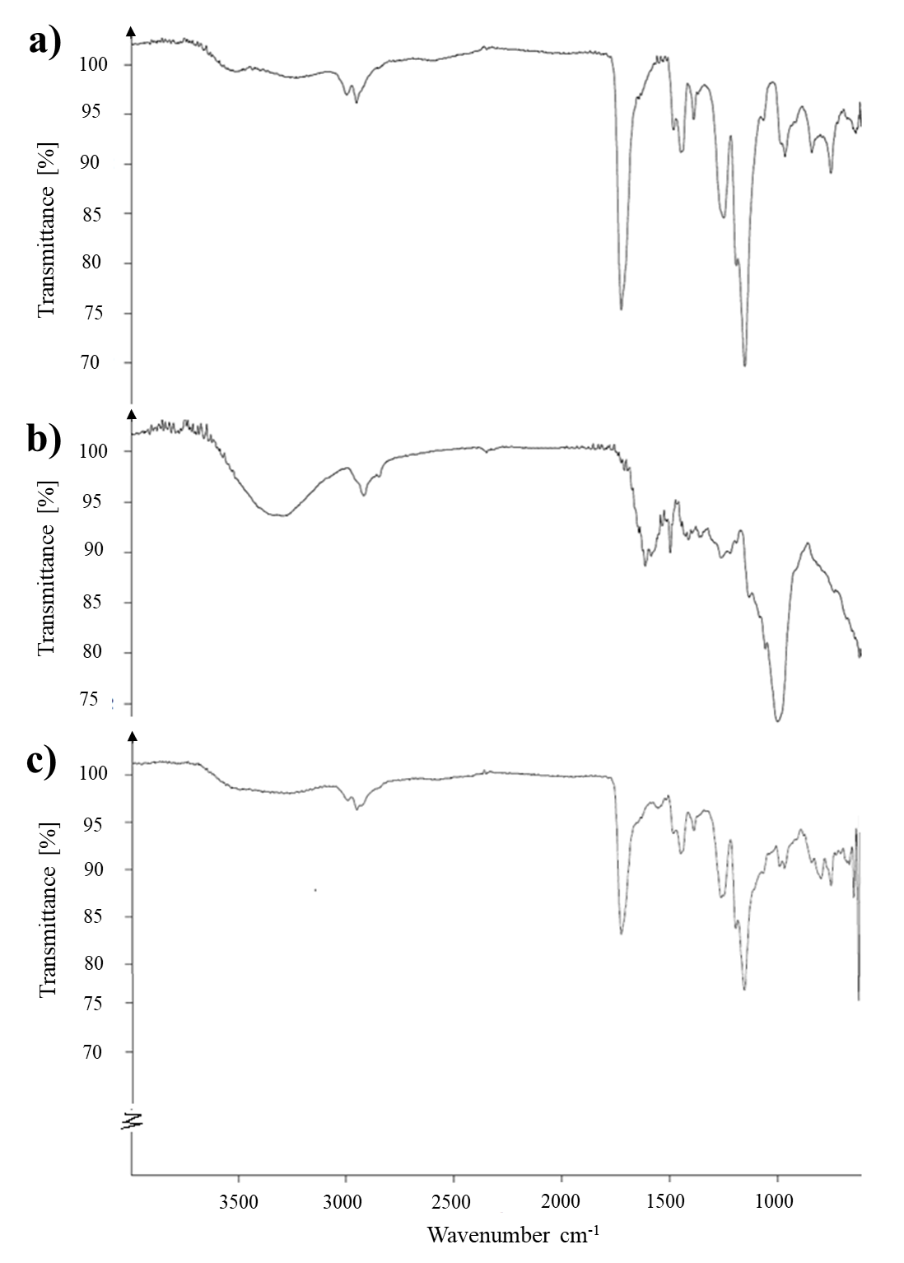
Figure 7 FTIR Spectra of (a) Polymer (Eudragit RS 100), (b) Antimicrobial agent (Curcumin) and (c) Antimicrobial electrospun nanofibrous membrane.
Curcumin loaded electrospun nanofibrous membrane FTIR spectra, Figure 7 (c), indicates the peaks for the constituents of polymer and curcumin such as at 3310 cm⁻¹ (phenolic OH), at 1740 cm⁻¹ (C=O ketone), at 2970 cm⁻¹ (alkane CH₃ stretching), at 1550 cm⁻¹ (C=C) and at 1160 cm⁻¹ (C–O). These results confirms the incorporation of antimicrobial agent (curcumin) into the nanofibrous membrane while, no apparent chemical linkages between the antimicrobial agent and polymer are observed.

Kirby Bauer Disk Diffusion Test Results
Inhibition zones are measured around the nanofibrous membrane without curcumin and 9 wt% curcumin loaded nanofibrous membrane disks in the agar plate. From results presented in Figure 8 (b) it is evident that, the curcumin spreads into the agar and stops the growth of bacteria in the indicated zones compared to the zones having disks of nanofibrous membrane without curcumin.
Figure 8 Kirby Bauer Disk Diffusion, Agar plate loaded with disks (a) before and (b) after incubation at 37 ºC for twenty-four (24) hours.
The inhibition of bacterial growth is confirmed by several researchers. Xie et al [19] exhibited the drug release properties of the SF/PEG nanofibrous membranes loaded with curcumin. Nguyen et al. [16] reported higher closure rates of wounds treated with Cur-loaded PLA nanofibers. Wang et al. proposed that PVP nanofibers loaded with curcumin display enhanced bioavailability and effective anticancer effect [17]. The current results shows promising properties for the development of curcumin based antimicrobial membranes for medical applications.

Conclusion
In this research work, an economical and readily available natural antimicrobial agent “Curcumin” extracted from a turmeric plant is successfully blended into a nanofibrous membrane using electrospinning technique for medical applications. The nanofibrous membranes were characterized for morphology, chemistry and its antimicrobial effectiveness. The SEM results evidences the formation of smooth, uniform and beadless nanofibers, clustered in a fibrous mat/membrane when the concentration of curcumin was 9 wt%, was achieved. The FTIR analysis confirmed the incorporation of antimicrobial agent “curcumin” into the nanofibrous membrane without chemical linkages between the antimicrobial agent and the polymer. The Kirby Bauer Disk Diffusion test results verified the antimicrobial effectiveness of the fabricated curcumin loaded nanofibrous membranes.

Future work
Future work in progress is in the direction of incorporating several other naturally occurring antimicrobial agents such as Aloe Vera, Neem and Basil etc. and their blends into the nanofibrous membranes for high-end medical applications at lower cost.

References
[1] Kenry, Lim CT. Nanofiber technology: current status and emerging developments. Prog Polym Sci 2017;70:1–17. doi:10.1016/j.progpolymsci.2017.03.002.
[2] Ahmed FE, Lalia BS, Hashaikeh R. A review on electrospinning for membrane fabrication: Challenges and applications. Desalination 2015;356:15–30. doi:10.1016/j.desal.2014.09.033.
[3] Zhang H, Zhen Q, Liu Y, Liu R, Zhang Y. One-step melt blowing process for PP/PEG micro-nanofiber filters with branch networks. Results Phys 2019;12:1421–8. doi:10.1016/j.rinp.2019.01.012.
[4] Kim T, Naoki W, Miyawaki J, Park J Il, Lee C, Jung HK, et al. Synthesis of surface-replicated ultra-thin silica hollow nanofibers using structurally different carbon nanofibers as templates. J Solid State Chem 2019;272:21–6. doi:10.1016/j.jssc.2019.01.025.
[5] Mendes AC, Strohmenger T, Goycoolea F, Chronakis IS. Electrostatic self-assembly of polysaccharides into nanofibers. Colloids Surfaces A Physicochem Eng Asp 2017;531:182–8. doi:10.1016/j.colsurfa.2017.07.044.
[6] Yu DG, Gao LD, White K, Branford-White C, Lu WY, Zhu LM. Multicomponent amorphous nanofibers electrospun from hot aqueous solutions of a poorly soluble drug. Pharm Res 2010;27:2466–77. doi:10.1007/s11095-010-0239-y.
[7] Nayak R, Padhye R, Kyratzis IL, Truong YB, Arnold L. Recent advances in nanofibre fabrication techniques. Text Res J 2012;82:129–47. doi:10.1177/0040517511424524.
[8] Ye Z, Nain AS, Behkam B. Spun-wrapped aligned nanofiber (SWAN) lithography for fabrication of micro/nano-structures on 3D objects. Nanoscale 2016;8:12780–6. doi:10.1039/c6nr03323g.
[9] Khil M, Cha D, Kim H, Kim I, Bhattarai N. Electrospun Nanofibrous Polyurethane Membrane as Wound Dressing. J Biomed Mater Res 2003;67B:675–9. doi:10.1002/jbm.b.10058.
[10] Wang X, Hsiao BS. Electrospun nanofiber membranes. Curr Opin Chem Eng 2016;12:62–81. doi:10.1016/j.coche.2016.03.001.
[11] Feng C, Khulbe KC, Matsuura T, Tabe S, Ismail AF. Preparation and characterization of electro-spun nanofiber membranes and their possible applications in water treatment. Sep Purif Technol 2013;102:118–35. doi:10.1016/j.seppur.2012.09.037.
[12] Chen JP, Chang GY, Chen JK. Electrospun collagen/chitosan nanofibrous membrane as wound dressing. Colloids Surfaces A Physicochem Eng Asp 2008;313–314:183–8. doi:10.1016/j.colsurfa.2007.04.129.
[13] Jiang S, Ma BC, Reinholz J, Li Q, Wang J, Zhang KAI, et al. Efficient Nanofibrous Membranes for Antibacterial Wound Dressing and UV Protection. ACS Appl Mater Interfaces 2016;8:29915–22. doi:10.1021/acsami.6b09165.
[14] Seda Tiğli Aydın R, Eroğlu AN, Karakeçili A, Çalımlı A. Designing double-layered nanofibrous membranes as a wound dressing material. Fibers Polym 2016;17:1765–75. doi:10.1007/s12221-016-6668-4.
[15] Ocampo PS, Lázár V, Papp B, Arnoldini M, Zur Wiesch PA, Busa-Fekete R, et al. Antagonism between bacteriostatic and bactericidal antibiotics is prevalent. Antimicrob Agents Chemother 2014;58:4573–82. doi:10.1128/AAC.02463-14.
[16] Nguyen TTT, Ghosh C, Hwang SG, Tran LD, Park JS. Characteristics of curcumin-loaded poly (lactic acid) nanofibers for wound healing. J Mater Sci 2013;48:7125–33. doi:10.1007/s10853-013-7527-y.
[17] Wang C, Ma C, Wu Z, Liang H, Yan P, Song J, et al. Enhanced Bioavailability and Anticancer Effect of Curcumin-Loaded Electrospun Nanofiber: In Vitro and In Vivo Study. Nanoscale Res Lett 2015;10:1–10. doi:10.1186/s11671-015-1146-2.
[18] Xie M, Fan D, Zhao Z, Li Z, Li G, Chen Y, et al. Nano-curcumin prepared via supercritical: Improved anti-bacterial, anti-oxidant and anti-cancer efficacy. Int J Pharm 2015;496:732–40. doi:10.1016/j.ijpharm.2015.11.016.
[19] Xie X, Yu J, Zhao Z, Zheng Z, Xie M, Wang X, et al. Fabrication and drug release properties of curcumin-loaded silk fibroin nanofibrous membranes. Adsorpt Sci Technol 2019;37:412–24. doi:10.1177/0263617418820416.
[20] Bazbouz MB, Liang H, Tronci G. A UV-cured nanofibrous membrane of vinylbenzylated gelatin-poly(ɛ-caprolactone) dimethacrylate co-network by scalable free surface electrospinning. Mater Sci Eng C 2018;91:541–55. doi:10.1016/j.msec.2018.05.076.
[21] Silva SS, Caridade SG, Mano JF, Reis RL. Effect of crosslinking in chitosan/aloe vera-based membranes for biomedical applications. Carbohydr Polym 2013;98:581–8. doi:10.1016/j.carbpol.2013.06.022.
[22] Li M, Mondrinos MJ, Chen X, Lelkes PI. Electrospun blends of natural and synthetic polymers as scaffolds for tissue engineering. Annu Int Conf IEEE Eng Med Biol - Proc 2005;7 VOLS:5858–61.
[23] Bhattarai DP, Aguilar LE, Park CH, Kim CS. A review on properties of natural and synthetic based electrospun fibrous materials for bone tissue engineering. Membranes (Basel) 2018;8. doi:10.3390/membranes8030062.
[24] Tiwari SK, Venkatraman SS. Importance of viscosity parameters in electrospinning: Of monolithic and core-shell fibers. Mater Sci Eng C 2012;32:1037–42. doi:10.1016/j.msec.2012.02.019.
[25] Abutaleb A, Lolla D, Aljuhani A, Shin HU, Rajala JW, Chase GG. Effects of surfactants on the morphology and properties of electrospun polyetherimide fibers. Fibers 2017;5. doi:10.3390/fib5030033.
[26] Gu SY, Ren J. Process optimization and empirical modeling for electrospun poly(D,L-lactide) fibers using response surface methodology. Macromol Mater Eng 2005;290:1097–105. doi:10.1002/mame.200500215.
[27] Sencadas V, Ribeiro C, Nunes-Pereira J, Correia V, Lanceros-Méndez S. Fiber average size and distribution dependence on the electrospinning parameters of poly(vinylidene fluoride-trifluoroethylene) membranes for biomedical applications. Appl Phys A Mater Sci Process 2012;109:685–91. doi:10.1007/s00339-012-7101-5.
[28] Reddy D. Formulation and in vitro evaluation of antineoplastic drug loaded nanoparticles as drug delivery system. African J Pharm Pharmacol 2013;7:1592–604. doi:10.5897/ajpp2013.3436.
[29] Verma P, Gupta RN, Jha AK, Pandey R. Development, in vitro and in vivo characterization of Eudragit RL 100 nanoparticles for improved ocular bioavailability of acetazolamide. Drug Deliv 2013;20:269–76. doi:10.3109/10717544.2013.834417.
[30] Rohman A, Sudjadi, Devi, Ramadhani D, Nugroho A. Analysis of curcumin in curcuma longa and Curcuma xanthorriza using FTIR spectroscopy and chemometrics. Res J Med Plant 2015;9:179–86. doi:10.3923/rjmp.2015.179.186.
[31] Siregar C, Martono S, Rohman A. Application of Fourier transform infrared (FTIR) spectroscopy coupled with multivariate calibration for quantitative analysis of curcuminoid in tablet dosage form. J Appl Pharm Sci 2018;8:151–6. doi:10.7324/JAPS.2018.8821.

Biography
Dr. Javeed Ashraf Awan is an Associate Professor in Chemical Engineering at the University of the Punjab. He has been working as postdoctoral researcher for 3 years at Chemical Engineering, Technical University of Denmark on different energy related projects funded by Danish Ministry of Science Technology and Innovation. He has completed his PhD in Energy and Process Engineering (Chemical Engineering) in September 2009 from “Ecole Nationale Superieur Des Mines De Paris” known as (Mines ParisTech-France). During his PhD he has been working on Gas Processors Association-USA (GPA-037) Project titled “Thermodynamics of Natural Gas Containing Organic Sulfur Species-Alkanolamine Aqueous Solutions in the Presence of Acid Gases”. He has published his research work in international/national peer reviewed journals. He is also working as Industrial consultant on different projects related to CO2 capture, Acid gas removal, Biofuels, Coal Power Generation, Sulfur Chemistry and Removal Management, Energy Conservation and Environmental Management Systems and Thermodynamic Modeling (CPA-EoS, Electrolyte-UNIQUAC, GCA-EoS) for reactive and non-reactive systems.

Presenting author details
Full name: Dr. Javeed Ashraf Awan
Contact number: 00-92-300-4345047
Twitter account: N/A
Linked In account:
Session name/ number:
Category: (Oral presentation/ Poster presentation) Oral Presentation

