Effects of Hydrothermal Pretreatment by Steaming on Catalytic Performance of Modified HZSM-5 Catalysts for the Conversion of
n-Pentane to Aromatics
Chaninwut Kalajuck, the Petroleum and Petrochemical College, Thailand
Siriporn Jongpatiwut, the Petroleum and Petrochemical College, Thailand
Thirasak Rirksomboon, the Petroleum and Petrochemical College, Thailand

Abstract

The primary economic aim of petrochemical manufacturers is to maximize the value added of products. Therefore, one of the reasonable routes being recently interesting is to convert the excess low-valued C₅ fraction into high-valued aromatic products, benzene, toluene, and xylene (BTX), especially p-xylene which is industrially important intermediate used to produce terephthalic acid, for the polyethylene terephthalate (PET) production. Due to the shape selective properties of HZSM-5 zeolite (MFI) catalysts, benzene, toluene, and xylene (BTX) are predominantly presented in the aromatic fractions. Chemical liquid deposition (CLD) of silica on the external surface of HZSM-5 (silylation) has proven to be the most effective approaches for preparing stable and highly selective catalysts. Silylation by using tetraethyl orthosilicate (TEOS) leads to a narrowing and/or blocking of the pore openings and simultaneously to the passivation of acid sites in the pore mouth region of HZSM-5. High p-selectivity of HZSM-5 in xylene isomerization is attributed to the greater diffusivity of p-xylene compared with that of o- or m-xylene. According to previous studies, it was shown that the zeolitic acid sites, especially Lewis acid site, affect significantly the aromatics selectivity and the modifications of ZSM-5 zeolite catalysts by gallium ion-exchange, silylation, and strong electrostatic adsorption (SEA), respectively, can reach 100% p-xylene among xylenes selectivity. However, aromatic selectivity was not satisfactory. In this work, the effects of different hydrothermal pretreatment parameters, steaming concentration, temperature, and time, on the acidity and catalytic performance of modified H-ZSM5 zeolites to maximize the activity of n-pentane conversion, aromatics and p-xylene selectivity. The effect of reaction temperature will be investigated on the activity of steamed, silylated, gallium ion-exchanged ZSM-5 zeolite catalysts for the n-pentane aromatization reaction. The catalyst activity was carried out in a continuous flow fixed-bed reactor at 500-550 ºC, atmospheric pressure, and WHSV of 5 h⁻¹. The catalysts were characterized by several techniques including BET, TPD, TPR, TPO, XRD, and XRF.

Image
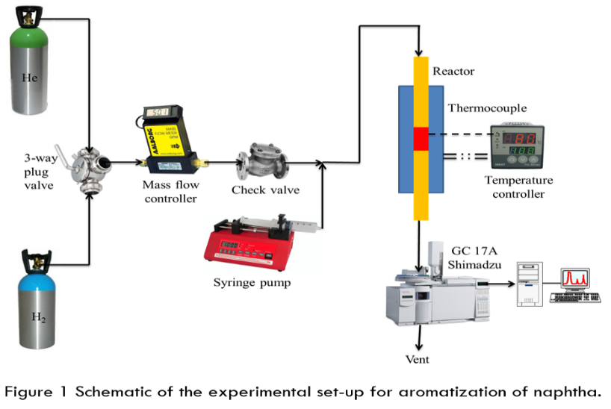
Recent Publications
- Kubo, K., Iida, H., Namba, S. and Igarashi, A. (2015). Comparison of steaming stability of Cu-ZSM-5 with those of Ag-ZSM-5, P/H-ZSM-5, and H-ZSM-5 zeolites as naphtha cracking catalysts to produce light olefin at high temperatures. Applied Catalysis A: General, 489, 272-279.
- Kubo, K., Iida, H., Namba, S. and Igarashi, A. (2014). Effect of steaming on acidity and catalytic performance of H-ZSM-5 and P/H-ZSM-5 as naphtha to olefin catalysts. Microporous and Mesoporous Materials, 188, 23-29.(Kubo, Iida, Namba, & Igarashi, 2015; Rahimi & Karimzadeh, 2011)
- Rahimi, N. and Karimzadeh, R. (2011). Catalytic cracking of hydrocarbons over modified ZSM-5 zeolites to produce light olefins: A review. Applied Catalysis A: General, 398(1-2), 1-17.(Smiekova, 2004)
- Choudhary, T. V., Kinage, A., Banerjee, S. and Choudhary, V. R. (2005). Influence of hydrothermal pretreatment on acidity and activity of H-GaAlMFI zeolite for the propane aromatization reaction. Microporous and Mesoporous Materials, 87(1), 23-32.
- Smiekova, A. (2004). Aromatization of light alkanes over ZSM-5 catalystsInfluence of the particle properties of the zeolite. Applied Catalysis A: General, 268(1-2), 235-240.

 Biography
I continually incorporated a combination of intellect for understanding into my way of thinking and research in the master’s degree of Petroleum Technology. For the six consecutive years studying in petrochemicals and petroleum field, its led me to acquire not only some instructions to fulfill those answers but also the strong background information, such as Petroleum Refining Technology, Chemical processes in petrochemicals industries and Heterogeneous Catalyst. This research gave me an excellent opportunity to gain knowledge and explore the field pervasively which enkindled me to know the variety of catalysts and their performance.
.
Email: K.Chaninwut@gmail.com

