Impacts of SiC_{w} reinforcement on microstructure and mechanical characteristics of TiC-WC_{n} matrix composites

Hamidreza Sharifian Ghazijahani ^{a*}, Saeid Sharifiyan Ghazijahani ª, Yaghoub Pazhouhanfar ª, Shahrzad Shaddel ^{b}, Seyed Ali Delbari ^{c}, Mehdi Shahedi Asl ^{c}

ª Aliyazh Sanat Sahand Ipak Company, P.O. Box: 51576-13536, Tabriz, Iran
^{b} Department of Materials Engineering, Sahand University of Technology, Tabriz, Iran
^{c} Department of Mechanical Engineering, University of Mohaghegh Ardabili, Ardabil, Iran
* Corresponding authors: H. Sharifian Ghazijahani (hamidsharifiyan1353@gmail.com)

Abstract
In this work, the influence of adding 0, 10, 20 and 30 vol% SiC_{w} (silicon carbide whiskers) on the microstructure and mechanical properties of TiC-3 wt% WC_{n} was investigated. All designed samples were spark plasma sintered under the same conditions: sintering temperature of 1900 °C, the external pressure of 40 MPa, and dwell time of 7 min. The sintered samples with 20 and 30 vol% SiC_{w} reached the RD more than 100%. On the contrary, the lowest RD was related to the sample with 10 vol% SiC_{w}. On the other hand, the most significant values of Vickers hardness (28.58 GPa) and flexural strength (694 MPa) were obtained for TiC-3 wt% WC_{n} and TiC-3 wt% WC_{n}-20 vol% SiC_{w} composites, respectively. It was also discussed that the main reason for obtaining the RD>100% probably was due to the formation of nonstoichiometric TiC_{x} over the SPS process.

Keywords: TiC, WC, SiC, Spark Plasma Sintering, Composite

1. Introduction
Nowadays, Titanium carbide (TiC) has attracted considerable attention due to the qualifications that offers. This astonishing UHTC, as a reliable high-temperature structural substance, has found lots of applications as rocket nozzle throat liners, high-speed cutting tools, jet engine components and leaning edge parts thanks to its inherent combination of characteristics, namely high melting point, relatively low density, excellent hardness, good thermal conductivity, good wear resistance, extreme thermal and chemical stability, and low thermal expansivity [1–3]. However, the practical application of this unique material in the monolithic form is limited because of poor fracture toughness and thermal shock resistance [4,5]. Moreover, the sintering of this substance is challenging too, due to the low self-diffusion coefficient and the strong covalent bonds [2,7]. On the other hand, using high sintering temperatures and holding time can affect the qualities of the TiC part through the excessive grain growth [6]. To uplift the mentioned poor mechanical properties, adding a ceramic or metallic sintering aid(s) such as TiB₂, TiN, SiC, WC, NbC, and Co, Cr, Mo, Ni, etc. can be the solution [7–10]. In terms of poor sinterability and extensive grain growth, utilization of a newly developed technology called spark plasma sintering (SPS) instead of conventional methods is the cure. Through this first-rate technology, ceramics and metals can be sintered at a lower temperature and also a short time compared with the hot-press method [11–18]. Namini et al. scrutinized the role of nano-sized WC additive on thermomechanical and microstructure of TiC-based composite samples. A near fully dense sample with 99.9% RD obtained with adding 3 wt% WC to TiC. Moreover, the best values of Vickers hardness and flexural strength were obtained for the mentioned composite sample; 28.6 GPa and 620 MPa, respectively [19,20]. Finally, Shahedi et al. studied using SiC whiskers as an additive on the qualifications of TiC-based composites. The best value of bending strength was achieved for the sample doped with 20 vol% SiC_{w}, while the sample with 30 vol% of reinforcement provided better values of hardness (~29 GPa) and thermal conductivity (~40 W/mK) [21]. Although some brilliant papers have published on the influence of adding WC and SiC on the TiC-base composite samples separately, in this research work both of these reinforcements have added to the TiC at the same time. Actually, the effect of adding different volume percentages of silicon carbide whiskers on the qualifications of TiC-3 wt% WC_{n} samples investigated in this work.

2. Experimental procedure
Commercially available powders were used in this study to produce TiC-based composite samples. The characterizations of initial powders, namely TiC, WC_{n}, and SiC_{w}, are presented in Table 1. The SEM images and XRD patterns attributed to these initial powders are indicated in Fig. 1. As it is clear, the only peaks related to starting materials are present, showing their high purity and the lack of unwanted phases. For the present research work, four different specimens were produced based on the information provided in Table 2. First, all starting powders were weighted and mixed based on the designed composition in Table 2. For dispersing the powders, an ultrasonic stirrer with the medium of ethanol was utilized for 20 min. The slurry was milled at the rpm of 90 using zirconia cup/balls for 60 min to mix properly. Afterward, a rotary evaporator was used to heating the prepared slurries at 120 °C to eliminate the ethanol. The sintering process was implemented for sintering the samples with a diameter of 30 mm by an SPS machine under the following circumstances: sintering temperature of 1900 °C, holding time of 7 min, and external pressure of 40 MPa. Over the SPS process, the temperature of specimens was measured by an optical pyrometer. Ultimately, after reducing the temperature, the samples were removed from the machine. The surfaces of as-produced samples were grinded to eliminate the foil. The Archimedes principle was applied to calculate the bulk density of the composite samples. Then, the relative density of specimens was estimated by measuring the theoretical density of samples by implementing the role of mixtures. Phase analysis was carried out utilizing a Philips PW3710 X-ray diffraction machine, and to study on the microstructure and the chemical composition of phases, a Tescan S8000 FESEM equipped with an EDS was used. The Vickers hardness evaluation was accomplished by applying 49 N load on the polished surfaces of as-sintered composite specimens (five indentations for each sample). For measuring the three-point bending strength, an STM-250 universal testing machine was used. The dimension of test samples was 3×4×28 mm³ with a 15 mm of span length, and the load was applied on the polished surfaces. The Archimedes method and the role of the mixture were used for calculating the bulk and relative density of as-sintered composite samples, respectively, where the immersion medium in the Archimedes method was distilled water. Moreover, gaseous pycnometry was implemented to estimate the precise values of starting powders’ densities: Ti: 4.45, Mo: 2.43, and B₄C: 10.25 g/cm³. Metallographic techniques and an etchant named Kroll's reagent (containing 85 ml of H₂O, 10 ml of HNO₃, and 5 ml of HF) was used to make the surface of specimens ready. To capture the microscopic images on the both polished and fracture surfaces of samples, an Olympus optical microscope (RMG3) and a Cam Scan 2300 scanning electron microscopy (Czech) equipped with an EDS analyzer (DXP-X10P) was employed. Moreover, an XRD tester (D5000, Siemens) was utilized for phase studies. The possibility of in-situ reactions thermodynamically was studied using chemical software (HSC, Outokumpu, Finland). The micro and macro hardness values of samples were calculated utilizing a Vickers tester (the UK, diamond indenter with the shape of a pyramid, 0.3 kg of load for 15 secs) and a Vickers hardness instrument (30 kg of load for 15 secs) on the polished surfaces, respectively. Also, an STM-250 universal testing machine was used to obtain the tensile and three-point bending test results (the crosshead speed of the machine was set on 0.5 mm/min). The standard samples of the tensile test (2×5×15 mm³) and three-point bending test (3×4×34 mm³) were prepared by an electrical discharge machine.
Table 1. Technical data of initial powders.
Materials | Supplier | Particle Size/  Length & Diameters | Purity (%)
TiC | Xuzhou Hongwu Nanometer Material Co., China | <12 µm | >99%
SiC_{w} | Xuzhou Hongwu Nanometer Material Co., China | 5–30 µm & 0.1–1 µm | >99%
WC_{n} | Xuzhou Hongwu Nanometer Material Co., China | <100 nm | >99%

Table 2. The composition of designed samples.
Sample | WCn (vol%) | SiC_{w} (wt%)
TS0 | 3 | 0
TS10 | 3 | 10
TS20 | 3 | 20
TS30 | 3 | 30

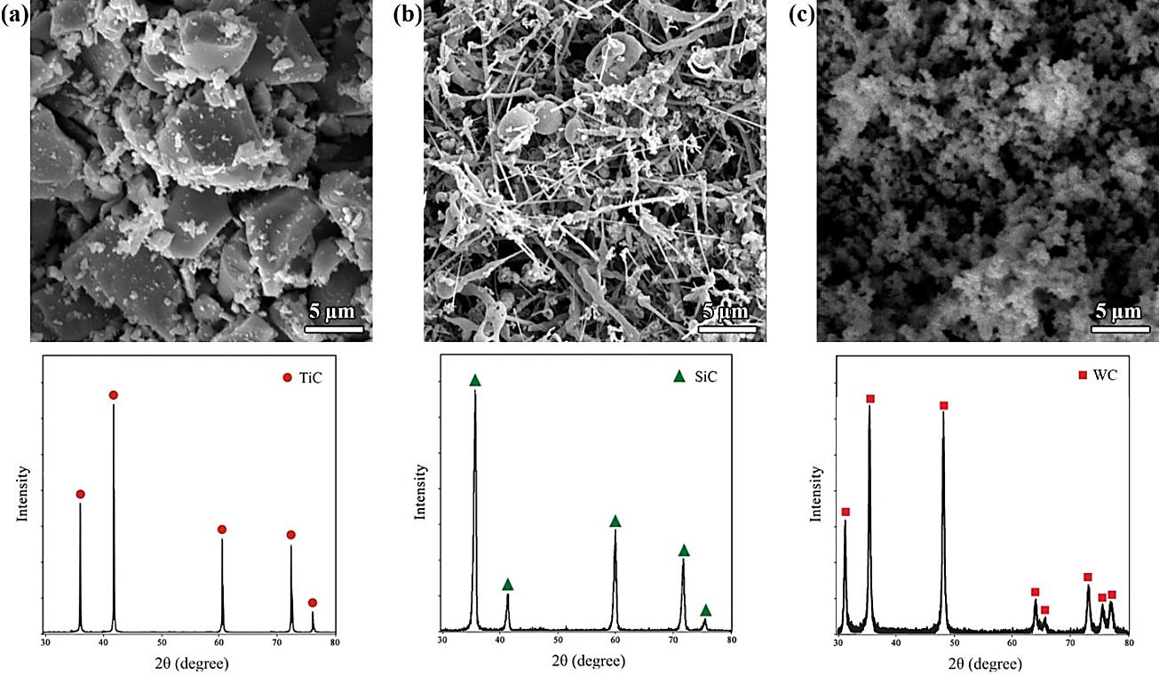
Fig. 1. Scanning electron microscopy micrographs and related XRD patterns of starting materials;
(a) TiC, (b) SiC_{w}, and (C) WC_{n}.

3. Results and discussion
3.1. Consolidation behavior
Fig. 2 indicates the relative density values of as-produced composite specimens. According to this diagram, adding 10 vol% SiC_{w} to TiC-3wt% WC_{n} had a destructive role in the relative density compared with the sample without any SiC_{w} content. However, the relative densities more than 100% obtained for both specimens with 20% and 30% SiC_{w} as an additive, and the most significant value was attributed to TiC-3wt% WC_{n}-30 vol% SiC_{w} by 103.65%. Accordingly, adding more SiC_{w} to the TiC-WC_{n} system led to a better diffusion bonding among the matrix particles and the elimination of available pores. The relative densities higher than 100% are related to the complicated nature of TiC substance. As it is clear in Fig. 3, TiC_{x} has different stoichiometry and consequently provides a range of characteristics in terms of morphology, consolidation behavior, hardness, grain size, and bulk modulus [22–24]. Although synthesizing TiC with the stoichiometric ratio of C/Ti=1 is possible, the possibility of formation of vacancies at high temperatures will be high too [22,24]. Therefore, the relative densities of the samples doped with 20 vol% and 30 vol% SiC_{w} calculated more than 100% because of not taking into account the different theoretical densities of nonstoichiometric TiC_{x} in the calculations.
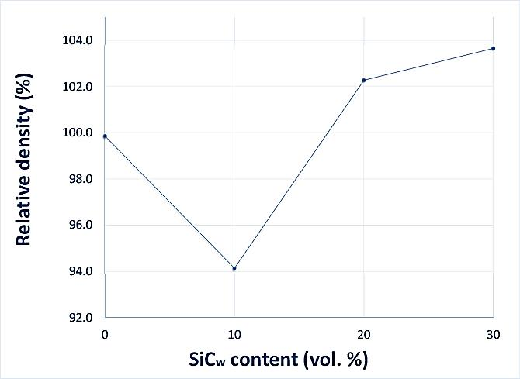
Fig. 2. The relative density of as-sintered TiC-3 wt% WC_{n}-(0, 10, 20, and 30 vol%) SiC_{w} samples.

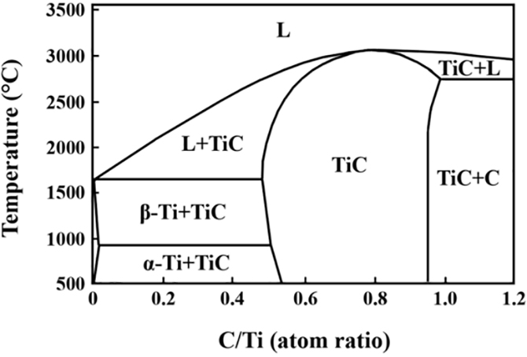
Fig. 3. Ti-C phase diagram [13].

3.2. Microstructural evaluation
The black-scattered SEM images of as-sintered samples are presented in Fig. 4. As can be seen in all micrographs, two different phases are observable; the bright-colored phases, which belong to the TiC matrix, and the grey-colored ones, which are related to the additives, namely WC_{n}/SiC_{w}. Moreover, the homogeneous distribution of additives has acted as an inhibitor against the TiC aggressive grain growth. The distribution of various elements, namely Ti, C, Si, and W, in the sample doped with 20 vol% SiC_{w} is shown in Fig. 5, indicating the uniform distribution of additives into the matrix.
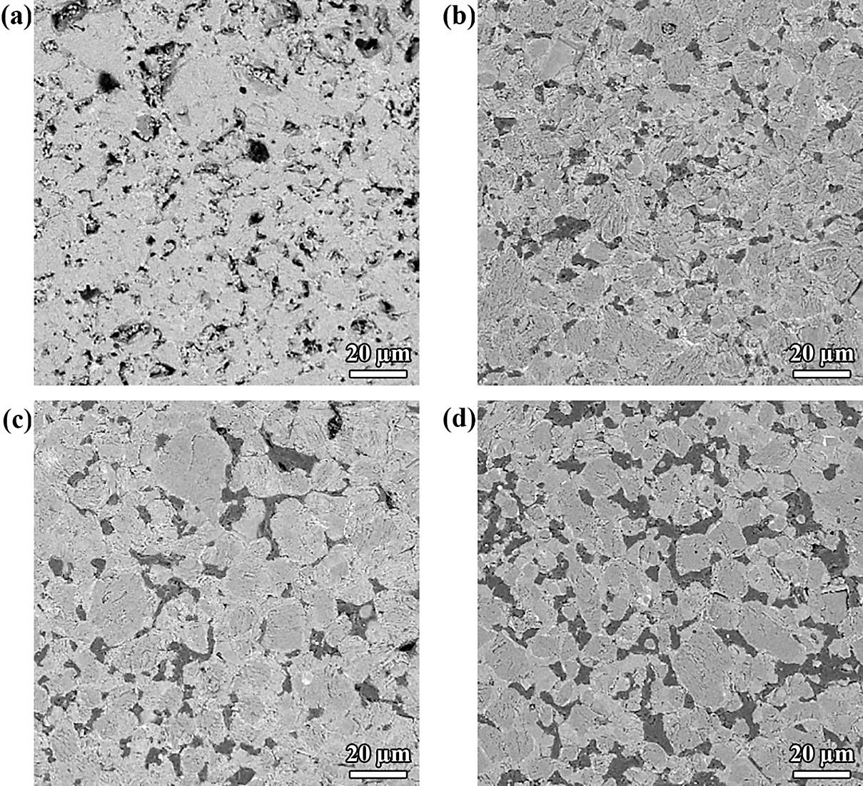
Fig. 4. SEM micrographs of as-sintered TiC-3 wt% WC_{n} with different vol% of SiC_{w}:
(a) 0, (b) 10, (c) 20, and (d) 30.

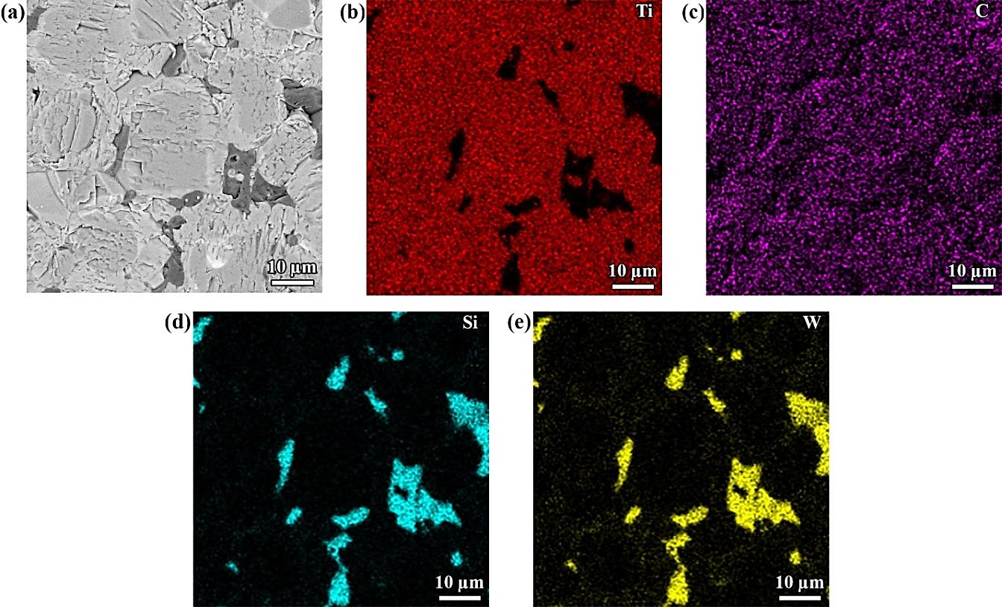
Fig. 5. SEM micrographs of as-sintered TiC-3 wt% WC_{n}-20 vol% SiC_{w}
with corresponding EDS elemental maps.

XRD patterns of as-produced samples with 0 vol% and 30 vol% of SiC_{w} are presented in Fig. 6. According to the X-ray diffraction patterns indicated in this Fig., the majority of peaks related to TiC in the sample with SiC_{w} content were marginally lower than the one without SiC_{w}, thanks to the TiC_{x} formation with more value of C/Ti ratio or the probable creation of Ti-rich (Ti,Si)C because of substituting silicon into the titanium lattices. Moreover, the availability of Ti₃SiC₂ peaks revealed the possibility of a chemical reaction between SiC_{w} and the TiC matrix. However, the peaks related to Ti₃SiC₂ were weak in the XRD patterns provided in this study. The reason can be due to the similar crystalline structure of TiC_{x} and Ti₃SiC₂, which in both of them the carbon atoms occupied the octahedral positions.
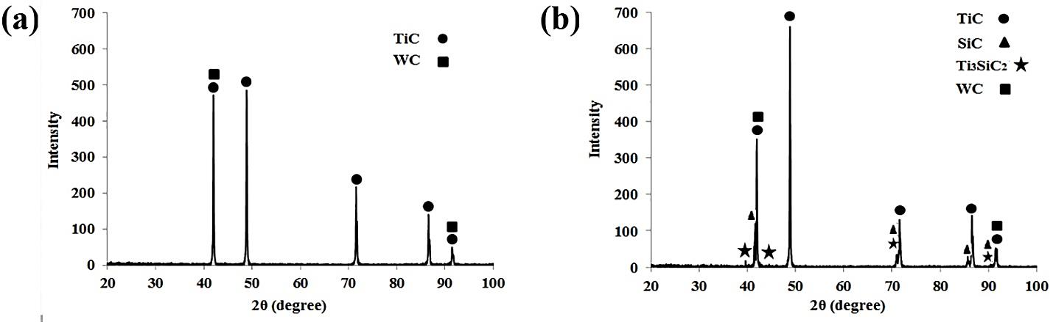
Fig. 6. XRD patterns of as-sintered specimens with (a) 0 vol% SiC_{w}, and (b) 30 vol% SiC_{w}.

Fig. 7 shows the fractographs of as-produced composite samples doped with 3 wt% WC_{n} and different amounts of SiC_{w}. As it is clear, the intergranular mode was the dominant fracture mode in all four specimens. It is also observable that the samples with 0 vol% and 10 vol% SiC_{w} contain some pores that indicate the incomplete consolidation due to the not enough sintering temperature or dwell time. On the other hand, adding more SiC_{w} to the specimens led to eliminating the mentioned pores and obtaining the fully dense materials (Fig. 7 (c) and (d)).
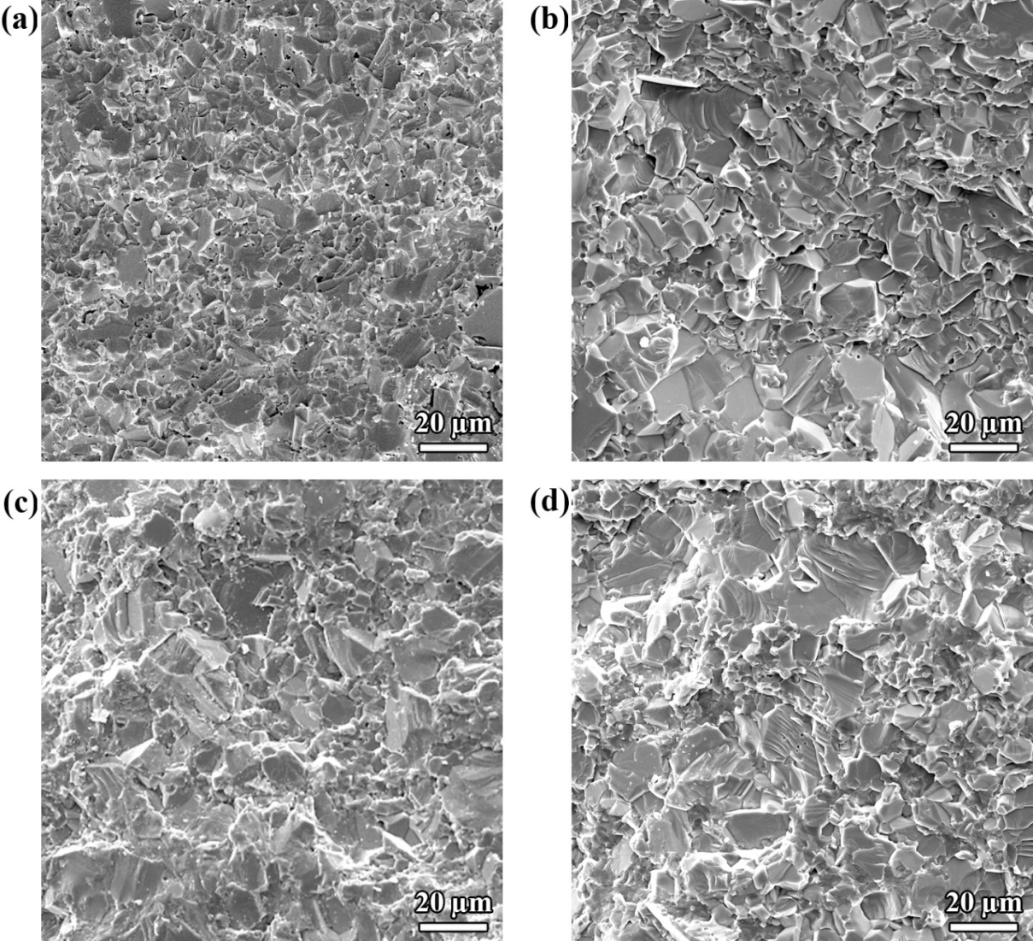
Fig. 7. SEM fractographs of as-sintered TiC-3 wt% WC_{n} with different vol% of SiC_{w}:
(a) 0, (b) 10, (c) 20, and (d) 30.

3.3. Mechanical properties
The influence of SiC_{w} volume fraction on the Vickers hardness of TiC-3 wt% WC_{n} is exhibited in Fig. 8. As shown in this Fig., the most significant value, namely 28.58 GPa, is related to the sample with zero vol% of SiC_{w}, showing the destructive role of this additive on the Vickers hardness. This effect was so intense that with adding just 10 vol% SiC_{w}, the Vickers hardness dropped by ~ 60%, standing at 11.63 GPa. However, adding more additive improved this quality so that the Vickers hardness of sample with 30 vol% SiC_{w} was roughly equal with the one with no SiC_{w} content (27.32 GPa). So, it seems the relative density and TiC content, as a harder phase compared with SiC_{w}, have been the predominant factors on the Vickers hardness. Fig. 9 presents the effect of adding different volume fraction of SiC_{w}, namely 0, 10, 20 and 30, on the flexural strength of TiC-3 wt% WC_{n}. Looking into this Fig., the best value of flexural strength is obtained for the sample with 0 vol% SiC_{w} (620 MPa), while the weakest value is related to the one with 10 vol% SiC_{w} (368 MPa). As known, the chief factors that affect this characteristic are relative density, grain size, and the interfacial bonding of matrix/reinforcement(s). Although the TiC/SiC_{w} interface is relatively strong and adding this additive can improve the flexural strength, the presence of a considerable amount of porosity and also formation of a brittle in-situ formed phase can act as the predominant factors. Moreover, the formation of the brittle phase of T₃SiC₂ at the TiC/SiC_{w} interfacial areas, plays the predominant role in the samples with 20 and 30 vol% SiC_{w} content. On the other hand, even though the Vickers hardness of TiC- 3 wt% WC_{n}-30 vol% SiC_{w} was higher than the one with 20 volume fraction of silicon carbide, the latter showed the better flexural strength in comparison with the former. The reason can be similar with the one explained for the flexural strength, namely the formation of higher amount of brittle phase of Ti₃SiC₂.
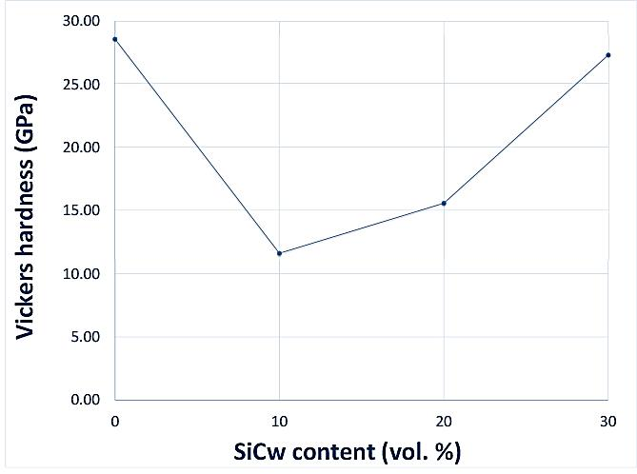
Fig. 8. Vickers hardness of as-produced composite samples with different content of SiC_{w}.

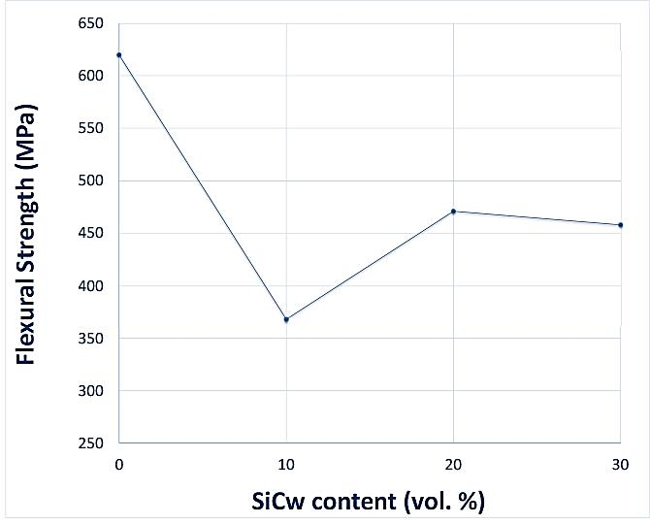
Fig. 9. Flexural strength of as-produced composite samples with different content of SiC_{w}.

Conclusions
The influence of adding different contents (0, 10, 20 and 30 vol%) of silicon carbide whiskers on the consolidation behavior, microstructure, microhardness, and flexural strength of TiC-3 wt% WC_{n} has been scrutinized. The microstructural study revealed that adding SiC_{w} additive had no significant influence on the grain size of the composite samples. The best values of the relative density of 103.65% and Vickers hardness of 28.58 GPa were obtained for the samples with 30 and 0 volume fraction of SiC_{w}, respectively. Also, the specimen with 20 vol% silicon carbide whiskers indicated the highest flexural strength (694 MPa). On the contrary, the lowest of the mentioned quality was achieved for the TiC- wt% WC_{n}-10 vol% SiC_{w}. The relative densities higher than 100% were due to the formation of nonstoichiometric TiC_{x}.

References
[1] J. Zhang, L. Wang, W. Jiang, L. Chen, Effect of TiC content on the microstructure and properties of Ti3SiC2-TiC composites in situ fabricated by spark plasma sintering, Mater. Sci. Eng. A. 487 (2008) 137–143. doi:10.1016/j.msea.2007.12.004.
[2] K.W. Chae, K. Niihara, D.Y. Kim, Improvements in the mechanical properties of TiC by the dispersion of fine SiC particles, J. Mater. Sci. Lett. 14 (1995) 1332–1334. doi:10.1007/BF00270718.
[3] B. Zou, W. Ji, C. Huang, J. Wang, S. Li, K. Xu, Effects of superfine refractory carbide additives on microstructure and mechanical properties of TiB2-TiC+Al2O3 composite ceramic cutting tool materials, J. Alloys Compd. 585 (2014) 192–202. doi:10.1016/j.jallcom.2013.09.119.
[4] A. Jam, L. Nikzad, M. Razavi, TiC-based cermet prepared by high-energy ball-milling and reactive spark plasma sintering, Elsevier, 2017. doi:10.1016/j.ceramint.2016.11.039.
[5] C. Magnus, T. Kwamman, W.M. Rainforth, Dry sliding friction and wear behaviour of TiC-based ceramics and consequent effect of the evolution of grain buckling on wear mechanism, Wear. (2019) 54–67. doi:10.1016/j.wear.2019.01.026.
[6] A.M. Locci, R. Orrù, G. Cao, Z.A. Munir, Effect of ball milling on simultaneous spark plasma synthesis and densification of TiC-TiB2 composites, Mater. Sci. Eng. A. 434 (2006) 23–29. doi:10.1016/j.msea.2006.06.131.
[7] G.M. Song, Y.K. Guo, Y. Zhou, Q. Li, Preparation and mechanical properties of carbon fiber reinforced-TiC matrix composites, J. Mater. Sci. Lett. 20 (2001) 2157–2160. doi:10.1023/A:1013788701303.
[8] L. Wang, W. Jiang, L. Chen, Fabrication and characterization of nano-SiC particles reinforced TiC/SiCnano composites, Mater. Lett. 58 (2004) 1401–1404. doi:10.1016/j.matlet.2003.09.053.
[9] L. Wang, W. Jiang, L. Chen, Rapidly sintering nanosized SiC particle reinforced TiC composites by the spark plasma sintering (SPS) technique, J. Mater. Sci. 39 (2004) 4515–4519. doi:10.1023/b:jmsc.0000034145.54280.53.
[10] W.J. Li, R. Tu, T. Goto, Preparation of TiC-TiB2-SiC ternary eutectic composites by arc-melting and their characterizations, Mater. Trans. 47 (2006) 1193–1197. doi:10.2320/matertrans.47.1193.
[11] A. Teber, F. Schoenstein, F. Têtard, M. Abdellaoui, N. Jouini, Effect of SPS process sintering on the microstructure and mechanical properties of nanocrystalline TiC for tools application, Int. J. Refract. Met. Hard Mater. 30 (2012) 64–70. doi:10.1016/j.ijrmhm.2011.06.013.
[12] S.A. Delbari, A. Sabahi Namini, M. Shahedi Asl, Hybrid Ti matrix composites with TiB2 and TiC compounds, Mater. Today Commun. (2019) 100576. doi:10.1016/j.mtcomm.2019.100576.
[13] S.A. Delbari, B. Nayebi, E. Ghasali, M. Shokouhimehr, M. Shahedi Asl, Spark plasma sintering of TiN ceramics codoped with SiC and CNT, Ceram. Int. 45 (2019) 3207–3216. doi:10.1016/j.ceramint.2018.10.223.
[14] M. Shahedi Asl, S.A. Delbari, F. Shayesteh, Z. Ahmadi, A. Motallebzadeh, Reactive spark plasma sintering of TiB 2 –SiC–TiN novel composite, Int. J. Refract. Met. Hard Mater. 81 (2019) 119–126. doi:10.1016/j.ijrmhm.2019.02.022.
[15] F. Shayesteh, S.A. Delbari, Z. Ahmadi, M. Shokouhimehr, M. Shahedi Asl, Influence of TiN dopant on microstructure of TiB2 ceramic sintered by spark plasma, Ceram. Int. 45 (2019) 5306–5311. doi:10.1016/j.ceramint.2018.11.228.
[16] A.S. Namini, M. Shahedi, A. Seyed, A. Delbari, Influence of Sintering Temperature on Microstructure and Mechanical Properties of Ti – Mo – B 4 C Composites, Met. Mater. Int. (2019). doi:10.1007/s12540-019-00469-y.
[17] L. Cheng, Z. Xie, G. Liu, Spark plasma sintering of TiC ceramic with tungsten carbide as a sintering additive, J. Eur. Ceram. Soc. 33 (2013) 2971–2977. doi:10.1016/j.jeurceramsoc.2013.04.017.
[18] L. Cheng, Z. Xie, G. Liu, Spark plasma sintering of TiC-based composites toughened by submicron SiC particles, Ceram. Int. 39 (2013) 5077–5082. doi:10.1016/j.ceramint.2012.12.002.
[19] A. Sabahi Namini, Z. Ahmadi, A. Babapoor, M. Shokouhimehr, M. Shahedi Asl, Microstructure and thermomechanical characteristics of spark plasma sintered TiC ceramics doped with nano-sized WC, Ceram. Int. 45 (2019) 2153–2160. doi:10.1016/j.ceramint.2018.10.125.
[20] A. Babapoor, M.S. Asl, Z. Ahmadi, A.S. Namini, Effects of spark plasma sintering temperature on densification, hardness and thermal conductivity of titanium carbide, Ceram. Int. 44 (2018) 14541–14546. doi:10.1016/j.ceramint.2018.05.071.
[21] M. Shahedi Asl, Z. Ahmadi, A. Sabahi Namini, A. Babapoor, A. Motallebzadeh, Spark plasma sintering of TiC–SiCw ceramics, Ceram. Int. 45 (2019) 19808–19821. doi:10.1016/j.ceramint.2019.06.236.
[22] C.-C. Jiang, T. Goto, T. Hirai, Microhardness of non-stoichiometric TiCx, plates prepared by chemical vapour deposition, J. Less Common Met. 163 (1990) 339–346. doi:10.1016/0022-5088(90)90600-O.
[23] X. TONG, T. YANO, T. ISEKI, Sintering Behavior of TiC Reinforced SiC Composites Doped with Ti and C, J. Ceram. Soc. Japan. 104 (1996) 594–598. doi:10.2109/jcersj.104.594.
[24] Z. Zhang, C. Geng, Y. Ke, C. Li, X. Jiao, Y. Zhao, H. Tang, M. Wang, Processing and mechanical properties of nonstoichiometric TiC (0.3 ≤ x ≤ 0.5), Ceram. Int. 44 (2018) 18996–19001. doi:10.1016/j.ceramint.2018.07.141.

