Evaluation of physical and mechanical characteristics of ZrB₂–SiC-diamond_{nano} composites

Saeid Sharifiyan Ghazijahani ^{a*}, Hamidreza Sharifian Ghazijahani ª, Yaghoub Pazhouhanfar ª, Abbas Sabahi Namini ^{b,c}, Seyed Ali Delbari ^{d}, Mehdi Shahedi Asl ^{d}

ª Aliyazh Sanat Sahand Ipak Company, P.O. Box: 51576-13536, Tabriz, Iran
^{b} Department of Engineering Sciences, Faculty of Advanced Technologies, University of Mohaghegh Ardabili, Namin, Iran
^{c} Department of Engineering Sciences, Faculty of Advanced Technologies, Sabalan University of Advanced Technologies(SUAT), Namin, Iran
^{d} Department of Mechanical Engineering, University of Mohaghegh Ardabili, Ardabil, Iran
* Corresponding authors: S. Sharifian Ghazijahani (saeedsharifiyan@gmail.com)

Abstract
The effect of adding various amounts of nano-diamond additive (0, 1, 2, and 3 wt%) on the densification behavior and mechanical properties of ZrB₂-25 vol% SiC samples were investigated in this research. All samples were spark plasma sintered at 1900 °C under 40 MPa external pressure for 7 min. Relative density (RD) values higher than 99.9% were obtained for the samples with 0, 1, and 2 wt% nano-diamond, while adding 3 wt% diamond dropped the RD by ~1.2%. The XRD and microstructural evaluations revealed the formation of some in-situ phases, namely ZrC and B₄C. The highest Vickers hardness (24.7 GPa) and fracture toughness (5.8 MPa.m^{1/2}) were achieved for the samples doped with 2 and 3 wt% nano-diamond, respectively.

Keywords: ZrB₂; SiC; nano-diamond; SPS.

1. Introduction
Zirconium diboride (ZrB₂) owns strong covalent bonds and a hexagonal crystal structure. This material has a poor sinterability owing to its covalent bonds and slight penetration through the volume and grain boundaries; therefore, high sintering temperature and high external pressure would be needed to reach a fully dense part. Moreover, using this material for some specific applications has some difficulties due to its low oxidation resistance at high temperatures and poor mechanical qualities [1, 2]. Lots of research work has been implemented to overcome the mentioned limitations. It should be mentioned that ZrB₂-SiC is the most famous ZrB₂-matrix composite that has received quite a few researches. Improving the sinterability, densification behavior, toughness, hardness, bending strength, and resistance to oxidation are among the most significant influences of adding silicon carbide to the zirconium diboride-matrix composites [3–6]. In addition, the application of a newly developed sintering method, named spark plasma sintering (SPS) process, can lead to obtaining better mechanical properties because of its inherent characteristics, low working temperature, short holding time, and possible application of an external pressure [7–9]. A near fully dense composite specimen was obtained when ZrB₂-C composite specimens sintered at 1900 °C for 2 hours by the hot-press technique. Due to the presence of the soft phase of carbon, the hardness of samples decreased when more carbon additive was added to the composites [6]. The ZrB₂-20 vol% SiC-5 vol% black carbon composite specimens were produced using the hot-press process at a temperature of 1900 °C. Adding black carbon led to a decrement of porosity percentage in microstructures of sintered specimens owing to the chemical interaction among the carbonic additive and the available unwanted oxide phases. The fracture toughness of composite samples remarkably rose in comparison with the monolithic specimens, standing at 6.6 MPa.m², but the hardness and bending strength reduced gradually [10]. The ZrB₂-SiC-C composites were manufactured through the pressure-less sintering of ZrB₂ powders coated with polycarbosilane at 2000 °C, resulting in a relative density of 96.7% [11]. By adding carbon nanotubes (CNTs) to the specimens processed through hot pressing technique at 1900 °C for 1 hour with an applied pressure of 30 MPa, the fracture toughness grew up by 15%, but no noticeable changes were observed in the hardness, bending strength, and thermal conductivity values [12]. A drop in the bending strength and an improvement in fracture toughness were reported for the specimens sintered at 2000 °C by hot press method and reinforced with short carbon fibers [13–15]. The fracture toughness of zirconium diboride - 20 vol% silicon carbide - matrix composites strengthened with adding 10 vol% graphite flakes while bending strength and hardness values dropped marginally [16–18]. Lots of researches have been accomplished to study the influences of carbon additives on the microstructure, consolidation manner, and mechanical characteristics of ZrB₂-matrix composite materials. However, no study was found on the influences of diamond addition on the qualities of zirconium diboride matrix composites. In this investigation, therefore, four series of ZrB₂-25 vol% SiC-based samples with different weight percentages (0, 1, 2, and 3) of nano-diamond were produced using SPS method at 1900 °C, a holding time of 7 min, and an applied pressure of 40 MPa.

2. Experimental procedure
The technical information of commercially available initial powders, namely ZrB₂, SiC, and nano-sized diamond, is reported in Table 1. The initial powders were weighted according to the compositions shown in Table 2. The mixtures of powders were prepared by the ultrasonic method in ethanol medium for 60 min and mixed in an ultrasonic bath for 30 min to obtain complete homogeneous mixtures. Afterward, the prepared slurries were heated on a hot plate agitator and then in an oven to eliminate ethanol and to dry completely, respectively, followed by crushing and sieving the dried mixtures. Then, the final mixtures were loaded into a graphite die and processed using a spark plasma sintering apparatus (20T-10, China) at 1900 °C for 7 min under an external pressure of 40 MPa. After cooling, the as-sintered samples (diameter of 30 mm) were removed from the die and the available graphite layers on the specimens were eliminated by grinding. The rule of mixtures and Archimedes’ principles were implemented to calculate the theoretical density and the bulk density of SPSed composite samples, respectively. The microscopical evaluation was accomplished by a FESEM equipped with an EDS to implement the elemental examination. The phase analysis of sintered materials was accomplished using an XRD, and the HSC software (Outokumpu, Finland) was used to study the feasibility of possible chemical reactions over the sintering process. The hardness of as-produced composite samples was determined by a Vickers hardness device. Finally, the fracture toughness of specimens was determined by measuring the length of the cracks generated after applying the Vickers indentation.
Table 1. Technical data of starting powders
Materials | Particle size | Purity (%)
ZrB₂ | < 2 µm | 99.9
SiC | < 500 nm | 99.0
Nano-diamond | < 10 nm | 98.3

Table 2. The compositions of SPSed samples
Sample | Composition
ZSD0 | ZrB₂-25 vol% SiC
ZSD1 | ZrB₂-25 vol% SiC-1 wt% nano-diamond
ZSD2 | ZrB₂-25 vol% SiC-2 wt% nano-diamond
ZSD3 | ZrB₂-25 vol% SiC-3 wt% nano-diamond

3. Results and discussion
3.1. Consolidation behavior
Fig. 1 exhibits the relative densities of SPSed ZrB₂-SiC-based composite samples. A near fully dense specimen was obtained for the one with no nano-diamond content, reaching an RD of 99.9%. When
1 wt% nano-diamond was added to the ZrB₂-25 vol% SiC system, the ZSD1 sample reached a relative density of 100%. Although the most significant value of RD was related to the ZSD1 specimen, those with 0 and 2 wt% nano-diamond can also be considered as the fully dense materials with relative densities of 99.9%. However, adding 3 wt% nano-diamond had a destructive influence on the relative density of the samples, as RD of the ZSD3 sample dropped by ~ 1.2% in comparison with the fully dense ones. The XRD analysis result of the SPSed ZSD3 specimen (Fig. 2) reveals peaks associated with the ZrB₂ matrix and secondary phase of SiC (α-type with hexagonal structure). Nevertheless, nano-diamond peaks were not available, showing the possibility of full consumption of diamond additive during the sintering process. The XRD results also revealed the formation of Graphite, ZrC, and B₄C phases during the process. Accordingly, a proportion of nano-diamond additive turned into the graphite phase and the remaining reacted with other initial materials, which led to the production of the mentioned carbide phases. It seems that the diamond additive reacted with the oxide layers of B₂O₃ and ZrO₂ on ZrB₂ and SiO₂ on SiC particles. Fig. 3 presents the Gibbs free energy of the probable chemical reactions among the SiC/nano-diamond additives and the available oxide layers on the starting powders. These reactions can result in the reduction of such harmful phases and consequently, the generation of fine SiC and ZrB₂ grains. Although silicon carbide is known as a stable phase in composite materials, a chemical reaction among SiC and oxide layers can probably occur thermodynamically on the ZrB₂ particles at temperatures higher than 1760 °C (Eq. 1). Therefore, new fine zirconium diboride grains can form with high sinterability. The by-product gaseous phases in Eq. 1 can leave the furnace due to the vacuum condition and the application of external pressure.
5SiC + 2ZrO₂ + B₂O₃ = 2ZrB₂ + 5 SiO (g) + 5CO (g) (1)
Similar to SiC, the carbonic phase (nano-diamond) can be also beneficial in eliminating the unwanted oxide layers (Eq. 2). Diamond is thermodynamically a more powerful reducer agent compared with SiC, so the chemical reaction (Eq. 2) occurred at a lower temperature (1515 °C).
5C + ZrO₂ + B₂O₃ = ZrB₂ + 5CO (g) (2)
Not only the nano-diamond additive can eliminate the oxide layers on the zirconium diboride particles, but it can also be helpful in eliminating the unwanted surface phases on the SiC particles, especially SiO₂, based on Eq. 3. This reaction is thermodynamically possible at temperatures higher than 1515 °C.
3C + SiO₂ = SiC + 2CO (g) (3)
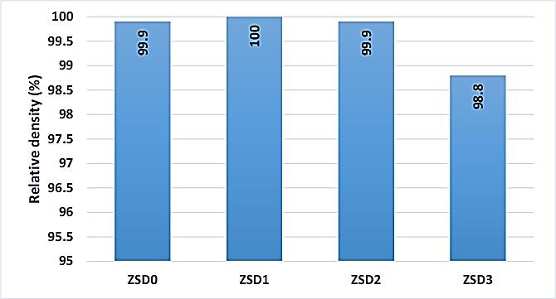
Fig. 1. The relative density of the as-sintered ZrB₂-25 vol% SiC-(0, 1, 2, and 3 wt%) nano-diamond specimens

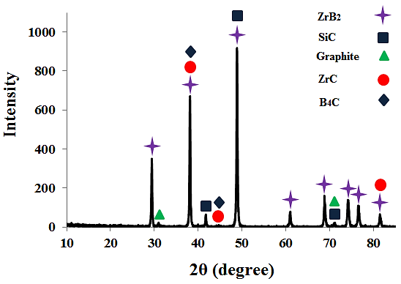
Fig. 2. The XRD analysis result of the ZSD3 specimen

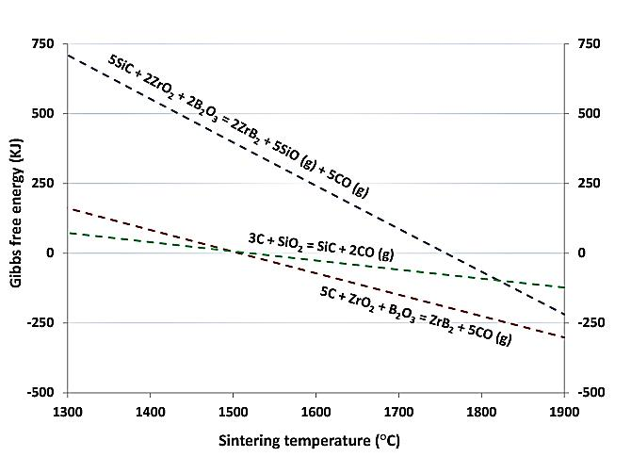
Fig. 3. The Gibbs free energy of the probable chemical reactions during the SPS process vs. sintering temperature

3.2. Microstructural evaluation
Fig. 4 exhibits SEM images of the fracture and polished surfaces of the ZSD0 sample. The presence of the ZrB₂ phase (bright-colored) and SiC phase (dark-colored) is apparent in these images. As was mentioned before, this composite roughly reached its theoretical density; thus, the availability of no porosity in the micrograph makes sense. The presence of SiC as a secondary phase played a significant role in obtaining a fine microstructure because of inhibiting extensive grain growth. The SEM images of the polished surface of the ZSD1 specimen and the related EDS examination results are shown in Fig. 5. The microstructural evaluation also confirmed the achievement of a relative density of 100%. The EDS analysis indicated an area rich in carbon, boron, and zirconium elements, which can indicate the existence of in-situ formed ZrC and B₄C phases. The formation of the mentioned in-situ phases, namely ZrC and B₄C, was indicted in the SEM images of the ZSD3 specimen and the related EDS analysis (Fig. 6 c and d). Clearly, the EDS results prove the availability of Zr, C, and B-enriched phases. Moreover, Fig. 6a follows the calculated RD (98.8%) obtained for the ZSD3 specimen due to the presence of the pores in the microstructure.
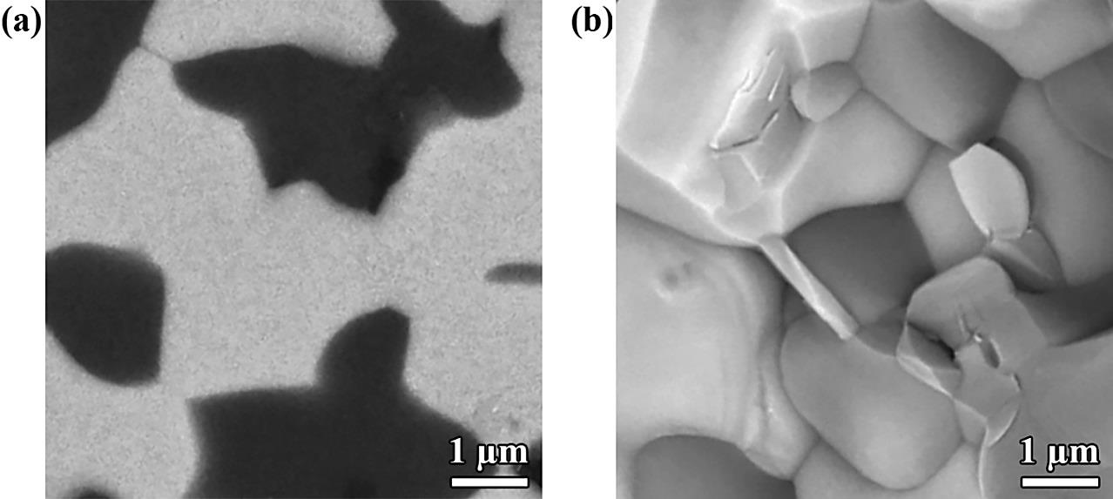
Fig. 4. SEM images of the as-sintered ZSD0 sample on the (a) polished and (b) fracture surfaces

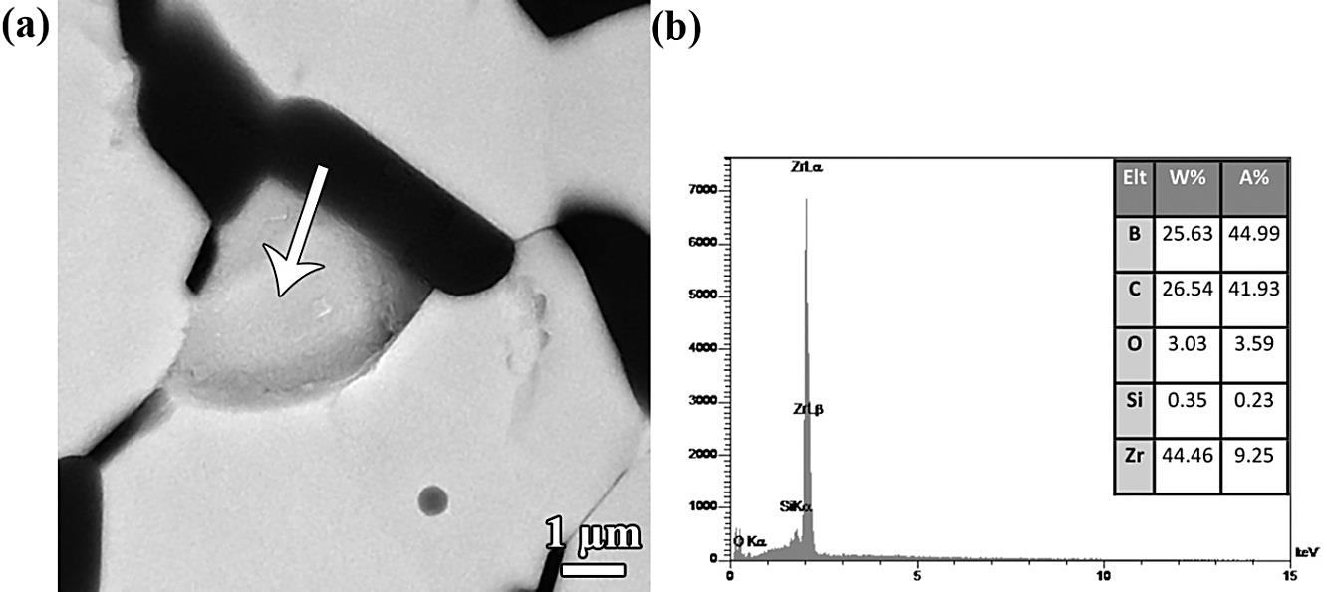
Figure 5. (a) SEM image of the as-sintered ZSD1 sample on the polished surface, and (b) corresponding EDS analysis

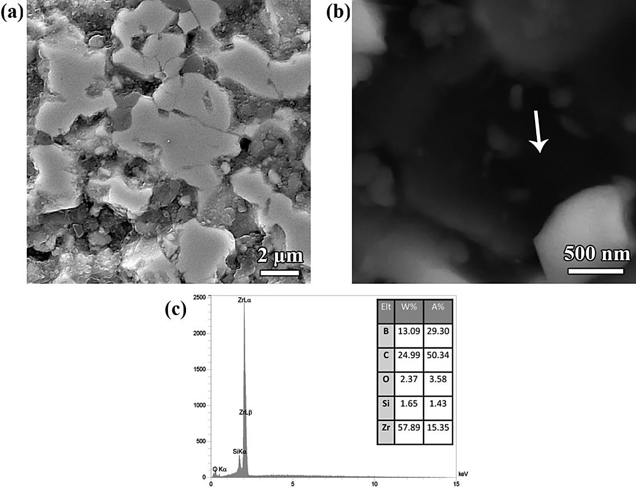
Fig. 6. SEM images of the as-sintered ZSD3 sample on the (a) polished surfaces, (b) fracture surfaces, and
(c) the corresponding EDS analysis

3.3. Mechanical properties
Fig. 7 displays the Vickers hardness of SPSed composite samples. It is known that relative density is one of the chief parameters affecting the mechanical properties of sintered materials. As the pores have no resistance against an indenter, a porous material provides a low level of hardness. In other words, the sample with no nano-diamond additive reached a hardness of 19.5 GPa, while all other samples doped with nano-diamond (namely ZSD1, ZSD2, and ZSD3) presented higher values of hardness (23.4, 24.6, and 22.2 GPa, respectively). It seems that the formation of in-situ carbide phases, which have high hardness values, led to an increment in the hardness of samples doped with nano-diamond. The lower hardness of the ZSD3 sample is due to the presence of 1.2% porosity in the microstructure. The calculated values of fracture toughness of as-sintered composite samples are represented in Fig. 8. These values were determined by measuring the length of the cracks formed due to the application of Vickers indenter. The fracture toughness of samples rose linearly from 4.3 MPa.m^{1/2} (ZSD0) to 5.8 MPa.m^{1/2} (ZSD3) with adding more nano-diamond additive. The route of the propagating crack in the ZSD0 specimen is illustrated in Fig. 9a. As it is clear, the presence of SiC secondary phases deflected the crack over its propagating route. Moreover, other toughening mechanisms including branching and bridging of crack(s) and also fracturing of secondary phase (SiC) are visible in this micrograph. Figs. 9b and 9c present the SEM images of the propagated crack(s) after applying Vickers indentation. It seems that the cracks lost more energy when they struck the in-situ formed phases, leading to better fracture toughness values than the sample with no nano-diamond additive. Overall, the difference in thermal expansion coefficient of various available phases (ZrB₂, SiC, ZrC, B₄C, and graphite) can cause residual stresses at their interfaces during the cooling process from the ultimate sintering temperature to the room temperature. The interaction between the crack and microstructure is dominantly controlled by the residual stresses created owing to the incompatibility of thermal and mechanical characteristics of the phases. Moreover, the deflection of crack has a significant effect on the fracture toughness, which extremely influenced by different factors, and consequently more deflections on the way of crack can absorb more energy, leading to a higher value of fracture toughness.
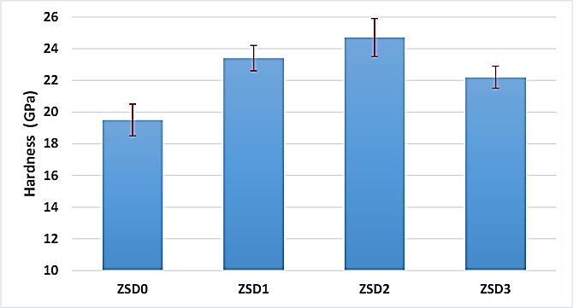
Fig. 7. Vickers hardness of the sintered specimens containing 0, 1, 2, and 3 wt% nano-diamond

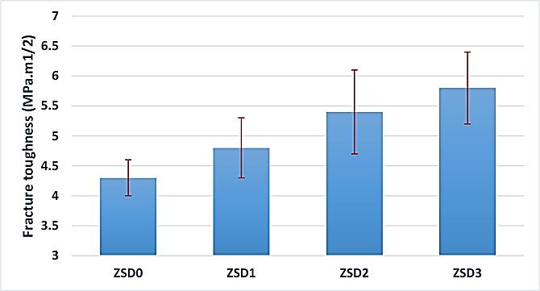
Fig. 8. Fracture toughness of the sintered specimens containing 0, 1, 2, and 3 wt% nano-diamond

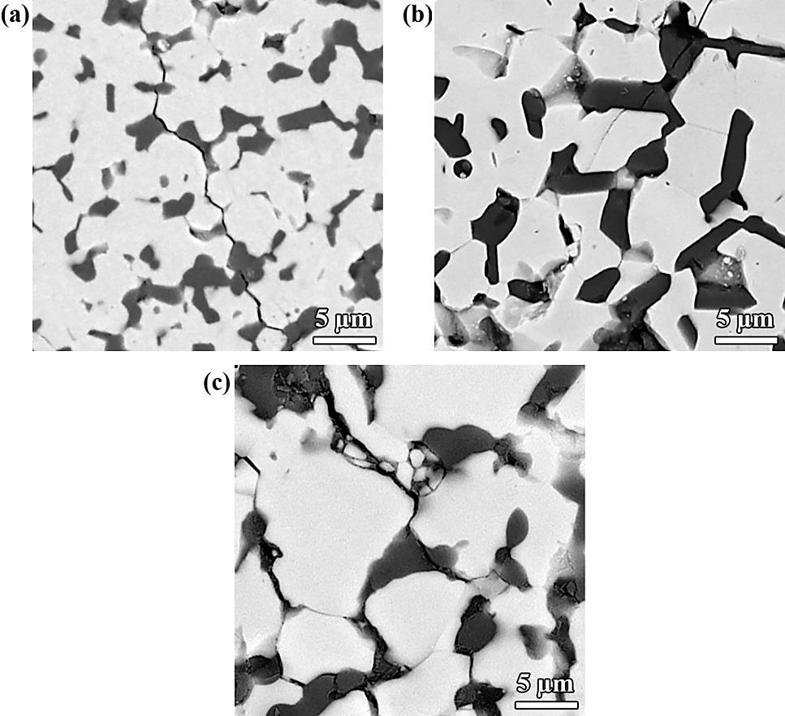
Fig. 9. SEM images of propagated cracks due to applying Vickers indenter on the polished surfaces of composite samples;
(a) ZSD0, (b) ZSD2, and ZSD3

Conclusions
Although adding 3wt% nano-diamond had a destructive effect on the relative density of SPSed samples, the addition of 1 and 2 wt% of this additive had no significant influence on the RD of sintered samples. According to reaching the fully dense samples (ZSD0, ZSD1, and ZSD2), it seems that the sintering conditions were suitable for these composite specimens. XRD assessment disclosed the formation of
in-situ produced phases of ZrC and B₄C during the SPS process. The most significant values of hardness (24.7 GPa) and fracture toughness (5.8 MPa.m^{1/2}) were obtained for the ZSD2 and ZSD3 samples, respectively, due to the existence of SiC and in-situ formation of new phases at the same time. Finally, the micrographic evaluation revealed the effect of different toughening mechanisms on obtaining higher values of fracture toughness in the samples doped with nano-diamond.

References
[1] W.G. Fahrenholtz, G.E. Hilmas, I.G. Talmy, J.A. Zaykoski, Refractory Diborides of Zirconium and Hafnium, J. Am. Ceram. Soc. 90 (2007) 1347–1364. doi:10.1111/j.1551-2916.2007.01583.x.
[2] B. Basu, K. Balani, Advanced Structural Ceramics, John Wiley & Sons, Inc., Hoboken, NJ, USA, 2011. doi:10.1002/9781118037300.
[3] Z. Balak, M. Azizieh, H. Kafashan, M.S. Asl, Z. Ahmadi, Optimization of effective parameters on thermal shock resistance of ZrB₂ -SiC-based composites prepared by SPS: Using Taguchi design, Mater. Chem. Phys. 196 (2017) 333–340. doi:10.1016/j.matchemphys.2017.04.062.
[4] M. Shahedi Asl, M. Ghassemi Kakroudi, F. Golestani-Fard, H. Nasiri, A Taguchi approach to the influence of hot pressing parameters and SiC content on the sinterability of ZrB₂-based composites, Int. J. Refract. Met. Hard Mater. 51 (2015) 81–90. doi:10.1016/j.ijrmhm.2015.03.002.
[5] M. Shahedi Asl, A. Sabahi Namini, M. Ghassemi Kakroudi, Influence of silicon carbide addition on the microstructural development of hot pressed zirconium and titanium diborides, Ceram. Int. 42 (2016) 5375–5381. doi:10.1016/j.ceramint.2015.12.072.
[6] S. Zhu, W.G. Fahrenholtz, G.E. Hilmas, S.C. Zhang, Pressureless sintering of carbon-coated zirconium diboride powders, Mater. Sci. Eng. A. 459 (2007) 167–171. doi:10.1016/j.msea.2007.02.116.
[7] S.A. Delbari, B. Nayebi, E. Ghasali, M. Shokouhimehr, M. Shahedi Asl, Spark plasma sintering of TiN ceramics codoped with SiC and CNT, Ceram. Int. 45 (2019) 3207–3216. doi:10.1016/j.ceramint.2018.10.223.
[8] S.A. Delbari, A. Sabahi Namini, M. Shahedi Asl, Hybrid Ti matrix composites with TiB₂ and TiC compounds, Mater. Today Commun. (2019) 100576. doi:10.1016/j.mtcomm.2019.100576.
[9] F. Shayesteh, S.A. Delbari, Z. Ahmadi, M. Shokouhimehr, M. Shahedi Asl, Influence of TiN dopant on microstructure of TiB₂ ceramic sintered by spark plasma, Ceram. Int. 45 (2019) 5306–5311. doi:10.1016/j.ceramint.2018.11.228.
[10] S.R. Levine, E.J. Opila, M.C. Halbig, J.D. Kiser, M. Singh, J.A. Salem, Evaluation of ultra-high temperature ceramics foraeropropulsion use, J. Eur. Ceram. Soc. 22 (2002) 2757–2767. doi:10.1016/S0955-2219(02)00140-1.
[11] S. Zhu, W.G. Fahrenholtz, G.E. Hilmas, Enhanced densification and mechanical properties of ZrB₂–SiC processed by a preceramic polymer coating route, Scr. Mater. 59 (2008) 123–126. doi:10.1016/j.scriptamat.2008.02.043.
[12] W.-B. Tian, Y.-M. Kan, G.-J. Zhang, P.-L. Wang, Effect of carbon nanotubes on the properties of ZrB₂–SiC ceramics, Mater. Sci. Eng. A. 487 (2008) 568–573. doi:10.1016/j.msea.2007.11.027.
[13] F. Yang, X. Zhang, J. Han, S. Du, Processing and mechanical properties of short carbon fibers toughened zirconium diboride-based ceramics, Mater. Des. 29 (2008) 1817–1820. doi:10.1016/j.matdes.2008.03.011.
[14] F. Yang, X. Zhang, J. Han, S. Du, Mechanical properties of short carbon fiber reinforced ZrB₂–SiC ceramic matrix composites, Mater. Lett. 62 (2008) 2925–2927. doi:10.1016/j.matlet.2008.01.076.
[15] F. Yang, X. Zhang, J. Han, S. Du, Characterization of hot-pressed short carbon fiber reinforced ZrB₂–SiC ultra-high temperature ceramic composites, J. Alloys Compd. 472 (2009) 395–399. doi:10.1016/j.jallcom.2008.04.092.
[16] X. Zhang, Z. Wang, X. Sun, W. Han, C. Hong, Effect of graphite flake on the mechanical properties of hot pressed ZrB₂–SiC ceramics, Mater. Lett. 62 (2008) 4360–4362. doi:10.1016/j.matlet.2008.07.027.
[17] S. Zhou, Z. Wang, W. Zhang, Effect of graphite flake orientation on microstructure and mechanical properties of ZrB₂–SiC–graphite composite, J. Alloys Compd. 485 (2009) 181–185. doi:10.1016/j.jallcom.2009.05.126.
[18] Z. Wang, S. Wang, X. Zhang, P. Hu, W. Han, C. Hong, Effect of graphite flake on microstructure as well as mechanical properties and thermal shock resistance of ZrB₂–SiC matrix ultrahigh temperature ceramics, J. Alloys Compd. 484 (2009) 390–394. doi:10.1016/j.jallcom.2009.04.109.

