Investigation on microstructural characterization of
TiB2-TiN composites

Yaghoub Pazhouhanfar ^{a*}, Abbas Sabahi Namini ^{b,c}, Saeid Sharifiyan Ghazijahani ª,
Hamidreza Sharifian Ghazijahani ª, Seyed Ali Delbari ^{d}, Mehdi Shahedi Asl ^{d}

ª Aliyazh Sanat Sahand Ipak Company, P.O. Box: 51576-13536, Tabriz, Iran
^{b} Department of Engineering Sciences, Faculty of Advanced Technologies, University of Mohaghegh Ardabili, Namin, Iran
^{c} Department of Engineering Sciences, Faculty of Advanced Technologies, Sabalan University of Advanced Technologies(SUAT), Namin, Iran
^{d} Department of Mechanical Engineering, University of Mohaghegh Ardabili, Ardabil, Iran
* Corresponding authors: Y. Pazhouhanfar (Y-Pazhouhanfar@assico.ir)

Abstract
In this paper, the influence of titanium nitride as a sintering aid on the relative density and microstructure of TiB₂ ceramic was examined. Monolithic TiB₂ and TiB₂ doped with 5 wt% TiN were sintered at 1900 ˚C for 7 min under the pressure of 40 MPa by spark plasma. The addition of TiN affected the microstructure of TiB₂-based sample considerably depicting the finer grains in the as-sintered ceramic. Detail investigation by the map analysis and energy dispersive spectroscopy results revealed the formation of in-situ nano-sized hBN secondary phase in the TiN-doped TiB₂. In addition, TiN played a remarkable role on increasing the relative density of TiN-doped TiB₂ ceramic producing a nearly fully dense ceramic with relative density of 99.9% in comparison with the monolithic ceramic having 96.7% relative density.

Keywords: Densification; Microstructure; Spark plasma sintering; TiB₂; TiN; hBN nano-platelets.
1. Introduction
Titanium diboride has recently attracted remarkable attention due to having combined inimitable characteristics such as high melting point (3225 ˚C), considerable elastic modules (<500 GPa), super high hardness (~25 GPa), high electrical conductivity, fairly low thermal expansion coefficient (4.6×10⁻⁶ K⁻¹), excellent wear resistance, appreciable chemical stability, and high oxidation resistance [1]–[4]. These excellent characteristics have made this ceramic as a unique potential material for high temperature applications including ceramic cutting tools, impact-resistance armors, and corrosion resistance parts [5]–[8]. However, due to the relatively low self-diffusion coefficient, strong covalent bonding and the surface covered with oxide layers (mostly TiO₂ and B₂O₃), the sinterability of monolithic titanium diboride is not satisfactory [9]–[12]. To overcome the aforementioned problems, sintering aids are generally used to decrease the sintering temperature [13]–[15]. Non-metallic sintering aids e.g. TaC, MoSi₂, TiSi₂, TiC, WC, SiC, ZrB₂, Si₃N₄, B₄C, AlN and multi-walled carbon nanotubes have been applied to lower the sintering temperature and hinder the grain growth [16]–[18]. As an alternative strategy, spark plasma sintering (SPS) is an effective technique for the production of fine microstructures thanks to its rapid heating and short dwell time in comparison with conventional methods. In this method, materials are charged into a graphite die using a high pulsed electrical current under an external pressure for sintering process [19]–[21]. In this study, the effect of TiN sintering aid on the relative density and microstructure of TiB₂ ceramic was investigated. Two different monolithic TiB₂ and TiB₂ doped with 5 wt% TiN ceramics were fabricated using SPS method at the temperature of 1900 ˚C for holding time of 7 min under 40 MPa pressure. The as-sintered samples were investigated by X-ray diffraction (XRD) for the possibility of new phase formation and scanning electron microscopy (SEM) for the microstructural studies.

2. Experimental procedure
2.1. Materials and process
Commercially available TiB₂ and TiN powders were used as matrix substance and sintering aid, respectively. The materials were weighed for preparation of two ceramics: monolithic TiB₂ and TiB₂ doped with 5 wt% TiN. The initial powders were mixed in ethanol medium for half an hour under sonication. Then, the produced slurry, denoted as TiB₂/TiN mixture, was heated at 120 °C for 3 h while stirring using a hot plate magnetic agiator. For the complete moisture removal, the sample was kept in an oven at 120 °C for 24 h. Finally, the obtained powders were placed into a die made of graphite (inner diameter of 30 mm) to produce a disk-shaped specimen (~5 mm height). The SPS process was performed using an SPS-20T-10, China apparatus at the temperature of 1900 ˚C and 7 min dwell time under vacuum condition and a pressure of 40 MPa. The sintering procedure of monolithic TiB₂ was also carried out at the same conditions using initial TiB₂ powder.
2.2. Characterization
The ratio of the as-sintered and theoretical densities were used to calculate the relative density of the prepared ceramics. For measuring the density of the as-sintered samples, Archimedes principles were employed and the theoretical density was measured through the role of mixtures. The microstructural investigations on the polished and fracture surfaces were carried out by a SEM. In addition, ImageJ software was utilized for estimating grain size of the as-sintered samples. Furthermore, an energy dispersive spectroscopy (EDS) analyzer (DXP-X10P) equipped in the SEM instrument was utilized for the elemental analysis. The phase analysis was acquired by an XRD (Philips PW1730).

3. Results and discussion
Fig. 1 indicates the backscattered SEM micrographs of the polished surfaces of the as-prepared monolithic TiB₂ and TiB₂-5 wt% TiN ceramics. The relative density of 96.7% is calculated for the monolithic sample using Archimedes principles. The remaining 3.3% porosity is shown in the Fig. 1a as marked by white arrows. The presence of pores shows that the consolidation stage was not completed due to the short sintering temperature or short dwell time. The addition of TiN as an additive had a significant influence on the densification of the doped ceramic as it is seen in Fig. 1b. The calculated relative density of the doped sample by the Archimedes principles and ImageJ software shows that nearly fully dense ceramic could be obtained after the SPS process. Although the same process conditions were applied for the both samples, only TiN-doped TiB₂ ceramic presented a noticeable relative density (99.9%). The dark phases marked by black arrows belongs to TiN which were initially existed or perhaps formed in-situ as secondary phases.
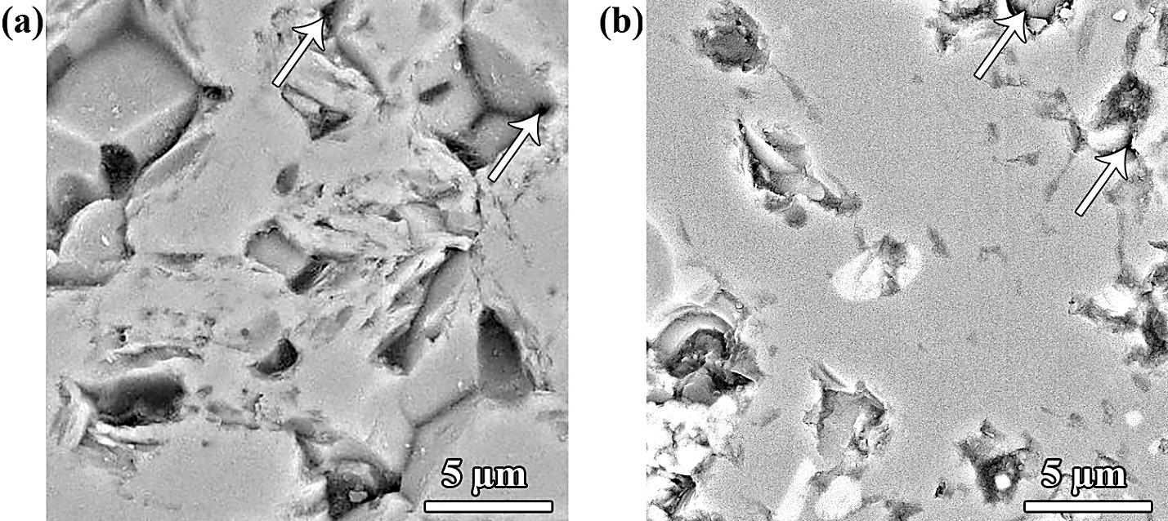
Fig. 1. Backscattered SEM images of the polished surfaces of (a) undoped TiB₂, and (b) TiB₂-5 wt% TiN ceramics.

Fig. 2 illustrates the backscattered SEM images of TiB₂ and the sample doped with 5 wt% TiN. The grains in the monolithic sample shown in Fig. 2a are much bigger compared with the doped ceramic. A mean grain size of 9.3µm was calculated for the undoped ceramic by the image analysis software which is larger in comparison with the initial TiB₂ powders used as starting material (<8 µm). Fig. 2b shows a finer microstructure. The mean grain size measured for the doped sample is ~4.8µm showing the remarkable role of TiN as an additive on hindering the grain growth.
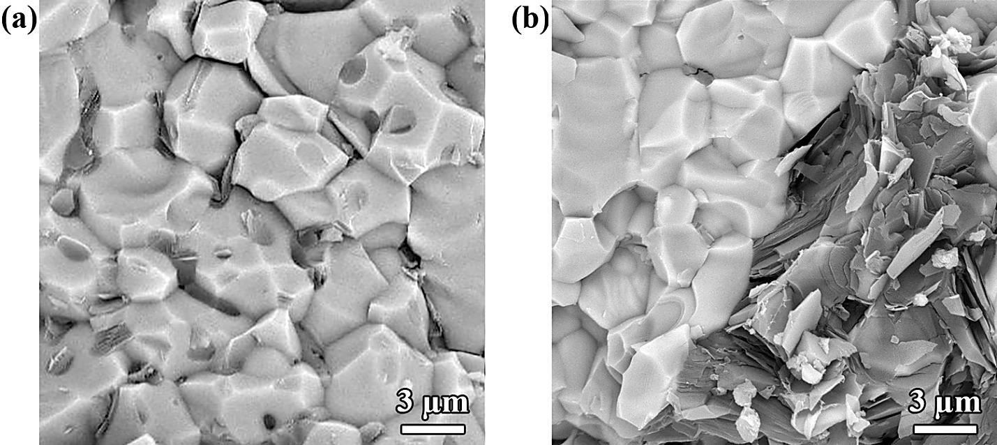
Fig. 2. Backscattered SEM images of the fracture surfaces of (a) undoped TiB₂, and (b) TiB₂-5 wt% TiN ceramics.

The phase analysis of SPSed monolithic TiB₂ and TiB₂-5 wt% TiN ceramics was scrutinized through their XRD patterns. The results for both samples are presented in Fig. 3. As it can be seen in Fig. 3a, the TiB₂ phase was formed as the only crystalline phase indicating no transformation in the sample. Moreover, according to Fig. 3b, the only peaks related to the starting materials were detected in the as-sintered TiB₂ doped with 5 wt% TiN. It can be concluded that no chemical interaction was occurred between the initial powders or the in-site produced phases are so rare which were not-detectable by the XRD diffractometer.
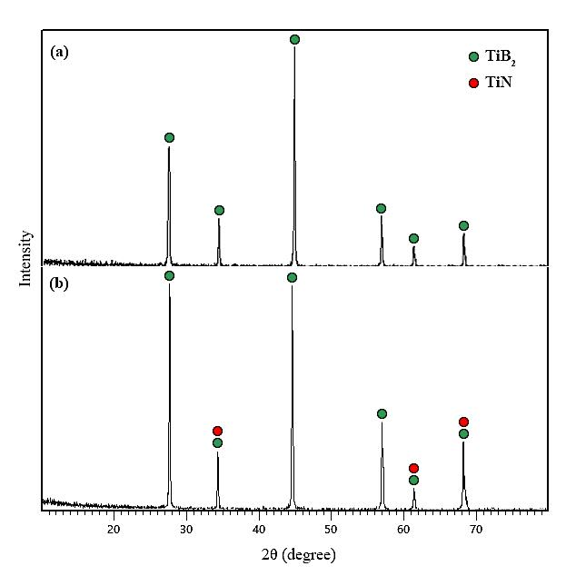
Fig. 3. XRD patterns of the as-prepared samples: (a) TiB₂, and (b) TiB₂ doped with 5 wt% TiN ceramics SPSed at the temperature of 1900 ˚C for 7 min holding time under the pressure of 40 MPa.

Fig. 4 shows another SEM fractograph of TiB₂ sample doped with TiN. Besides the TiB₂ matrix, two other different phases can be observed namely the bright and gray colored phases marked by white and black arrows, respectively. Based on the EDS analysis, the former phase is attributed to unreacted TiN due to its high chemical stability. Most TiN remained unchanged and dispersed between TiB₂ grains hindering the exaggerated grain growth. The latter phase (the gray one) can be attributed to the in-situ formation of hBN. As it was discussed before, due to the trace formation of this phase, it could not be detected in XRD pattern (Fig 3b). Kitiwan et al. [22] studied TiN-TiB₂ composites and reported the possible reactions led to the formation of hBN phase under the SPS process. It was explained that while both TiN and TiB₂ are available, TiN and TiB₂ lose nitrogen and boron at the high temperature, respectively, making the formation of hBN possible.
$TiN→{TiN}_{1-x}+x1/2N_{2}$ (1)
${TiB}_{2}→{TiB}_{2-y}+yB$ (2)
$∆1/2N_{2}+∆B→∆BN(∆=\min\left(x.y\right))$ (3)
Based on Fig. 4, two different kinds of fracture modes are feasible. As it is known, the large TiB₂ particles are broken during the crack propagation as the predominant fracture mode in the ceramic. The lines marked by light-gray arrows, presenting on the broken grains illustrate the brittle fracture happened in this ceramic. In addition, the role of secondary phase on crack deflection, marked by dark-gray arrow, is observed in this figure.
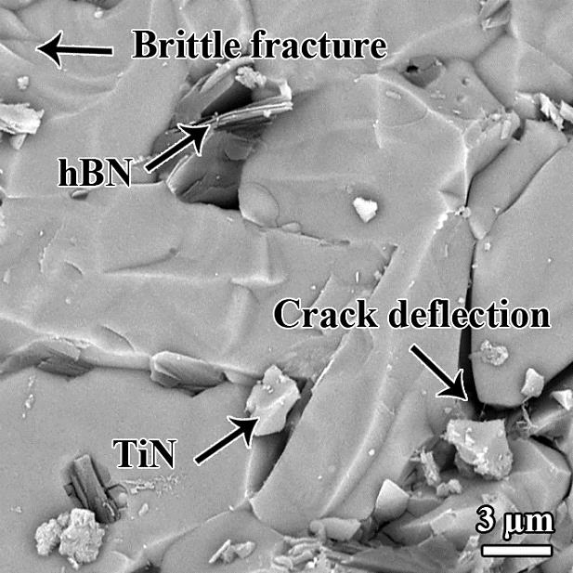
Fig. 4. Backscattered SEM image of the fracture surface of TiB₂ doped with 5 wt% TiN.

Fig. 5 shows another backscattered SEM image of TiB₂-5 wt% TiN ceramic and the attributed EDS point analysis. Fig. 5a presents a closer view of in-situ formed nano-platelets of hBN phase. This secondary phase has been produced due to the interaction between TiN particles and the TiB₂ matrix, as discussed earlier. Although the most proportion of titanium nitride was remained unreacted, the EDS analysis (Fig. 5b) proved the formation of such in-site formed nano-platelets of hBN.
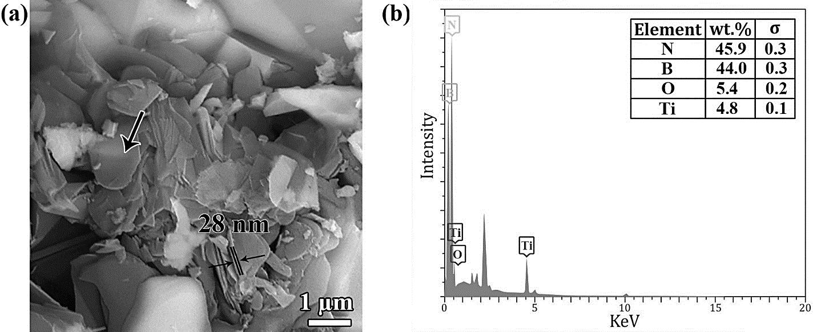
Fig. 5. Backscattered SEM fractograph of TiB₂-based ceramic doped with 5 wt% TiN,
and the corresponding EDS point analysis.

Conclusions
The effect of TiN as a sintering additive on the microstructure and sinterability of TiB₂ ceramic produced by spark plasma sintering at the temperature of 1900 ˚C for 7 min holding time under the pressure of 40 MPa was investigated in this research. The characterization results were compared with the monolithic sample fabricated at the same conditions. Including the sintering additive of TiN improved the relative density of TiB₂ ceramic by 3.2%. Furthermore, TiN additive hindered the aggregative grain growth of TiB₂ matrix yielding a finer microstructure. Although no evidence could be detected in the XRD pattern, the scanning electron microscopy fractographs revealed the formation of in-situ hBN in the TiN-doped TiB₂ ceramic indicating the negligible content of hBN secondary phase in the modified ceramic.
References
[1] Z. Ahmadi, B. Nayebi, M. Shahedi Asl, I. Farahbakhsh, and Z. Balak, “Densification improvement of spark plasma sintered TiB2-based composites with micron-, submicron- and nano-sized SiC particulates,” Ceram. Int., vol. 44, no. 10, pp. 11431–11437, Jul. 2018.
[2] A. Ebrahimi, H. Esfahani, A. Fattah-alhosseini, and O. Imantalab, “In-vitro electrochemical study of TiB/TiB2 composite coating on titanium in Ringer’s solution,” J. Alloys Compd., vol. 765, pp. 826–834, Oct. 2018.
[3] B. Basu, J. Vleugels, and O. Van Der Biest, “Fretting wear behavior of TiB2-based materials against bearing steel under water and oil lubrication,” Wear, vol. 250, no. 1–12, pp. 631–641, Oct. 2001.
[4] M. Kitiwan, A. Ito, J. Zhang, and T. Goto, “Densification and mechanical properties of cBN–TiN–TiB2 composites prepared by spark plasma sintering of SiO2-coated cBN powder,” J. Eur. Ceram. Soc., vol. 34, no. 15, pp. 3619–3626, Dec. 2014.
[5] W. Ji et al., “Fabrication and properties of TiB2-based cermets by spark plasma sintering with CoCrFeNiTiAl high-entropy alloy as sintering aid,” J. Eur. Ceram. Soc., vol. 35, no. 3, pp. 879–886, Mar. 2015.
[6] S. K. Bhaumik, C. Divakar, L. Rangaraj, and A. K. Singh, “Reaction sintering of NiAl and TiB2–NiAl composites under pressure,” Mater. Sci. Eng. A, vol. 257, no. 2, pp. 341–348, Dec. 1998.
[7] A. Rabiezadeh, A. M. Hadian, and A. Ataie, “Synthesis and sintering of TiB2 nanoparticles,” Ceram. Int., vol. 40, no. 10, pp. 15775–15782, Dec. 2014.
[8] G. Zhao, C. Huang, H. Liu, B. Zou, H. Zhu, and J. Wang, “Microstructure and mechanical properties of TiB2–SiC ceramic composites by Reactive Hot Pressing,” Int. J. Refract. Met. Hard Mater., vol. 42, pp. 36–41, Jan. 2014.
[9] A. Rabiezadeh, A. Ataie, and A. M. Hadian, “Sintering of Al2O3–TiB2 nano-composite derived from milling assisted sol–gel method,” Int. J. Refract. Met. Hard Mater., vol. 33, pp. 58–64, Jul. 2012.
[10] M. Shahedi Asl, Z. Ahmadi, S. Parvizi, Z. Balak, and I. Farahbakhsh, “Contribution of SiC particle size and spark plasma sintering conditions on grain growth and hardness of TiB2 composites,” Ceram. Int., vol. 43, no. 16, pp. 13924–13931, Nov. 2017.
[11] K. Farhadi, A. Sabahi Namini, M. Shahedi Asl, A. Mohammadzadeh, and M. Ghassemi Kakroudi, “Characterization of hot pressed SiC whisker reinforced TiB2 based composites,” Int. J. Refract. Met. Hard Mater., vol. 61, pp. 84–90, Dec. 2016.
[12] A. Sabahi Namini, S. N. Seyed Gogani, M. Shahedi Asl, K. Farhadi, M. Ghassemi Kakroudi, and A. Mohammadzadeh, “Microstructural development and mechanical properties of hot pressed SiC reinforced TiB2 based composite,” Int. J. Refract. Met. Hard Mater., vol. 51, pp. 169–179, Jul. 2015.
[13] J. Lin, Y. Yang, H. Zhang, Q. Lin, and B. Zhu, “Synthesis and characterization of in-situ CNTs reinforced TiB2-based composite by CVD using Ni catalysts,” Ceram. Int., vol. 44, no. 2, pp. 2042–2047, Feb. 2018.
[14] Z. Fu and R. Koc, “Pressureless sintering of TiB2 with low concentration of Co binder to achieve enhanced mechanical properties,” Mater. Sci. Eng. A, vol. 721, pp. 22–27, Apr. 2018.
[15] I. Farahbakhsh, Z. Ahmadi, and M. Shahedi Asl, “Densification, microstructure and mechanical properties of hot pressed ZrB2–SiC ceramic doped with nano-sized carbon black,” Ceram. Int., vol. 43, no. 11, pp. 8411–8417, Aug. 2017.
[16] M. Shahedi Asl, I. Farahbakhsh, and B. Nayebi, “Characteristics of multi-walled carbon nanotube toughened ZrB2–SiC ceramic composite prepared by hot pressing,” Ceram. Int., vol. 42, no. 1, pp. 1950–1958, Jan. 2016.
[17] D. Demirskyi, H. Borodianska, Y. Sakka, and O. Vasylkiv, “Ultra-high elevated temperature strength of TiB2 -based ceramics consolidated by spark plasma sintering,” J. Eur. Ceram. Soc., vol. 37, no. 1, pp. 393–397, Jan. 2017.
[18] T. S. R. C. Murthy, R. Balasubramaniam, B. Basu, A. K. Suri, and M. N. Mungole, “Oxidation of monolithic TiB2 and TiB2–20wt.% MoSi2 composite at 850°C,” J. Eur. Ceram. Soc., vol. 26, no. 1–2, pp. 187–192, Jan. 2006.
[19] A. Babapoor, M. S. Asl, Z. Ahmadi, and A. S. Namini, “Effects of spark plasma sintering temperature on densification, hardness and thermal conductivity of titanium carbide,” Ceram. Int., vol. 44, no. 12, pp. 14541–14546, Aug. 2018.
[20] M. Shahedi Asl, “A statistical approach towards processing optimization of ZrB2–SiC–graphite nanocomposites. Part I: Relative density,” Ceram. Int., vol. 44, no. 6, pp. 6935–6939, Apr. 2018.
[21] E. Ghasali and M. Shahedi Asl, “Microstructural development during spark plasma sintering of ZrB2–SiC–Ti composite,” Ceram. Int., vol. 44, no. 15, pp. 18078–18083, Oct. 2018.
[22] M. Kitiwan, A. Ito, and T. Goto, “Spark plasma sintering of TiN–TiB2 composites,” J. Eur. Ceram. Soc., vol. 34, no. 2, pp. 197–203, Feb. 2014.

