Study on properties of triplet Ti–TiB–TiC composites

Abbas Sabahi Namini ^{a,b*}, Yaghoub Pazhouhanfar ^{c}, Hamidreza Sharifian Ghazijahani ^{c},
Saeid Sharifiyan Ghazijahani ^{c}, Seyed Ali Delbari ^{d}, Mehdi Shahedi Asl ^{d}

ª Department of Engineering Sciences, Faculty of Advanced Technologies, University of Mohaghegh Ardabili, Namin, Iran
^{b} Department of Engineering Sciences, Faculty of Advanced Technologies, Sabalan University of Advanced Technologies(SUAT), Namin, Iran
^{c} Aliyazh Sanat Sahand Ipak Company, P.O. Box: 51576-13536, Tabriz, Iran
^{d} Department of Mechanical Engineering, University of Mohaghegh Ardabili, Ardabil, Iran
* Corresponding authors: A. Sabahi Namini (sabahi@uma.ac.ir)

Abstract
Four hybrid titanium-based samples with different amounts of B₄C as reinforcement and the same numbers of specimens with TiB₂ + TiC additives were produced using the SPS method at 1200 °C. For a reliable comparison, stoichiometry relations of starting powders were applied to estimate the precise contents of mentioned reinforcements to reach the same vol% of final TiB and TiC phases. To make a reliable comparison, the microstructure, relative density (RD), and mechanical properties of both series of SPSed composite samples were studied. The in-situ TiB_{w} phase formation in both series of samples was confirmed using XRD and microscopical evaluation. Samples doped with B₄C exhibited better UTS, tensile elongation, and bending strength compared with the ones doped with TiB₂ + TiC. The sample with the least B₄C content presented the best values of mentioned mechanical properties.

Keywords: Spark plasma sintering; Hybrid composites; In-situ/ex-situ; Ceramic reinforcement.
1. Introduction
Ti have exhibit a wide range of characteristics, viz. excellent corrosion resistance, high-temperature resistance, remarkable specific strength and toughness, biocompatibility, and low weight. These combinations of qualities have made Ti-based materials a great candidate for many conventional and advanced applications such as automotive, defense, aerospace, chemical, and biomedical [1–5]. In addition, the values of strength, hardness, wear-resistance, and thermal conductivity of monolithic titanium are not enough for many high-tech applications and they should be improved one way or another [6,7]. To tackle the mentioned difficulties of using pure titanium, developing new alloys and composites can be a possible solution. Many researches have been implemented to investigate the influence of adding alloying components (like Mo, Al, Ni, V, etc.) and ceramic reinforcements (like SiC, TiC, Si₃N₄, TiN, TiB, etc.) on the characteristics of Ti-based substances [8–10]. Recently, some first-rate techniques based on conventional powder metallurgy processes have been developed to fabricate high-quality composite parts. Spark plasma sintering (SPS) is one of these techniques that has found lots of proponents due to its unique advantages, namely low working temperature, fast heating-up, short holding time, and application of external pressure [11–13]. Various studies have been implemented regarding the influences of adding TiB₂, TiC, and B₄C on the mechanical properties and microstructure of Ti-based MMCs. Sabahi Namini et al. added TiB₂ as a reinforcement to SPSed Ti-based composites and obtained a near fully dense sample (99.55% of relative density). They also reported a TiB₂ amount of 4.8 wt% and a sintering temperature of 1200 °C as the optimum parameters to reach the best values of hardness and flexural strength [14–16]. Jia et al. examined the effect of boron carbide particle size and its influence on the amount of in-situ produced phases. They also scrutinized the reactions under solid states in a Ti-B₄C system [17,18]. This research project has made a complete comparison between the composites doped with B₄C and those doped with TiB₂ + TiC. The amounts of B₄C and TiB₂ + TiC as the additives were selected such that the final calculated amounts of phases in as-sintered samples (TiB + TiC) would be equal to each other.

2. Experimental procedure
Table 1 indicates the initial powders used in this study. These powders were picked out through high-quality materials that were available commercially. At first, all powders were weighed based on the compositions presented in Table 2 to reach the exactly designed combinations formed under the in-situ reaction between the matrix of titanium and additives. Afterward, a turbula mixer was utilized to mix the as-received powders at 60 rpm for 5 hrs. Then, the mixed-powders were loaded into a graphite die to be sintered using a spark plasma sintering (SPS) machine. The sintering conditions consisted of a temperature of 1200 °C and a dwell time of 5 min under 50 MPa external pressure for all composite samples. The codes designated for each sample are also visible in Table 2. In this study, the amount of TiB₂ + TiC and B₄C reinforcements were selected precisely to provide the best circumstances for a reliable comparison. In the other words, due to the decomposition of B₄C and formation of TiB + TiC phases (in Ti-B₄C system), the interaction between TiB₂ and Ti, and production of TiB phase (in Ti-TiB₂-TiC system), stoichiometry relations of starting powders were examined to reach the precise amount of initial materials. The weight percentages of ceramic additives are shown in Table 2.

Table 1. Technical information of starting materials.
Materials | Company | Particle size (µm) | Purity (%)
Ti | Sigmaaldrich | < 60 µm | > 98%
B₄C | Sigmaaldrich | < 50 µm | > 98%
TiB₂ | Xuzhou Hongwu Nanometer Material | < 50 µm | > 98%
TiC | Xuzhou Hongwu Nanometer Material | < 20 µm | > 98%

Table 2. Coding system and the combination of composite samples before and after the SPS process
Sample | Starting materials |  | Products
Sample | Matrix Ti (wt%) | Additives (wt%) | Matrix Ti (vol%) | TiB (vol%) | TiC (vol%)
0.24B1200 | 99.76 | 0.24 B₄C | 98.75 | 1 | 0.25
0.48B1200 | 99.52 | 0.48 B₄C | 97.34 | 2.15 | 0.51
0.96B1200 | 99.04 | 0.96 B₄C | 94.33 | 4.57 | 1.1
1.92B1200 | 98.08 | 1.92 B₄C | 86.97 | 10.43 | 2.6
0.6T0.27T1200 | 99.13 | 0.6 TiB₂ + 0.27 TiC | 98.75 | 1 | 0.25
1.27T0.55T1200 | 98.18 | 1.27 TiB₂ + 0.55 TiC | 97.34 | 2.15 | 0.51
2.7T1.19T1200 | 96.11 | 2.7 TiB₂ + 1.19 TiC | 94.33 | 4.57 | 1.1
6.17T2.82T1200 | 91.01 | 6.17 TiB₂ + 2.82 TiC | 86.97 | 10.43 | 2.6

Archimedes technique and the mixture rule were used to obtain the values of bulk densities and relative densities of as-sintered composite samples using distilled water as a medium. The routine metallography process and an etchant solution (krolls reagent containing 5 ml Hf, 10 ml HNO₃, and 85 ml H₂O) were used to prepare the surfaces of specimens. All samples were studied by both optical and SEM microscopic equipped with a EDS system. Moreover, a D5000 Siemens XRD device was employed to identify the initial and final phases of samples. Afterward, both macro- and microhardness of specimens were determined using Vickers macro hardness instrument (a load of 30 Kg for 15 sec) and a UK Eseway Vickers microhardness tester (with a load of 300 g for 15 sec), on the polished surfaces; respectively. An EDM performed in the preparation of standard samples for UTS (2×5×15 mm³) and three-point bending (3×4×34 mm³) tests. Both these tests were carried out through a STM-250 universal testing machine with a crosshead speed of 0.5 mm/min. Selected parameters for doing these tests at high temperatures were a cross-section of 2 × 6 mm² and a gauge length of 18 mm at 600 °C.

3. Results and discussion
3.1. Phase identification and thermodynamics
The kinds of chemical reactions occurring among the initial materials over the sintering process were detected through XRD analysis, as presented in Figure 1. The patterns shown in the figure reveal Ti (α) and (β) peaks in every composite samples, indicating the two-phase matrix. Figure 1 (a) illustrates the XRD patterns related to the samples doped with B₄C. As it is clear, TiB and TiC peaks are present in almost all samples as the in-situ products of Ti-B₄C interaction (TiC peaks are not visible only in the samples with the least additive). Moreover, XRD evaluation revealed the presence of remained B₄C phase in all samples doped with boron carbide. This confirms an incomplete reaction between Ti matrix and B₄C likely because of insufficient temperature or time of the SPS process. The possible reaction resulted in the formation of mentioned in-situ phases is shown in Eq. 1, which explains the production of TiB and TiC phases at the same time. According to Eq.1, greater TiB phases will be produced in comparison with TiC phases. For such a reaction to progress completely, however, enough B₄C must be available unless occurring such a reaction would be impossible, which will make it difficult to detect the minor product (TiC) through XRD analysis.
5Ti + B₄C = TiC + 4TiB Eq. 1
The XRD results associated with the samples doped with TiB₂ and TiC Fig. 1(b) illustrate TiB₂ peaks only in the samples with relatively higher contents of TiB₂ (6.17T2.82T1200 and 2.7T1.19T1200). The absence of such peaks (TiB₂) in the samples is because all of them were consumed during the sintering process or remained extremely trace not detectable by the XRD analysis. The presence of unreacted TiB₂ can be attributed to the coarse size of some titanium diboride particles, or insufficient sintering time or temperature to convert all those particles into the TiB phase according to Eq. 2.
Ti + TiB₂ = 2TiB Eq. 2
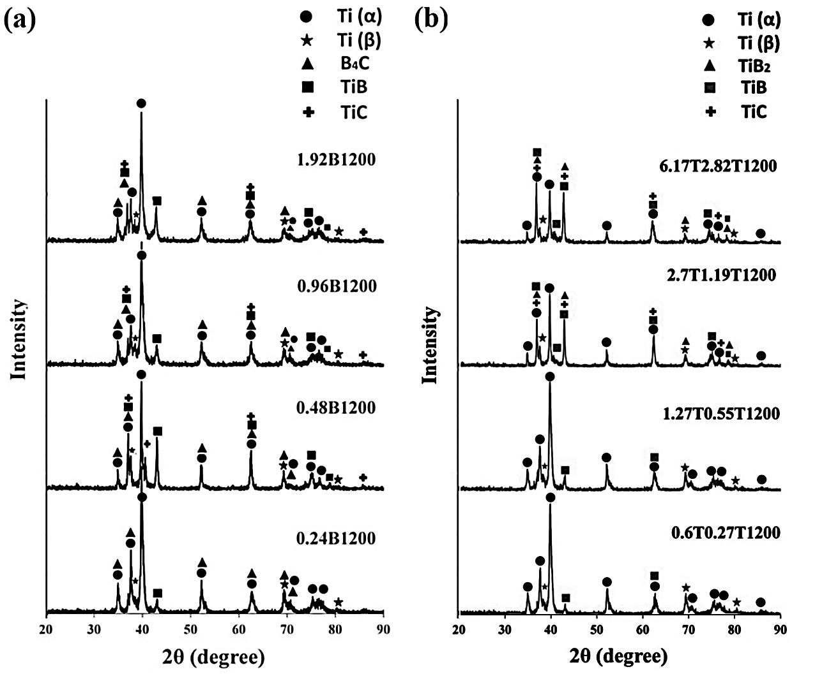
Fig. 1. X-ray diffraction patterns of as-produced composite specimens doped with (a) B₄C and (b) TiB₂ + TiC

3.2. Relative density and microstructure
The relative density and mechanical properties of the as-sintered specimens are reported in table 3. Also, the RDs of specimens doped with B₄C and those doped with TiB₂ + TiC are depicted in Figure 2. As it is clear, Ti-B₄C composites exhibit more RD compared with Ti-TiB₂-TiC samples. All the composites doped with boron carbide reached an RD above 99%, and the best value (99.93%) was related to 0.48B1200 specimen. Among the composites doped with TiB₂ + TiC, the best value of RD (99.71%) belonged to the one with the lowest additive contents, while the weakest value of around 98% was obtained for 6.17T2.82T1200 specimen. It seems that the bond between TiB₂ and TiC was not very strong leading to forming lots of porosity in these areas.

Table 3. RD and mechanical properties of as-produced TMCs
Sample | Relative density (%) | UTS (MPa)  At room temperature | Elongation (%)  At room temperature | UTS (MPa)  At high temperature | Elongation (%)  At high temperature | Bending strength (MPa) | Hardness  (HV₃₀ kg) | Microhardness  (HV_{300 gr})
0.24B1200 | 99.86 ± 0.04 | 509 ± 16 | 6.45 ± 0.33 | 232 | 10.22 | 1136± 06 | 292 ± 6 | 301 ± 15
0.48B1200 | 99.93 ± 0.01 | 502 ± 14 | 4.59 ± 0.26 | 249 | 9.23 | 1051 ±27 | 343 ± 3 | 385 ± 11
0.96B1200 | 99.81 ± 0.03 | 494 ± 08 | 4.37 ± 0.17 | 268 | 9.21 | 1003 ±32 | 352 ± 5 | 422 ± 04
1.92B1200 | 99.77 ± 0.01 | 270 ± 42 | 3.13 ± 0.34 | 279 | 5.43 | 875 ± 31 | 381 ± 4 | 530 ± 37
0.6T0.27T1200 | 99.71 ± 0.06 | 413 ± 11 | 4.18 ± 0.16 | 250 | 9.45 | 1097 ± 43 | 311 ± 4 | 321 ± 18
1.27T0.55T1200 | 99.00 ± 0.08 | 388 ± 18 | 3.11 ± 0.28 | 257 | 12.44 | 873 ± 28 | 353 ± 4 | 358 ± 39
2.7T1.19T1200 | 98.43 ± 0.05 | 370 ± 7 | 3.30 ± 0.21 | 278 | 9.37 | 859 ± 22 | 367 ± 1 | 470 ± 24
6.17T2.82T1200 | 98.02 ± 0.09 | 304 ± 27 | 2.99 ± 0.38 | 343 | 8.92 | 846 ± 25 | 414 ± 15 | 552 ± 33

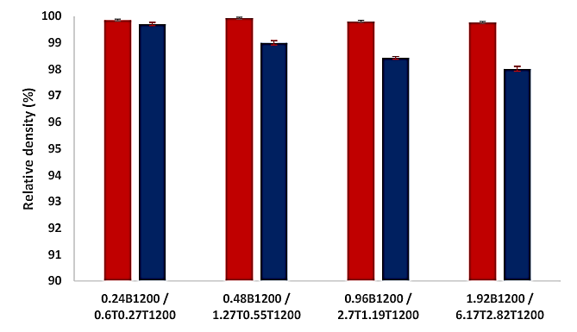
Fig. 2. The relative density of as-produced composites doped with B₄C and TiB₂+TiC

The optical microscopic images of both series of as-sintered materials are shown in Figure 3. Figure 3 (a-d) displays the samples doped with B₄C, and the others belong to Ti-TiB₂-TiC specimens. As it can be seen, remained B₄C and in-situ formed phases (TiB + TiC) are detectable in the Ti-B₄C samples. Remained B₄C (dark-colored phase) is surrounded by some in-situ formed phases (gray-colored phase). According to Eq. 1, this gray-colored phases should be composed of TiB whiskers (TiB_{w}) and TiC particles, which will be further scrutinized through the SEM examination in the following. As discussed above, the presence of remained B₄C in these samples is because of insufficient sintering time/temperature or the large size of boron carbide particles. As shown in Figure 3 (a-d), there are some large B₄C particles with a reaction zone containing TiB + TiC phases around them, while the reaction entirely progressed in regions where smaller particles were available. The optical microscopic images of Ti-TiB₂-TiC composites are exhibited in Figure 3 (e-h). TiB whiskers and TiC particles are also present in these samples. The difference between these series of samples with those doped with B₄C is that TiC phase formed in-situ in Ti- B₄C while it was added ex-situ in Ti-TiB₂-TiC specimens.
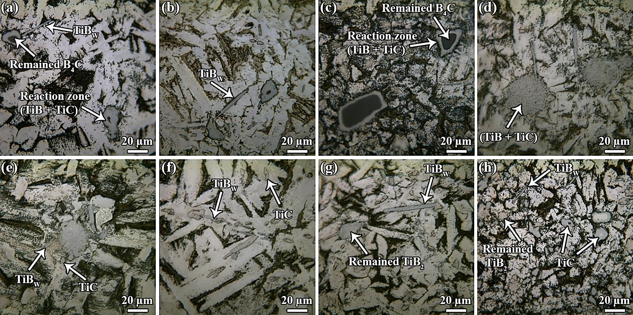
Fig. 3. Optical microscopic images of polished surfaces of (a) 0.24B1200, (b) 0.48B1200, (c) 0.96B1200, (d) 1.92B1200, (e) 0.6T0.27T1200, (f) 1.27T0.55T1200, (g) 2.7T1.19T1200, and (h) 6.17T2.82T1200

The SEM images of as-sintered composites are illustrated in Figure 4. The images of the samples doped with different amounts of B₄C are presented in Figure 4 (a-d). As it can be seen, the reaction entirely progressed between Ti-matrix and fine B₄C particles, and no remained boron carbide phase is visible. A closer view of the reaction zone and in-situ formed phases
(TiB_{w} + TiC) can be seen in the interface of Ti and B₄C (Fig. 5 (a)). As a matter of fact, the availability of stacking faults is very common in some crystalline planes of TiB_{w}, namely ${\left(101\right)}_{TiB}$ and ${\left(10\overline{1}\right)}_{TiB}$, facilitating the formation of TiC. Figure 4 (e-h) displays the SEM micrographs of as-sintered Ti-TiB₂-TiC samples. Four various phases, including Ti-matrix, remained TiB₂, in-situ formed TiB_{w}, and ex-situ added TiC are detectable in these images. A remained TiB₂ particle surrounded by TiB phase is visible in Figure 5 (h), showing that the sintering conditions (time and temperature) were not sufficient to turn all the phase into the in-situ formed one. The SEM image of 2.7T1.19T1200 sample represents TiB whiskers in Ti matrix at high magnification (Fig. 5 (b)).
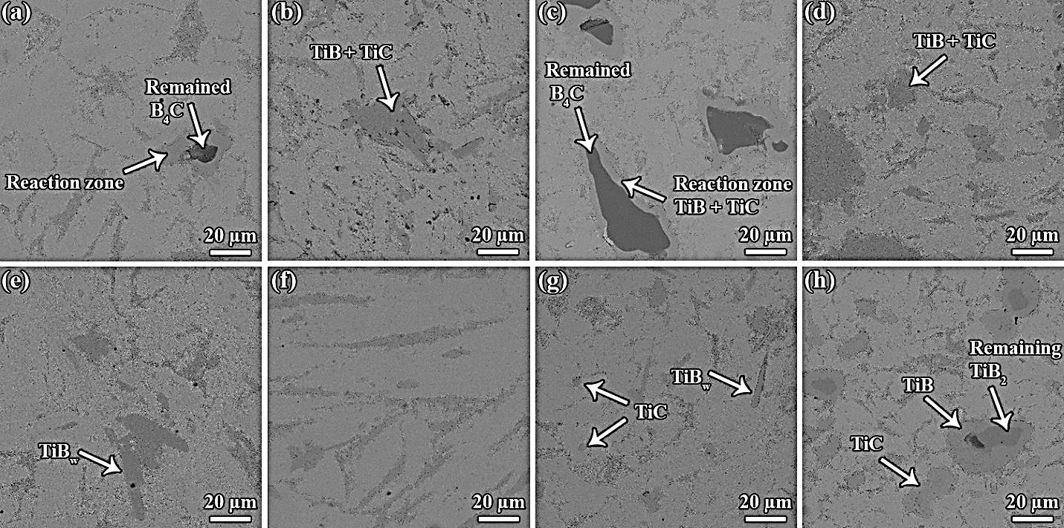
Fig. 4. SEM microscopic images of polished surfaces of (a) 0.24B1200, (b) 0.48B1200, (c) 0.96B1200, (d) 1.92B1200, (e) 0.6T0.27T1200, (f) 1.27T0.55T1200, (g) 2.7T1.19T1200, and (h) 6.17T2.82T1200

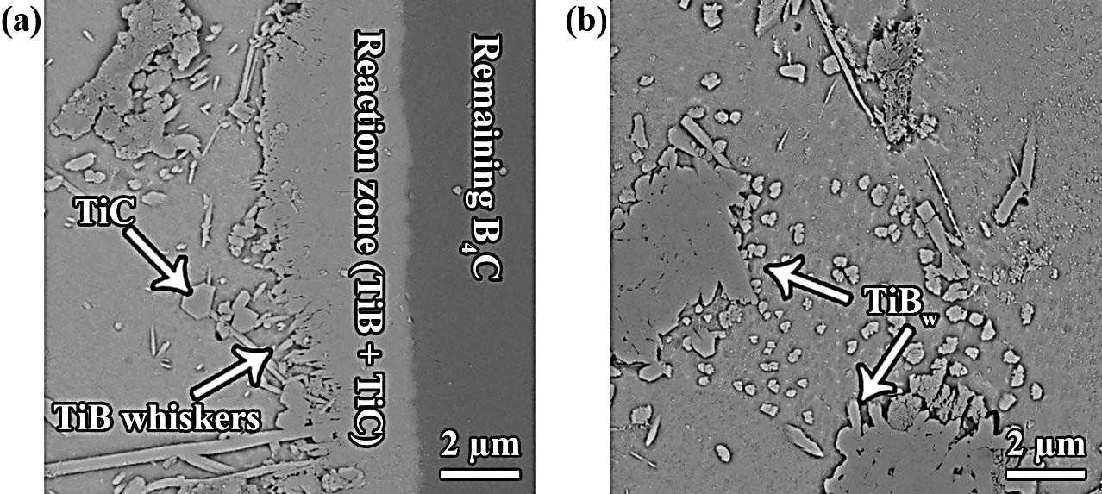
Fig. 5. SEM microscopic images of polished surfaces of (a) 0.96B1200, and (b) 2.7T1.19T1200

3.4. Mechanical properties
The mechanical characteristics, including ultimate tensile strength, elongation, hardness, and bending strength of both series of composites, are presented numerically in Table 3 and graphically in Figure 6. As it is clear in Figure 6 (a), further addition of reinforcements to the Ti-matrix led to lower UTS values for both series of samples at room temperature. Moreover, increasing the amounts of unreacted phases in the Ti-matrix, namely B₄C in Ti-B₄C and TiB₂/TiC in Ti-TiB₂-TiC specimens, possibly played a destructive role in the UTS values of samples owing to their poor bonding with matrix. Weak interfacial bonds between secondary phases and matrix can act as probable zones for initiating cracks, and consequently, they can lead to UTS reduction. However, the samples doped with B₄C (except the specimen with the highest amount of additive) provided better UTS values compared with those doped with TiB₂ + TiC at room temperature. Contrarily, the samples doped with TiB₂ + TiC presented better UTS performance at high temperatures compared with those with B₄C additives. As it is obvious in Figure 6 (b), increasing the additive level led to an increment at high-temperature UTS values. Delbari et al. [2] have explained that this phenomenon takes place because plastic deformation capability of Ti-matrix rises at high temperatures due to some reasons: (1) more activate slip systems and (2) stress concentration in the vicinity of releasing secondary phases. The best elongation value of about 6.5% at room temperature was obtained for the sample with the least B₄C content. Besides, all samples doped with boron carbide had better elongation percentages at room temperature compared with their counterparts doped with TiB₂ + TiC. The poorest value of elongation (lower than 3%) at room temperature was related to the specimen dope with 6.17 wt% TiB₂ and 2.82 wt% TiC (Fig. 6 (c)). The reasons mentioned for the better UTS of Ti-B₄C samples at room temperature are true for the elongation at the same temperature. Incidentally, remained unreacted particles with poor interfacial bonds to the matrix played the predominant role in dropping the tensile elongation at room temperature. In addition, the highest percentage of about 12.5 for elongation at high temperature was obtained for the samples doped with 1.27 wt% TiB₂ + 0.55 wt% TiC, while the lowest value belonged to that doped with 1.92 wt% B₄C (Fig. 6 (d)). The macro/micro hardness values for both series of specimens (Fig. 6 (e-f)) indicate that both macro/micro hardness of each series rose roughly with rising amounts of additives to the titanium matrix. As it is clear, ceramic particles are much harder than the Ti - matrix, thus it is apparent that the hardness of as-sintered specimens increases with raising ceramic particles content. On the other hand, the samples with TiB₂ + TiC reinforcements reached higher macro/micro hardness in comparison with their counterparts doped with boron carbide. In fact, the remaining unreacted reinforcements played the dominant role in the values of macro/micro hardness. As TiB₂ is harder than B₄C, the samples with remained titanium diboride exhibited higher hardness than the ones with remained boron carbide. However, the best values of macro and micro hardness (around 415 HV_{30 kg} and 550 HV _{300 gr}, respectively) were obtained for the sample doped with higher content of TiB₂ + TiC. Finally, the results of bending strength values of specimens (Fig. 6 (g)) follow the trends for UTS at room temperature. Addition of more additives led to poorer values of bending strength for each series of composites, but the ones doped with B₄C presented better values, with the best result (1136 MPa) recorded for 0.24B1200 sample.
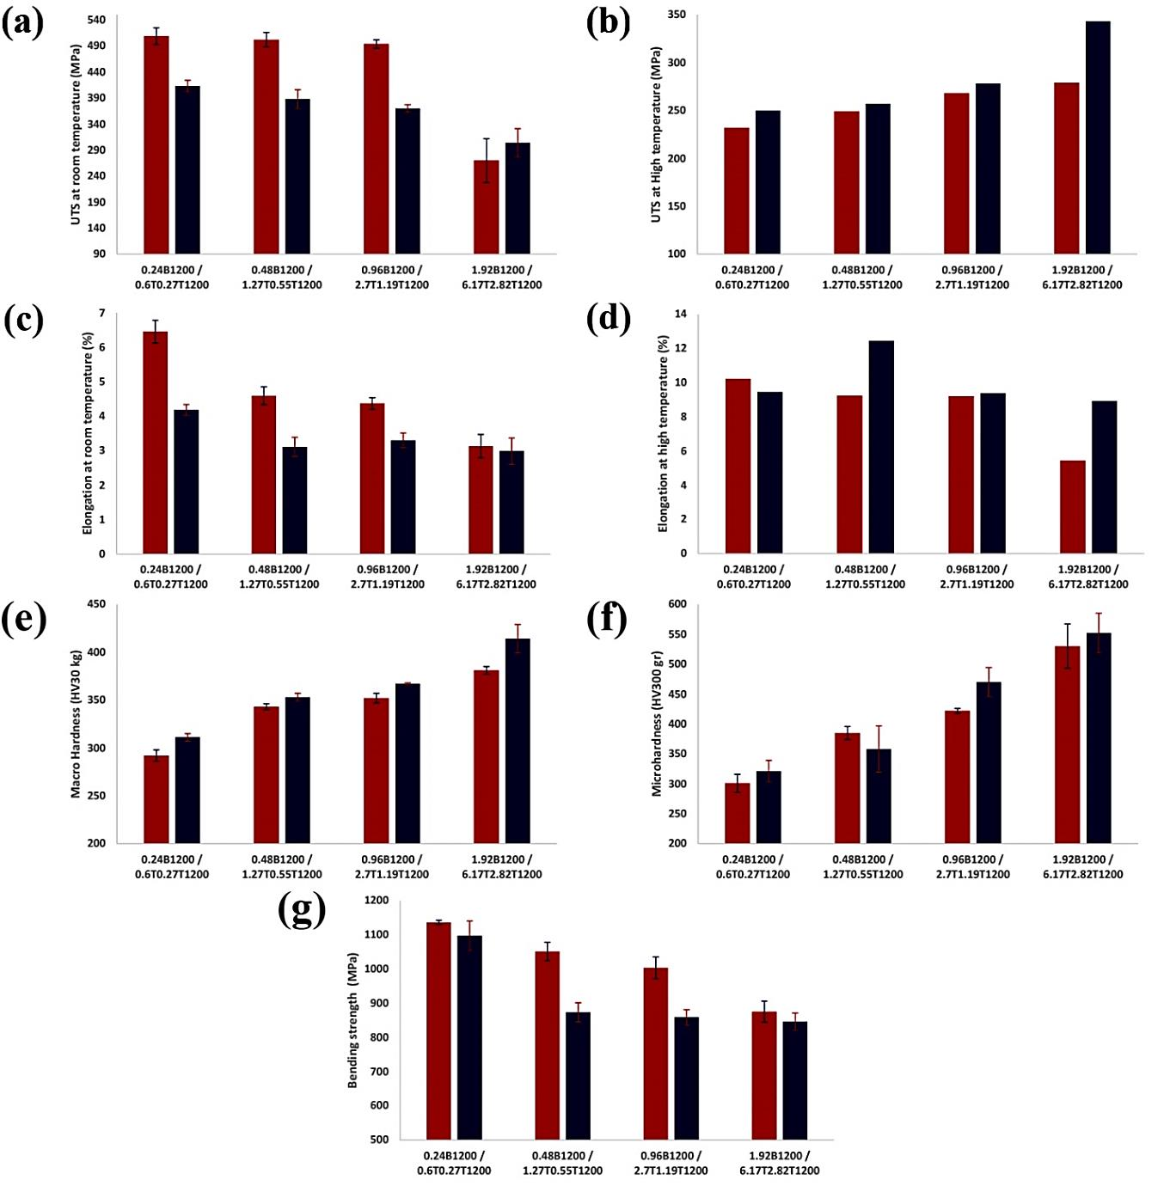
Fig. 6. Mechanical characteristics of the as-sintered samples doped with B₄C and TiB₂+TiC (a) ultimate tensile strength at room temperature, (b) ultimate tensile strength at high temperature, (c) elongation at room temperature, (d) elongation at high temperature, (e) macro hardness, (f) microhardness, and (g) bending strength.
4. Conclusions
Two different series of specimens with different amounts of B₄C and TiB₂ + TiC as reinforcements were spark plasma sintered at 1200 °C. The microstructure, RD, and mechanical properties were investigated for as-sintered specimens. The samples doped with B₄C exhibited better RD compared with the ones doped with TiB₂ + TiC. Moreover, Ti-B₄C samples reached better UTS, elongation, and bending strength in comparison with their counterparts at room temperature owing to having more contents of in-situ formed phases. The best values of mentioned properties were related to the sample doped with the lowest amount of boron caribe (UTS: 509 MPa, elongation: 6.45%, and bending strength: 1136 MPa). Finally, Ti-TiB₂-TiC samples presented higher macro/micro hardness than Ti-B₄C specimens because of having unreacted TiB₂ particles that is harder than B₄C.

References
[1] B.A. Obadele, O.O. Ige, P.A. Olubambi, Fabrication and characterization of titanium-nickel-zirconia matrix composites prepared by spark plasma sintering, J. Alloys Compd. 710 (2017) 825–830. doi:10.1016/j.jallcom.2017.03.340.
[2] S.A. Delbari, A. Sabahi Namini, M. Shahedi Asl, Hybrid Ti matrix composites with TiB2 and TiC compounds, Mater. Today Commun. 20 (2019) 100576. doi:10.1016/j.mtcomm.2019.100576.
[3] H. Yuanfei, K. Wei, Y. Xiaofang, L. Jiuxiao, H. Guangfa, L. Weijie, Z. Di, Effect of La and B Addition on the Microstructure and Mechanical Properties of Titanium Matrix Composite, Rare Met. Mater. Eng. 45 (2016) 3104–3107. doi:10.1016/S1875-5372(17)30062-0.
[4] F.-C. Wang, Z.-H. Zhang, Y.-J. Sun, Y. Liu, Z.-Y. Hu, H. Wang, A. V. Korznikov, E. Korznikova, Z.-F. Liu, S. Osamu, Rapid and low temperature spark plasma sintering synthesis of novel carbon nanotube reinforced titanium matrix composites, Carbon N. Y. 95 (2015) 396–407. doi:10.1016/j.carbon.2015.08.061.
[5] H. Duan, Y. Han, W. Lu, L. Wang, J. Mao, D. Zhang, Configuration design and fabrication of laminated titanium matrix composites, Mater. Des. 99 (2016) 219–224. doi:10.1016/j.matdes.2016.03.061.
[6] Z. Hu, G. Tong, Q. Nian, R. Xu, M. Saei, F. Chen, C. Chen, M. Zhang, H. Guo, J. Xu, Laser sintered single layer graphene oxide reinforced titanium matrix nanocomposites, Compos. Part B Eng. 93 (2016) 352–359. doi:10.1016/j.compositesb.2016.03.043.
[7] W. Zhang, Y. Liu, B. Liu, X. Li, H. Wu, J. Qiu, A new titanium matrix composite reinforced with Ti-36Nb-2Ta-3Zr-0.35O wire, Mater. Des. 117 (2017) 289–297. doi:10.1016/j.matdes.2016.12.029.
[8] Z. Cao, X. Wang, J. Li, Y. Wu, H. Zhang, J. Guo, S. Wang, Reinforcement with graphene nanoflakes in titanium matrix composites, J. Alloys Compd. 696 (2017) 498–502. doi:10.1016/j.jallcom.2016.11.302.
[9] C. HAN, Y. LI, X. LIANG, L. CHEN, N. ZHAO, X. ZHU, Effect of composition and sintering temperature on mechanical properties of ZrO2 particulate-reinforced titanium-matrix composite, Trans. Nonferrous Met. Soc. China. 22 (2012) 1855–1859. doi:10.1016/S1003-6326(11)61397-6.
[10] Y. Han, J. Li, G. Huang, Y. Lv, X. Shao, W. Lu, D. Zhang, Effect of ECAP numbers on microstructure and properties of titanium matrix composite, Mater. Des. 75 (2015) 113–119. doi:10.1016/j.matdes.2015.03.018.
[11] Y. Jiao, L. Huang, L. Geng, Progress on discontinuously reinforced titanium matrix composites, J. Alloys Compd. 767 (2018) 1196–1215. doi:10.1016/j.jallcom.2018.07.100.
[12] H. Attar, S. Ehtemam-Haghighi, D. Kent, M.S. Dargusch, Recent developments and opportunities in additive manufacturing of titanium-based matrix composites: A review, Int. J. Mach. Tools Manuf. 133 (2018) 85–102. doi:10.1016/j.ijmachtools.2018.06.003.
[13] S.W. Maseko, A.P.I. Popoola, O.S.I. Fayomi, Characterization of ceramic reinforced titanium matrix composites fabricated by spark plasma sintering for anti-ballistic applications, Def. Technol. 14 (2018) 408–411. doi:10.1016/j.dt.2018.04.013.
[14] A. Sabahi Namini, M. Azadbeh, M. Shahedi Asl, Effect of TiB2 content on the characteristics of spark plasma sintered Ti–TiBw composites, Adv. Powder Technol. 28 (2017) 1564–1572. doi:10.1016/j.apt.2017.03.028.
[15] A. Sabahi Namini, A. Motallebzadeh, B. Nayebi, M. Shahedi Asl, M. Azadbeh, Microstructure–mechanical properties correlation in spark plasma sintered Ti–4.8 wt.% TiB2 composites, Mater. Chem. Phys. 223 (2019) 789–796. doi:10.1016/j.matchemphys.2018.11.057.
[16] A. Sabahi Namini, M. Azadbeh, M. Shahedi Asl, Effects of in-situ formed TiB whiskers on microstructure and mechanical properties of spark plasma sintered Ti–B4C and Ti–TiB2 composites, Sci. Iran. 25 (2018) 762–771. doi:10.24200/sci.2017.4499.
[17] L. Jia, S. Li, H. Imai, B. Chen, K. Kondoh, Size effect of B4C powders on metallurgical reaction and resulting tensile properties of Ti matrix composites by in-situ reaction from Ti–B4C system under a relatively low temperature, Mater. Sci. Eng. A. 614 (2014) 129–135. doi:10.1016/j.msea.2014.07.020.
[18] L. Jia, X. Wang, B. Chen, H. Imai, S. Li, Z. Lu, K. Kondoh, Microstructural evolution and competitive reaction behavior of Ti-B4C system under solid-state sintering, J. Alloys Compd. 687 (2016) 1004–1011. doi:10.1016/j.jallcom.2016.06.280.

