Removal of water from the spent sulphuric acid by using ceramic membrane
Tejay Lanjewar^{1*}, Mahesh Varma²
¹Phd Scholar ,VNIT NAGPUR, (Corresponding Author)
²Associate Prof.,VNIT NAGPUR,
¹tejaylanjewar@gmail.com, ²maheshnvarma@gmail.com,

Abstract
There are various industries which releases the effluent that contains the highly corrosive inorganic acids such as sulphuric acid and many more. It's very important to find out the efficient way to separate the water from the spent acid currently distillation is used which is not economical. In this paper separation of water from the spent sulphuric acid was done by fabricating the novel sandwich flat circular membrane. SiC is used as a base material for the fabrication of the membrane and nano-particle Tio₂ is filled between two Sic membrane and the average pore diameter is achieved up to 100 nm can be seen from the FESEM figure1. and porosity of the membrane is 60% .SDBS is used as additive in SiC membrane so that the sintering temperature of both SiC and Tio₂ can be sintered at 800 degree Celsius. Flux and various and properties of the membrane are thoroughly analyzed. Sic is used as base material and Tio₂ is supporting material for the membrane fabrication. Sic material can withstand at very high ph and hydrophilic in nature and Tio2 is nano particle and also acid resistant. Experimental setup is designed with the help of the Teflon material because Teflon is the only material which does not react the most of organic acid. Membrane shows a very good resistant to the acid as silica is present in the membrane which act as a antifouling agent and also absorb water.
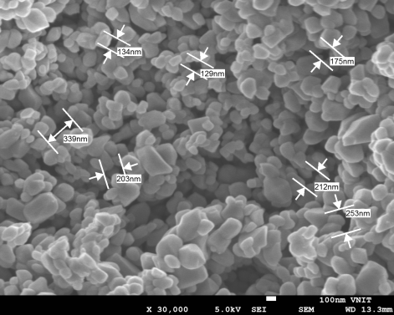
Figure 1: Sem Of Sandwich Membrane
Key words: antifouling , acid resistant

References
- Y. Dong, X. Feng, D. Dong, S. Wang, J. Yang, J. Gao, X. Liu, G. Meng, Elaboration
and chemical corrosion resistance of tubular macro-porous cordierite ceramic
membrane supports, J. Membr. Sci. 304 (1 –2) (2007) 65 –75.
- Osmonics,Nanofiltration—126acid waste ,http:// www.osmonics.com/products /Page233.htm, 1996

