On radially symmetric vibrations of functionally graded circular nanoplates using GDQR based on nonlocal elasticity theory
Chinika Dangi, RS PhD, Department of mathematics, Indian Institute of Technology Roorkee, Roorkee -247667, India,

Abstract (300 word limit)
In this paper, free axisymmetric vibrations of functionally graded thin circular nanoplates have been studied using Eringen’s nonlocal elasticity theory. The mechanical properties of the plate material vary according power law model. A simple computational formulation for the governing differential equation of motion for such a plate model has been derived using Hamilton's principle together with nonlocal theory for the clamped, simply supported and free plates at the periphery. Employing the generalized differential quadrature rule, the corresponding frequency equations have been obtained and solved numerally to retain their lowest three roots as the natural frequencies for the first three modes of vibration. The effect of various other parameters such as radius of the nanoplate, boundary conditions, material gradient index and nonlocal parameter on the vibration characteristics have been presented for two different functionally graded materials. In order to validate the accuracy and efficiency of the method, the results have been compared with those available in the literature.

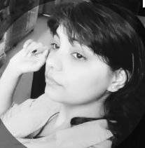
Biography
Chinika Dangi has her expertise in numerical techniques and improving the mechanical properties of materials which have constructive effect on mechanical systems.
Email:cdangi@ma.iitr.ac.in
Contact no: 9756609293

