Electric Discharge machining of metal matrix composites
BALWINDER SINGH, Deptt. Of Mechanical Engineering, CTIEMT Jalandhar, INDIA.

Abstract (300 word limit)
The present study manages an examination of the hybrid ED machining process conducted in a magnetic field for improving procedure execution. Past magnetic field-helped EDM systems, in any case, are restricted to use with a class of magnetic work piece. In this specific investigation, the magnetic field was combined with traditional EDM plasma zone to test hybrid process on Al-based Metal Matrix Composites. The machining parameters, for example, top current just as term of pulse-on were chosen to nail down their delayed consequences on the reaction parameters like Material Removal Rate (MRR) and the surface uprightness. The trial results demonstrate an improvement of 12.9% MRR and decrease in Recast layer development at higher flash vitality under the magnetic field condition. As the test result suggested that the magnetic power helped EDM bestowed apparent procedure steadiness, a profoundly proficient appropriate procedure of EDM with high caliber of machined surface could be practiced to fulfill present day mechanical applications.
Keywords- Metal, Matrix, Composites, non-conventional, machining, magnetic field

Image

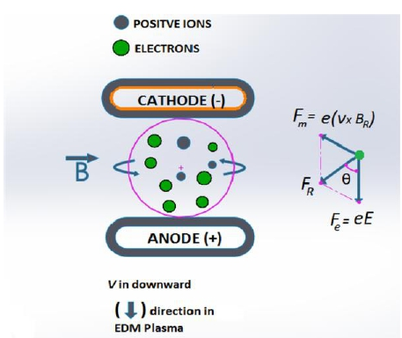

Figure 1. Schematic of tangential magnetic field and forces

Recent Publications (minimum 5)
- Sidhu, S S., Batish A, Kumar S (2015) Analysis of residual stresses in particulate reinforced aluminium matrix composite after EDM Materials Science and Technology : 1743284715Y-0000000033.
- Judal K B., and Vinod Yadava (2013) Cylindrical electrochemical magnetic abrasive machining of AISI-304 stainless steel." Materials and Manufacturing Processes28. 449-456.
- Kala, Prateek, and Pulak M. Pandey (2015) Comparison of finishing characteristics of two paramagnetic materials using double disc magnetic abrasive finishing. Journal of Manufacturing Processes 17: 63-77.
- Heinz K, Kapoor, SG, DeVor, RE, Surla V (2011) An investigation of magnetic field-assisted material removal in micro-EDM for nonmagnetic materials. Journal of Manufacturing Science and Engineering 133: 021002.
5. Patel K M, Pulak M, Pandey, Venkateswara Rao (2009) Determination of an optimum parametric combination using a surface roughness prediction model for EDM of Al2O3/SiCw/TiC ceramic composite. Materials and Manufacturing Processes 24 : 675-682.

Biography (150 word limit)
Balwinder Singh has his expertise in mechanical engineering in machining of composite materials. He has experience of more than 10 years in research,evaluation ,teaching and administration in education institutions. He has completed his PhD in Industrial Engineering and has published many research papers in international and national journals.
Email: bal.ctiemt@gmail.com

