Sol-gel synthesis of silane-Al₂O₃ nanocomposite superhydrophobic coatings

Mehdi Khodaei, PhD, Faculty of Materials Science and Engineering, K.N. Toosi University of Technology, Tehran, Iran.

Abstract (300 word limit)
Superhydrophobicity is attractive phenomenon in functional surfaces/coatings which leads to the additional properties such as self-cleaning, anti-corrosion, anti-bacterial, anti-fouling. Silanes based sol–gel coatings are the subject of extensive research nowadays. Such coatings have superior properties than conventional organic coating and are in the category of "green coatings". It has been well stablished that hierarchical structure in micro and nano scale on the surface as well as surface energy reduction plays an important role in prompting the superhydrophobic (water contact angle higher than 150) properties.
In this work, the combination of hierarchical structure synthesis and surface energy reduction have been done on silane-based coatings. The silane-based coating is selected as TEOS-GPTMS. The substrate is chemically etched aluminum which has micrometer surface roughness. The water contact angle (WCA) of TEOS-GPTMS coating on etched aluminum is about 96. In order to increase the WCA of coating two route have been done, which are the surface functionalization by a surface reduction agent (FAS17) and producing the nanoscale roughness in coating by adding the Al₂O₃ nanopowder into the coating. This two routs led to increase the WCA of the coating to 112 and 144, as shown in Fig.1. The last strategy was applying these two rout to the coating which increased the WCA of coating to 164 and produced the superhydrophobic coatings. The microstructural characterization has been performed by SEM and corrosion resistant of coatings has been examined.

Image

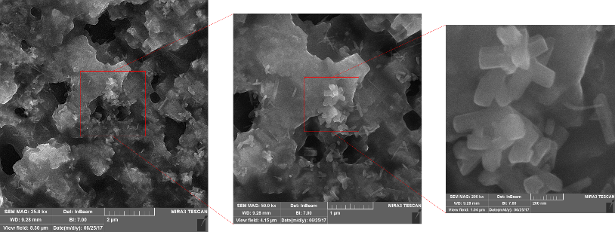
Recent Publications (minimum 5)
- P. Zhang and F. Lv, A review of the recent advances in superhydrophobic surfaces and the emerging energy-related applications, Energy, vol. 82, pp. 1068-1087, 2015.
- S. Liu, X. Liu, S. S. Latthe, L. Gao, S. An, S. S. Yoon, et al., Self-cleaning transparent superhydrophobic coatings through simple sol–gel processing of fluoroalkylsilane, Applied Surface Science, vol. 351, pp. 897-903, 2015.Harper C (2009) The neuropathology of alcohol-related braindamage. Alcohol Alcohol 44:136-140.
- J.-Y. Zhang, T. L. Smith, B. K. Endres and M. K. Debe, Superhydrophobic films, ed: Google Patents, 2015.
- J. Song, W. Xu, X. Liu, Y. Lu, Z. Wei and L. Wu, Ultrafast fabrication of rough structures required by superhydrophobic surfaces on Al substrates using an immersion method, Chemical engineering journal, vol. 211, pp. 143-152, 2012.
- D. Zhang, L. Wang, H. Qian and X. Li, Superhydrophobic surfaces for corrosion protection: a review of recent progresses and future directions, Journal of Coatings Technology and Research, vol. 13, pp. 11-29, 2016.

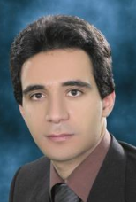Biography (150 word limit)
Mehdi Khodaei received his bachelor’s degree in 2005 and master’s degree in 2008 from the Department of Materials Engineering, Isfahan University of Technology, Iran. In 2014, he obtained his PhD degree from the University of Tehran, Iran in Nanotechnology-Materials Science. He was also a visiting researcher at Pohang University of Science and Technology (POSTECH), Korea, (March 2012–June 2013). His research area is in the field of Functional Nanocoatings, which is based on chemical, Sputtering deposition, pulsed laser deposition and suspension thermal Spray coatings. He is currently working as an assistant professor at Faculty of Materials Science and Engineering, K.N. Toosi University of Technology, Iran.
Email: khodaei@kntu.ac.ir

Notes/Comments:

