Developing of a 3D printing method to fabricate a bone replacement hydroxyapatite/polycaprolactone scaffolds
Sara Ahmadi PhD, National Elite Foundation, New Technologies Research Centre, Amirkabir University of Technology, Iran
Saeed Saber Samandari PhD, New Technologies Research Center, Amirkabir University of Technology, Iran

Abstract

Recently using 3D printing methods to fabricate all type of human organ has been considered. Among all of them, 3 D printed scaffolds to utilized as bone replacement implant have been investigated comprehensively. The advantage of this method is fabricating an implant with exact dimensions of the actual bone tissue. In addition, this method is faster than the conventional methods which surgeon used to apply to replace the injured or infected bone tissue.

First of all, polycaprolactone with different concentration of hydroxyapatite (0, 10%, 15% and 20%) were mixed completely. The HA/PCL composite was prepared with 40%, 50%, and 60% porosity. Then by using a spinneret, we transfer the HA/PCL composite to filament with a specific diameter (1.65-1.85 mm). We used these filaments to feed the 3D printer instrument. As a model, a femur bone of rabbit was used to design the scaffolds. The femur bone of rabbit was 3D scanned and transferred to a Simplify 3D software to prepare the 3D printing pattern. The open source 3D printer printed the HA/PCL filament exactly similar to the rabbit bone. The mechanical properties of the 3D printed scaffold was determined and compared to femur rabbit bone. In terms of 3D printed scaffold characterization, the yield strength, stress-strain, force, stiffness, compressive modulus, and surface morphology of them have been studied.
Image
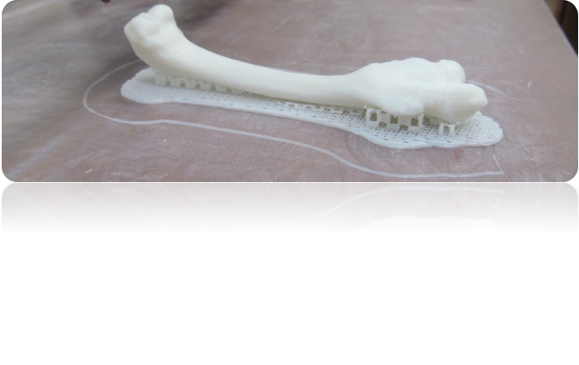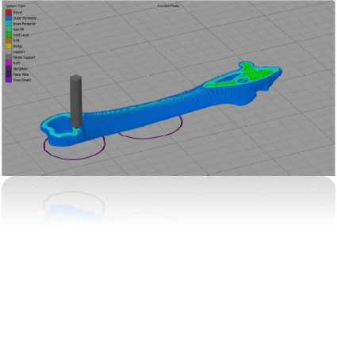
Figure1. 3D Simplify pattern and printed HA/PCL
Recent Publications
“Development and Validation of a Seizure Initiated Drug Delivery System for the Treatment of Epilepsy” Rikky Muller, Sara Ahmadi, Winston Ng, Zhilian Yue, Willo M. Grosse, Mark J. Cook, Gordon G.Wallace and Simon E. Moulton. “Sensors and Actuators Chemical :B”, 2016.
Investigating Drug Interaction with the Conducting Polymer Films using Quartz Crystal Microbalance” Sara Ahmadi, Paul J. Molino, Mark J. Cook, Gordon G. Wallace and Simon E. Moulton. “Sensors and Actuators Chemical :B”. 2017.
“Surface Modification of Synthetic and Natural Polymeric Materials"
Writer: Sara Ahmadi. September 2016.

.

Biography
Sara Ahmadi has her expertise in developing novel drug delivery systems for target and controlled drug release studies. She graduated with a PhD degree in December 2016 from University of Wollongong in Australia. The main focus of her research during PhD was using polymeric devices as drug carries for treating CNS disease. She won the National Elite Foundation Postdoctoral Fellowship of Iran in 2017. She started her postdoctoral research in 2017 in New Technologies Research Center of Amirkabir University of Technology. The basis of her postdoctoral research is developing novel composites aiming to on-demand delivery of NSAIDs drugs.
Email: s.ahmadi96@aut.ac.ir

Notes/Comments:

