Revifeel PLUS: Ceramic tiles with improved thermal comfort
Ana Sampaio, CeNTI, Portugal
Miguel Gonçalves, CeNTI, Portugal
Bruna Moura, CeNTI, Portugal
André Assembleia, CeNTI, Portugal
Carla Silva, CeNTI, Portugal
Miguel Ribeiro, CeNTI, Portugal
José Silva, CeNTI, Portugal
Hugo Costa, CeNTI, Portugal
Pedro S. Marcos, Revigrés, Portugal

Abstract (300 word limit)
Ceramic tiles are known for their intrinsic properties, such as high durability, water and chemical resistance and easy maintenance. However, for applications in warm residential areas (e.g. living rooms, bedrooms), or sun-exposed areas (e.g. areas surrounding pools), users generally choose materials with improved performance in terms of thermal comfort, such as wood tiles. Bearing in mind this limitation, CeNTI and Revigrés joined forces to improve the performance of ceramic tiles at the thermal comfort level, with the main objective of combining technical properties, design and comfort.
The work and developments carried out in the scope of Revifeel Plus project allowed to improve the ceramic tiles thermal comfort performance (temperature, sensation to the touch) suitable for flooring applications, namely for indoor (REVIFEEL WARMUP and REVIFEEL HEATSYSTEM) and outdoor applications (REVIFEEL COOLDOWN).
From the project developments, three distinct and complementary technological solutions were achieved:
• REVIFEEL WARMUP: ceramic floor tiles with an innovative surface treatment that reduces the sensation of cold to the touch in indoor residential applications;
• REVIFEEL COOLDOWN: ceramic tiles with IR-reflective properties resulting from the direct additivation of ceramic raw materials during the tiles production; this technological solution aims to eliminate the sensation of excessive heat given off by ceramic surfaces due to exposure to solar radiation;
• REVIFEEL HEATSYSTEM: ceramic tiles with an integrated heating system, a solution that is highly efficient, easy to install and maintain.

Image
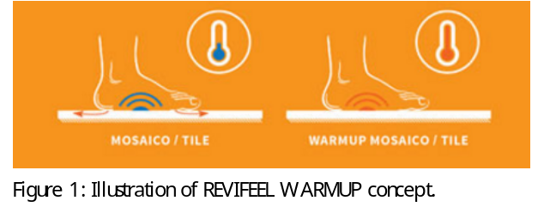
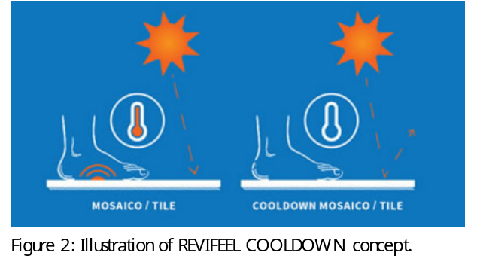
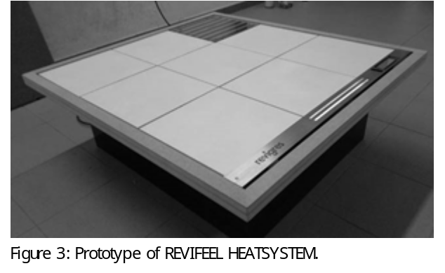
Recent Publications (minimum 5)
- A. Sampaio, J. Sousa, J. Branquinho, M. Gonçalves, A. Montes, D. Coelho, “Ceramic materials with improved thermal comfort”, poster, 6th Workshop on Green Chemistry and Nanotechnologies in Polymer Chemistry, Bragança (Portugal), 2015
- R. M. Novais, M.P. Seabra, J.A. Labrincha, “Ceramic tiles with controlled porosity and low thermal conductivity by using pore-forming agents”, Ceramics International, Volume 40, Issue 8, Part A, September 2014, Pages 11637–11648
- C. Ferraria et. al, “A composite cool colored tile for sloped roofs with high ‘equivalent’ solar reflectance”, Energy and Buildings, Volume 114, 15 February 2016, Pages 221–226
- US8461486, “Heating tile and heated floor using the same”, Liu, C. Feng e L.(2013)
- A. Sampaio, M. Gonçalves, B. Moura, M. Ribeiro, J. Silva, H. Costa, P. S. Marcos; “Revifeel PLUS: Ceramic tiles with improved thermal Comfort”, CINCOS'16 – Proceedings, November 2016

Biography (150 word limit)
Ana Sampaio holds a Master in Chemical Engineering from Faculdade de Engenharia da Universidade do Porto (FEUP). Currently, she is working as researcher of the Polymers Team in the main area of Functional Materials and Solutions at CeNTI. Her work has focused on the research and development of new functional materials (thermal management and thermal comfort; liquid and stain repellence; cleanability; waterproof, breathability and moisture management; scratch and abrasion resistance; anti-UV and IR-reflective properties; among others) for application in different areas and industries. She has skills and expertise in development of surface treatments, polymeric composites and multilayer structures, as well as in several coating technologies, including ultrasonic deposition and UV-curing.

Email: asampaio@centi.pt

Notes/Comments:

