


Development of composite bioresorbable stents: computational and experimental investigation
Fan Zhao¹, Fujun Wang¹, Lu Wang^{1,}*

- Key Laboratory of Textile Science and Technology of Ministry of Education, College of Textiles, Donghua University, Shanghai, China.

Abstract:

Stents are vital devices to treat vascular stenosis in pediatric patients with congenital heart disease. Bioresorbable stents (BRSs) have been applied to reduce challenging complications caused by permanent metal stents. However, it remains almost a total lack of BRSs with satisfied compression performance specifically for children with congenital heart disease, leading to importantly suboptimal effects. In this work, Composite bioresorbable stents with poly(p-dioxanone) (PPDO) monofilaments and poly(p-dioxanone)/polycaprolactone (PPDO/PCL) composite braided yarns (cBYs) were fabricated on a 32 bobbin braiding machine (Fig. 1(a)) with different feed yarn ratios (7:1 for cBRS type A, 3:1 for cBRS type B, and 32:0 for PPDO prototype). Then they were thermally treated in air at 90 $℃$ for an hour to stabilize the structure and soften the cBYs to composite melted yarns (cMYs). The compression properties of cBRSs were evaluated using a parallel compression tester (Fig. 1(b)). The stent stress distribution and deformation mechanism were also analyzed by finite element analysis (Fig. 1(c)).
Two restriction force, the friction force between yarns, and the peeling force (PF) among bonded cMYs existed in the cBRSs. The friction resistances were all less than 100 mN in the prototypes. However, the peeling force (PF) of the bonded yarns was as high as 2126.67 ± 133.14 mN, which restricted yarn movement greatly (Fig. 2). The compression force was promoted dramatically for the novel composite prototype stents by 124.06 % in cBRS-A and 169.58 % in cBRS-B prototype, compared with that in the control (572.60 ± 27.98 mN/cm). Stability of the composite self-expanding prototypes to resist deformation was also higher than that in the control prototype. Specifically, the values were 89.89 ± 1.76 %, 93.09 ± 1.78 % and 94.05 ± 1.60 % for the control group, cBRS type A, and cBRS type B, respectively (Fig. 3(b)). Von Mise stress distribution when prototypes compressed to 50 % of their origin diameters were shown in Fig. 4. Higher stresses existed in cMYs for cBRSs. And with the increase of bonding points, stress difference between cMYs and PPDO increased, as shown in cBRS type B. Moreover, bonded yarns bent greatly and braiding angles kept unaltered in cBRSs, resulted in higher Von Mises stress concentrated near the bonding points compared with PPDO prototype (Fig. 5). Hence, the cBRSs mechanically reinforced skeletons were formed by the connected and bonded cMYs, and the stability to resist external load increased with the number of composite yarns.
The results of this study may inspire future development of bioresorbable polymeric stents and open new prospects for the use of composite design in medical devices.

Keywords: composite bioresorbable stent; reinforced compression performance; congenital heart disease; computational simulation

Images/Graphs/Tables:
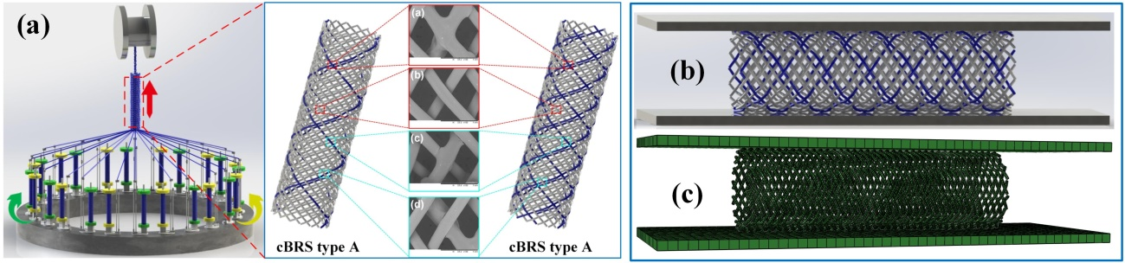
Fig. 1 (a) Schematic diagram and morphology of cBRSs; (b) Parallel compression measurement; (c) Finite element simulation

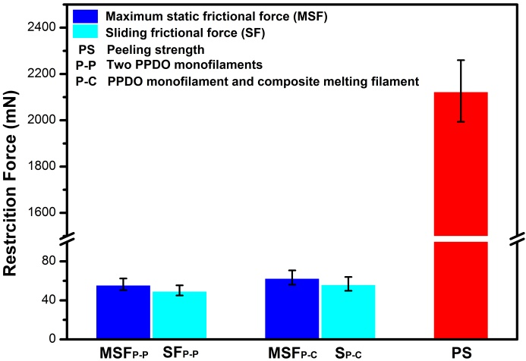
Fig. 2. Restriction force existed in the cBRS type A and type B

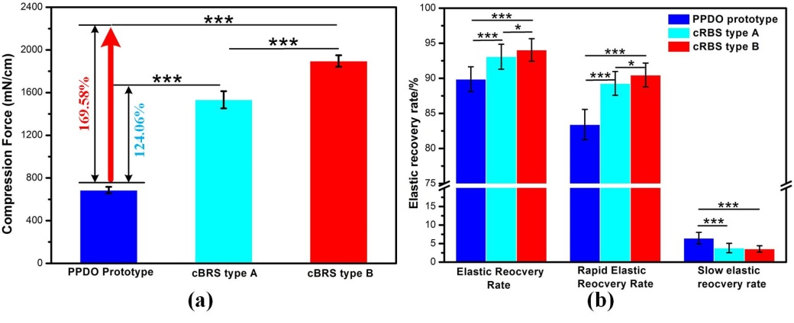
Fig. 3 Compression force and elastic recovery rate of different prototypes: (a) Compression force of different types of prototype stents when compressed to 50% of origin outer diameters; (b) Elastic recovery rates of different types of prototypes

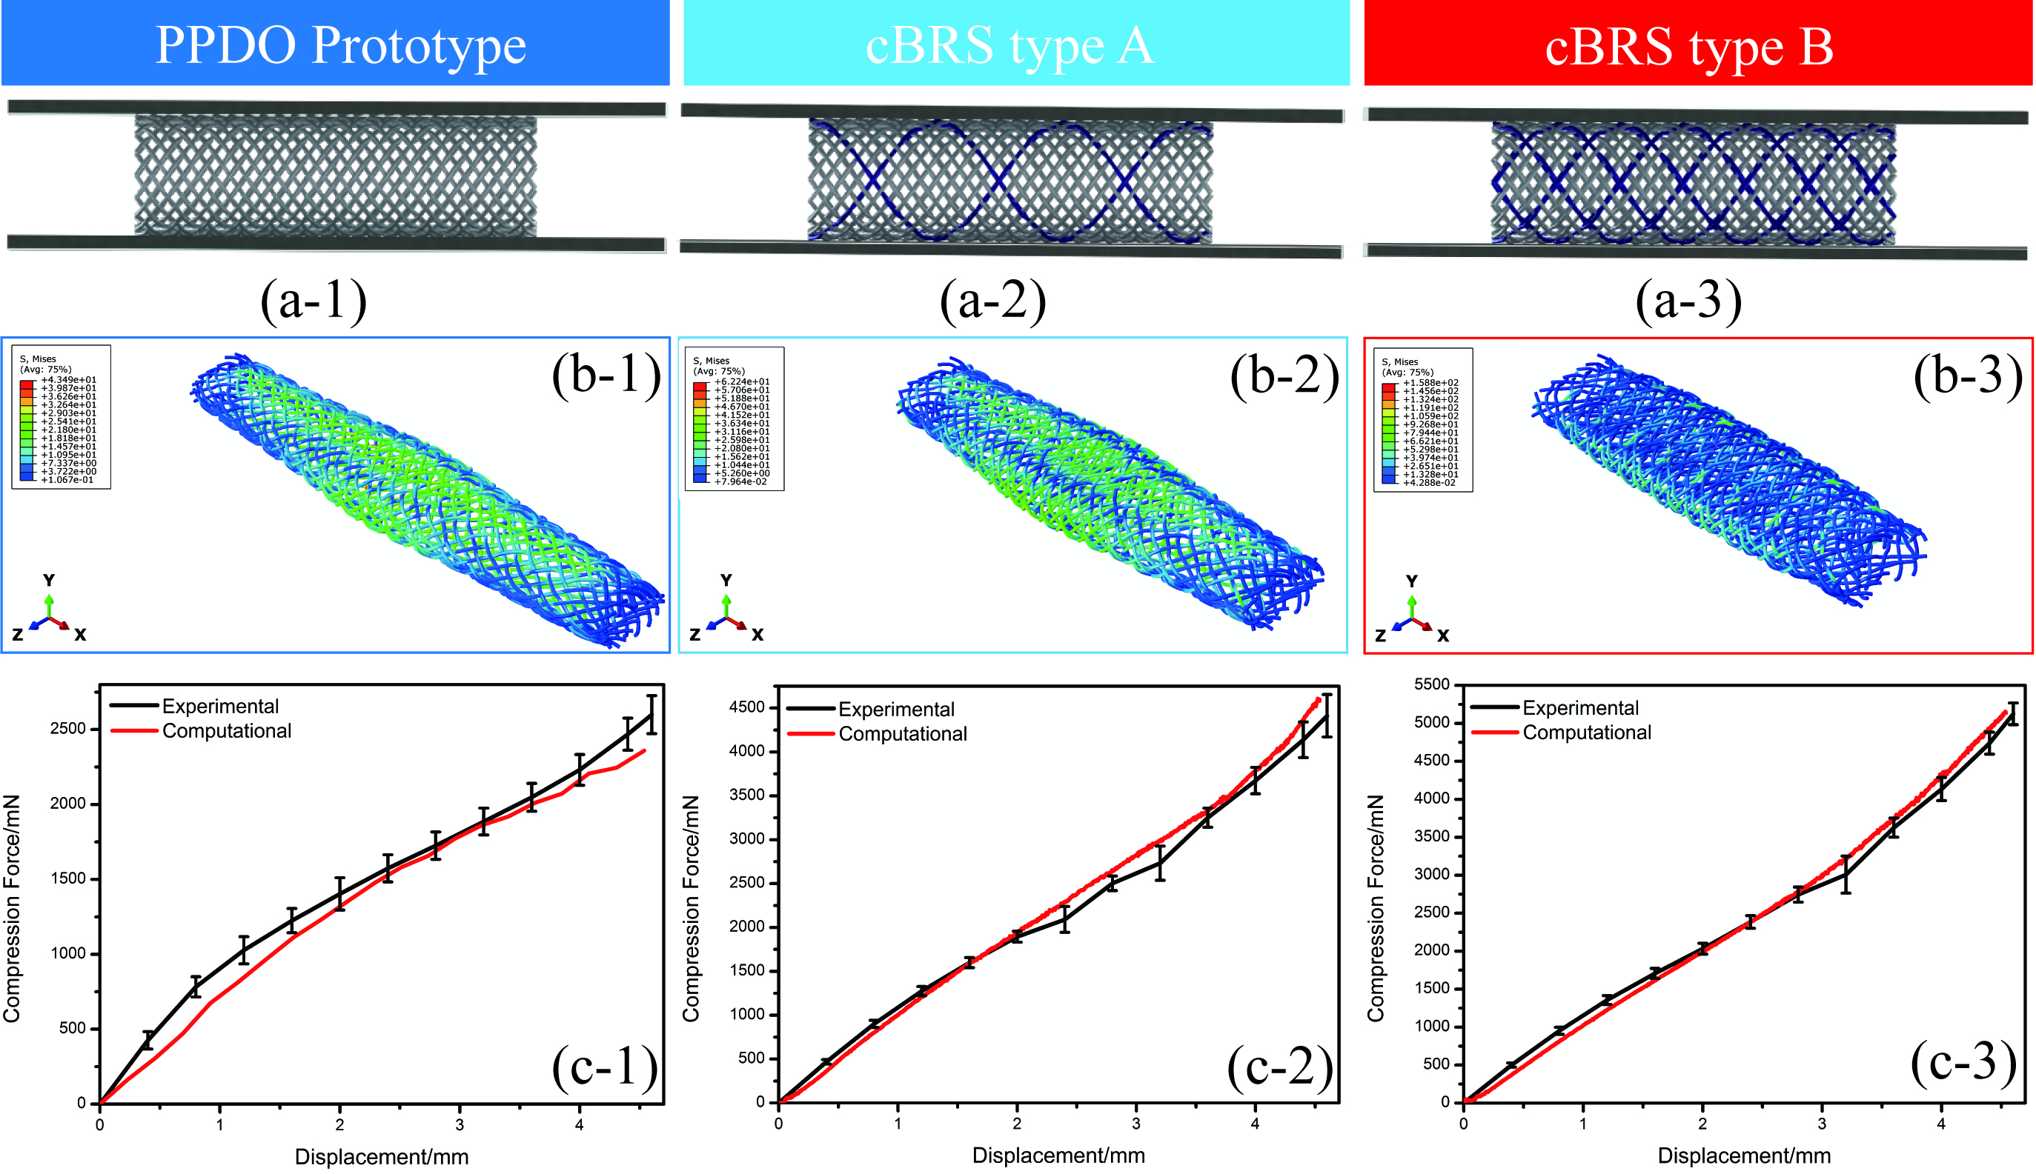
Fig. 4. Finite element analysis of three types of prototype stents. (a) Three prototype models and two parallel plates were constructed to simulate compression process; (b) Distribution of Von Mise stress in three types of prototype stents after comprssed to 50% of their origin diameters; (c) Computational and experimental compression force versus displacement curves

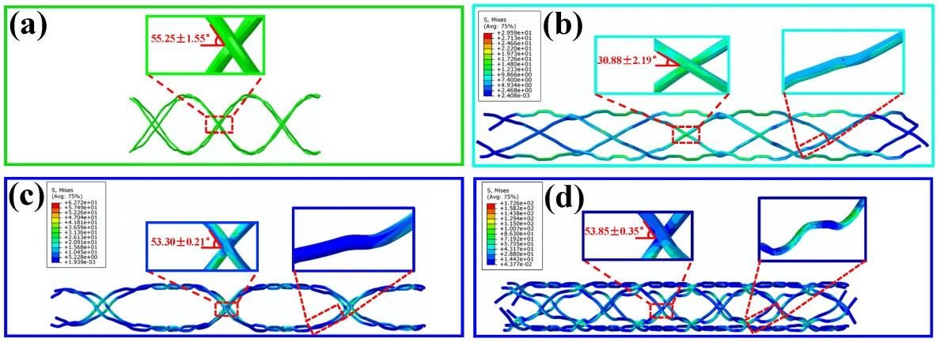
Fig. 5 The behavior of braiding angle in bonding points and the yarn morphology between interlacing points. (a) the simulation of partial yarns of cBRSs and control prototypes before compression; (b) the simulation of control group after compression to 50% of its original diameter; (c) the simulation of cMYs of cBRS type A after compression to 50% of its original diameter; (d) the simulation of cMYs of cBRS type B after compression to 50% of its original diameter

Recent Publications:

A new approach to improve the local compressive properties of PPDO self-expandable stent
F. Zhao, W. Xue, F. Wang, Ch. Y, H. Xu, Y. Hao and L. Wang

Composite self-expanding bioresorbable prototype stents with reinforced compression performance for congenital heart disease application: computational and experimental investigation
F. Zhao, W. Xue, F. Wang, L. Liu, H. Shi and L. Wang

The research progress of fiber based tissue-engineering heart valve
F. Zhao, F. Wang, Y. Mao, L. Wang

- Modeling of Braiding Parameter Impact on Pore Size and Porosity in a Tubular Braiding Fabric
C. Li, X. Wang, F. Zhao, F Wang, Z. Ting, L. Wang

- Experimental and analytical evaluation on the mass transfer performance of braided stent-grafts
W. Xue, L. Gao, X. Fang, F. Zhao, J. Gao, G. Guan, J. Lin, F. Wang and L. Wang

- Design and fabrication of a composite bioresorbable tubular stent. Chinese patent.
F. Wang, F. Zhao, X. Wen, L. Wang

- A technique and its method for fabricating textile based biodegradable reinforced stents. Chinese patent.
F. Wang, F. Zhao, L. Wang

- A method for fabricating eight types of instruction in warp knitting machine of cylinder type. Chinese patent.
L. Wang, F. Zhao, W. Wang, F. Wang, J. Lin, L. Wang

- A technique and its method for fabricating triple-layer composite small-diameter artificial vessel. Chinese patent.
F. Wang, F. Zhao, L. Wang, W. Wang

Biography:
Fan Zhao is a Ph.D student in Donghua University and a visiting Ph.D student in the North Carolina State University. He got the bachelor degree from Dalian Polytechnic University in the textile engineering. And he will obtain his doctor degree next year on the biomedical engineering. During his Ph.D project, he fabricated and evaluated novel composite polymeric bioresorbable stents. He designed and fabricated two types of bioresorbable stents by using a semi-crystallized polymer and optimizing braiding technology to reinforce their mechanical properties. Experimental (physical, mechanical, degradation properties) and numerical investigations of stents were conducted. The biological evaluation is also undergoing, including cell proliferation and animal experiment. His research interests are mainly on the functionalization and design of biomaterials, biointerface science, biomolecular, tissue engineering and targeted drug delivery. He has published more than 11 papers in reputed journals and applied 5 patents. He plans to continue his post-doc study in USA on biomaterials next year.
Presenting author details
Full name (As per the passport): Fan Zhao
University/Industry/Organization name (Present working): Donghua University
Designation(Director/Prof/Assistant or Associate prof/Researcher/ Scientist /PhD Student): PhD Student
Country: China
Mobile number (country code – number) : 1-5713759324
Official Email ID: zhaofan_dhu@163.com
Presentation type (Oral/Poster): Oral
Category (Invited talk/Young researcher Invited talk/E-poster):
Track number (This is very important to schedule your talk): Follow this link - http://optics.conferenceseries.com/call-for-abstracts.php –
Research interest: biomaterial
Your profile page URL in your department: no
Year of birth: 06/02/1992
Linked In/Facebook/twitter account: zhaofan_dhu@163.com
Postal address: 4396 OKEMOS RD, APT E115, OKEMOS, MICHIGAN, USA.

