Innovations in regenerative medicine that improve the results of stem cell treatment: 3D cultivation, in vivo modeling of stem cell niche, and prenatal stem cells exosomes
Abhijit Bopardikar MD, Oleksandr Kukharchuk Prof., Anand Baskaran Padma Priya MS, Andrii Kukharchuk MD, Rohit Kulkarni MD, Sunil Pophale, ReeLabs, India

Statement of the Problem: Hair loss are currently being addressed by hair follicle transplantation. However, for large areas of alopecia, the patient does not have enough hair for auto-transplantation. Proliferation and differentiation of stem cells (SCs) requires a specific microenvironment – “stem cells niche”. For in vivo modulation of organ-specific niches during SCs transplantation could be useful fetal tissue extracts (FTEs). Exosomes are small vesicles that are secreted by various cell types, including SCs. Exosomes can be carried to distant sites via biological fluids and may therefore induce the phenotypic modifications in recipient cells. Methodology & Theoretical Orientation: Multiplying SCs of hair follicles in 2D culture and introduce them into the scalp skin to form de novo hair follicles were unsuccessful. We developed a technology for creating new hair follicles from SCs in 3D cultures. Also we investigated the content of growth factors in FTEs; and studied the efficacy of FTEs in patients who did not respond to SCs treatment. Finally, we created rejuvenation program, which includes SCs transplantation and exosomes of SCs administration. Findings: the SCs were transferred to a 3D culture where the formation of primary hair follicles suitable for transplantation occurred under the influence of a specific combination of growth factors. We showed high efficacy of using FTEs for modeling the SCs niche in treatment of liver cirrhosis and non-healing wound in patients who did not have positive response to previous SCs treatment. Transplantation of prenatal hepatoblasts, hematopoietic SCs, and fetal liver extracts administration showed efficacy in 75% of liver cirrhosis cases that was characterized by significant decrease of liver fibroscan density, decrease of portal hypertension and ascites, decrease or normalization of biochemical markers of liver damage. In patients with chronic non-healing wounds administration of FTEs activated the wound epithelialization with complete healing. Patients GAIS results after rejuvenation program: optimal cosmetic results – 78.9%; significant improvement but not complete correction – 9.7%; improvement, but required additional correction – 11.3%. The program significantly reduces the biological age, and Frailty Index that evidences about the decrease in risk of aging disease appearance. Conclusion & Significance: 3D cultivation, in vivo modeling of SCs niche and prenatal SCs exosomes can significantly improve results of the use of SCs in regenerative medicine.

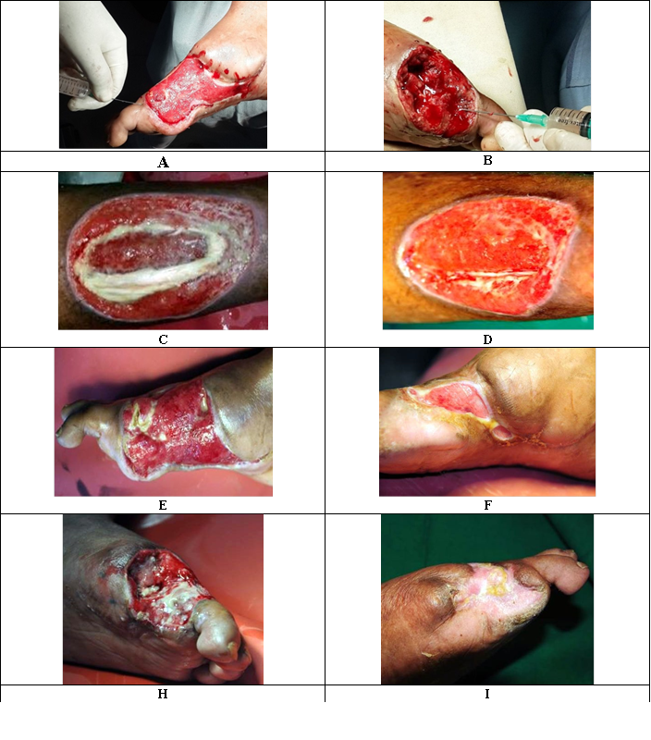
Dynamics of wound healing in patients with chronic critical limb ischemia after the stem cell niche modeling
A: The patient B., diabetes mellitus, diabetic foot; after 3 months post administration of stem cells, fetal skin tissue extract was administered in the periphery of wounds for modeling niche; B: The patient C., thromboangiitis obliterans; after 3 months post administration of cells, extract of fetal liver was administered into the bed of wounds for modeling niche; E: Patient B., diabetes mellitus, diabetic foot; after stem cells treatment; necrotized tissues observed; canal filled with pus; F: Patient B., 7th day after second fetal liver and fetal skin tissue extracts administrations; intensification and accelerating epithelialization of wound; H: Patient C., thromboangiitis obliterans (Berger's disease); after stem cells treatment; I: Patient C., 15th day after last fetal liver and fetal skin tissue extracts administrations; complete healing of the wound.
Recent Publications)
- Bhattacharya B, Stubblefield Ph. Human Fetal Tissue Transplantation, Springer-Verlag London, 2013.
- Dame C, Fahnenstich H, Freitag P, Hofmann D, Abdul-Nour T, Bartmann P, Fandrey J (1998) Erythropoietin mRNA Expression in Human Fetal and Neonatal Tissue Blood, Vol 92, No 9 (November 1), 1998: pp 3218-3225
- Kukharchuk O, Padma Priya AB, Kukharchuk A, Kulkarni R, Bopardikar A, Pophale S (2017) Modelling of organ-specific niches in regenerative medicine. BIT’s 11th Annual World Congress of Regenerative Medicine & Stem Cells-2017. Conference Abstract Book, Singapore, 2017: 077.
- Rebecca L (2017) Fetal Membranes in Regenerative Medicine: New Tricks from an Old Dog? Stem Cells Translational Medicine 6: 1767–1776.
- Shea M, Addison A, Taylor N, Sebire S (2012) High quality genomic DNA extraction from postmortem fetal tissue. July 2012 doi: 10.3109/14767058.2012.704442

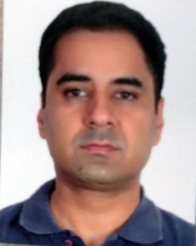
Abhijit Bopardikar, MD, Promoter and Founder Director of ReeLabs Pvt. Ltd, Mumbai and Vadivarhe; Speciality Chemicals Ltd. (V.S.C.L.), Vadivarhe, Nasik, since February 2009. ReeLabs has exclusive, sophisticated, state-of- the- art technology of collecting, processing and storing stem cells from all possible human sources, outstanding R&D to further the industry and unparalleled experience of treating over 10000 cases with their proprietary therapy protocols. ReeLabs is further involved in wide range of exceptional nutraceutical products through their ‘functional foods’ division (ReeVeda) targeting several disorders naturally without side effects and niche, never-seen-before baby products through their sister concern (ReeBaby).

Email: asb@reelabs.com

