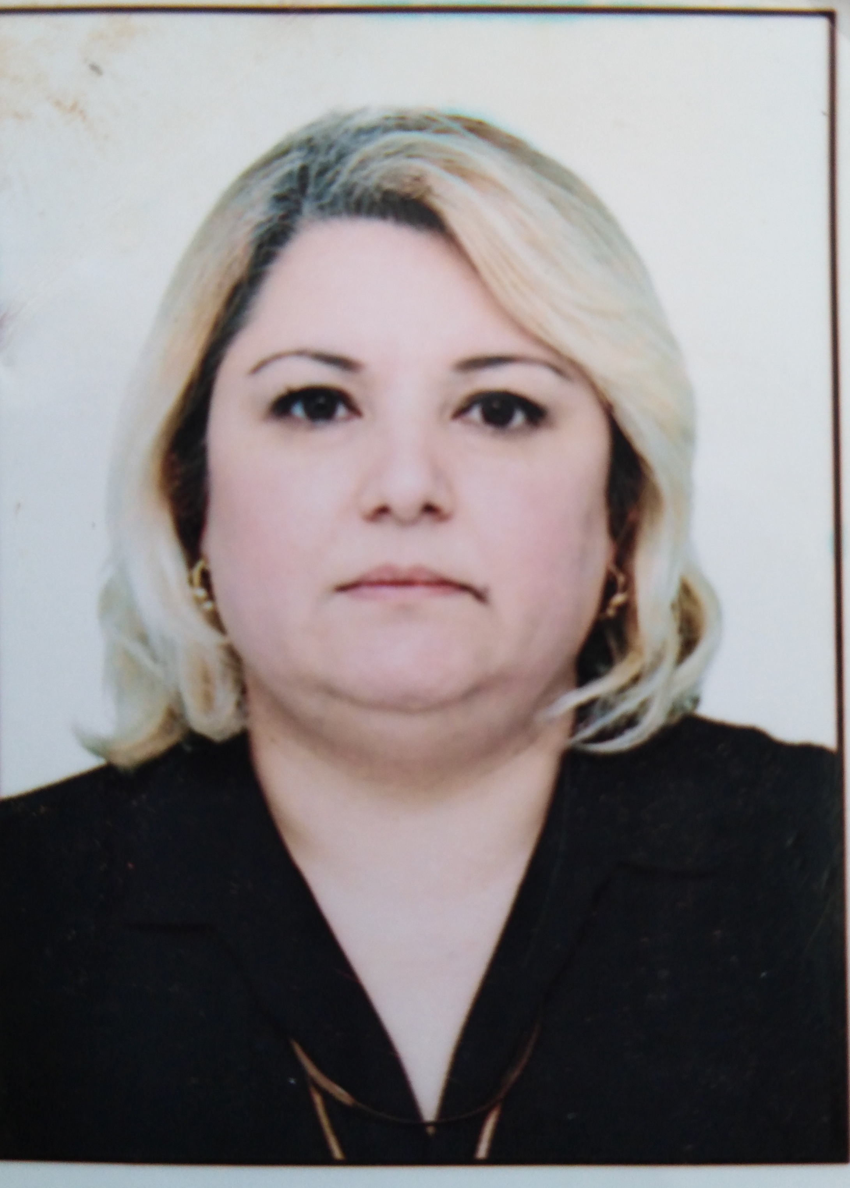
Title: Studying Wx genes of local wheat varieties for further selection
Gulshen Huseyn Poladova, Ph.Doctor of Aqrarian Sciences
Genetic Resources Institute of the Azerbaijan National Academy of Sciences
e-mail: shenova1@yahoo.com

With increasing population growth humanity is forced to increase agricultural production, the basis of which is grain farming. All this makes us relate to the identification of directions increase the sustainability and efficiency of grain production.
The molecular genetic characteristics of the collections of soft and hard wheat varieties of domestic selection for the genes responsible for the synthesis of amylose are carried out. Based on the results, it is possible to create a set of common wheat lines with different allelic composition of Wx genes.
A comparative analysis of the quality indices of local varieties was carried out to determine the influence of these genes on the baking quality indices of local varieties.
The analysis material was 36 local varieties of soft and durum wheat and spelled.
According to the analysis of 14 samples of durum wheat, Wx-B1 - Wx-B1e genes (amplification by the type of e-allele) were found in four samples. Samples, “Qarabağ” and “Shiraslan 23” are heterogeneous, there are found with “e” and “ a "alleles for Wx-B1. in durum wheat no amplification of Wx-D1 on all markers.
In soft wheat samples “Əkinçi 84” and “Gönən”, using molecular markers, the putative “b” allele for Wx-B1 - Wx-B1b (zero-allele) was revealed. Samples “Pervin" and "Shаfəq 2" carry the "e" allele in Wx-B1 - Wx-B1e (amplification by the type of e-allele). Tetraploid wheat (“Pərinc”) lacks Wx-D1 amplification on all markers.
The remaining samples - for all genes, the allele "a" - wild type.

Biograph
Gulshen Huseyn Poladova has completed my PhD at the age of 44 years from Agricultural Research Institute, Ministry of Agriculture of Azerbaijan and postdoctoral studies from Genetic Resources Institute of the Azerbaijan National Academy of Sciences. I am is the Senior Researcher, Technology Department, in Genetic Resources Institute. At the moment, I have about 20 publications in our journals.

Presenting author details
Full name: Gulshen Huseyn Poladova
Contact number: +994 50 6888807
Twitter account:
Linked In account:Gulshen Poladova
Session name/ number:12
Category: ( Poster presentation)

