Endothelial factors in the cancer stem-cell maintenance in high grade brain tumors
Julie Gavard, PhD, CRCINA, Team SOAP, INSERM, CNRS, Universite de Nantes, Nantes, France

Abstract (300 word limit)

Glioblastoma are one of the most lethal forms of adult cancer with a median survival of around 15 months. A new strategy suggests targeting the glioblastoma stem-like cell population (GSC). These GSCs constitute a self-autonomous reservoir of malignant cells able to initiate, maintain, and repopulate the tumor mass. In situ, GSCs reside within the vascular niche in tight interaction with brain endothelial cells. Interestingly, this vital dialogue might be required upon tumor regeneration following treatment and could also be maintained outside the niche upon colonization of brain tissues at early stage of tumor formation.

These so-called glioblastoma stem-like cells retain the ability to expand ex vivo as tumorspheres and recapitulate tumor ontogenesis in mice, whilst they sustain radio- and chemo-resistance. Although their identity and fate are regulated by external cues emanating from endothelial cells, the nature of such angiocrine signals is still unknown. Here, we deployed a mass spectrometry proteomic approach to characterize the factors released by brain endothelial cells.

We report the identification of the vasoactive peptide apelin as a central regulator for endothelial-mediated self-renewal of patient-derived glioblastoma stem-like cells. Genetic and pharmacological targeting of apelin cognate receptor APLNR abrogates apelin- and endothelial-mediated pro-self-renewal effects on glioblastoma stem-like cells and suppresses tumor initiation and growth. Functionally, selective competitive antagonists of APLNR were shown to be safe and effective in lengthening the survival of intracranially xenografted mice. Therefore, the APLN/APLNR signaling nexus may operate as a paracrine signal that sustains tumor cell expansion and progression, suggesting that apelin is a druggable factor in glioblastoma.

We anticipate that our results will increase our knowledge on signaling mechanisms involved in tumor initiation, progression and resistance, and could help the design of new strategies to face this devastating human cancer.

Image
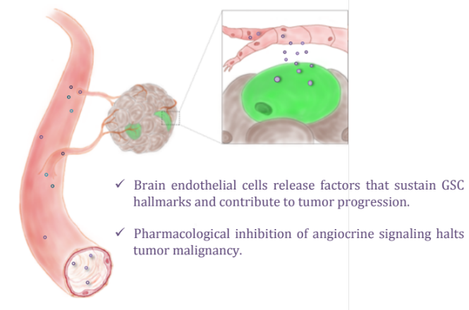
Recent publications (minimum 5)
- Jacobs KA et al. Neutralizing gp130 interferes with endothelial-mediated effects on glioblastoma stem-like cells. Cell Death Diff. 2017; 24:384
- Harford-Wright E et al. β-escin selectively targets the glioblastoma-initiating cell population and reduces cell viability. Oncotarget. 2016; 7:66865-79
- Treps L et al. Extracellular vesicle-transported Semaphorin3A promotes vascular permeability in glioblastoma. Oncogene. 2016; 35:2615-23
- Le Guelte A et al. Semaphorin 3A elevates endothelial cell permeability through PP2A inactivation. J Cell Sci. 2012; 125:4137-46
- Galan-Moya EM et al. Secreted factors from brain endothelial cells maintain glioblastoma stem-like cell expansion through the mTOR pathway. EMBO Rep. 2011; 12:470-6


Biography (150 word limit)
Dr Gavard received her Ph.D. from University Paris VI in 2004, graduating Cum Laude in Cell Biology and Development. She joined Dr Silvio Gutkind’s laboratory at NIH, USA, where she demonstrated that vascular permeability increase involved the endocytosis of the cell-cell adhesion molecule VE-cadherin. Her pioneer work was awarded by the NIH (Fellow Award for Research Excellence, 2007) and received the cover picture of Nature Cell Biology and Developmental Cell. In 2008, she was appointed permanent researcher at CNRS to join the Institute Cochin, Paris and was granted with a Marie Curie reintegration award. She rapidly established an independent team, focusing her research on the signaling mechanisms involved in non-oncogene addiction and loss of vascular homeostasis. She is currently leading a team in the Research Cancer & Immunology Center in Nantes-Angers. In 2012, Dr Gavard was given the honorary Bronze Medal from CNRS.
Email: julie.gavard@inserm.Fr

Notes/Comments:

