Automatic control of physiological state for future clinical treatment

- Necessity of mathematical models -
Tomohiko Utsuki, Ph.D, Tokai University, Japan

Abstract (300 word limit)
In operating room, emergency room and intensive care unit, medical staff have so heavy burden that they can't sometimes have enough time and attention for clinical treatment. Especially, many routine tasks, which demand advanced knowledge and skills to medical staff, are required for the management of physiological state pertinent to life-support. Thus, it is very useful to develop and apply automatic control systems of physiological state for alleviating such burden in clinical treatment. Actually, a few of systems have been developed and attempted to apply to patients in clinical treatment, such as automatic control systems of blood-sugar level, hemoglobin oxygen saturation in artery, and concentration of carbon dioxide in alveoli. Notably, an automatic control system of brain temperature was developed and clinical applied.
The designing and development of such system usually require a model of relevant physiological state as the controlled object in the simulation test of the system or as the element added in the system's controller, because heuristic system designing based on experiments on animals is not allowed ethically. On the stage of basic development, even if a system is designed by a method without using model, such as “Fictitious Reference Iterative Tuning”, a model of physiological state is necessary for verification of the system by simulation.
In this presentation, various automatic control systems of physiological state are presented including each model used in the development. Moreover, a model of cerebral blood circulation and extracellular fluid migration in cerebral tissue are explained, which are constructed as the elements of the integrative model of brain’s physiological state. This integrative model is required for developing an integrated control system, by which intracranial pressure, cerebral blood flow and brain temperature will be automatically controlled in consideration of the mutual effects for advanced brain resuscitation.

Image
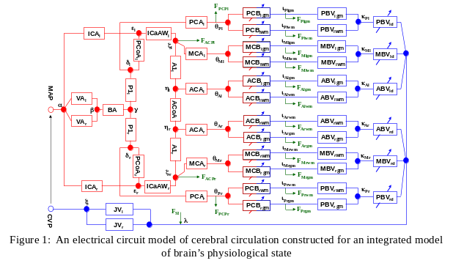
Recent Publications (minimum 5)
- Utsuki T (2017) A model of cerebral blood circulation for future automatic control of brain state. Proc the IASTED Int Conf Modelling Identification Control 158-165.
- Utsuki T (2015) Automatic Control of Brain Temperature by Surface Cooling. Advances in Medicine and Biology 93. Nova Science Publishers, Inc, New York, pp.31-57.
- Utsuki T (2015) Development of a cerebral circulation model for the automatic control of brain physiology. Proc 37th Ann Int Conf IEEE Eng Med Biol Soc 1890-1893.
- Utsuki T, Wakamatsu H (2014) Development of Automatic Brain Temperature Controller Based on Conditions of Clinical Use. Electronics and Communications in Japan 97(4):19-29.
- Wakamatsu H, Utsuki T, Mitaka C, Ohno K (2010) Clinical system engineering of long-term automatic thermal control during brain hypothermia under changing conditions. Technology and Health Care 18(3):181-201.

Biography (150 word limit)
In 2006, Dr. Tomohiko Utsuki obtained his Ph.D in Health Science from Tokyo Medical and Dental University in Japan. He is currently an associate professor of biomedical engineering at Tokai University in Japan.
His main research is “automatic control of physiological state for future medical treatment”, especially he developed an automatic control system of brain temperature and actually applied it to patients for clinical hypothermia in the intensive care unit of Tokyo Medical and Dental University, Medical Hospital. Currently, he I constructing models of cerebral blood flow, intracranial pressure and brain temperature in consideration of them distribution, in brain tissue in order to develop an automatic integrated control system of brain's physiological state for more advanced brain resuscitation treatment.
Email: tom.utsuki@tolai-u.jp

Notes/Comments:

