جامعة النيلين
كلية علوم البصريات
دور الموجات فوق الصوتية للعين في التشخيص قبل عملية الساد
رغده فيصل عبد الفتاح متولي - طالب مسجل لنيل درجة الدكتوراة
الخلاصة
الهدف
تهدف الدراسة الى ابراز أهمية الموجات فوق الصوتية للعين في التشخيص قيل عملية الساد.
الطرق
تم اجراء دراسة اكلينيكية مقطعية بقسم التصوير الطبي بمستشفى العيون الجامعي بجامعة النيلين على 220 مريض مسن (50-90 سنة) مصاب بمرض الساد الشيخوخي، في الفترة بين يناير الى مايو 2016.

حيث تم اجراء كشف الموجات فوق الصوتية للعين قبل العملية بعد أخذ تاريخ المريض واجراء الكشوفات الأولية مثل كشف الاجزاء الخارجية للعين وقياس حدة البصر. حيث تم استبعاد الأشخاص الذين تم تشخيصهم من قبل بأمراض في العين والذين لديهم تاريخ مرضي، عملية جراحية سابقة أو ضربة في العين.

تم استخدام جهاز الموجات فوق الصوتين (نيديك) بالاتصال المباشر بالعين وهي مغلقة بعد استخدام الجل. تم أخد صور أفقية ورأسية ومائلة بشدة عالية (90- 80 dB) وشدة متوسطة من الموجات (60-70 dB).
النتائج
من 220 مريض بالساد الشيخوخي، أكثر من 57% لديهم أمراض في الجزء الخلفب من العين. 22.73% لديهم ترسبات كالسيوم في السائل الزجاجي للعين، 10% لديهم نزيف في السائل الزجاجي، 7.27% لديهم بروز خلفي في العين، و6.36% لديهم انفصال خلفي في السائل الزجاجي للعين. كذلك انفصال الشبكية وتمزق الشيكية أعطت نتائج متساوية (4.55%) بينما ورم الجسم الهدبي يمثل 1.82%.
الخلاصة
أوضحت الدراسة بأن الموجات فوق الصوتية للعين مهمة للكشف عن أمراض الجزء الخلفي من العين ومن الأفضل أن تكون ككشف دوري قبل عملية الساد لأن ذلك يساعد في التخطيط السليم للعملية، القياس الصحيح للعدسة التي سوف تزرع في العين ويعطي خلفية عن حدة البصر بعد العملية.

الكلمات المفتاحية: الموجات فوق الصوتية للعين، الساد الشيخوخي، أمراض الجزء الخلفي من العين.

Alneelain University
Faculty of Optometry and Visual Sciences
Role of Ophthalmic Ultrasonography in Investigation before Cataract Surgery
Raghda Faisal Abdelfatah Mutwaly; PhD candidate
Abstract
AIM
The study aimed to demonstrate the importance of B-scan ultrasonography as diagnostic and prognostic method before cataract surgery.
METHODS
A cross-sectional prospective study was conducted in the department of medical photography at Alneelain University Eye Hospital, Khartoum, Sudan in 220 eyes of 220 old patients (50 – 90 years) with senile cataract in period from January to May 2016.
Diagnostic B-scan ultrasound where performed before cataract surgery after taking history and doing basic eye examination techniques, like slit lamp examination and visual acuity test. Patients of diagnosed posterior segment lesions were excluded and those who had previous history of ocular surgery or trauma were excluded.
A Nidek Echo Scan Model US-4000 with a probe of direct contact to closed eye was used after application of the gel. Then anterio-posterior, longitudinal and transverse views of B-scan along with A-scan were taken. High gain (80 to 90dB) and medium gain (60 to 70dB) sensitivity were used. However, dynamic B-scan was used to enhance differential diagnosis in such cases.
RESULTS
Out of 220 patients with senile cataract, more than 57% of patients had posterior segment lesions. 22.73% had asteroid hyalosis, 10% had vitreous hemorrhage, 7.27% had posterior staphyloma, and 6.36% had posterior vitreous detachment. However, retinal detachment and retinochaisis showed equal result of 4.55%, while ciliary body tumor was 1.82%.
CONCLUSION
The study revealed that ophthalmic ultrasonography is essential for the detection of hidden posterior segment lesions and likely to be performed routinely before cataract surgery. This would help in surgical planning, correct measurement of IOL power that will be implanted in the eye and give a background about visual outcome postoperatively.
However, the most common posterior segment lesion in old patients is asteroid hyalosis. Ciliary body tumor is the only neoplastic lesion found in old patients.
Keywords: Ophthalmic ultrasonography, Senile Cataract, Posterior Segment lesion.

Introduction
Ultrasound is an acoustic wave that consists of an oscillation of particles within a medium. The frequency used in the diagnostic ophthalmic ultrasound for posterior segment is 8–10 MHz¹. There are four modes of ophthalmic ultrasound which include A-mode, B-mode, M-mode and Doppler ultrasound. The brightness mode (B-scan) provides cross sectional image and gives a better demonstration of the shape and topography of the lesions.² Over the last 30 years ultrasonography has greatly advanced and this has enabled us to study posterior segment of the eye even in the presence of opaque media.³
Senile cataract is a physiological age-related degeneration that occurs in old subjects after 50 years of age. It’s an opacification of the crystalline lens which associated with severe decrease of vision.⁴ When the density of cataract is high, it will obstacle the viewing of the interior tissue structures lying behind the lens by using ophthalmoscope, because light cannot pass through opaque media. In contrast, ultrasound can pass through this opaque media.
In addition, old subjects may have many posterior segment lesions in the eye which are hidden by cataract. Earlier studies showed that B-scan ultrasonography are essential prior to cataract surgery.⁵⁻¹⁰
On the other hand previous studies¹¹⁻¹⁷depicted the posterior segment lesions in elderly patients with senile cataract, they use two dimensional display ultrasound. Qurashi⁵ reported that posterior segment lesion in non-traumatic cataract are 1.77% had asteroid hyalosis, 1.03% had posterior vitreous detachment, 1.47% had retinal detachment and 1.91% had vitreous hemorrhage. Anteby⁶ et al founded that 19.8% had posterior segment pathology, the common lesion was posterior staphyloma (7.2%), retinal detachment was 4.5% and vitreous hemorrhage was 2.5%. Salman⁹ et al demonstrated that 23.5% had posterior vitreous detachment and 4% had retinal detachment in old patients. Furthermore, Skeik et al¹⁰ concluded that posterior staphyloma (7.9%) was common in old patients.
Therefore, ultrasound is of high concern in preoperative evaluation. As a result, the purpose of this study is to evaluate the importance of ocular echography before cataract surgery as a diagnostic and prognostic method.
Subjects and Methods
Participants
The study protocol was approved by the Ethics Committee of Scientific Research Deanship at Alneelain University. All procedures conformed to the Declaration and all subjects were gave informed consent.
A prospective cross-sectional study was conducted at the Department of Medical Photography in Alneelain University Eye Hospital, Khartoum, Sudan in 220 elderly patients with senile cataract from January to May 2016. Each subject underwent basic eye examinations, including history, assessment of visual acuity, slit lamp examination (Topcon-400) and B-scan ultrasonography (Nidek Echo-scan model US-4000, Japan).
However, the inclusion criteria were as follows: age between 50 to 80 years, Sudanese ethnicity and all subjects were diagnosed as senile cataract. Only one eye of each subject was included in the study. Subjects with diagnosed posterior segment pathology were excluded and those who had previous histories of ocular surgery or trauma were excluded.
B-scan ultrasonography
A Nidek Echo-scan (US-4000, Japan) with a probe of direct contact to the closed eye was used after application of the gel. Then anterio-posterior, longitudinal and transverse views of B-scan along with A-scan were taken. High gain (80 to 90dB) and medium gain (60 to 70dB) sensitivity were used. Whereas, dynamic B-scan was used to enhance differential diagnosis in such cases. All examinations were performed by the same operator under free living condition.
Statistical Analysis
The statistical analysis was performed using SPSS software, version 18.0 for Windows. Data was displayed in tables and results of B-scan was shown.
Results
A total of 220 eyes of 220 subjects (116 males and 104 females) were enrolled. The age range was (50 – 90) years with mean of 67±22 years. Considering B-scan results, the study revealed that most of patients (57.77%) had posterior segment lesions and the distribution of pathologies are summarized in table 1.
Table 1 Posterior segment pathologies
Posterior segment lesion | F | %
Retinal detachment | 10 | 4.55
Posterior vitreous detachment | 14 | 6.36
Asteroid hyalosis | 50 | 22.73
Vitreous hemorrhage | 22 | 10
Ciliary body tumor | 4 | 1.81
Posterior staphyloma | 16 | 7.27
Retinochaisis | 10 | 4.55
Normal posterior segment | 94 | 42.73
Total | 220 | 100

Out of 220 eyes, asteroid hyalosis (22.73%) (figure 1) was the most common posterior segment lesion. 10% had vitreous hemorrhage (figure 2), 7.27% had posterior staphyloma (figure 3), 6.36% had posterior vitreous detachment (figure 4) and retinal detachment (figure 5) and retinochaisis (figure 6) had same results of 4.55%. While ciliary body tumor showed only 1.82% (figure 7).

Figure 1 Ophthalmic ultrasonography shows Asteroid hyalosis
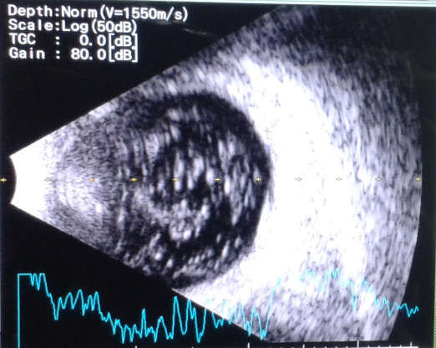

Figure 2 Ophthalmic ultrasonography shows vitreous hemorrhage
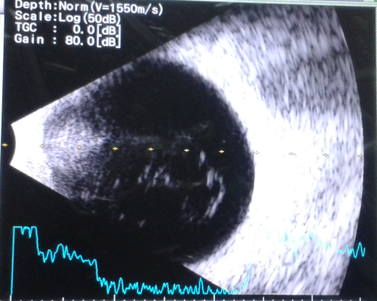

Figure 3 Ophthalmic ultrasonography shows posterior staphyloma.
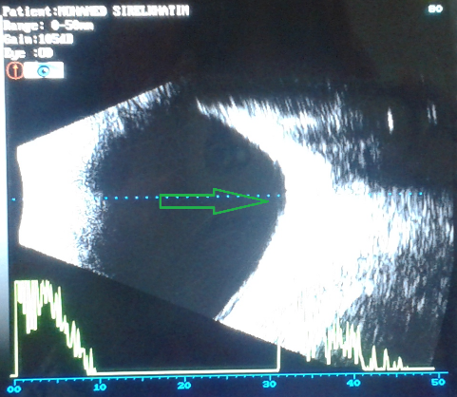

Figure 4 Ophthalmic ultrasonography shows posterior vitreous detachment.
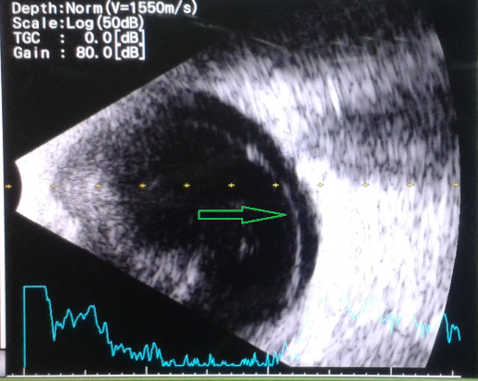

Figure 5 Ophthalmic ultrasonography shows total retinal detachment
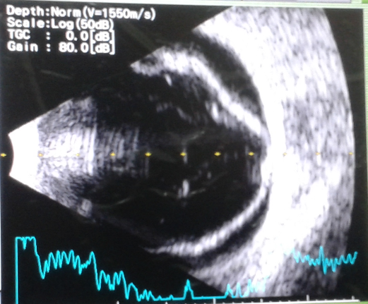
Figure 6 Ophthalmic ultrasonography shows retinochaisis (arrow)
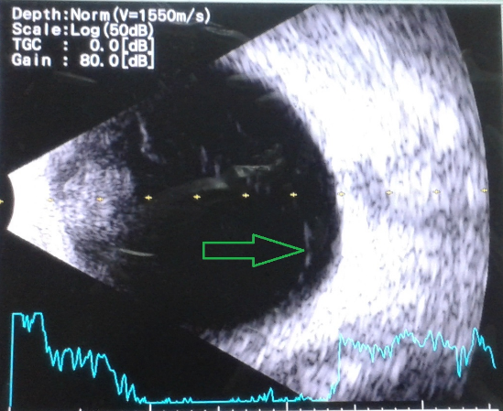

Figure 7 Ophthalmic ultrasonography shows ciliary body tumor (arrow)
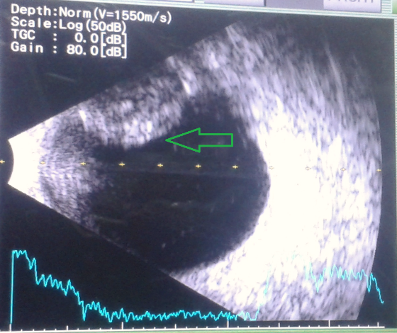

Discussion
A cross-sectional study was performed in 220 elderly Sudanese patients (50-90) years with senile cataract before surgery in order to detect the importance of B-scan ultrasonography in preoperative investigations. B-scan ultrasonography showed that most of patients had posterior segment lesions (57.77%). Asteroid hyalosis (22.73%) was the common posterior segment lesion in old patients. This is because its physiological age related degeneration results from accumulation of calcium particles within vitreous body. This agree with other studies in India (22%) and south Africa (23%)^{10’12}. In contrast, the spikes of A-scan in this lesion may be higher than the retinal spikes, thus it will give false results in calculation of intraocular lens (IOL) power. Also if density of asteroid hyalosis is high post-operative vision may not reach the standard.
Vitreous hemorrhage (10%) is similar to that found in other study in Pakistan (12%)¹¹. However, posterior vitreous detachment was (7 %) closer to other study in Bahrain (9%)¹³. Vitreous hemorrhage and posterior vitreous detachment may result from systemic diseases like diabetes and hypertension.
In addition, it has been noticed that posterior staphyloma was more than expected (7%) which is higher than other study in Niger (5%)¹⁴. This indicates that patients possibly of having myopia and unaware of it. Also it may be result from thinning in sclera and choroid with increasing age⁴. In this case the axial length of the eye is longer than 23mm and it is difficult to make accurate calculation for IOL power especially when optic nerve is involved. So in this case B-scan along with A-scan is preferable to insure its position and to confirm our calculation.
A lower incidence of retinochaisis (4.55%) and retinal detachment (4.55%) was noticed as compared to that found in other study in Pakistan (3%)¹¹. These findings may due to systemic diseases also like diabetes and hypertension. On the other hand, in case with retinal detachment a combination surgery of cataract and retinal detachment will be better. Also to relieve refractive error after surgery it’s better to change the retinal gate into the correct position.
The study revealed that ciliary body tumor is the only neoplastic disease food in old patients and this agree with other studies². Study in South Africa¹⁰ reported that choroidal melanoma (1%) is the only neoplasia found. They included wide range of age. Thus neoplasia in old patients requires further assessment and follow-up.
Conclusion
The study speculated that ophthalmic ultrasonography is essential before cataract surgery because. This would assist in detection of a hidden posterior segment pathologies of the eye, determination of correct planning for surgery, measurement of IOL power correctly and give an idea about post-operative vision.
In addition, the most common posterior segment lesion in old patients is asteroid hyalosis. However, ciliary body tumor is very rare and it’s the only neoplastic lesion found in old patients.
References
- Byarne S. Green R (2010): Ultrasound of the eye and orbit, 2nd edition, Jaypee Brothers, New Delhi, P:1 – 5.
- Srivastava PK (2007): Step by step ophthalmic ultrasound, 1st edition, Jaypee Brothers, New Delhi, P:180 – 185.
- Kanski J. J. (2010): clinical ophthalmology: A systemic approach. 7th edition, Butterworth-Heinemann, P. 337 – 343.
- Yanoff M, Fine BS. (1989): Ocular Pathology. A Text and Atlas. 3rd ed. Philadelphia: JB Lippincott;. p. 408.
- Qureshi M. Laghari K. Role of B-scan ultrasonography in pee-operative cataract patients. Inter J heal science. 2010; 4(1):31 – 37.
- Anteby I Blumenthal E. Zamir E. Waindim P. The role for preoperative ultrasonography for patients with dense cataract: a retrospective study of 509 cases. 1998; 29(2):114 – 122.
- Salman A. Parmar B. Vanila C. Nelson C. I ultrasonography before surgery in eyes with advanced cataract? J postgrad med. 2006; 52(1):19 -22.
- Meenkashi V, Jyothirmayi T. Sree B. Role of B-scan ultrasonography in cataract patients in a Tertiary care centre. Res gat. 2015; 22:15-25.
- Pereira N. Nassaralla B. Nassaralla J. The role of ocular echography before cataract surgery. J 2004; 45:352 - 365.
- Sheikh F. Narsani A. Jatoi S. Sheik Z. Preoperative posterior segment evaluation by ultrasonography in dense cataract. Pak j ophthalmol. 2009; 25(3):135 –. 140.
- Garg J. Tirkey E. Jain S. Lakhatakia S. Tiwari A. B-scan ultrasonography in eye with advanced cataracts: A useful prognostic tool. J evol med dent science. 2015; 4(37):6372 – 6377.
- Zafar D. Sajad A, Qadeer A. Role of B-Scan ultrasonography for posterior segment lesions. Pak J LUMHS. 2008; 7:7–12.
- Bello TO, Adeoti CO. Ultrasonic assessment in pre-operative cataract patients. Niger Postgrad Med J. 2006; 13(4):326–8.
- Ali S. Rehman H. Role of B-scan in preoperative detection of posterior segment pathologies in cataract patients. Pak J Ophthalmol. 1997; 13(4):108–112.
- Mecheil A. Roe of B-scan ultrasonography in detecting posterior segment pathologies in senile cataract patients. Int. ophthalmol J. 2016; 14(1):5 – 10.
- Ejaz A. Aamir A. Iftikhar A. Mehmood H. Diagnostic Applications of B-Scan. Pak J Ophthalmol 2007; 23(2):80-83.
- Haile M, Mengistu Z. B-scan ultrasonography in ophthalmic diseases. East Afr Med J. 1996; 73(11): 703-710.

