ASSOCIATION OF SYMPTOMATIC SYRINGOMYELIA WITH ACUTE BACTERIAL MENINGITIS IN A 3-YEAR-OLD PATIENT

A CASE REPORT

Tooryalai Jalalzai, Consultant Pediatrician, MD, DCH
Lima Helali 3rd year resident of pediatric medicine
Department of Pediatric Medicine, French Medical Institute for Mother and Children (FMIC)

ABSTRUCT:
Syringomyelia is a rare condition in children specially in younger than 5 years. As it has slow progression therefore it takes years to becomes symptomatic and to be diagnosed.
In most cases syringomyelia is a chronic spinal disorder which progress slowly.
We report a case of symptomatic syringomyelia associated with acute bacterial meningitis in a 3 years old patient in French Medical Institute for Mothers and Children (FMIC).

Key words: syringomyelia, pediatrics, acute bacterial meningitis

1.INTRODUCTION:
Syringomyelia is the development of a fluid-filled cavity or syrinx within the spinal cord. Hydromyelia is a dilatation of the central canal by cerebrospinal fluid (CSF) and may be included within the definition of syringomyelia. [1]
If ventricular CSF does not communicate with the fluid within the spinal cord, it is called Non communicating syringomyelia. If ventricular CSF communicates with the fluid within the spinal cord, then it is called communicating syringomyelia. [2]
the first time spinal cord cavitation was explained by Esteine in 1546 in a paper entitled “La Dissection Du Corps Humain” and the term syringomyelia was firstly used by d’Angers in 1827. [5]
Generally, there are two forms of syringomyelia: congenital and acquired. [4]
Causes of syringomyelia are: [5]
- Congenital malformations (eg, Klippel-Feil syndrome, Arnold Chiari type I malformation, and tethered spinal cord)
- Postinfectious
- Postinflammatory (transverse myelitis and multiple sclerosis)
- Spinal neoplasms (especially ependymoma and hemangioblastoma)
- Posttraumatic [up to date]
- Disorders affecting the spinal cord
Disorder affecting spinal cord
If no cause found for syringomyelia then it is called idiopathic syringomyelia.[6]
Sign and symptoms of syringomyelia develops insidiously over years or decades. In general patients may develop numbness, weakness, muscle atrophy, trophic ulcerations, sphincters dysfunction, pain and spine deformity (scoliosis) [7]
Here we report a case of sympomatic syringomyelia associated with acute meningitis in a 3 years old patient in FMIC.

CASE PRESENTATION:

A 3-years-old boy weighing 13kg previously healthy, presented to FMIC with 1week history of inability to move legs, inability to stand and walk associated with fever, headache, vomiting and irritability.

Problem started acutely with limping in right leg which gradually increased and in 2 days the child was not able to walk without support and then could not stand without support and finally the child became unable to move legs with sensory loss in legs and loss of sphincters control. During the illness patient was febrile, had headache, vomiting and irritable.

Patient was admitted for 3days in a local hospital, treated with high dose of ceftriaxone. Due to limited diagnostic facility just CBC and CRP was tested which were normal. After 3 days patient was referred to FMIC.

At arrival in physical examination the child was ill looking, conscious level was altered, GCS 12/15, had neck stiffness. Upper limbs were not affected and respiration was normal. Deep tendon reflexes were absent in lower limbs sensation was impaired from toes to the hip joints. There were no signs of cranial nerve involvement.

Past history was unremarkable there was no any specific illness and no any trauma in the past.

The case reported as an acute flaccid paralysis for polio screening.

CBC, CRP, SGPT, CPK, RFT, serum electrolyte was normal. Serum glucose level was 78mg/dl.

CSF analysis performed which was panic:

CSF glucose = 2mg/dl, protein > 14000/dl, Cells > 1200/dl with lymphocyte predominant (80%). CSF culture was negative, CSF for AFB smear was also negative and CSF PCR for TB was negative too.

Chest X-ray was normal and Monteux test was negative.

Brain MRI revealed normal brain parenchyma and ventricles.

Spine MRI revealed syringomyelia in dorso-lumber spine from D8-L1

Figure.1

Spine MRI significant cystic syringohydromyelia along the dorso-lumber spine from the D8 to L1 vertebrae effacing the extradural space at this level measuring 9.7cm x 1.1cm in cranio-caudal and transverse diameters respectively.

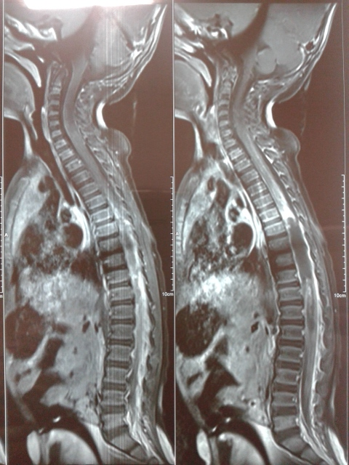

Figure.2

Brain MRI of same patient which reveals normal brain paranchyma.

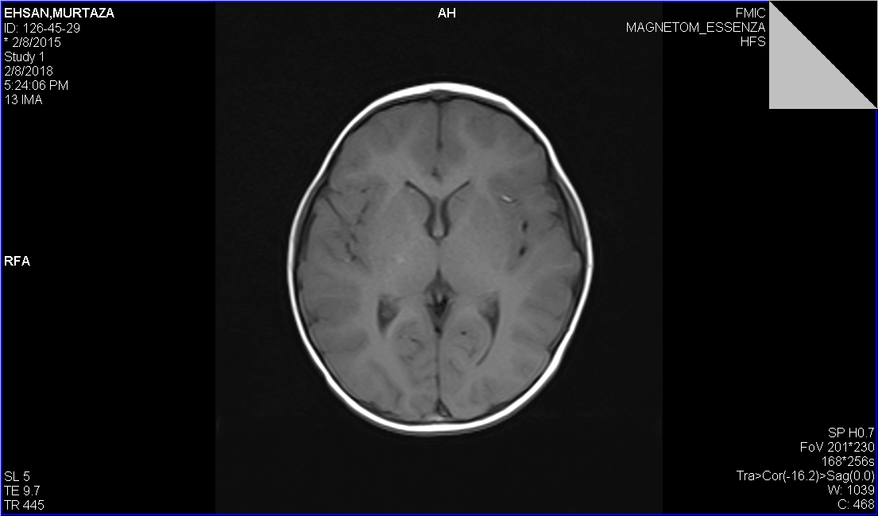

Supportive treatment and combined antibiotics (Ceftriaxone and Vancomycin) started. Patient had good clinical improvement. On 3rd day of treatment patient was afebrile, had no vomiting and irritability. He was able to set in bed and play with toes. On same day CSF analysis repeated which also showed improvement;

CSF glucose 37mg/dl (serum glucose 88mg/dl), Protein 446mg/dl, cells 2900 with lymphocyte predominant (65%)

On 9th day of treatment CSF analysis repeated which showed glucose 74mg/dl (serum glucose 95mg/dl), protein 75mg/dl, cells 04/dl. We continued same treatment for 14 days and referred the patient to neurosurgeon.

Unfortunately, there was no facility for treatment of such case inside the country, the patient was referred abroad by neurosurgeon and the family could not afford to take the child out of country, therefore the syringomyelia left untreated.

As tuberculous (TB) is common in our country therefore patient was closely followed in OPD base for any signs and symptoms of TB. Fortunately, patient was never febrile, he had good weight gain and always was playful but he was not able to move, paresthesia in legs with sphincters dysfunction persist.

DISCUSSION:

Symptomatic syringomyelia is rare pathology in children below 5 years old. Acute syringomyelia associated with acute bacterial meningitis was never seen in FMIC in last 10 years which suggests that this association is a very rare condition.

CONCLUSION:

Symptomatic syringomyelia may occur even in children less than 5-year-old

We suggest CSF analysis in selected cases of syringomyelia to rule out associated central nervous system infection.

Does bacterial meningitis precipitate signs and symptoms of syringomyelia?

Are patients with syringomyelia more prone to the central nerve system infections?

Further studies are needed to answer these questions.

Reference:
- Hassan Ahmad Hassan Al-Shatoury, MD, PhD, MHPE; Chief Editor: Selim R Benbadis, MD more...(Nov 2017 – Syringomyelia, Medscape)
- Nelson textbook of pediatrics 20th edition (syringomyelia-Harold Rekate)
- international society for pediatric neurourgery ISPN
- Wikipedia (Syringomyelia)
- Andrew Eisen, MD, FRCPC, Section Editor, Michael J Aminoff, MD, DSc Deputy Editor Janet L Wilterdink, MD Disclosures (up to date)
- June-Kai Chen, Chia-Hsiu Chen, Chia-Ling Lee, Tien-Wen Chen,1Ming-Cheng Weng,1 and Mao-Hsiung Huang Department of Physical Medicine and Rehabilitation, Kaohsiung Medical University
Hospital, and 1Department of Physical Medicine and Rehabilitation, Kaohsiung Municipal Hsiao Kang Hospital, Kaohsiung, Taiwan.
- Nelson textbook of pediatrics 20th edition (syringomyelia-Harold Rekate)

