GALLBLADDER CLEAR CELL CARCINOMA: A CASE REPORT
Bayanduuren B*, Altankhuyag B, Enkhbayar, Mishigdorj L, Bulgan ch, Gonchigsuren D
Grand med Hospital, Mongolia
*Email: mgl_bayanaa@yahoo.com
Tel: +976-99215191
Abstract
GALLBLADDER CLEAR CELL CARCINOMA: A CASE REPORT
Bayanduuren B*, Altankhuyag B, Enkhbayar, Mishigdorj L, Bulgan ch, Gonchigsuren D
Grand med Hospital, Mongolia
*Email: mgl_bayanaa@yahoo.com
Tel: +976-99215191
Introduction: Worldwide, the highest incidence rates (up to 7.5 per 100,000 in men and 23 per 100,000 in women) occur among populations in the Western part of South America (Chile and Peru), in North American Indians, in Mexican Americans, and in northern India. The best characterized risk factor for the development of gallbladder cancer is chronic inflammation associated with gallstones. Metastatic clear cell carcinoma in the gallbladder is extremely rare, with reported frequencies of less than 0.6% in large autopsy reviews
Case presentation: 54-year-old female, with no prior medical conditions presented with a 10 days history of upper abdominal pain. Last 4 days ago right abdomen upper quadrant pain, vomiting. Routine hematological leukocytosis and biochemical tests were CRP increased. An abdominal ultrasound revealed the gallbladder is enlargement, about 6.0*3.0 cm like the mudstone in the gallbladder. GB wall thickening/double/. Common bile duct is dilated /1.2cm/. Computed tomography imaging: Moderate thickening with surrounding mild edematous changes in wall of the gallbladder. Size of the GB is moderated dilated with diffuse sludges. IHBD is no dilated, CBD is mild dilated 1.2 cm and no sign of biliary tract obstruction. An open cholecystectomy. Upon pathologic investigation, the morphologic and immunophenotypic features supported a diagnosis of clear cell variant of gallbladder carcinoma.
Discussion: Gallbladder cancer was first described in 1777. Clear cell gallbladder carcinoma was first reported in 1926 by Tyson and Piney, 5 in which they originally described a unique type of gallbladder tumor and named it as hypernephroma of the gallbladder. Clear cell carcinoma represents on average over 90% of all malignancies of the kidney. Approximately 20%-30% of patients with clear cell carcinoma have metastatic disease at presentation and nearly 50% of patients with advanced disease die within 5 years of diagnosis.
Conclusion: Clear cell carcinoma very rare disease. Our team diagnosed during surgery and histological analysis. As a result of the surgery patient was completely healed and discharged from hospital. After from hospital discharged, we sent to national cancer center.
Keyword: Clear cell carcinoma, gallstone disease, open cholecystectomy, intraoperative cholangiogram, gallbladder tumor
Background:
Incidence of 6500 cases annually in the United States, gallbladder cancer is the fifth most common gastrointestinal tract malignancy in this country. Incidence increases with age and is two to six times higher in women than in men. Worldwide, the highest incidence rates (up to 7.5 per 100,000 in men and 23 per 100,000 in women) occur among populations in the Western part of South America (Chile and Peru), in North American Indians, in Mexican Americans, and in northern India. The best characterized risk factor for the development of gallbladder cancer is chronic inflammation associated with gallstones. Although only 0.5–3% of patients with cholelithiasis will develop gallbladder cancer, gallstones are present in 70–90% of patients diagnosed with gallbladder cancer. However, the 20-year risk of developing cancer for patients with gallstones is less than 0.5 percent for the overall population and 1.5 percent for high-risk groups. Polypoid lesions of the gallbladder are associated with increased risk of cancer, particularly in polyps larger than 10mm. The calciﬁed “porcelain” gallbladder is associated with more than a 20 percent incidence of gallbladder carcinoma. When diagnosed, about 25 percent of gallbladder cancers are localized to the gallbladder wall, 35 percent have regional nodal involvement and /or extension into adjacent liver, and approximately 40 percent have distant metastasis.
Metastatic tumors to the gallbladder are uncommon. The most common metastatic tumors to the gallbladder are metastatic melanomas and metastatic carcinomas from stomach, pancreas, ovary, bile ducts, colon and breast [1]. Metastatic clear cell carcinoma in the gallbladder is extremely rare, with reported frequencies of less than 0.6% in large autopsy reviews [2]. Clear cell carcinoma is a rare tumor accounting for 3% of all malignancies in adults and 85% of primary renal tumors. The most frequent sites of metastasis are lung (55%), regional lymph nodes (34%), liver (33%), bones (32%), adrenal (19%), contralateral kidney (11%) and CNS (6%) [2].
Case report
Patient was a 54-year-old female. Patient was right upper abdominal pain and epigastric middle pain. Nausea and vomiting. Pain was started 10 days ago, after ate dumplings. No history of previous any gastrointestinal disease. The physical examination: Tenderness in right hypochondrium. Lump in the hypochondrium. Murphy’s sign was positive.
The patient’s in blood test increased white blood cell and C- reactive protein. /Table.1/. No cancer tumor markers were performed at the time.
Blood test, 2019
Name | Reference | Result
 | CBC
WBC | 4-10*10³/L | 11.5*10³/L
Neutrophil | 34-71% | 76%
 | Biochemistry
CRP | 0-5mg/l | 108.19mg/l
Fibrinogen | 2-4g/l | 7.12g/l
Table. 1. Changes of blood test

Radiology examination:
Abdominal ultrasound examination: Gallbladder is enlargement, about 6.0*3.0 cm like the mudstone in the gallbladder. GB wall thickening /double/. Common bile duct is dilated /1.2cm/ //Figure.1/
Abdominal contrast CT examination: Moderate thickening with surrounding mild edematous changes in wall of the gallbladder. Size of the GB is moderated dilated with diffuse sludges. IHBD is no dilated, CBD is dilated 1.2 cm and no sign of biliary obstruction. Normal parenchymal contour and thickness of both kidneys. No renal masse (Figure. 2-4).
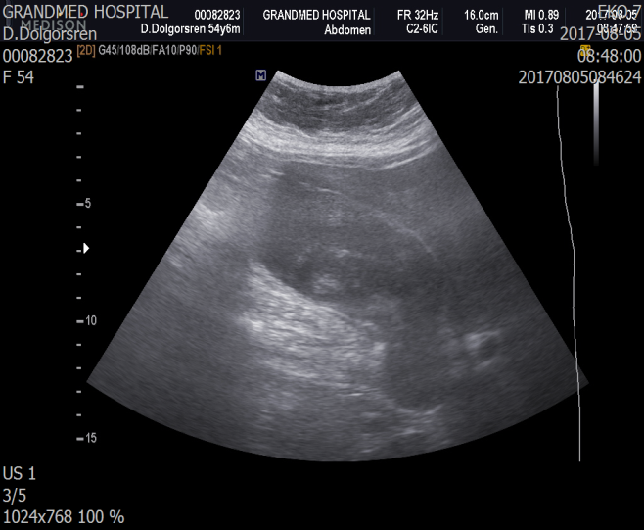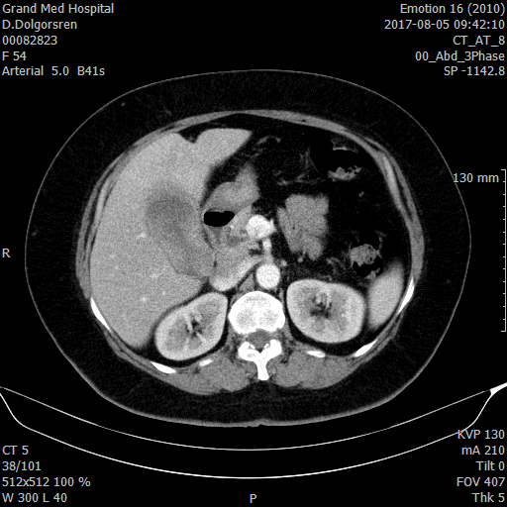
Figure 1. Abdominal ultrasound Figure 2. Contrast CT abdomen /frontal/
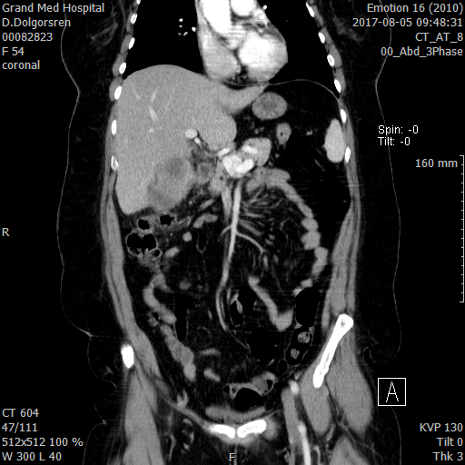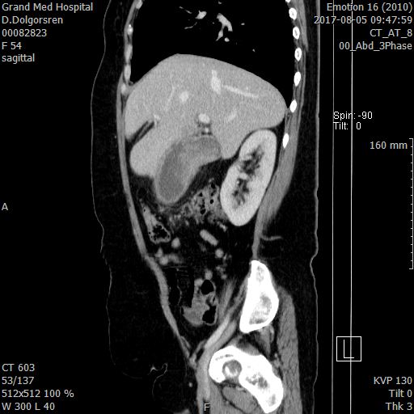
Figure 4. Contrast CT abdomen: Gallbladder wall thickness

Figure 3. Contrast CT abdomen /coronal
Treatment
We were emergency surgery of under general anesthesia open cholecystectomy and intraoperative cholangiogram. During surgery gallbladder was distended and gallbladder wall very thickness, hardness (Figure. 5-7). In cholangiogram common bile duct no obstructive sign (Figure. 8-9).

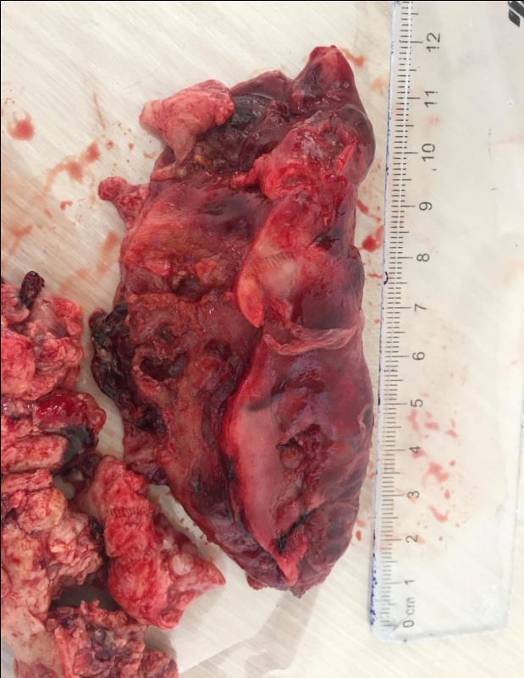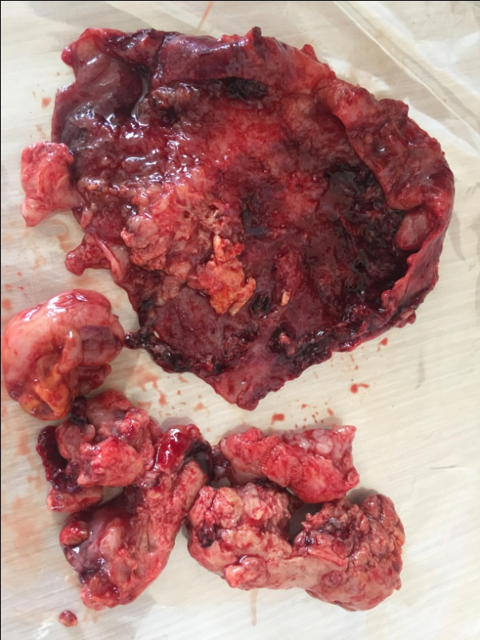
Figure 5. Gallbladder carcinoma with stone Figure 6. Gallbladder carcinoma
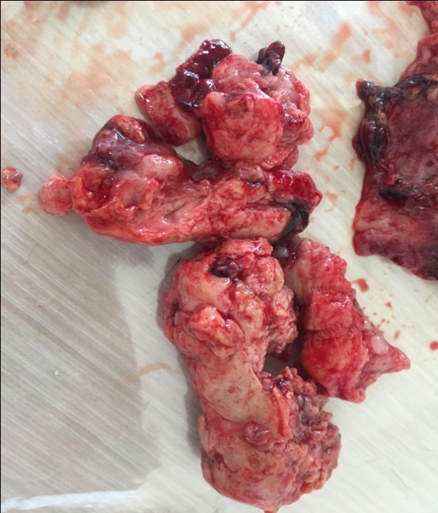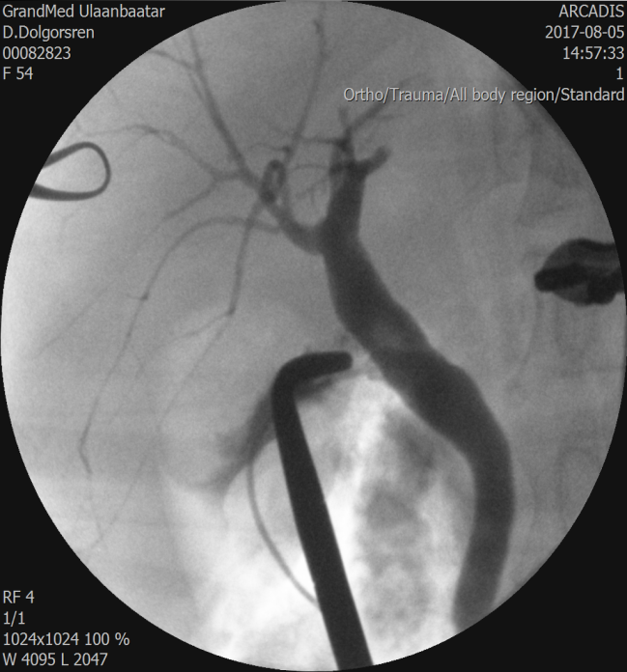
Figure 7. Gallbladder carcinoma Figure 8. Intraoperative cholangiogram/ by contrast/

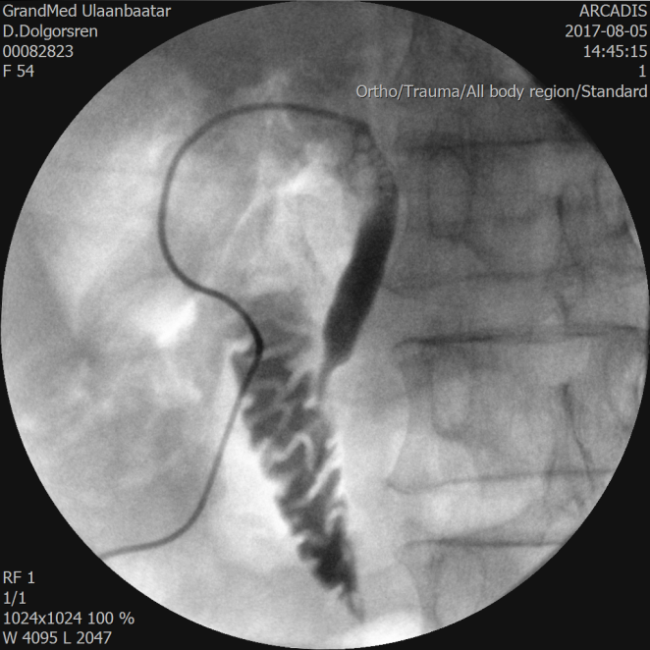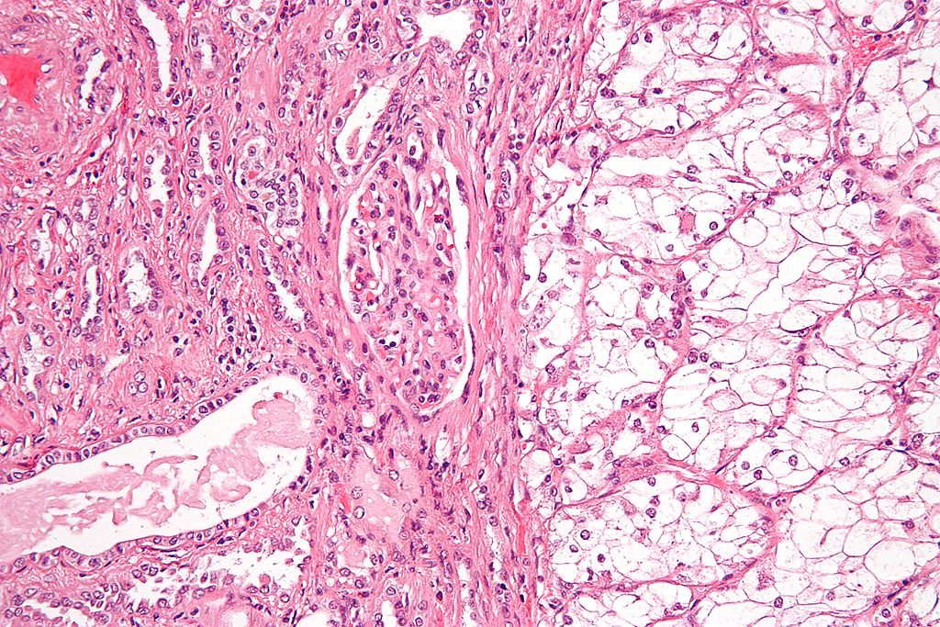
Figure 10: Clear cell carcinoma in the gallbladder with a high mitotic activity
Figure 9. Intraoperative cholangiogram/ by contrast/

Histology examination: Undifferentiated carcinoma on the background of chronic cholecystitis. Done consultation from Campus medicus Europa.
Campus medicus Europa: This is rare case of a clear cell carcinoma in the gallbladder with a high mitotic activity. A metastatic renal cell carcinoma has to be ruled out (Figure 10).
Discussion:
Clear cell carcinoma is a rare primary gallbladder neoplasm and has been characterized as a distinctive type of gallbladder tumor and extrahepatic bile ducts by WHO.

