INTRODUCTION

Gaucher’s disease is one of the most common lysosomal storage diseases characterized by hematologic abnormalities, organomegaly, and skeletal involvement. It is caused by reduced activity of the enzyme acid β-glucosidase which is encoded by a gene on chromosome 1q21-q31¹. The enzymatic defect results in the accumulation of glycolipid substrates, mainly glucosylceramide, in cells of the macrophage-monocyte system. It is one of the most prevalent genetic defects among Ashkenazi Jews². There are 3 clinical subtypes distinguished by the presence or absence and progression of neurologic manifestations: type 1 or the adult, non neuronopathic form; type 2, the infantile or acute neuronopathic form; and type 3, the juvenile or subacute neuronopathic form³.

Here we report a case of Gaucher’s disease that presented with pancytopenia and splenomegaly. We present this case to emphasize the importance of considering storage disorders like Gaucher’s disease when evaluating a case of unexplained pancytopenia and organomegaly even in adults.

CASE REPORT

A 20 year old female presented with generalised weakness and easy fatigability, menorrhagia and dragging sensation in the left upper quadrant of abdomen. There was no history of fever, rashes, joint or bone pain, yellowish discoloration of eyes and urine, night sweats or weight loss. There was no history of similar illness in her family members which included her parents and one sibling and there was no consanguinity among parents. On physical examination, the patient had pallor but no icterus or lymphadenopathy. She had massive splenomegaly with firm consistency, regular margin and smooth surface and a non tender, mild hepatomegaly. There was no sign of any neurological deficit and the rest of the systemic examination was normal. Lab investigations showed pancytopenia (hemoglobin=6.8 g/dl, white blood cells=2.45x10⁹/L and platelets=40x10⁹/L). Examination of peripheral smear showed severe anemia with marked anisopoikilocytosis with microcytic hypochromic blood picture with moderate leukopenia and marked thrombocytopenia. Corrected reticulocyte count was 1.6%. Liver and kidney function tests were normal. Prothrombin time was 14s [international normalized ratio(INR)=1.14]. Serum Iron was 30mcg/dl with total iron binding capacity = 474mcg/dl suggesting chronic blood loss. Ultrasonography confirmed massive splenomegaly (23cm) and mild hepatomegaly (15cm) with normal portal vein diameter and no evidence of splenic vein thrombosis. Montoux test was negative and Erythrocyte sedimentation rate was normal. Serological markers for HIV, Hepatitis B and Hepatitis C were negative. Antinuclear antibody, malaria antigen test and rK 39 antibody were also negative. To evaluate the cause of pancytopenia, bone marrow biopsy was done which revealed hypercellular marrow with clusters of ovoid macrophages with abundant fibrillary cytoplasm and round eccentric nucleus (gaucher cells). To confirm the diagnosis of Gaucher’s disease (Type 1), β-glucosidase enzyme assay by fluorometry method was done which showed β-glucosidase level of 0.51 nmol/hour/ml (normal value >2 nmol/hour/ml). Final diagnosis was G.D (type-1).

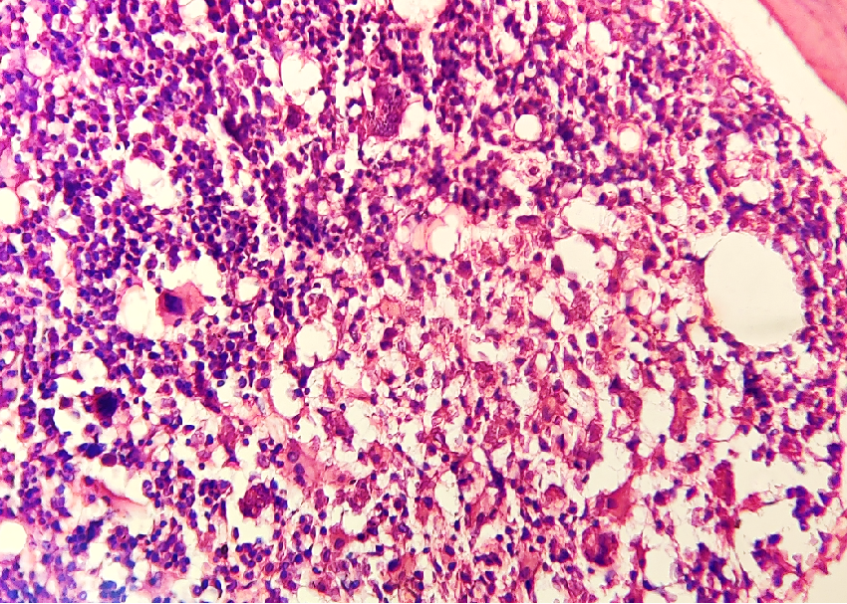
40x view of H & E stained bone marrow biopsy showing clusters of ovoid macrophages with abundant fibrillary cytoplasm and round eccentric nucleus (gaucher cells)

DISCUSSION

Gaucher’s disease is an autosomal recessive disorder that affects all racial and ethnic groups with maximum prevalence among Ashkenazi Jews. It is characterized by the deficiency of the enzyme glucocerebrosidase which results in accumulation of glucocerebroside in the cells of reticuloendothelial system. It is classified into three clinical subtypes of which Type 1 is the non neuronopathic form and is the most common subtype. Although about two thirds of patients present before the age of 20, Gaucher’s disease has been well documented in adults⁴. The most common signs and symptoms observed in GD are splenomegaly (95%), hepatomegaly (87%), radiological bone disease (81 %), thrombocytopenia (50%), anemia (40%), growth retardation (34%), bone pain (27%), and bone crisis (9%)⁵. Our case presented with organomegaly and pancytopenia with no evidence of bone disease on skeletal survey and Dual-Energy X-ray Absorptiometry scan. In this background we considered hematological malignancies, hemoglobinopathies, infective disorders and infiltrative disorders in our differential diagnosis. Hematological disorders were ruled out because of absence of important signs like jaundice, leukocytosis, lymphadenopathy and abnormal hemoglobin electrophoresis. Certain infectious disorders like HIV, kala azar, tuberculosis and malaria can present with massive splenomegaly but our patient did not have fever throughout the course of illness and these were subsequently ruled out on the basis of serological tests. Infiltrative disorders like sarcoidosis and certain storage disorders can present with organomegaly and pancytopenia. Sarcoidosis was ruled out by normal serum angiotensin converting enzyme level and absence of lung disease. The clinical symptom profile of our case was consistent with Gaucher’s disease and bone marrow examination showing gaucher cells supported our diagnosis. All suspected cases, however, must be confirmed by demonstrating decreased acid β-glucosidase activity in isolated leukocytes as pseudo-Gaucher cells can be seen in many hematological malignancies and AIDS.

CONCLUSION

This case emphasises the importance of considering storage disorders like Gaucher’s disease in patients presenting with pancytopenia and organomegaly even in adulthood. A high index of suspicion is needed for early diagnosis so that timely and appropriate treatment can be administered.

REFERENCES

1.Brady RO, Kanfer JN, Bradley RM, Shapiro D. Demonstration of a deficiency of glucocerebroside-cleaving enzyme in Gaucher's disease. The Journal of clinical investigation. 1966 Jul 1;45(7):1112-5.

2. Zimran A, Gelbart T, Westwood B, Grabowski GA, Beutler E. High frequency of the Gaucher disease mutation at nucleotide 1226 among Ashkenazi Jews. American journal of human genetics. 1991 Oct;49(4):855.

3. Beutler E, Grabowski GA. Gaucher disease. In: Scriver C, Beaudet AL, Sly WS, Valle D, editors. The Metabolic and Molecular Bases of Inherited Disease. 8th ed. New York: McGraw-Hill; 2001. pp. 3635–3668.

4. Levrat V, Forest I, Fouilhoux A, Guffon N. [Gaucher disease in childhood] Rev Med Interne. 2007;28(2):S183–6.

5. Kaplan P, Andersson HC, Kacena KA, Yee JD. The clinical and demographic characteristics of nonneuronopathic Gaucher disease in 887 children at diagnosis. Arch Pediatr Adolesc Med. 2006;160(6):603–8

