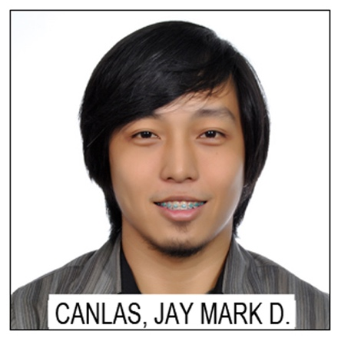
Chronic Epigastric Pain Presenting in a Case of Duodenal Diverticulum: A Case Report

Jay Mark D. Canlas, M.D.
Department of Surgery
Mary Johnston Hospital
Tondo, Manila, Philippines

Bowel diverticulosis presents in >10% among patients in the 5th to 6th decades of life. Mostly are asymptomatic and >95% are found in the colon. The duodenum is the next common area predisposed to diverticula formation, which is existent in 1-5% of cases. Only a minority of such cases present with symptoms and would require surgical intervention.

Our case is of an 81 year old female who presented with chronic bouts of epigastric pain for the past decade, with increasing recurrence 3 weeks prior to admission. Whole abdominal CT scan with contrast showed colonic diverticulitis, and was treated as such. She was discharged accordingly. However, due to recurrence of aforementioned epigastric pain, she was readmitted and upper GI endoscopy revealed a duodenal diverticula. She was medically cleared and underwent laparoscopic diverticulectomy via wedge resection using endoscopic GI staplers for the duodenal diverticulum, for which she tolerated well.

Duodenal diverticula rarely present with symptoms and their mere presence is not an indication for surgery. However, if major complications present or if symptoms are refractory to medical management, surgical intervention can be considered, whether via open or laparoscopic technique. Laparoscopic technique has been exhibited to be a safe and feasible option for the surgical management of duodenal diverticula.

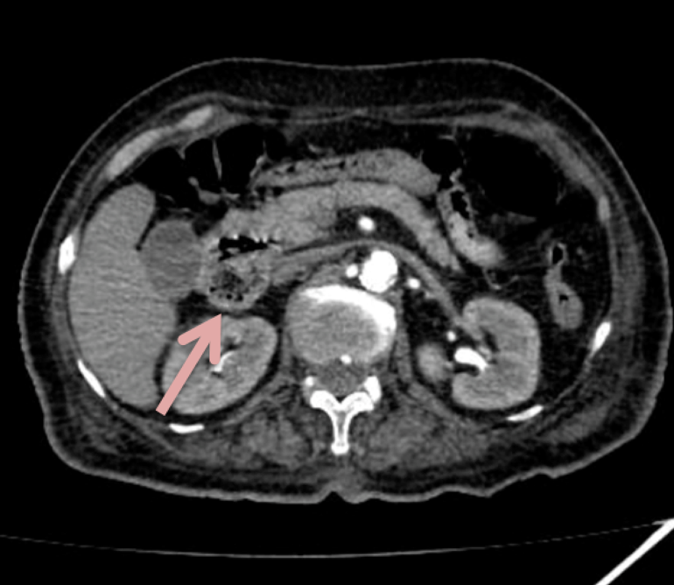

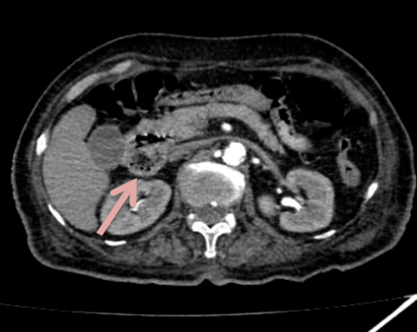
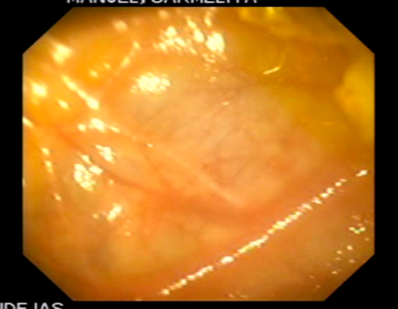

Figure 1: Endoscopic image of the noted outpouching segment at the 2nd portion of the duodenum. A CT scan confirms the presence of the diverticulum.

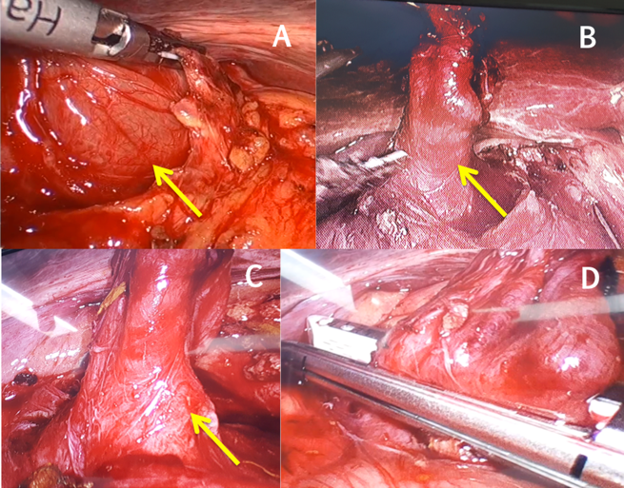
Figure 2. Diagnostic laparoscopy, wedge resection of duodenal diverticulum. All yellow arrows point to the duodenal diverticula seen over the second portion of the duodenum. A: Diverticulum being freed from the duodenum itself and the overlying omentum. B, C: Diverticulum freed from adhesions. D: Linear GI stapler applied, prior to resction of the diverticulum.

Biography

Dr. Canlas is a 4th year surgical resident at the Department of Surgery of Mary Johnston Hospital in Tondo, Manila, Philippines. He got his medical degree from the University of Santo Tomas Faculty of Medicine and Surgery in Manila, Philippines. He has been consistent and likewise successful in case report forums and research competitions in his institution. He has also experience in international conventions in presenting various research outputs.
Presenting author details
Full name: Jay Mark D. Canlas, M.D.
Contact number: 0922 894 7997
Email id: jm.canlasmd@gmail.com
Category: POSTER
Session name: Surgery case reports
Research interest: Minimally invasive surgery

