The case of successful extra-cardiac hemodynamic correction of congenital anomalies of the systemic venous connection into the left atrium.
Saliev B Kh, Islamov NK, Nasirov MM, Muborakov TU
Tashkent Pediatric Medical Institute

Background: The total anomaly of the confluence of the caval veins in the left heart is one of rare diseases. In this regard, according to medical sources, does not have any statistical estimates of detectability. Taking into account the peculiarities of the hemodynamics of this defect, patients come in a complicated state, when surgical care is of an immediate nature.
Pathological anatomy: The occurrence of an anomaly of the confluence of the caval veins in the cavity of the left atrium is associated with disturbances in the processes of obliteration of the left cardial vein and the development of the coronary sinus. Isolated confluence of the left superior vena cava into the left atrium is rare (Tuchman H. etal., 1956; Sherafat M. etal., 1971). Most often, the anomaly is combined with the posterior secondary defect of the interatrial septum in the area of ​​the coronary sinus (RaghibG .etal., 1965), with the incomplete form of atrioventricular canal defect and in 1/3 cases with the absence of the inferior vena cava (Podzolkov VP et al., 1984 ).
Hemodynamics: At the confluence of both caval veins into the cavity of the left atrium, there is a volume overload of the left heart, only the presence of a defect of the interatrial and interventricular septum ensures the flow of blood into a small circle of blood circulation. The absence of a full hemodynamic load on the right parts of the heart leads to their hypoplasia. At the same time, the volume overload of the left atrium with a simultaneous flow of blood from the pulmonary veins and both caval veins determines the development of chronic severe hypoxemia and congestive pulmonary hypertension. Great importance is the condition of the atrioventricular valves in particular the left AV valve, which, with a given defect, is the only functioning heart valve. It is his functional state that determines the degree of heart failure.
Indication for operation:Taking the note of the complexity of the anatomy of the defect, the nature of severe hemodynamic disorders to determine the indication for possible surgical treatment is the age of the patient, the size of the trunk and branches of the pulmonary artery, the degree of pulmonary hypertension and heart failure. In this pathology, the operation of choice is the operation of an out-of-cardiac hemodynamic correction: a cavopulmonary anastomosis, a bidirectional cava pulmonary anastomosis of Glen, various variants of the Fontaine operation.
Case:
Patient G.L. 2013 b. (4 year old girl), admittedto the Cardiosurgery Department of the TashPMI Clinic
8.02. 2017 preliminary diagnosis: the CHD. Complex type was made. Abnormal flow of the inferior vena cava into the cavity of the left atrium.ASD.VSD.Hypoplasia of the right heart.Heart failure.Chronic hypoxemia.
Complaints on admission to shortness of breath with minor physical exertion, fast fatigue, lag in physical development, general weakness, malaise, cyanotic skin. From an anamnesis the heart defect was detected from a birth. During the 3 years was observed in the clinic of TashPMI. Due to the complexity of the defect, treatment in abroad was recommended. Was supervised byGP-cardiologist. On examination: the patient had a cyanotic shade of the skin and mucous membranes, a lag in physical development, shortness of breath, weakness and rapid fatigue during physical exertion. Laboratory data were unchanged, normal levels of hemoglobin were noted in the dynamics.
On the chest X-ray: hypervolemia of the PC. The heart is enlarged in diameter. Sinuses are free.
ECG:SA blockade II degree II type with a heart rate of 54-109 beats per minute. The deviation of the electric axis to the left.Blockade of the anterior branch of the left branch of the bundle.
Echocardiography (6.02.2017): Abnormal entry of the caval and hepatic veins into the left atrium. Secondary ASD (10mm).VSD (7 mm).Signs of hypoplasia of the right heart.Final diastolic volume of LV 65 ml. Faction of exile 60%.RPA 10 mm LPA 10 mm.
Contrast MSCT (February 8, 2017) - the upper caval vein and the additional upper vena cava (RSVC) flow into the left atrium. Hepatic veins flow into the cavity of the left atrium. The lower caval vein flows into the SVC through v.azigos (Figs. 1 and 2).
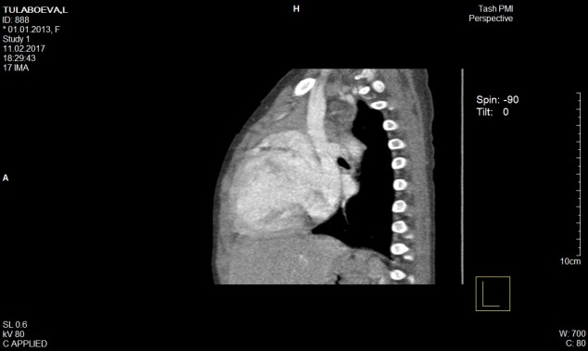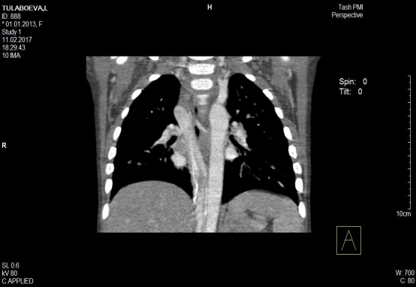
Fig. 1 MSCT of the patient before surgery.

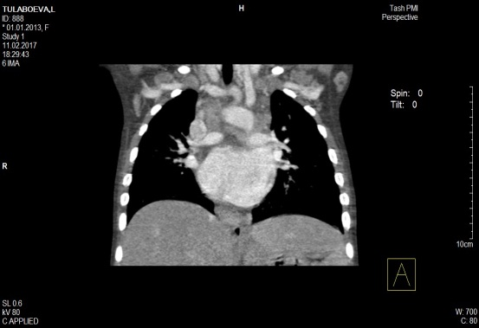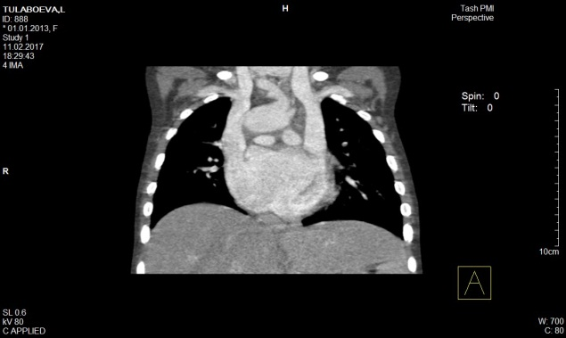
Fig. 2MSCT of the patient before surgery.

Schematically, the pathology can be reflected as follows (Fig. 3)
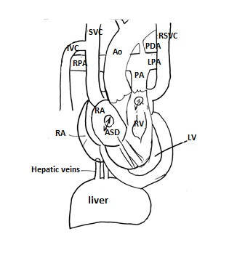

The patient was electively performed an operation (18.02.17): Performing of a two-sidedly-directed cava-pulmonary anastomosis Glen, ligation of the PDA, ligation of the pulmonary trunkunder the by-pass conditions and cold cardioplegia.
On the operation: when cardiac revision, hypoplasia of the right atrium and right ventricle is revealed, which are spread out on the enlarged left atrium and left ventricle. There are two upper caval veins (right SVC) and (left SVC), the lower cave vein flows through the vazigos into the right SVC. With tensiometry, the pressure in the pulmonary artery is 10 mm Hg. In the revision of the right atrium, the hepatic veins enter the cavity of the left atrium. 2-sided bi-directional cavapulmonal anastomosis by Glenwas the only correction method. A ligation of the PDA, ligation of the PA trunk, was performed, anastomoses were placed between the two upper caval veins and both branches of the pulmonary artery in the side along Glen. With tensiometry CVP 22 mm Hg. The operation is completed usually (Figures 4 and 5).
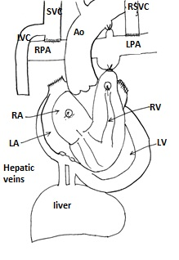
Figure 4.Schematic representation of the performedoperation.

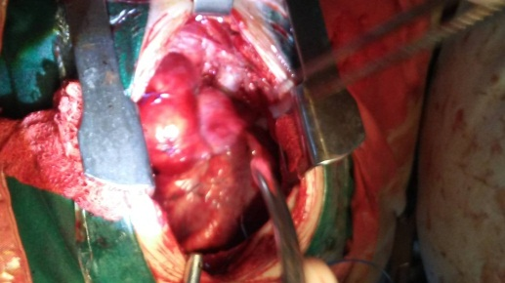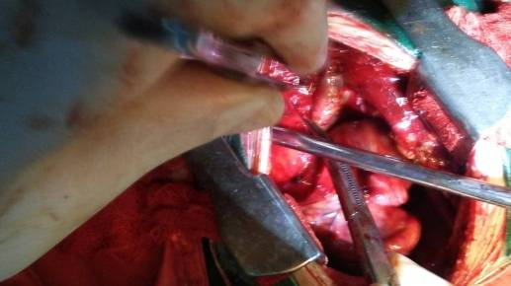
Figure 5.Intraoperative photo. The arrow denotes right and left anastomoses (respectively) between the caval veins and the pulmonary arteries

The early postoperative period was complicated with an increase in CVP to 24 mmHg, followed by a decrease to 15 mmHg. On the 10th day a tracheostomy was established due to the fact that pronounced bronchoresis was noted (adaptation of the lungs to increased flow in the PC). Extubationon 12th days. During the entire period of stay in the ICU (20 days) patient received sydromatic therapy: inotropic support (dopamine, dobutamine, milrenon), plasma and albumin transfusion, antibacterial therapy, etc. The index of saturation after the operation is 80-90%. EchoCG (10.03.2017): Final diastolic size = 32 Final diastolic volume = 33 ml of Final systolic size = 20 Faction of exile = 64%; Circulatory insufficiency II grade. Hypoplasia of the right ventricle.On SVC flow from up to down. The patient was discharged on day 25 postop in a relatively satisfactory state.
From 20.04.17g the repeated contrast MSCT was performed: the function of anastomoses is satisfactory (Figures 6 and 7).
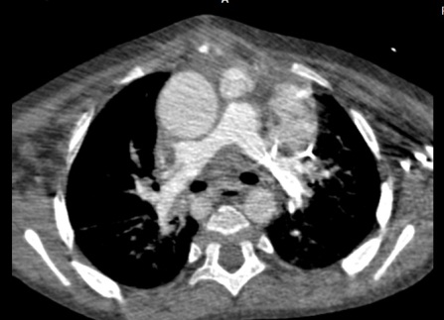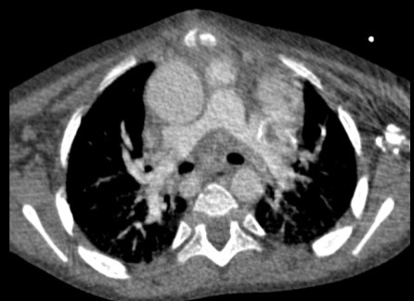
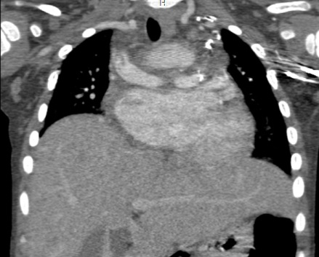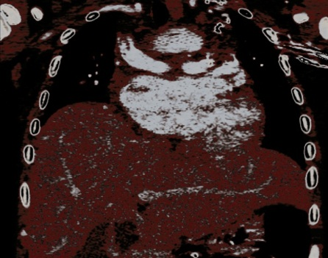
Fig. 6. The arrow indicates the areas of anastomoses between the caval veins and the branches of the pulmonary artery. An asterisk denotes the site of the ligation of the pulmonary artery trunk.

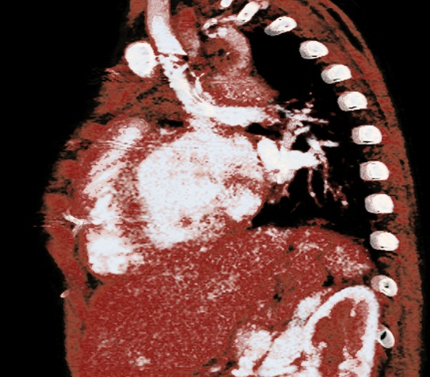
Figure 7.Side image. The arrow indicates an anastomosis between the additional caval vein and the left branch of the pulmonary artery.

References:
- Kabbani S. S., Feldman M., Angelini P. et al. Single (left) superior vena cava draining into the left atrium. Surgicalreport // Ann. thorac. Surg.—1973.—Vol. 16, N 5.—P. 518-525.
- De Leval M. R., Ritter D. G., McGoon D. C, Danielson G. K.Anomalous systemic venous connection. Surgical considerations// Mayo Clin. Proc—1975.—Vol. 50, P. 599-610.
- Reinery A. Persistent left superior vena cava connected to the right atrium // Bull. Soc. ital. Cardiol.—1979.—Vol. 24.—P. 151-158.
- Walters HL. (2003) Anomalous systemic venous connections. In: Mavroudis C, Backer CL, eds. Pediatric Cardiac Surgery, 3rd ed. Philadelphia, PA: Mosby, Inc.
- Siewers RD. (1998) Anomalies of systemic venous drainage.In: Kaiser, LR, Spray TL, eds. Mastery of Cardiothoracic Surgery. Philadelphia, PA: Lippincott-Raven.
- De Leval M. (1983) Anomalies of the systemic venous return.In: Stark J, de Leval MR, eds. Surgery for Congenital Heart Defects. London: Grune and Stratton, pp. 253–260.
- Winter FS. (1954) Persistent left superior vena cava; survey of world literature and report of thirty additional cases. Angiology 5, 90–132.
- Hurwitt ES, Escher DJ, Citrin LI. (1955) Surgical correction of cyanosis due to entrance of left superior vena cava into left auricle. Surgery 38, 903–914.
- Miller GA, Ongley PA, Rastelli GC, et al. (1965) Surgical correction of total anomalous systemic venous connection: report of case. Mayo ClinProc 40, 532–538.
- De Leval MR, Ritter DG, McGoon DC, et al. (1975) Anomalous systemic venous connection. Surgical considerations. Mayo ClinProc 50, 599–610
- Shumacker HB Jr, King H, Waldhausen JA. (1967) The persistent left superior vena cava. Surgical implications, with special reference to caval drainage into the left atrium. Ann Surg 165, 797–805.
- Kirsch WM, Carlsson E, Hartmann AF Jr. (1961) A case of anomalous drainage of the superior vena cava into the left atrium. J ThoracCardiovascSurg 41, 550–556
- Gardner DL, Cole L. (1955) Long survival with inferior vena cava draining into left atrium. Br Heart J 17, 93–97.
- Gautam HP. (1968) Left atrial inferior vena cava with atrial septal defect. J ThoracCardiovascSurg 55, 827–829.
- Meadows WR, Bergstrand I, Sharp JT. (1961) Isolated anomalous connection of a great vein to the left atrium. The syndrome of cyanosis and clubbing, “normal” heart, and left ventricular hypertrophy on electrocardiogram. Circulation 24, 669–676.
- Anderson RC, Adams P Jr, Burke B. (1961) Anomalous inferior vena cava with azygos continuation (infrahepatic interruption of the inferior vena cava). Report of 15 new cases. J Pediatr 59, 370–383.
- Fisher MR, Hricak J, Higgins CB. (1985) Magnetic resonance imaging of developmental venous anomalies. Am J Roentgenol145, 705–709.
- Davis WH, Jordaan FR, Snyman HW. (1959) Persistent left superior vena cava draining into the left atrium, as an isolated anomaly. Am Heart J 57, 616–622.
- Gueron M, Hirsh M, Borman J. (1969) Total anomalous systemic venous drainage into the left atrium. Report of a case of successful surgical correction. J ThoracCardiovascSurg58, 570–574.
- Roberts KD, Edwards JM, Astley R. (1972) Surgical correction of total anomalous systemic venous drainage. J ThoracCardiovascSurg 64, 803–810.

