
Title: A Practical Exemplary Experience of Rheumatic Heart Disease (RHD) Prevention at Farta Woreda of South Gonder Zone, Ethiopia: A Community Service Project
Correspondent author: ¹Dr.Mestet Yibeltal Shiferaw (Email:jininuyibeltl@gmail.com)
Co-authors
² Denekew Tenaw (Bsc in PH)
² Endeshw chekol (Msc in Biochemistry)
² Rahel Mulatie (Msc in Epidemiology)
²Dejene Shifera (MD)
¹Addis Ababa University School of Medicine, Ethiopia.
² Debre Tabor University, College of Health Sciences, Ethiopia.

Abstract
Background: Rheumatic heart disease (RHD) continued being the commonest cause of acquired heart disease in children of Africa and Ethiopia. Though there exist an established preventable cause, the practice of prevention is yet unsatisfactory as evidenced by rampant cases with significant morbidity and mortality. Currently, the practice of primary prevention of rheumatic heart disease is gaining more attention as this deadly disease showed no significant reduction with the previously emphasized secondary prevention especially to those setups where there are rudimentary level curative cardiac surgical services; underscoring the importance of instituting the most effective and integrated prevention strategy. The fact that health extension workers (HEWs) are the frontline health professionals in Ethiopian context, especially in the preventive aspect of health, assessing the knowledge and practice of them regarding the deadly disease of rheumatic disease in children is crucial to fill the gap if any is available.
Methodology: First, up-to-date recommendations on prevention of rheumatic heart disease were searched, and surveillance on the knowledge & practice of frontline health professionals on rheumatic heart disease prevention among 40 health extension workers of Farta woreda, South Gondar, Ethiopia (project site) was done. Two kebeles of Farta woreda were selected using random sampling method for initiation of health education for parents by the trained HEWs together with the project runners.
Result: Majority 31 (77.5%) of the HEWs didn’t knew whether a causal relationship between acute bacterial tonsilo-pharyngitis and acute rheumatic fever (ARF) & RHD exists; nearly all of HEWs didn’t know primary, secondary and tertiary level of RHD prevention ways and have never been trained for. Training was given for 40 HEWs for two days. In addition, this project gave health education to parents living in 2 selected kebeles of Farta woreda jointly by the project runners & the HEWs trained by this project. The positive feedback loop of this project just started and yet to continue & scaled up to bring tangible reduction of RHD in Ethiopia.
Conclusion: The policy makers should give priority to the deadly rheumatic heart disease by making use of this exemplary project to scale up to a country level and integrating it to the existing other preventable diseases programme without adding a significant extra cost to the health sector.
Project design matrix
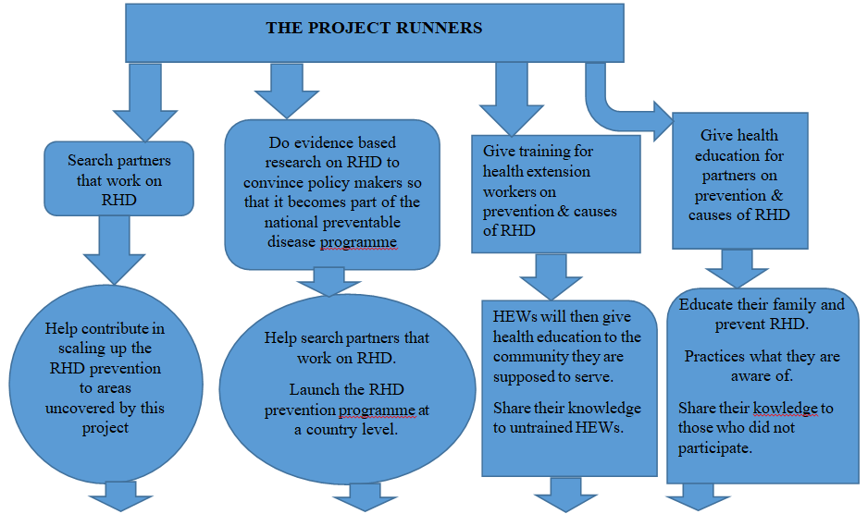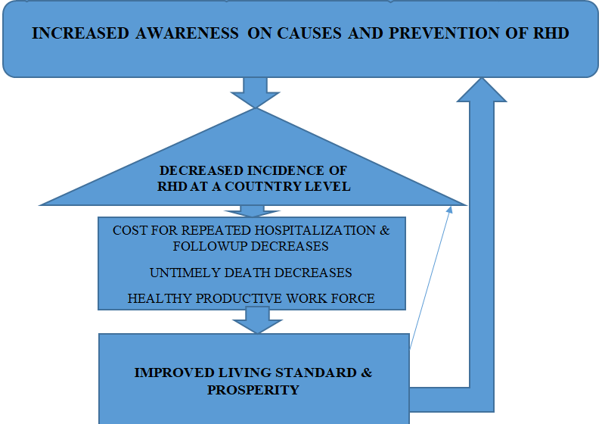

Biography:
Mestet Yibeltal (MD):
- Recived my doctor of medicine in 2016 from Jimma University.
- Joined Debretabor University and served as a lecturer & clinical service provider at Debretabor General Hospital (DGH) for 2 years.
- Provided a community service on the prevention of rheumatic heart disease in children at South Gonder district & certified.
- Conducted research on the awareness & practice of frontline health professional on prevention of rheumatic heart disease.
- Conducted research on prevalence of neural tube defect in mothers giving birth at DGH (waiting publication).
- Fourth (4th) year resident in Neurosurgery at Addis Ababa University.
- Published a paper by conducted systemic review on newly emerged COVID 19 infection with my peers.
- Published a case report on multiple site neural tube defects with my peers.
- Authored 1 book entitled ‘translating up-to-date evidences & research results into a practical community service’.
- Extremely interested in research, community service, teaching, clinical service, basic science, health education, writing academic & extra-academic books.
Presenting author details:
Full name: Mestet Yibeltal Shiferaw
Contact number: +251921219323
Twitter account: @YibeltalMestet
Linked In account: https://www.linkedin.com/in/mestet-yibeltal-878534144
Session name/ number: Cardiology Meet 2022
Category: Oral presentation

References
- WHO Executive Board 141st session report on Rheumatic heart disease 1 May 2017
- Evidence-based, best practice New Zealand Guidelines for Rheumatic Fever: Proposed Rheumatic Fever Primary Prevention Programme. Pediatr Infect Dis J. 2009; 13: 1-120.
- Rheumatic Fever and Rheumatic Heart Disease: World Health Organ Techn Rep Ser 2004;923:1-130
- John Hewitson and Peter Zilla Christiaan Barnard Division of Cardiothoracic Surgery University of Cape Town and Red Cross Children’s Hospital. Children’s heart disease in sub-Saharan Africa: Challenging the burden of disease. SAHeart 2010; 7:18-29
- Michael A. Gerber. Rheumatic Fever In: Robert M. Kliegman, Bonita F. Stanton, Joseph W. St. Geme III, Nina F. Schor, Richard E. Behrman, eds: Nelson text book of pediatrics 18th ed. Philadelphia: Elsevier Saunders; 2008. p140-144.
- Rheumatic fever and rheumatic heart disease. Report of a WHO Study Group. Geneva, World Health Organization, 1988 (Technical Report Series No. 764).
- American Heart Association. Treatment of acute streptococcal pharyngitis and prevention of rheumatic fever: a statement for health professionals. Pediatrics, 1995, 96(4 Pt 1):758–764.
- Seven key actions to eradicate rheumatic heart disease in Africa: the Addis Ababa communiqué. CVJ AFRICA Volume 27, No 3, May/June 2016
- Wyber, R. Grainger Gasser, A. Thompson, D. Kennedy, D. Johnson, T. Taubert, K. Carapetis, J. Tools for Implementing RHD Control Programmes, Quick TIPS Summary. World Heart Federation and RhEACH. Perth, Australia 2014.
- Maria MR. Awareness of rheumatic heart disease prevention among primary health providers and people age nine years and above in Kinondoni Municipality. Msc Dissertation. Dar Eselam; Tanzania, 2011.
- FMOH (1993). Health policy of the Transitional Government of Ethiopia, FMoH, Addis Ababa
- (WHO, 2008) Primary Health Care – Now More Than Ever & (WHO, 1978) Declaration of Alma-Ata on Primary Health Care.
- FMoH (2005a) & FMoH (2005b). Health Sector Strategic Plan (HSDP-III) & Health service extension program implementation guideline, Planning and Programming Department, FMOH, Addis Ababa, 2005/6-2009/10.
- FMoH, (2007). Health extension program in Ethiopia: Profile. Addis Ababa: Health Extension and Education Center Press.
- Mussie S. assessment of achievements and challenges of implementing health extension programme in Ensaro District, North-East Ethiopia. Addis Ababa, Ethiopia, October 24, 2013
- Kenyan ministry of health. Manual for community health volunteers on Non Communicable Diseases manual module 13, 2015.
- Global Health Data Exchange; http://ghdx.healthdata.org/ (accessed November 21 2017).
- Global Health Estimates 2015: Geneva: World Health Organization; 2016.
- Farquhar JW, Fortmann SP, Flora JA, Taylor CB, Haskell WL, Williams PT, Maccoby N, Wood PD:Effects of communitywide education on cardiovascular disease risk factors: The Stanford Five-City Project. JAMA1990, 264:359–365.
- Lennon D, Stewart J, Farrell E, Palmer A, Mason H:School-based prevention of acute rheumatic fever: a group randomized trial in New Zealand. Pediatr Infect Dis J2009, 28:787–794.
- Glanz K, Rimer BK, Viswanath K:Health Behavior and Health Education: Theory, Research, and Practice.4th edition. San Francisco: Jossey-Bass; 2008
- Carapetis JR, McDonald M, Wilson NJ:Acute rheumatic fever.Lancet2005, 366:155–168.
- Ramsey et al: Health education interventions to raise awareness of rheumatic fever: a systematic review protocol.Systematic Reviews 2013 2:58.
- Bach JF. Chalons S et al.10-years Educational Programme aimed at Rheumatic Fever Control in two French Caribbean islands. (1982-1992). Lancet 1996; 347: 644-648.
- Arya RK et al; Awareness about sore-throat, rheumatic fever and rheumatic heart disease in a rural community. Indian J Public Health jul-sep1992 36(3):63-7.
- Oli K. et al. Rheumatic heart disease prevalence among schoolchildren of an Ethiopian rural town. Cardiology. 1992; 80 (2):152-5.
- Oli K, Porteous J et al. Rheumatic heart disease among school children in Addis Ababa City: awareness and adequacy of its prophylaxis. Ethiop Med J. 1999 Jul; 37(3):155-61.
- S F Rizvi. Khan. et al. Statu WHO. Community Prevention and Control of Cardiovascular Diseases. Geneva, Switzerland: World Health Organization; 1986s of rheumatic heart disease in rural Pakistan. Heart 2004; 90:394–399.
- Steer A, Colquhoun S, Noonan S, Kado J, Viale S, Carapetis J. Control of rheumatic heart disease in the Pacific region. Pac Health Dialog 2006; 13:49–55.
- Carapetis J, Zuhlke L. Global reasearch priorities in rheumatic fever and rheumatic heart disease. Ann Pediatr Cardiol 2011; 4:4–12.
- Atun R, de Jongh T, Secci F, Ohiri K, Adeyi O. Integration of targeted health interventions into health systems: a conceptual framework for analysis. Health Policy Plan 2010; 25:104–11.
- Carapetis JR. Rheumatic heart disease in developing countries. N Engl J Med 2007; 357:439–41.
- Marijon E, Mirabel M, Celermajer DS, Jouven X. Rheumatic heart disease. Lancet 2012; 379:953–64.
- Watkins DA, Zuhlke LJ, Engel ME, Mayosi BM. Rheumatic fever: neglected again. Science 2009; 324:37.
- The Second Rheumatic Heart Disease Forum Report GLOBAL HEART World Heart Federation (Geneva). Elsevier Ltd. VOL. 8, NO. 3, 2013.
- Caring and Living as Neighbors. Nephrotic Syndrome Club Meeting, Hanoi, Vietnam, February 2012 [video]. September 10, 2012.
- Liesl J. Zühlke, Ganesan Karthikeyan y Cape Town, South Africa; and New Delhi, India Primary Prevention for Rheumatic Fever Progress, Obstacles, and Opportunities GLOBAL HEART, VOL. 8, NO. 3, 2013 221 September 2013: 221-226
- Wyber, R. Grainger Gasser, A. Thompson, D. Kennedy, D. Johnson, T. Taubert, K. Carapetis, J. Tools for Implementing RHD Control Programs (TIPS) Handbook. World Heart Federation and RhEACH. Perth, Australia 2014.
- Christian Barnard Division of Cardiothoracic Surgery University of Cape Town and Red Cross Children’s Hospital Children’s heart disease in sub-Saharan Africa: Challenging the burden of disease 2010; 7:18-29.

