Case Report
Spade of the Orient – A Case of Apical Hypertrophic Cardiomyopathy with Infarction

James Patrick A. Diaz, MD¹*, Christel M. Valdez, MD², Gina V. Alemany, MD^{1,2}, Jude Erric Cinco, MD^{1,2,3}

¹Cardiovascular Institute, The Medical City, Ortigas Avenue, Pasig City

²Department of Internal Medicine, The Medical City, Ortigas Avenue, Pasig City

³Ateneo School of Medicine and Public Health, Ortigas Avenue, Pasig City
*jpad11@yahoo.com, jpad18c@gmail.com

ABSTRACT:
Hypertrophic cardiomyopathy is a rare cause of chest pain with incidence of 2% in young adults, even rarer is the apical variant that involves thickening of the left ventricular apex. First discovered in Japan in the 1970s with incidence of 15% of HCM cases, and 17% in the Philippines. We present a case of a 32-year-old-male, who complained of intermittent exertional chest pain and palpitations. Electrocardiogram showed T wave inversion in the anterolateral leads. He was treated as a case of acute coronary syndrome. Echocardiogram showed concentric left ventricular hypertrophy. His symptoms persisted in the following months. A myocardial perfusion scan was done, showing no inducible ischemia. Further evaluation with cardiovascular magnetic resonance (CMR) with late gadolinium-enhancement (LGE) showed apical hypertrophy and evidence of myocardial infarction. Hence, diagnosed of apical hypertrophic cardiomyopathy. This case highlights the multiple imaging modalities available to assess cardiomyopathy; CMR-LGE yields more accurate information of the left ventricle, better risk/benefit ratio and is more cost-effective. This provides greater impact on risk assessment and long-term planning.

Keywords: acute coronary syndrome, apical hypertrophic cardiomyopathy, cardiovascular magnetic resonance, hypertrophic cardiomyopathy

INTRODUCTION
Hypertrophic cardiomyopathy (HCM), a sarcomere-related, genetically transmitted disease, is characterized by cardiac enlargement. The specific finding is left ventricular (LV) hypertrophy in the absence of secondary cause and non-dilated left ventricle with preserved or normal ejection fraction (1). The prevalence of HCM is about 2 in 1000 young adults. A variant called Apical Hypertrophic Cardiomyopathy (AHCM) is more common in males of Asian descent particularly in Japanese patients with incidence of 15% compared to 3% in North America (2, 3). Clinical presentation and characteristic patterns seen in electrocardiogram are sometimes mistaken for an overt coronary artery disease. The aim of this paper is to discuss a young patient who presented clinically with acute ischemic disease and was managed as a case of acute coronary syndrome (ACS). It also aims to enhance the importance and benefits of choosing the appropriate imaging modality to clinch the correct diagnosis.

CASE
A 32-year-old male complains of intermittent chest pain for about 7 months. He described the pain as heaviness, centrally located, non-radiating, with a severity of 7/10 during attacks, and is usually precipitated by exertion and work-related stress. The pain abates by resting for a few minutes. During that same time period, patient did “high-intensity” workout. This was followed by sudden onset chest pain, similar characteristics to those previously described, with associated shortness of breath. He sought consult in an emergency room, where he was diagnosed as a case of acute coronary syndrome and given ACS regimen based on his symptoms and electrocardiogram consistent with ischemic changes. No coronary angiogram was done due to unavailability of cardiac catheterization laboratory. His echocardiogram showed concentric LV hypertrophy with normal systolic function. He was sent home after a few days with Losartan 50 mg, Clopidogrel 75 mg, Atorvastatin 20 mg, Bisoprolol 5 mg, and Trimetazidine 35 mg. His symptoms, however persisted in the following months prompting consult in our institution and subsequent admission. He was also noted to have paroxysms of palpitations on exertion, but denies history of orthopnea, paroxysmal nocturnal dyspnea, lightheadedness and syncope. His past medical history consists of essential hypertension and allergies to aspirin and shellfish. He had stable vital signs, no jugular vein distention, apex beat at 5th intercostal space left midclavicular line, regular heart rhythm in auscultation, with no murmurs and S4 gallop. The resting electrocardiogram revealed deep T wave inversion in anterolateral leads (Fig. 1). He had unremarkable complete blood count, serum electrolytes and basic metabolic profile. Transthoracic echocardiogram revealed apical hypertrophy of the left ventricle with no significant LV outflow tract gradient (Fig. 2). Dipyridamole myocardial imaging revealed no evidence of inducible ischemia. On further evaluation, a cardiovascular magnetic resonance with late gadolinium-enhancement showed asymmetric hypertrophy of the mid to apical septum (up to 2 cm in maximum diameter) with hypokinetic apical segments, transmural infarct involving the apical inferior and true apical segments, and subendocardial infarct of the apical anterior, lateral and septum, including mid anterior and anterolateral segments (Fig. 3A, 3B, 3C). He was diagnosed to have a “mixed” type apical hypertrophic cardiomyopathy on the premise of 1.71 cm apical wall thickness, 1.68 apical to LV basal wall thickness ratio, and involvement of mid septum. A “spade-like” configuration of the LV septum at end diastole was also appreciated (Fig. 3D). The whole hospital stay was uneventful. He was sent home with the same medications.

DISCUSSION
Hypertrophic cardiomyopathy is a hereditary disorder of the cardiac myocytes with an autosomal dominant pattern. The most common genes involved are the MYH7 and MYBPC3, which are responsible for almost half of HCM cases (1). The mutation causes myocyte disarray, which eventually leads to interstitial fibrosis and cardiac hypertrophy (1). Moreover, these 2 genes are also the 2 most common causes of AHCM, a variant of HCM with predominance of left ventricular apical hypertrophy, first defined in Japanese patients in the mid-1970s (1, 4). There are 2 types of AHCM, the “pure” and “mixed” type. Pure-type AHCM is defined as hypertrophy predominantly confined to the apex, while the mixed-type shows hypertrophic involvement of the mid septum (5, 6). The diagnostic criterion is apical wall thickness of more than 1.5 cm o a ratio of apical to LV wall thicknesses of 1.3-1.5 (5). The prevalence of AHCM is more common in the Japanese population and lesser in the west. A small study done in the Philippines revealed that AHCM is 17% of diagnosed cases of HCM using echocardiogram and/or cardiac catheterization and left ventriculography (7). The most common presenting symptom is chest pain, followed by palpitations that are usually associated with exertion based on studies done in North America and China (8, 9). Myocardial infarction may be the first manifestation, but is not always synonymous with coronary artery disease (8). The underlying pathophysiology is most probably related to imbalance between oxygen supply and demand on the thickened myocardium, lowered coronary flow reserve with addition of impaired LV relaxation, and increased end diastolic pressure (1, 10). The exact mechanism however, is not yet known. Given this morbidity, no significant association was observed in terms of gender, history of hypertension, and type of AHCM (8).

The electrocardiogram shows diffuse T wave inversion, which is present in more than 90% of patients with AHCM. A giant T wave inversion is defined as depth more than 10 mm (6). In 2 case reports of AHCM aged 46 and 68, one presented with worsening dyspnea and the other with chest pain, respectively. Both cases underwent coronary angiography, which revealed no significant obstruction of epicardial coronary arteries, but had findings of systolic obliteration towards the apex on ventriculography and hypertrophy of mid to apical septum (11, 12). Angiography has the advantage of determining epicardial artery lesions and anatomic abnormalities. It can also assess left ventricular cavity well and demonstrate the “spadelike” configuration. Drawbacks for the said procedure are higher cost, invasiveness, dye exposure, and limited availability in certain areas especially in less developed countries. The most readily accessible diagnostic imaging procedure is an echocardiogram due to availability and low-cost. A disadvantage however is that images may be confounded by poor delineation of the endocardium and suboptimal measurements of the hypertrophied walls in up to 40% (10, 13). The advent of cardiovascular magnetic resonance imaging paved way to a more detailed evaluation of certain cardiomyopathies, including AHCM. It offered a more accurate assessment of the left ventricular hypertrophy and wall motion abnormalities compared with an echocardiogram. The high sensitivity of CMR for late gadolinium-enhancement (LGE) in detection of infarcted areas and intertstitial abnormalities is also advantageous to help differentiate ischemic from non-ischemic cause, and extension to other parts aside from the apex (10). Indeed, in comparison with other diagnostic imaging modalities, CMR provides a wide array of information relevant to management and long term plan for AHCM, especially in patients with increased risk of developing ventricular tachyarrhythmias and sudden cardiac death (SCD).

Long-term cardiovascular sequelae of AHCM include atrial fibrillation, myocardial infarction, stroke, transient ischemic attack, syncope and SCD in most studies, but lesser incidence for AHCM (13). The prognosis is also better for AHCM compared to HCM. Beta-blockers are the cornerstones of management with aim to decrease heart rate and increase diastolic time, thereby decreasing myocardial oxygen demand. The effect is more pronounced in patients who have ischemic chest pain. Diltiazem or Verapamil, both a nondihydropidine calcium channel blockers, are also an option if patient is intolerant to beta-blockers (1, 11-12). An implanted cardioverter/defibrillator as primary and secondary prevention can effectively prevent SCD in high-risk patients, which includes: survivors of cardiac arrest secondary to ventricular arrhythmia, family history of HCM with SCD, HCM with syncope, abnormal blood pressure response to exercise, LV wall thickness of more tan 30 mm, asymptomatic multiple nonsustained ventricular tachycardia, and extensive (>15% of the LV mass) LGE determined by CMR (14).

CONCLUSION
Apical hypertrophic cardiomyopathy is rare but can present as an overt case of acute coronary syndrome, and therefore, must be considered as a differential diagnosis in a young male patient presenting with chest pain. Our case demonstrated the utility of CMR-LGE to clinch the diagnosis and risk stratification for appropriate choice of medical management.

ACKNOWLEDGEMENT
The authors would like to thank all the people who were involved with this paper, especially the Radiology department of The Medical City for giving their time to discuss the images shown. We would also like to thank the Department of Internal Medicine and Cardiovascular institute of the The Medical City – Pasig City, Philippines for allowing us to present this rare case. We will be forever grateful.

REFERENCES
[1] Marian AJ, Braunwald E. Hypertrophic Cardiomyoapthy Genetics, Pathogenesis, Clinical Manifestations, Diagnosis, and Therapy. Circulation Research. 2017, 121 (DOI:10.1161/CIRCRESAHA.117.311059.): 749-770
[2] Maron BJ, Gardin, JM, Flack JM, Gidding SS, Kurosaki TT, Bild EE. Prevalence of hypertrophic cardiomyopathy in a general population of young adults. Echocardiographic analysis of 4111 subjects in the CARDIA Study. Circulation 1995. 92, 4, 78 (doi.org/10.1161/10): 785-789

[3] Kitaoka H, Doi Y, Casey SA, Hitomi N, Furuno T, Maron BJ. Comparison of prevalence of apical hypertrophic cardiomyopathy in Japan and the United States. American Journal of Cardiology. 2003 2015; 92. 10 (PMID: 14609593): 1183-1186
[4] Chikamori T, Doi YL, Akizawa M, Yonezawa Y, Ozawa T, McKenna WJ. Comparison of clinical, morphological, and prognostic features in hypertrophic cardiomyopathy between Japanese and western patients. Clin Cardiol. 1992;15(11):833-837
[5] Eun JC, Sang IC, Kwang NJ, Hyoon JK, Young JK, Byoung WC, et al. Hypertrophic Cardiomyopathy: Assessment with MR Imaging and Mutidetector CT. Radiographics 2010, 30 (10.1148/rg.305095074): 1309-1328
[6] Choi EY, Rims SJ, Kim YJ, Lee SC, Kang DH, Park SW, et al. Phenotypic spectrum and clinical characteristics of apical hypertrophic cardiomyopathy: multicenter echo-Doppler study. Cardiology. 2008;110 (doi.org/10.1159/000109407): 53-61
[7] Nambayan-Abad AM, Tamayo MBE, King AB. Hypertrophic Cardiomyopathies among Filipinos. Health Research and Development Infromation Network. 1995 (HERDIN Record no.: PCHRDPC961322)
[8] Eriksson MJ, Sonnenberg B, Woo A, Rakowski P, Parker TG, Wigle ED, et al. Long-term outcome in patients with apical hypertrophic cardiomyopathy. J Am Coll Cardiol. 2002 Feb 20; 39 (4):638-45.
[9) Yan, L, Wang Z, Xu, Z, Li Y, Tao Y, Fan C. T wohundred eight patients with apical hypertrophic cardiomyopathy in China: clinical feature, prognosis, and comparison of pure and mixed forms. Clin Cardiol. 2012, 35(10.1002/clc.20995):101-106
[10] Parisi R, Mirabella F, Secco GG, Fattori R. Multimodality Imaging in Apical Hypertrophic Cardiomyopathy. World Journal of Cardiology, September 2014, Vol. 6, No. 9 (DOI: 10.4330/wjc.v6.i9.916): 916-923
[11] Mirabbasi SA, Khalighi K, Mukkamala S, Kodali A. A Rare Case of Apical Hypertrophic Cardiomyopathy (AHCM). Journal of Community Hospital Internal Medicine Perspectives, 2017 Vol 7, No. 2 (doi.org/10.1080/20009666.2017.1324238): 122-125.
[12] Laksmanados, U, Kulkarni, A, Balakrishnan A, Shree N, harjai K, Jagasia D. All that Glitters is not Gold: Apical Hypertrophic Cardiomyopathy Mimicking Acute Coronary Syndrome. Cardiology Research, June 2012, Vol. 3, No. 3 (DOI:10.4021/cr180w): 137-139.
[13] Malik AO, Devabhaktuni S, Abela O, Diep J, Ahsan CH, Malik AA. Apical Hypertrophic Cardiomyopathy, a Review of Presentation, Pathophysiology, Diagnosis, and Natural Course of the Disease. Bangladesh heart Journal 2016, 31, (1): 29-36
[14] Gersh BJ, Maron BJ, Bonow RO, Dearani JA, Fifer MA, Link MS, et al. ACCF/AHA guideline for the diagnosis and treatment of hypertrophic cardiomyopathy: executive summary. Circulation, 2011, 124 (doi.org/10.1161/CIR.0b013e31822e230): 2761–2796.

LIST OF FIGURES

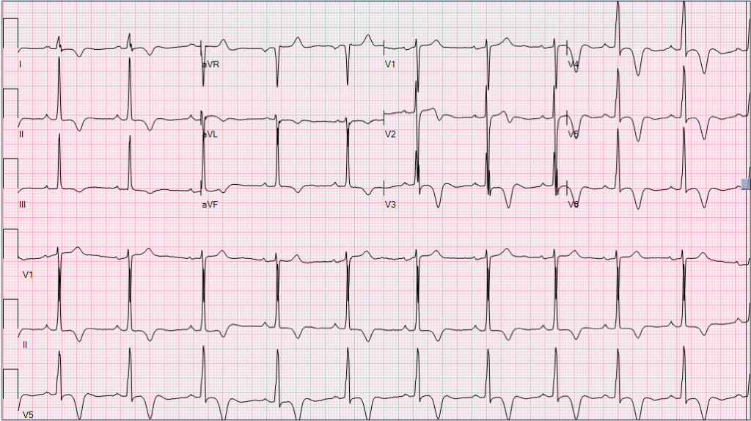

Figure 1. Diffuse T wave inversion in anterolateral leads (aVL, L1, V2-V6).

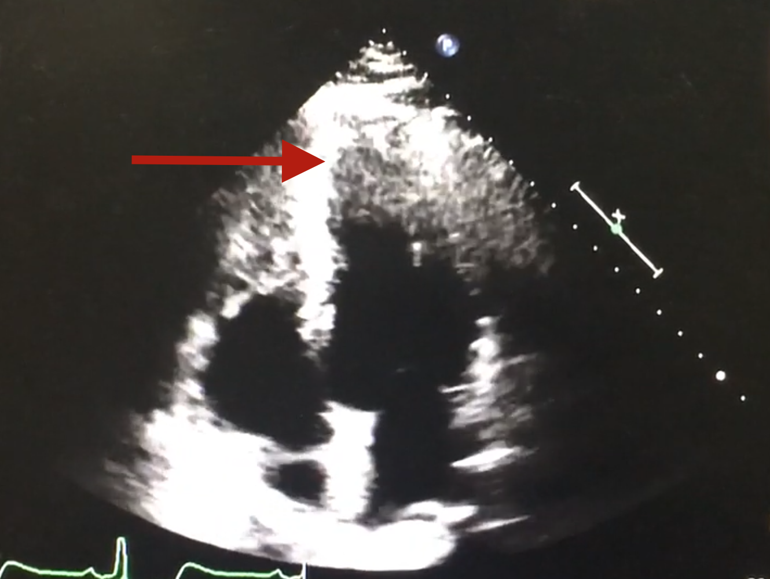

Figure 2. Transthoracic echocardiogram showing the apical hypertrophy of the left ventricle (red arrow).

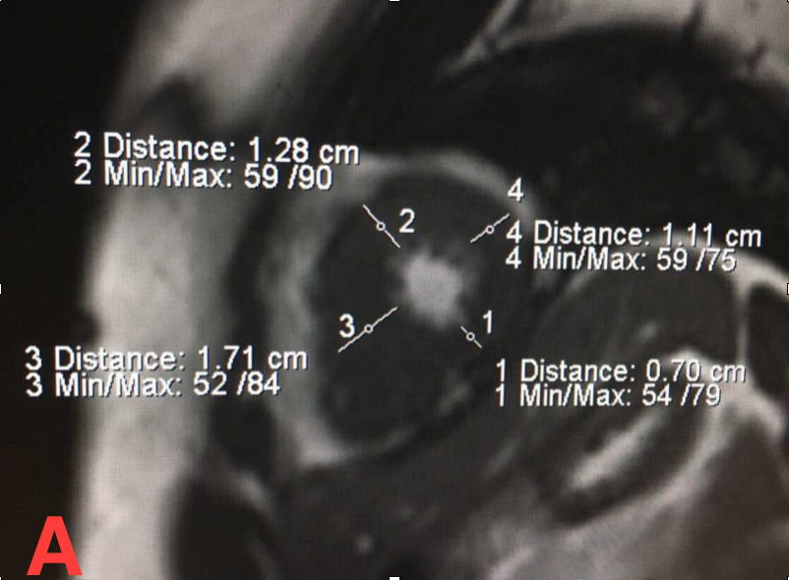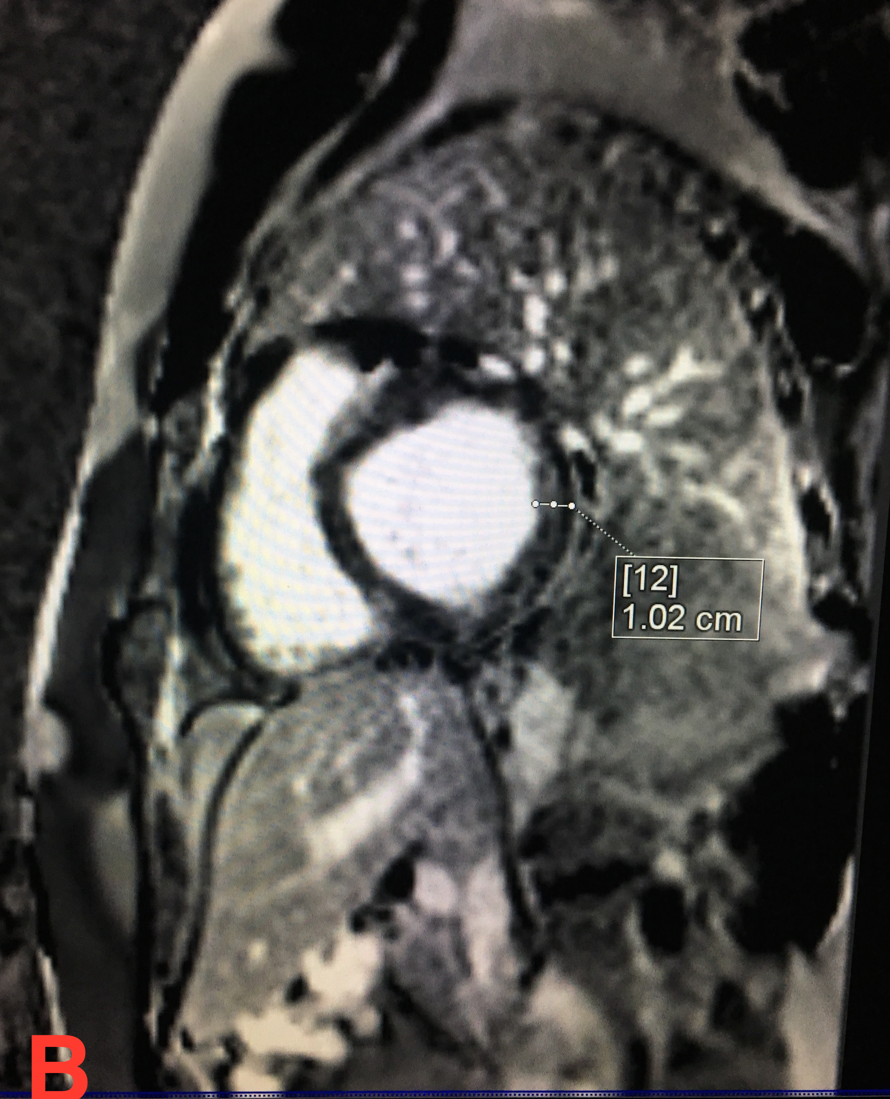

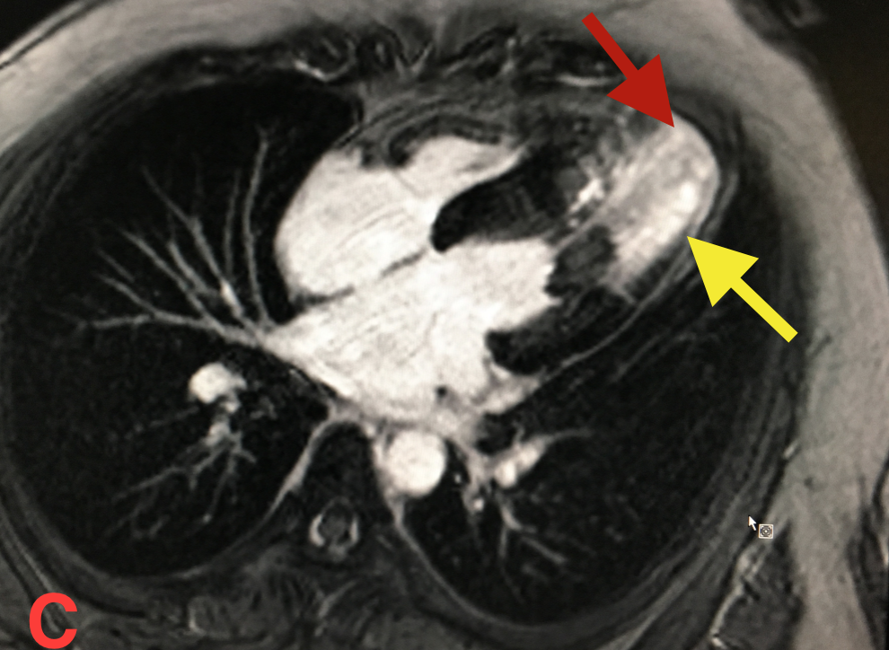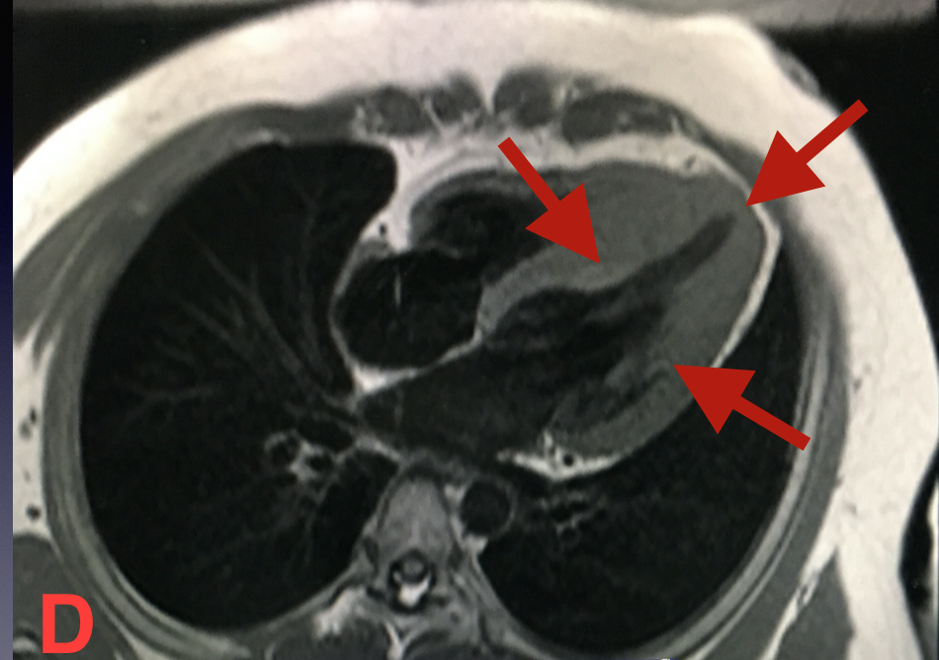

Figure 3. Cardiovascular magnetic resonance showing the left ventricular apical hypertrophy, A, and basal segment B. C, shows the transmural infarct (red arrow) and subendocardial arrow (yellow arrow). A “spadelike” configuration is appreciated at end diastole, D.

