Left ventricular untwist during isovolumic relaxation time in patients with diastolic dysfunction
Abstract
Background: The traditional echocardiographic parameters can evaluate the left ventricular (LV) diastolic function later to mitral valve opening (MVO), while the LV untwisting predominantly occurs during the isovolumic relaxation interval (IVRT) before MVO, so its assessment reflects the LV relaxation. The aim of this study was to employ speckle-tracking imaging (STI) to examine the LV untwisting during IVRT in patients with diastolic dysfunction.
Methods and results: In this study 70 patients with diastolic dysfunction and 25 healthy volunteers were recruited, all individuals were subjected to conventional echocardiography and STI. Using STI, The percentage changes between peak twisting and untwisting at MVO (%UT) was defined as (%dpTw - Utw_{MVO}), the untwisting rate during IVRT (UT rate) was defined as the (%dpTw - Utw_{MVO})/IVRT, where Utw_{MVO} is untwisting at MVO and Tw is the peak LV twist at end-systole. The %UT was significantly reduced among patients compared to controls (0.27± 0.08 vs 0.47 ± 0.06 at P ≤0.001) as such as the UT rate (0.37 ± 0.11 vs 0.67 ± 0.10 at p ≤0.001). Both of the %UT and the UT rate were inversely correlating with and LV wall thickness, peak twist, age, and the presence of DM and/or hypertension. The UT rate was positively correlating with Doppler tissue imaging (DTI) derived mitral annular velocity (e') and IVRT.
Conclusion: Based on STI, LV untwist during IVRT is impaired in patients with diastolic dysfunction. The UT rate and %UT may be beneficial noninvasive parameters for detection of LV diastolic dysfunction.
Key words: Untwisting, Diastolic dysfunction, Speckle tracking.
Introduction:-
Several imaging techniques has been developed for evaluation of LV diastolic dysfunction. However there is no single noninvasive method can provides a direct measurement of LV relaxation [1]. Echocardiographic assessment of LV filling using Doppler flow velocity of the LV inflow in conjunction with pulmonary venous (PVs) flow and mitral annulus velocity measurements using DTI have been used to identify patients with LV diastolic dysfunction, all these indices are load-dependent, measuring events that occur after MVO. Accordingly, evaluation of the earlier stages of LV relaxation including LV untwisting has become an important alternative. LV twisting and untwisting play a major role in LV mechanics [2]. LV untwisting process is the result of active and passive mechanisms with about 40 to 70% of LV recoil occur during IVRT, [3], high levels of stored potential energy from the active systolic twist are transformed into kinetic energy [4], adding a passive component to rapid early diastolic untwisting., hence, the evaluation of LV twisting and untwisting especially untwisting during IVRT may provide new pathophysiological insights in diastolic function[4]. A novel non-invasive methods to assess earlier stages of LV relaxation has been developed, 2D-STI has allowed LV untwisting to be evaluated non-invasively.
This study was conducted to assess LV untwisting during IVRT in patients with diastolic dysfunction.
Patients and methods:-
70 patients proved to have diastolic dysfunction, and 25 age and sex matched apparently healthy volunteers as controls were recruited from May of 2017 to October of 2018. The study included patients with diastolic dysfunction with normal EF. Patient suffering from arrhythmia, valvular lesions, history of ischemic heart disease (ECG changes and/or wall motion abnormality), bundle branch block, congenital heart disease, or cardiomyopathies were excluded. All individuals were subjected to full history taking, thorough clinical examination, 12 lead Electrocardiogram, transthoracic echocardiography (TTE), and STI.
TTE was done using a commercially available echo-cardiographic instrument (E9, GE Medical Systems, and Milwaukee, WI). LV end diastolic dimension and volume (LVIDd, and EDV), end systolic dimension and volume (LVID and ESV), fractional shortening (FS), ejection fraction (EF), and septal and posterior wall thickness (IVS and LVPW) were measured. Patients were identified to have diastolic dysfunction according to Doppler mitral flow pattern and DTI as either of the following: Grade 1 or abnormal relaxation pattern (E/A ratio <0.8 , e'<8 cm/s, and E/e'<8), Grade II or pseudo-normalized filling pattern (0.8 <E/A<2, e'<8 cm/s, and E/e' ratio of 8-14), or Grade III or restrictive filling pattern (E/A >2, e'<8 cm/s , and E/e'>14). From the apical 4 chamber view with the ECG connected to the patient. Using DTI the IVRT was estimated as the interval between the end of S wave and the onset of e' [1].
STI was used for assessment of LV rotational mechanics through scanning and recording from left para-sternal short axis view of both basal and apical planes to quantify basal and apical LV rotations using the same machine and probe with a probe frequency range 1.7-4.0 MHz at a high frame rate (range 80-110 frame/s). Basal level was identified as the plane showing tips of mitral valve leaflets at its center with full-thickness myocardium surrounding the mitral valve. Apical level was defined just proximal to the level of LV apical luminal obliteration at end-systole. Three consecutive cardiac cycles were digitally saved in a cine-loop format. Off-line analyses was done by an independent echocardiographer who was not involved in the image acquisition. The regions of interest were adjusted to include all myocardial thickness without including the pericardium. The endocardial borders of both basal and short axis planes were manually traced and subsequently tracked by the software. After processing, curves of basal and apical LV rotation, twist, peak untwist velocity (PUTV), UT rate were automatically generated by the software (Excel; Microsoft Corporation, Redmond, WA). The %UT at MVO was defined as (%dpTw - Utw_{MVO}), the UT rate during IVRT was defined as the (%dpTw - UT_{MVO})/IVRT, where UT_{MVO} is untwisting at MVO and Tw is the peak LV twist at end-systole (fig 1) [5].
Statistical analysis: Data were fed to the computer and analyzed using IBM SPSS software package version 20.0. (Armonk, NY: IBM Corp) Qualitative data were described using number and percent. The Kolmogorov-Smirnov test was used to verify the normality of distribution Quantitative data were described using mean, standard deviation. Significance of the obtained results was judged at the 5% level. The used tests were: 1 - Chi-square test, 2 - Fisher’s Exact or Monte Carlo correction, 3 - Student t-test, 4 - Mann Whitney test, 5 - Pearson coefficient, 6 - Spearman coefficient
Results:-
Of included subjects there was no significant difference between patients and controls as regard to Sex and age (P≥0.05), Increased prevalence of hypertension and diabetes mellitus (P≤0.001) (table 1), and significantly higher LA diameter (p<.001), and LV walls thickness (P<0.01) among patients. Nonsignificant difference was noted as regard to LVIDd, LVIDs, EDV, ESV, SV, FS and EF between patients and controls. There was a significant difference in transmitral Flow Doppler parameters; E wave (P<0.001), A wave (P<0.02), and E/A ratio (P<0.001), and DTI derived e’ velocity (P<0.001), a' velocity (P<0.001), e'/a' (P<0.001) and E/e' (P <0.001 respectively). Weak but statistically significant longer IVRT (P <0.044). Patients had a significantly higher apical rotation (14.23 ± 6.47 vs 8.12 ± 4.11at P <0.01), Tw (18.99 ± 6.52 vs 11.32 ± 3.75 at P <0.001), PUTV (-113.1 ± 40.15 vs -98.7 ± 24.39 at P ≤0.02), and untwisting degree at time point of MVO (13.94 ± 5.36 vs 6.1 ± 2.26 at p ≤0.001), nonsignificant difference in basal rotation (P>0.05). The %UT (0.27± 0.08 vs 0.47 ± 0.06 at P ≤0.001) and UT rate (0.37 ± 0.11 vs 0.67 ± 0.10 at p ≤0.001) were significantly reduced among patients compared controls (table 2) (fig 1, 2).
Both of the %UT and UT rate were inversely correlating with LV wall thickness, Tw, age, and the presence DM and/or hypertension (p<0.05). The UT rate was positively correlating with e' velocity and IVRT. The %UT and UT rate showed no correlation with E, A, E/A ratio, a', and E/e' ratio, PUTV, LV apical rotation and LV basal rotation among all patients (p>0.05 for all) (table 3).
Discussion:-

The major findings of this study were; first: there was a significantly higher apical rotation, peak twist, and PUTV While there was a significantly lowered %UT and UT rate during IVRT among included patients compared to controls. Second: the %UT and UT rate during IVRT were inversely correlating with LV wall thickness, peak twist, age, and the presence of DM and/or hypertension. Third: the UT rate during IVRT was positively correlating with the DTI derived e' and IVRT. Fourth: the %UT and UT rate during IVRT showed no correlation with mitral Doppler flow indices (peak E, A, E/A ratio), DTI derived a' velocity, E/e' ratio, PUTV, LV apical rotation and basal rotation among all patients.
Previous studies: LV twisting and untwisting play a major role in LV mechanics,[2] hence, the evaluation of LV twisting and untwisting especially untwisting during IVRT may provide new pathophysiological insights in LV function [4]. There is a significant relationship between LV untwisting and LV filling pressures, as untwisting is crucial in the development of intraventricular pressure gradient, a key element of LV early filling suggesting a role for impaired LV untwisting in the pathophysiology of diastolic dysfunction [6, 7]
The current study revealed that there was a significantly higher apical rotation, peak twist, and PUTV While there was a significantly lowered %UT and UT rate during IVRT among included patients compared to controls. Similar abnormalities in myocardial deformation have been described in patients with diastolic heart failure and preserved EF. In particular, Pacileo et al. [8] had suggested that a mechanical adaptation to subclinical systolic abnormalities might induce the early onset of diastolic dysfunction by a prolonged LV twist. As LV Tw is impaired only in heart failure with reduced EF but preserved in those with normal EF. LV twist is prolonged and PUTV is increased but its onset is delayed. The LV twist is ascribed to the dynamic interaction of epicardial ascending segment (AS) and endocardial descending segment (DS) of helical myocardial fibers ensuing counterclockwise rotation of the LV apex and clockwise rotation of the base [9]. AS systolic deformation occurs later to the DS contraction [10]. LV Tw is the maximal instantaneous summation of LV apical rotation and LV basal rotation [11]. In patients with diastolic dysfunction, the time to peak apical rotation is prolonged and leads to decrease in rotational deformation delay and near peak summation of both apical and basal rotation which results in increased peak LV twist. Patients with diastolic dysfunctions have a prolonged time to peak twisting which narrows the temporal hiatus with subsequent reduction of LV untwisting during IVRT [12-14], Subsequently, the inception of untwisting can be dissociated from the onset of the IVRT phase as result of extension of torsion intoIVRT producing an untwisting degree at the time point of MVO more close to the LV peak twist, hence, reduction of both the %UT and the UT rate during IVRT.
In the present study, the %UT and UT rate during IVRT were inversely correlating with LV wall thickness. Similar finding has been depicted by Kovacs et al. [15] on investigating untwisting dynamics in different forms of LV hypertrophy: in athlete's heart and hypertrophic cardiomyopathy, and healthy volunteers. Untwist rate was determined by STI, demonstrated that, its highest values were measured in athletes, while the lowest were found in HCM. Athlete's heart is characterized by increased untwist rate, which can aid diastolic function. Concluding that the evaluation of untwisting dynamics may help to distinguish pathological hypertrophy.
In the present study the %UT and UT rate during IVRT were inversely correlating with age, and the presence of DM and/or hypertension. Similar findings were identified in prior studies. Tadic et al. [16] using STI, found that LV Tw was increased in the hypertensive patients, whereas UT rate gradually decreased from the optimal BP, across the high-normal BP, to the hypertensive patients (p<0.001). In another study recently diagnosed hypertensive patients, the UT rate was significantly decreased in nondippers (P < 0.001) [17]. Hypertensive patients have impaired LV compliance, progressive remodelling and increased myocardial stiffness impairs the release of potential energy stored during systole resulting in prolonged LV twisting and reduced UT rate [18]. Lambadiari et al. [19] studded the effects of 6-month treatment with the glucagon like peptide-1 analogue liraglutide on LV myocardial deformation and oxidative stress in 60 subjects with newly diagnosed type 2 DM with diastolic dysfunction using STI. They found that 6 month treatment with liraglutide improved the LV twisting and untwisting by reducing oxidative stress in subjects with newly diagnosed T2DM. Takeuchi et al.[5] using STI had showed that with advancing age the Peak LV twist was significantly higher, and the rate of LV untwisting significantly reduced and delayed, this may contribute toward the tendency of diastolic dysfunction.
In diastolic dysfunction patients, as LV relaxation is reduced, also the DTI derived e' shows a progressive decline with increasing severity of diastolic dysfunction [1] so it correlates significantly with the reduced UT rate during IVRT in diastolic dysfunction patient as what is showed in the current study. While absence of correlation between UT rate and mitral inflow indices can be explained as follow: [1]. a) Mitral inflow indices are load dependent that begin after MVO while 50-70% of untwist occurs before MVO and prior to the inception of LV filling phase[1] b) LV stiffness increases the peak E wave velocity while UT rate decreases because the stiffness effect controlling mitral flow pattern are not the same that control untwist. c) The Peak E and E/A ratio shows U shaped pattern with progression of diastolic dysfunction from normal to decrease with impaired relaxation to increase and then normalize with pseudonormalized pattern to increase again with restrictive pattern[1]. d) Different timing of mitral inflow indices and LV untwisting.
Limitations: The study population was of relatively small size, and the majority of the patients had mild to moderate LV diastolic dysfunction. The lack of simultaneous invasive measurements for assessing LV diastolic function, although we substituted E/e′ for LV filling pressure in the present study.
Recommendations: Future studies consisting of a larger number of patients, including those with more stiffened LV, such as pseudonormalized or restrictive transmitral flow velocity, are required to confirm the clinical usefulness of diastolic LV untwisting during IVRT.
Conclusion: Based on STI, LV untwist during IVRT is impaired in patients with diastolic dysfunction. The UT rate and %UT may be beneficial noninvasive parameters for detection of LV diastolic dysfunction.

References
1. Nagueh SF, Smiseth OA, Appleton CP, Byrd BF, 3rd, Dokainish H, Edvardsen T, Flachskampf FA, Gillebert TC, Klein AL, Lancellotti P et al: Recommendations for the Evaluation of Left Ventricular Diastolic Function by Echocardiography: An Update from the American Society of Echocardiography and the European Association of Cardiovascular Imaging. European heart journal cardiovascular Imaging 2016, 17(12):1321-1360.
2. Sengupta PP, Khandheria BK, Narula J: Twist and untwist mechanics of the left ventricle. Heart failure clinics 2008, 4(3):315-324.
3. van Dalen BM, Soliman OI, Vletter WB, ten Cate FJ, Geleijnse ML: Insights into left ventricular function from the time course of regional and global rotation by speckle tracking echocardiography. Echocardiography 2009, 26(4):371-377.
4. Rademakers FE, Buchalter MB, Rogers WJ, Zerhouni EA, Weisfeldt ML, Weiss JL, Shapiro EP: Dissociation between left ventricular untwisting and filling. Accentuation by catecholamines. Circulation 1992, 85(4):1572-1581.
5. Takeuchi M, Nakai H, Kokumai M, Nishikage T, Otani S, Lang RM: Age-related changes in left ventricular twist assessed by two-dimensional speckle-tracking imaging. Journal of the American Society of Echocardiography : official publication of the American Society of Echocardiography 2006, 19(9):1077-1084.
6. Popescu BA, Calin A, Beladan CC, Muraru D, Rosca M, Deleanu D, Lancellotti P, Antonini-Canterin F, Nicolosi GL, Ginghina C: Left ventricular torsional dynamics in aortic stenosis: relationship between left ventricular untwisting and filling pressures. A two-dimensional speckle tracking study. European journal of echocardiography : the journal of the Working Group on Echocardiography of the European Society of Cardiology 2010, 11(5):406-413.
7. Nogami Y, Ishizu T, Atsumi A, Yamamoto M, Nakamura A, Machino-Ohtsuka T, Kawamura R, Seo Y, Aonuma K: Diastolic suction in heart failure: impact of left ventricular geometry, untwist, and flow mechanics. Life sciences 2014, 102(2):111-117.
8. Pacileo G, Baldini L, Limongelli G, Di Salvo G, Iacomino M, Capogrosso C, Rea A, D'Andrea A, Russo MG, Calabro R: Prolonged left ventricular twist in cardiomyopathies: a potential link between systolic and diastolic dysfunction. European journal of echocardiography : the journal of the Working Group on Echocardiography of the European Society of Cardiology 2011, 12(11):841-849.
9. Stohr EJ, Shave RE, Baggish AL, Weiner RB: Left ventricular twist mechanics in the context of normal physiology and cardiovascular disease: a review of studies using speckle tracking echocardiography. American journal of physiology Heart and circulatory physiology 2016, 311(3):H633-644.
10. Castella M, Buckberg GD, Saleh S, Gharib M: Structure function interface with sequential shortening of basal and apical components of the myocardial band. European journal of cardio-thoracic surgery : official journal of the European Association for Cardio-thoracic Surgery 2005, 27(6):980-987.
11. Sengupta PP, Tajik AJ, Chandrasekaran K, Khandheria BK: Twist mechanics of the left ventricle: principles and application. JACC Cardiovascular imaging 2008, 1(3):366-376.
12. Buckberg G, Hoffman JI, Nanda NC, Coghlan C, Saleh S, Athanasuleas C: Ventricular torsion and untwisting: further insights into mechanics and timing interdependence: a viewpoint. Echocardiography 2011, 28(7):782-804.
13. Buckberg GD, Hoffman JI, Coghlan HC, Nanda NC: Ventricular structure-function relations in health and disease: part II. Clinical considerations. European journal of cardio-thoracic surgery : official journal of the European Association for Cardio-thoracic Surgery 2015, 47(5):778-787.
14. Buckberg G, Hoffman JI, Mahajan A, Saleh S, Coghlan C: Cardiac mechanics revisited: the relationship of cardiac architecture to ventricular function. Circulation 2008, 118(24):2571-2587.
15. Kovacs A, Apor A, Nagy A, Vago H, Toth A, Nagy AI, Kovats T, Sax B, Szeplaki G, Becker D et al: Left ventricular untwisting in athlete's heart: key role in early diastolic filling? International journal of sports medicine 2014, 35(3):259-264.
16. Tadic M, Majstorovic A, Pencic B, Ivanovic B, Neskovic A, Badano L, Stanisavljevic D, Scepanovic R, Stevanovic P, Celic V: The impact of high-normal blood pressure on left ventricular mechanics: a three-dimensional and speckle tracking echocardiography study. The international journal of cardiovascular imaging 2014, 30(4):699-711.
17. Tadic M, Cuspidi C, Majstorovic A, Sljivic A, Pencic B, Ivanovic B, Scepanovic R, Kocijancic V, Celic V: Does a nondipping pattern influence left ventricular and left atrial mechanics in hypertensive patients? Journal of hypertension 2013, 31(12):2438-2446.
18. Tan YT, Wenzelburger F, Lee E, Heatlie G, Leyva F, Patel K, Frenneaux M, Sanderson JE: The pathophysiology of heart failure with normal ejection fraction: exercise echocardiography reveals complex abnormalities of both systolic and diastolic ventricular function involving torsion, untwist, and longitudinal motion. Journal of the American College of Cardiology 2009, 54(1):36-46.
19. Lambadiari V, Pavlidis G, Kousathana F, Varoudi M, Vlastos D, Maratou E, Georgiou D, Andreadou I, Parissis J, Triantafyllidi H et al: Effects of 6-month treatment with the glucagon like peptide-1 analogue liraglutide on arterial stiffness, left ventricular myocardial deformation and oxidative stress in subjects with newly diagnosed type 2 diabetes. Cardiovascular diabetology 2018, 17(1):8.

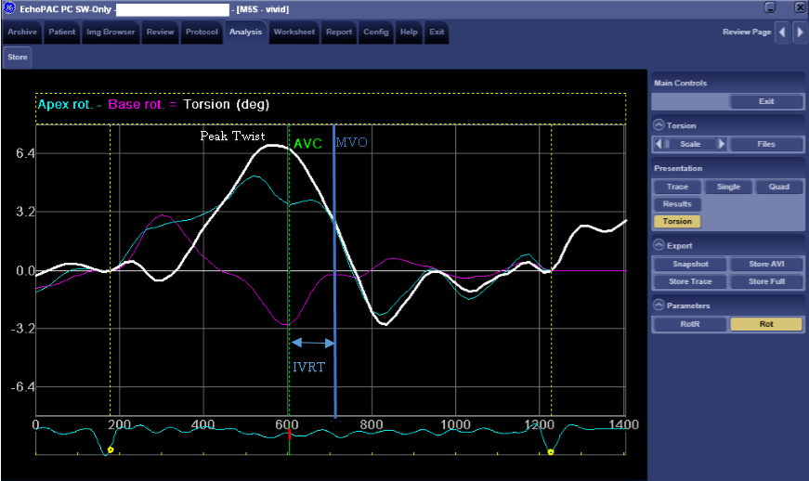
Figure 1: Torsion curve showing typical LV rotation, peak twist and untwist rate during IVRT in a healthy individual during resting conditions.
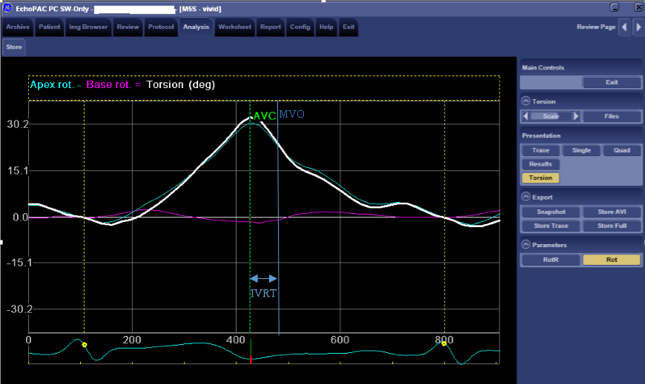
Figure 2: Torsion curve showing LV rotation, peak twist, and untwist rate during IVRT in diastolic dysfunction patient during resting conditions.

