Optical Coherence Characteristics of Suspected Hypersensitivity Reaction Following Ultimaster Drug-Eluting Stent Implantation

The number of bioresorbable polymer coating stents that are commercially available is increasing. They present some potential benefits by eliminating the need for long-term polymer exposure as well as other appealing characteristics that facilitate and enhance endothelial coverage.

Since it’s launch, several trails looked into the safety and efficacy of the bioresorbable stents. In 2014, the Century II trial compared the Ultimaster with Xience Everolimus-eluting stent with the circumferentially-coated durable polymer (Abbot Vascular). This trial concluded that the Ultimaster is non-inferior to Xience Everolimus DES in its primary endpoint which was target vessel failure TVF. In another word, it showed excellent performance at a low rate of risk events.

However, less is known regarding the effect of these new devices. In particular, the type of ISR and how it’s different regarding time course, morphology and more importantly in the clinical events.

A 59-year-old female presented to the cardiology clinic with a history of recent angina. Her risk factors included dyslipidemia, type II diabetes mellitus and previous PCI to both the right coronary artery (RCA) with Terumo Ultimaster 2.5 x38 mm Stent and the Circumflex artery (CX) using Abbot Xience Pro 2.25 X23m for non-ST elevation myocardial infarction in 2017. Stress echocardiogram proved reversible ischaemia in LAD and RCA regions and repeat catheterisation revealed an image angiographically compatible with significant in-stent restenosis (ISR) at mid-RCA stent; the CX showed moderate lesion just proximal to the previous stent which was widely patent and a severe proximal LAD disease. Surgical MDT was in favour of PCI as RCA anatomy distal to the stent is not graftable. For the RCA ISR treatment, we opted to perform Optical Coherence Tomography (OCT) for better characterisation of the lesion; this showed appropriate deployment of the stent, some areas with microvessels and per-strut low-intensity signals suggestive of endothelial dysfunction, intimal hyperplasia with interestingly focal areas of inflammation suggestive of polymer hypersensitivity. The ISR was treated with DES pre-dilated for optimisation.

The global literature and data on Ultimaster ISR and management (a paclitaxel-coated balloon, or a drug-eluting stent) are scarce, and to the very best of our knowledge, this case is one of the first descriptions of Ultimaster in-stent restenosis (or failure) secondary to possibly polymer allergic reaction. The use of intracoronary OCT imaging as an advanced imaging tool provided us with a unique opportunity to understand and manage complex and infrequent conditions like this one.

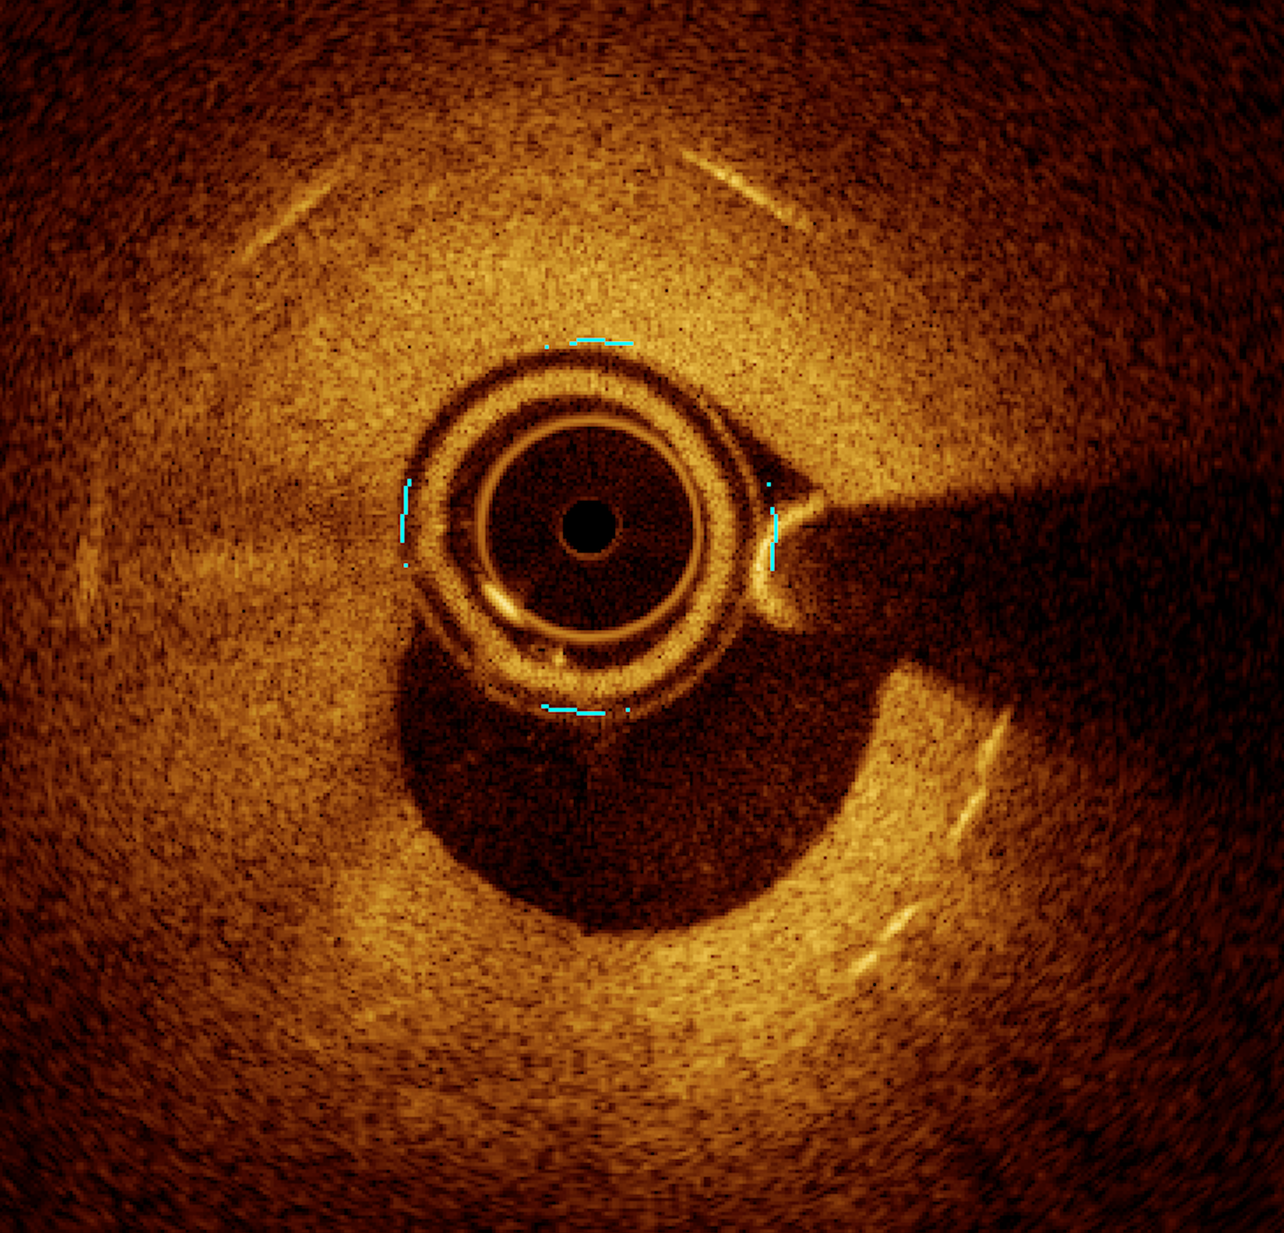

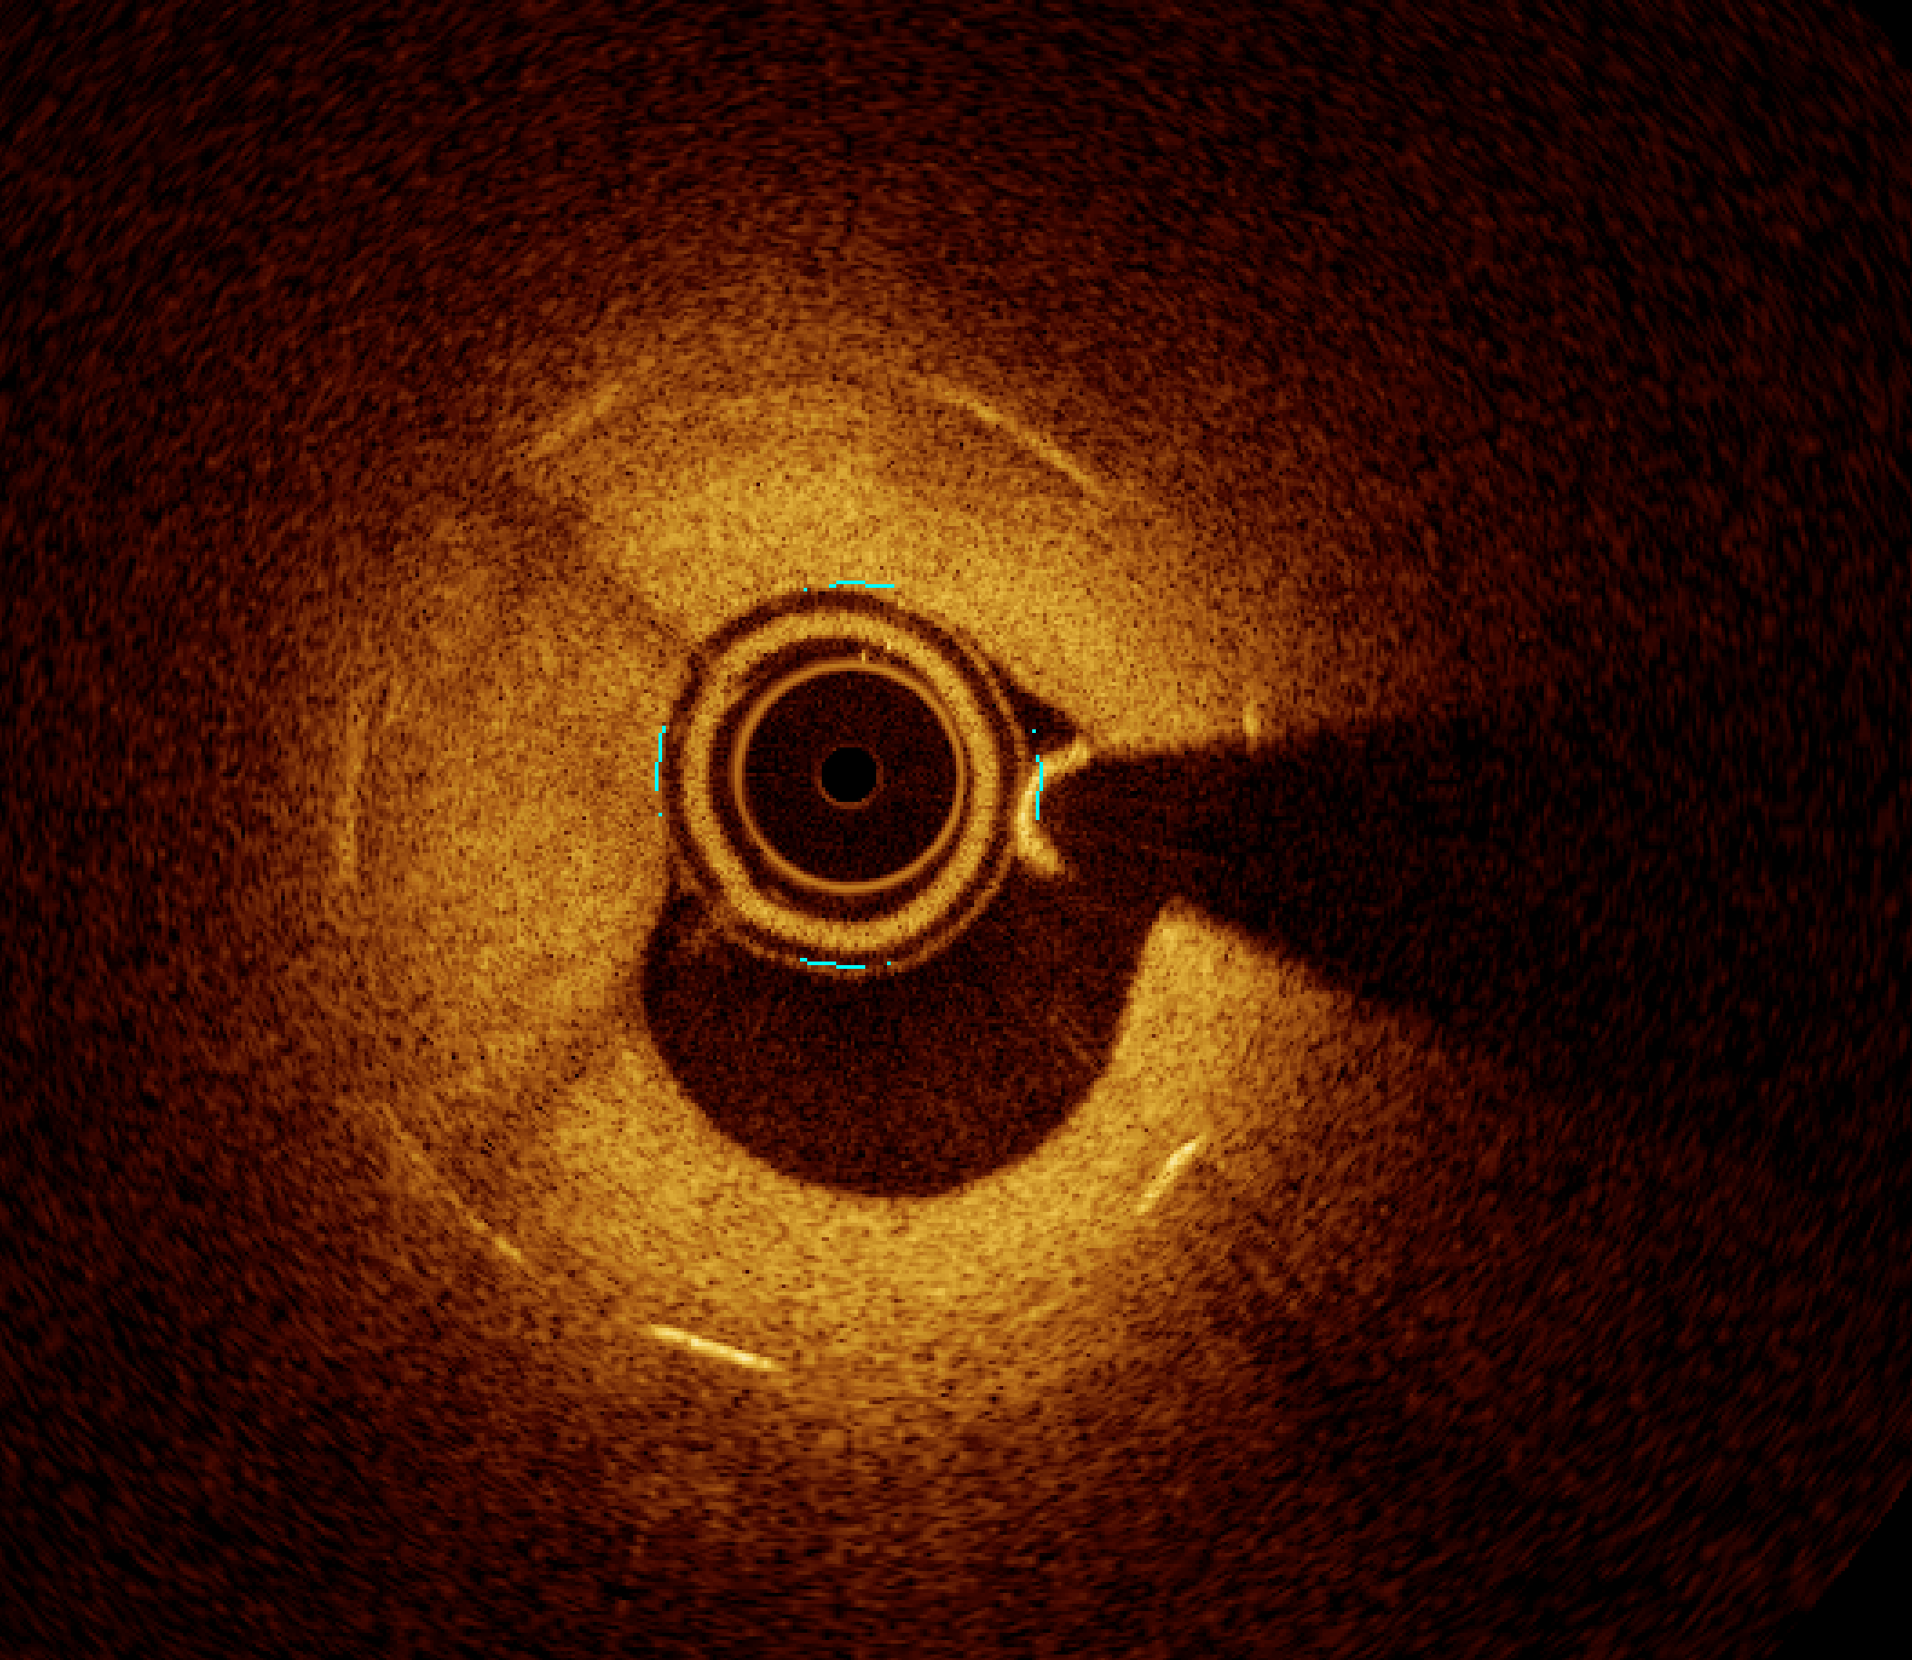

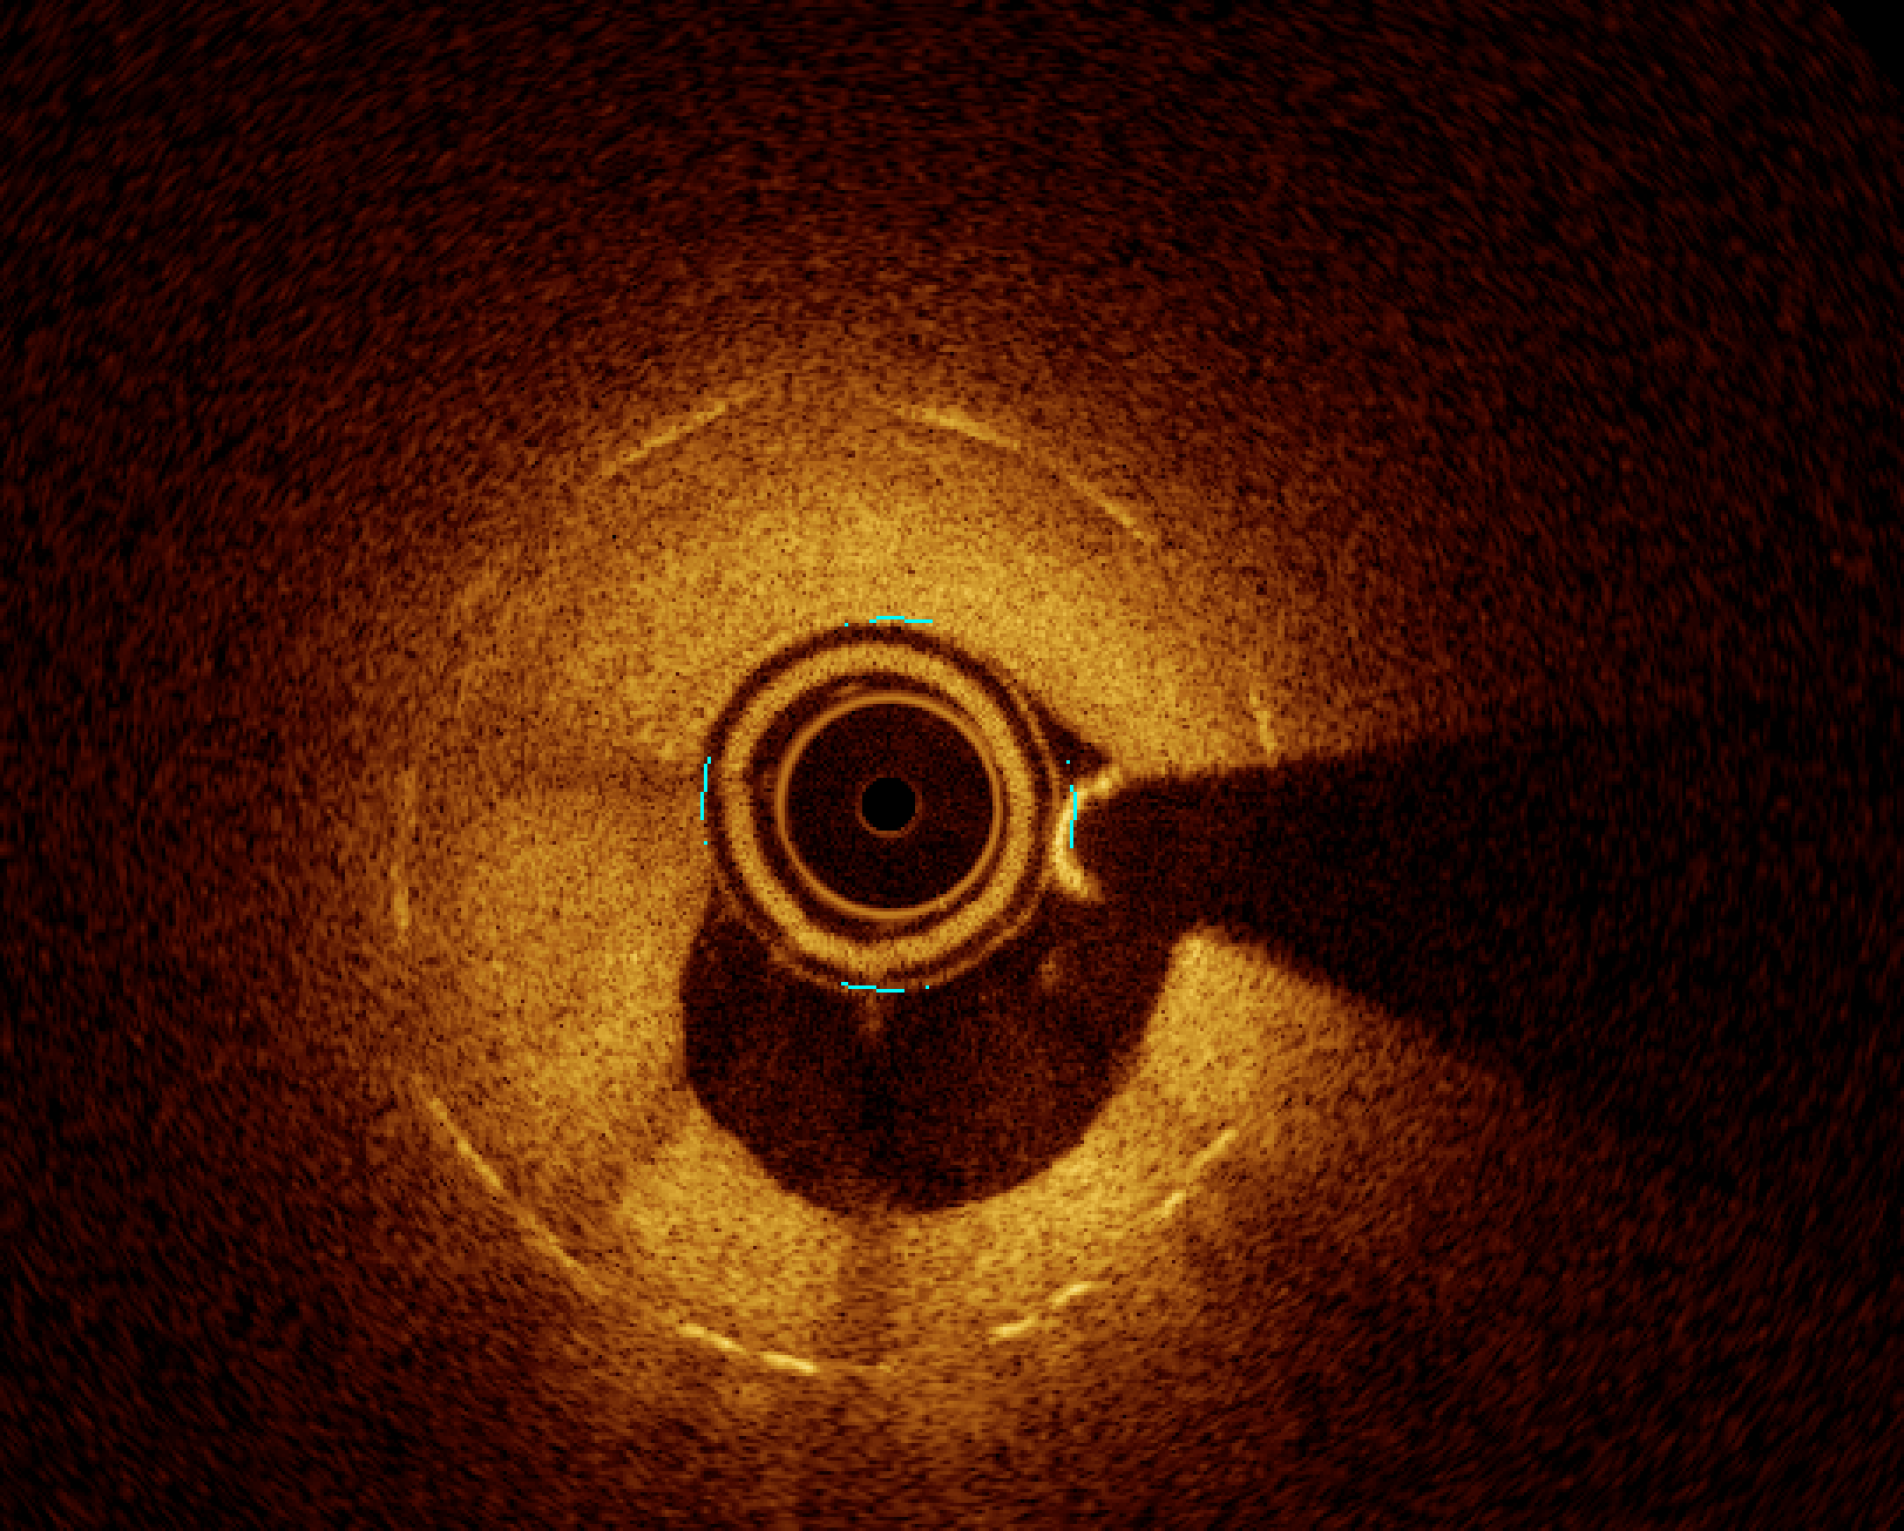

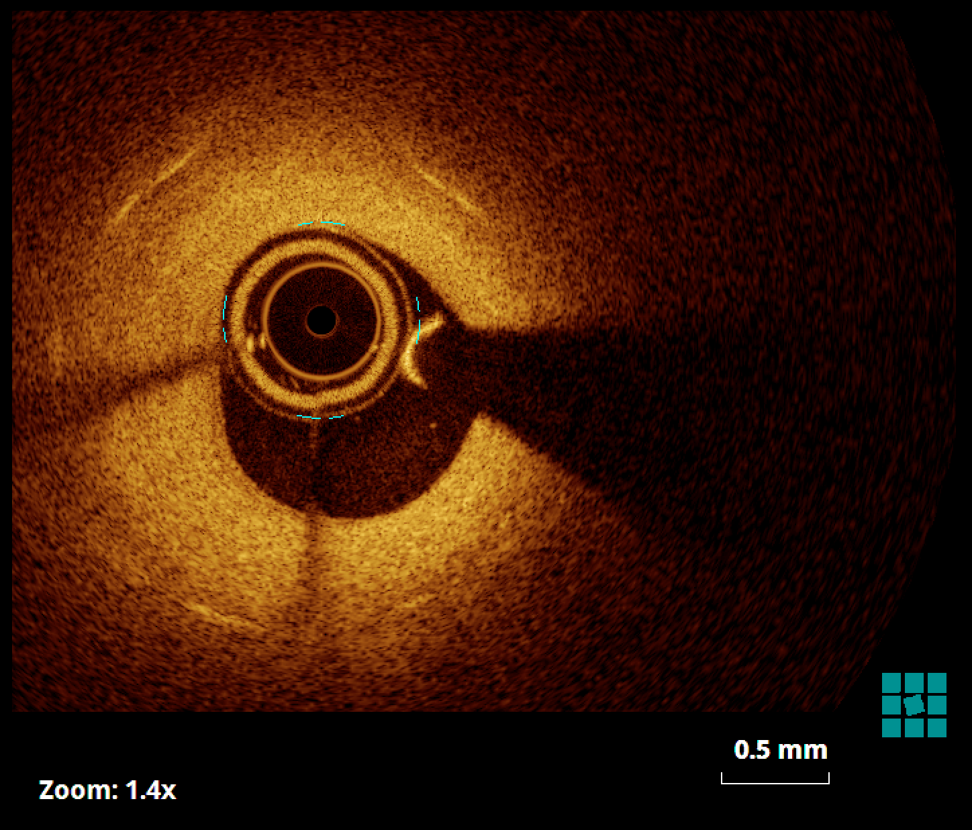

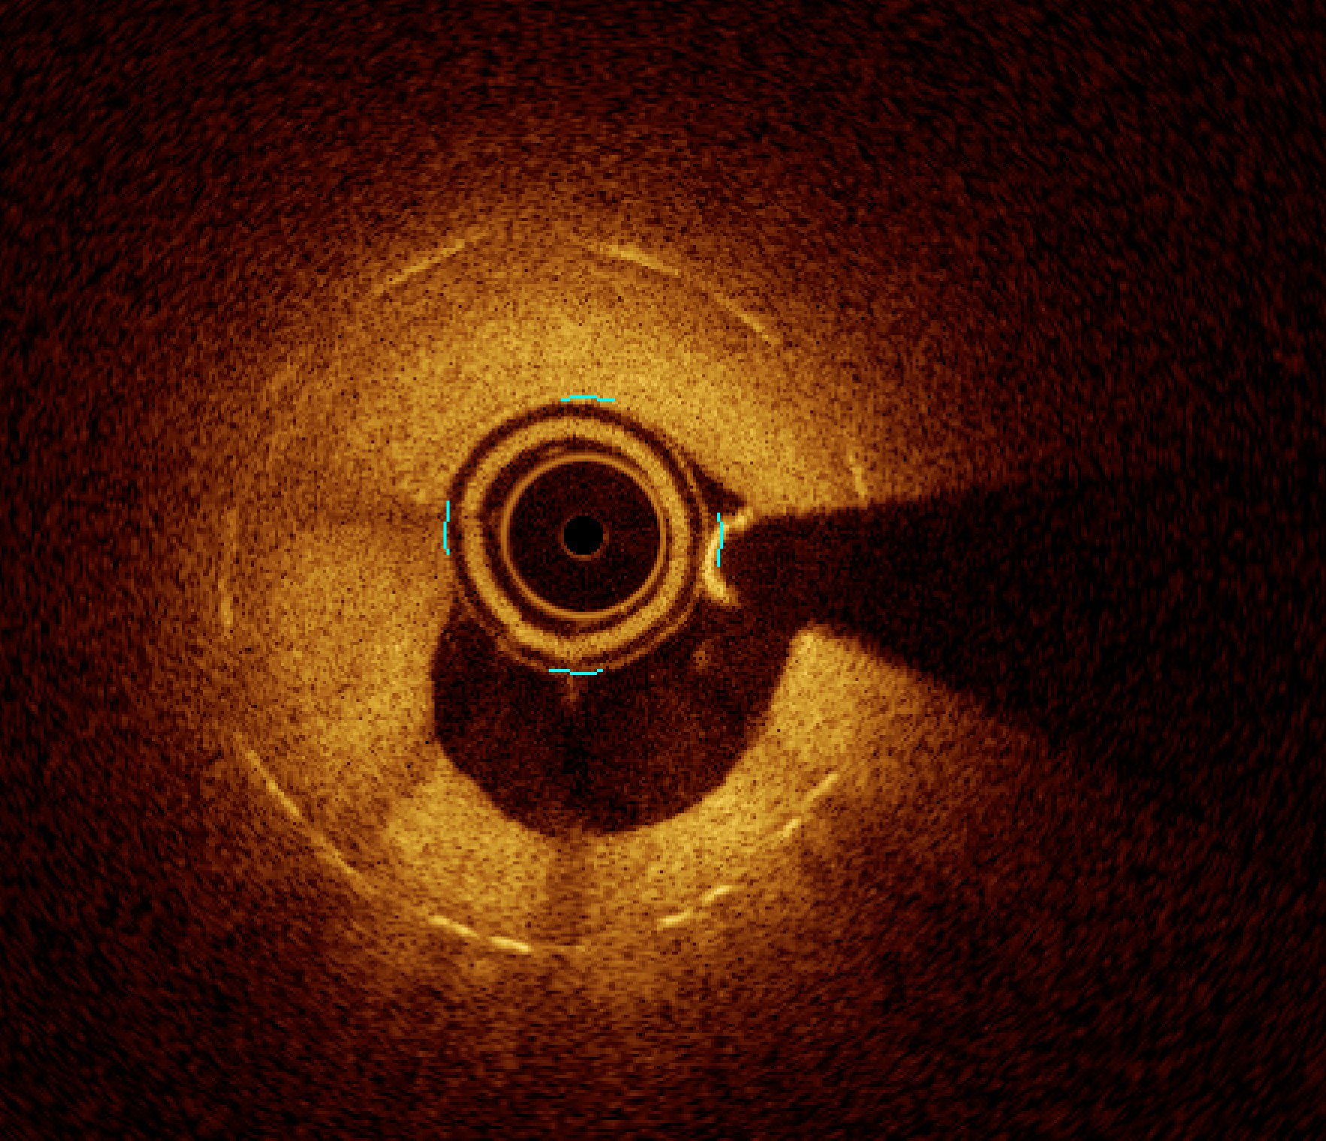

References
- Alberto Chisari et al. The Ultimaster Biodegradable-Polymer Sirolimus-Eluting Stent: An Updated Review of Clinical Evidence. Int J Mol Sci. . doi: 10.3390/ijms17091490

- Philippe Garot, MD et al. 2-Year Outcomes of High Bleeding Risk Patients After Polymer-Free Drug-Coated Stents. JACC doi.org/10.1016/j.jacc.2016.10.009

