Contrast induced nephropathy after femoral or radial access for diagnostic or interventional coronary management
CIN-FAVSRA

Abstract

BACKGROUND it remain unclear whether radial access (RA),compared with femoral access(FA),mitigates the risk of contrast induced nephropathy(CIN).

METHODS in a single center non randomized controlled trial in September 2016 to April 2017 we included 410 patients Incidence of CIN by considering of the type of access in high risk patients for CIN underwent coronary angiography or angioplasty.the primary CIN-FAVSRA endpoint was AKI,defined as an absolute (>0.5mg/dl) or a relative (>25%) increase in serum creatinin(sCr).

RESULTS CIN occurred in 49 patients (12%),from patients with CIN 39 patients (15.1%) had FA vs 10 patients (6.6%) with RA(OR:0.395;CI:0.191-0.817;p=0.0.01).but after adjusting the same group of Mehran risk score (both low ,high risk) the incidence of CIN significantly decreased in RA groups compared with FA(OR:0.387;CI:0.1720.751;p=0.007).

CONCLUTION in patients who underwent diagnostic angiography or angioplasty RA was associated a reduced risk of CIN compared with FA both low and high risk MS.

Background
In recent years, use of contrast agent (CA) has increased steadily in routine medical practice .in last two decades an increase of 390% in cardiac catheterization has been reported(1).inspite of improvement in their chemical structure CA still possess kidney toxicity & represent the third most common cause of hospital-acquired AKI ,increasing both short and long term risk for adverse event ,including the need for hemodialysis,MI,CHF,CVA and death(1).
Definition of CIN include absolute (>0.5mg/dl) or relative (25%) increase in Scr at 48-72hr after exposure to CA compared to baseline Scr Value when alternative explanation for renal impairment have been excluded.(1)
Although the risk of CIN is low (0.6-2.3%) in general population ,it may be very high (up to 50%) in selected such as sever CKD and DM(1).
The most popular theories include a combination of decreased renal medullary blood flow ,resulting in medullary ischemia ,free radicals Formation ,direct toxic effect on tubular cells (1).
Because no effective treatment exists for CIN ,preventive remain the key strategy.(1)

Comparison of previous study
In one study in Michigan related to 47 hospitals during 2010-2012 on 8225 patients was showed risk of bleeding and AKI was reduced in RA compared to FA .this study although hemorrhage act as an independent risk factor in AKI ,but RA has not reduced risk of CIN by decreasing of bleeding (4).

in the registry study in Pennsylvania during 2007-2014 about 5353 patients underwent TF PCI&2176 patients underwent TR PCI ,in this study incidence of CIN was 1.1% in RA & 2.4% in FA(P=0.001),and in this study concluded when access ,BARC score bleeding ,MS were independent risk factors for CIN (5).

FACTORS OR(95%CI). P VALUE

MS >=11 1.23(1.19-1.271) 0.0001
BARC score 1.65(1.17-3.66) 0.013
RA 0.6(0.59-0.01) 0.033
In the AKI-MATRIX study published in JACC 2017, RA was associated with decreasing of CIN in high risk groups of MS(>10)),but no significant relationship with low risk group (P=0.0025 vs P=0.27) ,(6).
In another study that was performed on 204 PCI done in department of interventional cardiology ,contrast volume was more in RA vs FA (P=.024),therefore the author has warned use of RA about patients with a higher risk for CIN (7).

Purpose of the study
The main purpose of this study was to assess the predictive power of the access (FA vs RA) in similar MS groups with (low score <=10 or high >10),[figure 1}in predicting CIN ,however to evaluate the effect others variable such as age ,sex,hypertension,hypotention,before and after serum creatinine ,LVEF,contrast volume ,procedures type(angiography or angioplasty),anemia, drop of HCT and rising of eosinophils plus monocytes after procedure,BARC score,smoking,Contrast agent type ,GFR score ,eGFR,BMI,BMI/eGFR,V/eGFR,IABP on CIN [table 4a,b,c].
Also we e relationship of these variable with access[table 3a,b,c].

Figure 1
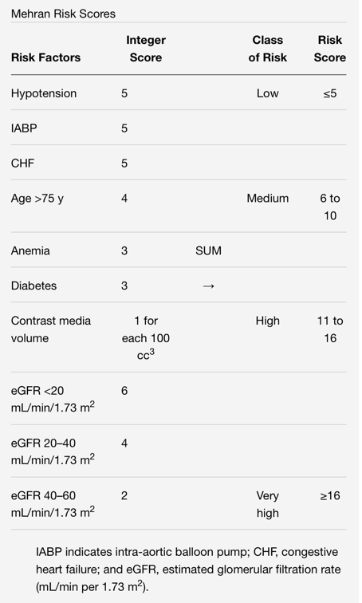
Methods
From September 2016 to April 2017, we enrolled all patients admitted to our RHC for elective or early invasive coronary catheterization .
We excluded congenital or structural heart disease and decision for FA or RA was belong to first operator of our center.
All patients weren't received any preventive medication for CIN except 500ml N/S pre and post procedure up to 12 hr.then clinical &Lab data such as access(FA or RA),contrast type, before and after Scr ,BARC score ,HTN,hypotension (SBP<80mmhg),use of IABP,LVEF,Hx of anemia,amount drop of Hct,before and after eosinophils and monocytes and amount of eosinophils and monocytes increased ,GFR score ,eGFR<60or>=60 ml/min/1.73m2),MS, contrast type ,procedure type(angiography vs pci),V/eGFR,BMI,V/eGFR,Scr ,Hct 48hr after procedure were detected[table1,2].
This study was single center and non randomized controlled trial.

Statistics

Statistics: Statistical analysis was performed with SPSS 15 for Windows (SPSS Inc., Chicago, Illinois). Mean standard deviation (SD) and frequency was used as descriptive analysis. For evaluation the distribution of data one-sample Kolmogorov-Smirnov test was used. To compare the mean variables between two groups, an independent t-test or Mann- Whitney U test was used. Qualitative data were compared with Chi2 test. Multivariable logistic regression models were used to identify the associates of CIN following procedure. Multivariable logistic regression model using the backward variable selection method was constructed based on variables that resulted significant (P<0.05) from univariable logistic regression.
During the follow up variables predictive of event were calculated through univariable and multi variables analysis by logistics regression ,cox regression and presented with ,respectively ,odd ratio(OR) and 95%CI.

Results

Of a total 410 patients(289 men,121 women ,mean age 61.3 ±10.8) years old)were included in this study .
The overall descriptive and frequency of baseline clinical and Lab characteristics of patients were showed in table 1,2.
CIN occurred in 49 patients (12%), primary endpoint was defined by absolute >=0.5mg/dl or relative > 25% increase in baselines Scr.
In our patients 258 vs 152 (62.9% vs 37.1%) had FA vs RA respectively[ table 1].
From patients with CIN 39 person (15.1%) had FA vs 10 person (6.6%) with RA.
Patients with AKI were older and frequently men and higher level of BARC score >=2( p=0.005),[table 4b,c].
Hct drop after procedure (>=3) had significant incidence in FA,[(p=0.004);OR=1.893;95 %CI=1.217-2.943];[table 3b].
Mean increased in Scr after procedure was 0.04mg/dl vs 0.0mg/dl in FA vs RA respectively (p=0.011).[table 3c].
Percentage of patients who developed with CIN were more common in older ,smoker ,hypertensive,diabetics,hypotensives,low lvef ,anemic high risk MS(score>10)Low eGFR,group patients,[table 4a,b]also in patients with more increased eosinophils plus monocytes after procedure[table4a,b],[figure2].

TABLE 1: Frequency Table

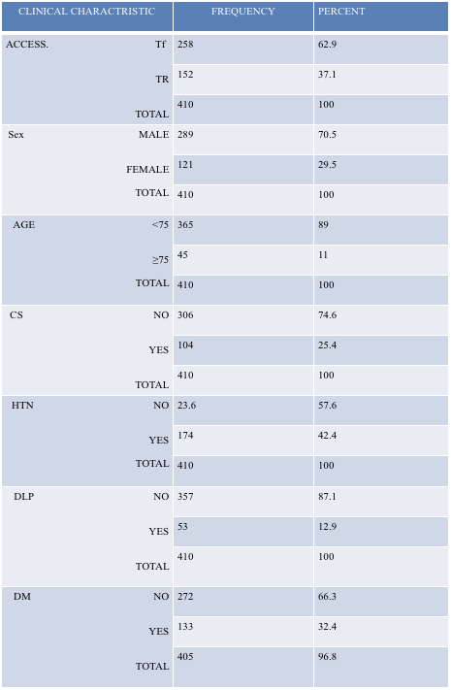
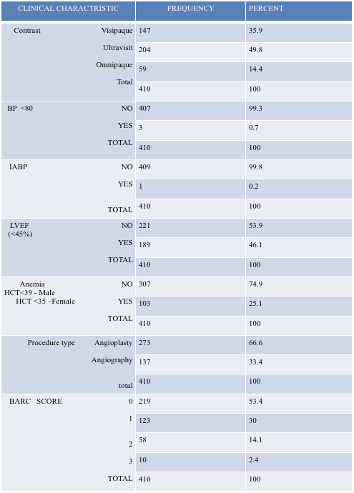

Table 2: descriptive

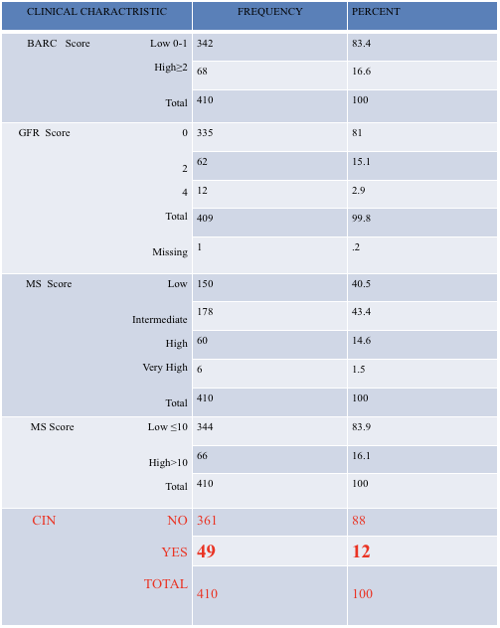

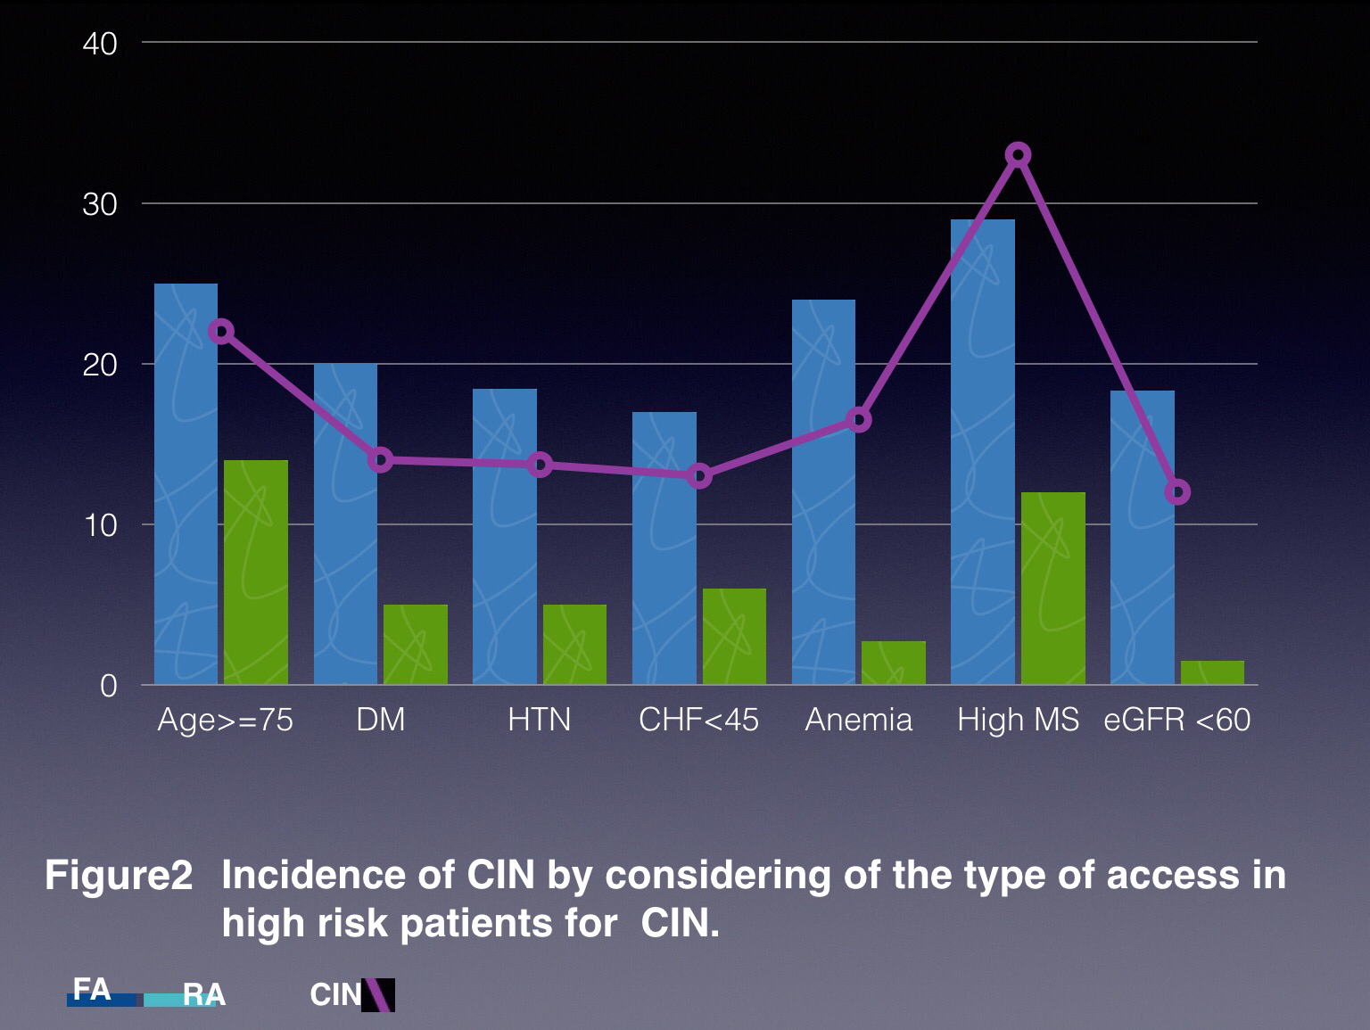

Continue results
In our analysis we showed that percentage of high BARC score ,contrast volume ,increase of eosinophils plus monocytes post procedure, Hct drop were more common in FA access groups [ table 3a,b,c ],[figure 3].

There isn't relationship between CIN and contrast type (p=0.589) [table 4a] showed as previous studies.

With access ,BARC score ,MS ,delta Hct ,age >75,GFR score ,we found significant correlation by multivariable regression test between CIN with BARC score (p=0.008),access(p=0.019) and MS (p=0.004) as independent risk factor,also most powerful risk factor was MS[table5].

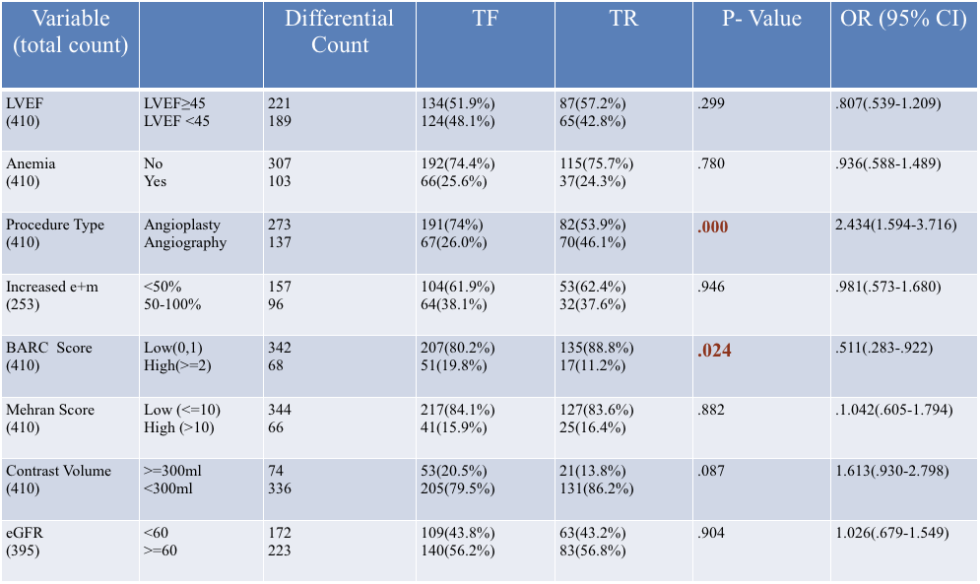
Table 3 - a :Correlation Of Access With Others Variables
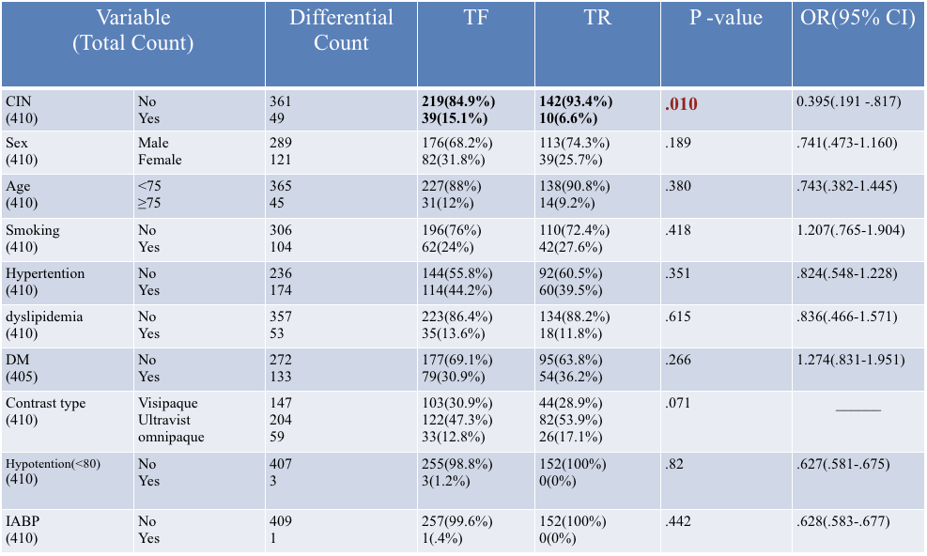

Table 3 - b :Correlation Of Access With Others Variables

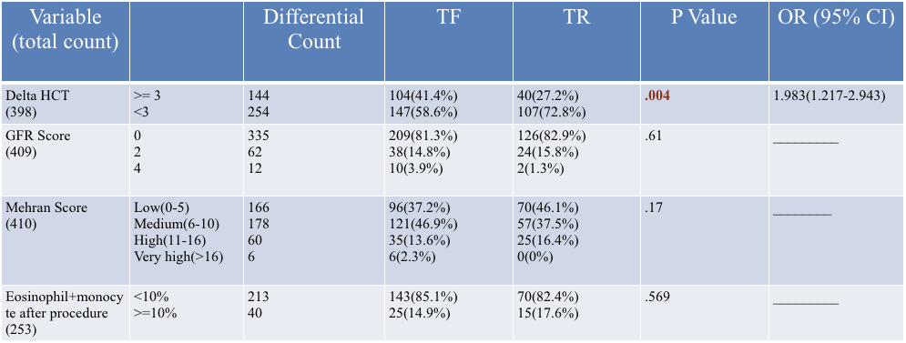
Table 3 – b (continue) :Correlation Of Access With Others Variables
Table 3-c: Correlation Of Access With Others Variables
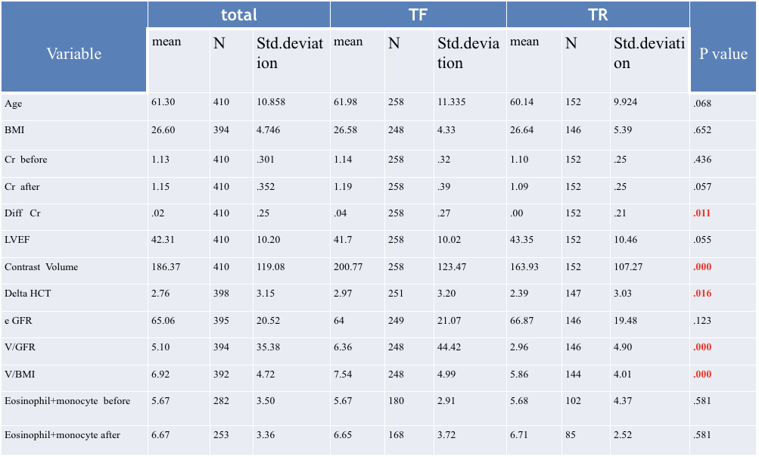

Discussion
Among patients who were done angiography or angioplasty ,use of RA was significantly associated with reduction in CIN compared with FA(6.6% vs 15.1%),p=0.01,OR=0.395,(95%CI=0.191-0.817);[table 3a].
These findings were consistent across predefined patients subgroups.
There was quantitative positives interaction testing in patients at highest risk such as those with high or low risk MS ,in whose a greater benefit of RA vs FA was observed , p=0.007 95%CI=0.172-0.757);[table 6].
In ours analysis there was significant correlation between CIN with age(p=0.024),MS(p=0.003),BARC score (p=0.005);[table 4a, b].
In another bi variables test with CIN ,we can't found significant p value ;however the frequency percentage of patients with CIN was more in subgroups of patients with characteristics that didn't have the characteristics of the rest of the patients such as anemia(16% vs10%),HTN(13% vs10%),lowLVEF(13% vs10%),DM(14% vs11%), increased eosinophils plus monocytes (17 %vs11.4%),lesser BMI(p=0.053);[table 4 a,b,c]

In the multi variables regression analysis between CIN and access ,BARC score,delta HCT>=3,age >75’GFR score ,the most important independent risk factor for CIN was MS(p=0.004);95%CI=1.52-9.01[table 5].

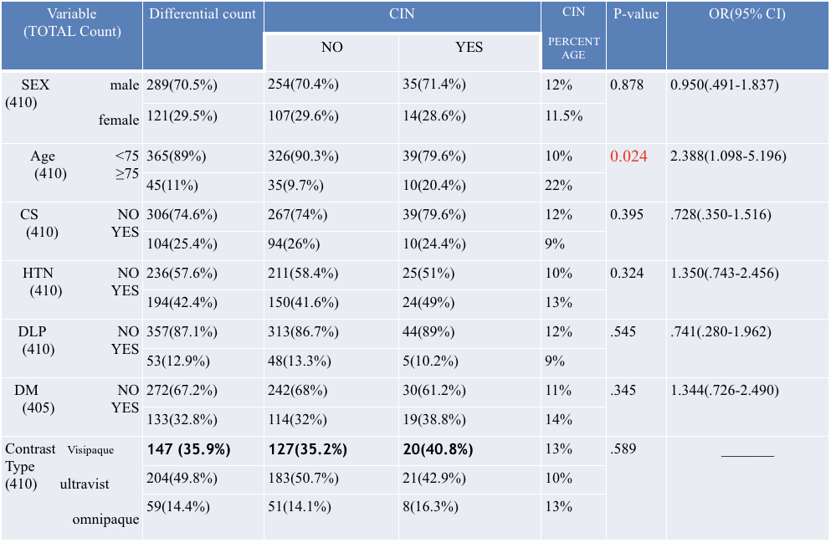
Table 4-a: Correlation Of CIN With Others Variables

Table4-b: Correlation Of CIN With Others Variable
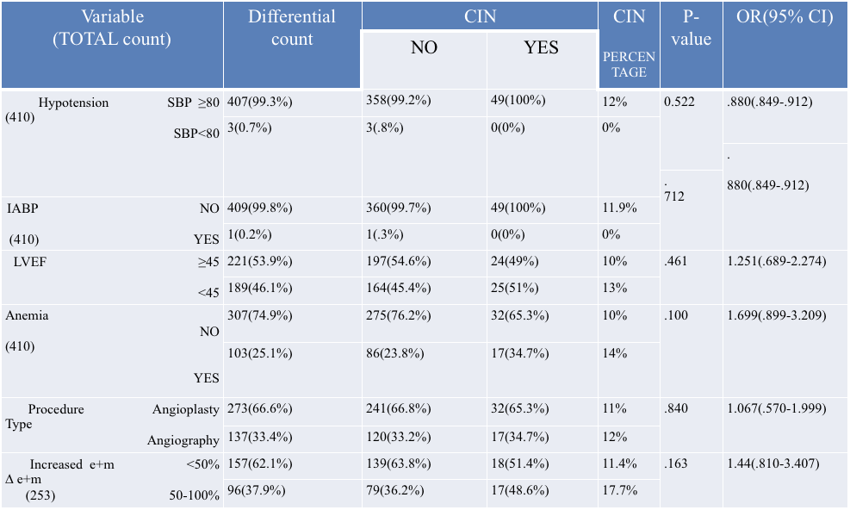

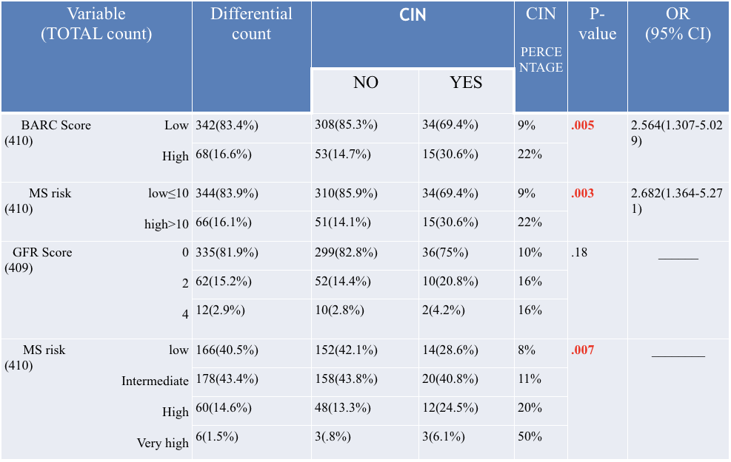
Table 4-b(continue): Correlation Of CIN With Others Variable

Table 4-c: Correlation Of CIN With Others Variables
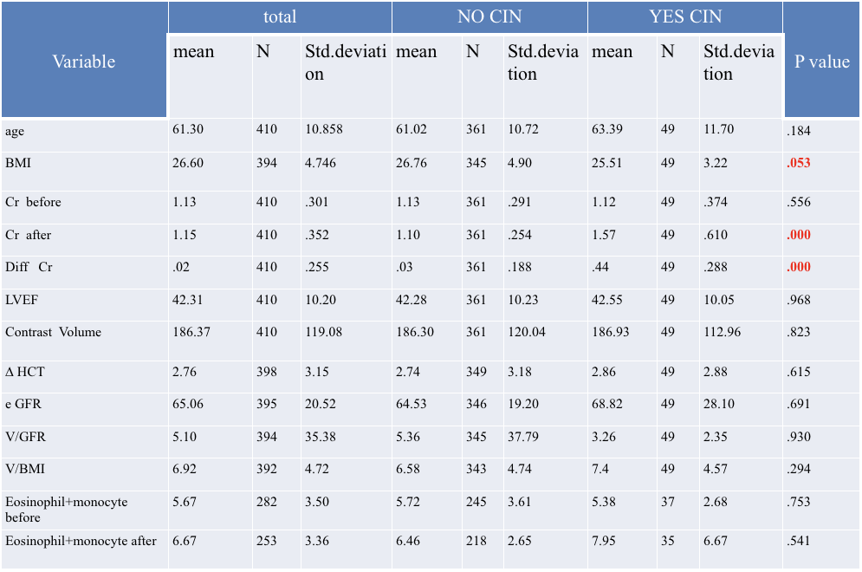

Table 5: Multi Variable Regression Analysis Between CIN And Some Variable
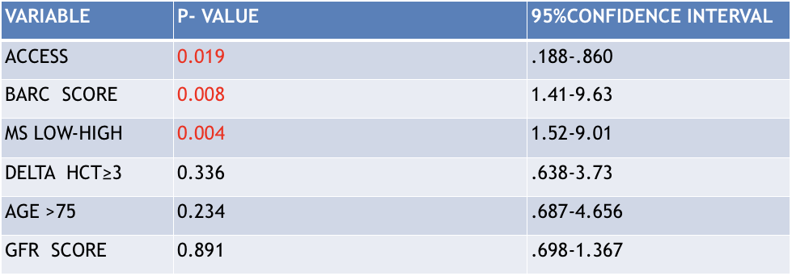

Variable Including : Access , BARC Score ,MS (Low Or High),Delta HCT (≥3), Age >75 , GFR Score.

Table 6: Correlation Of CIN With Access In Similar MS risk Group

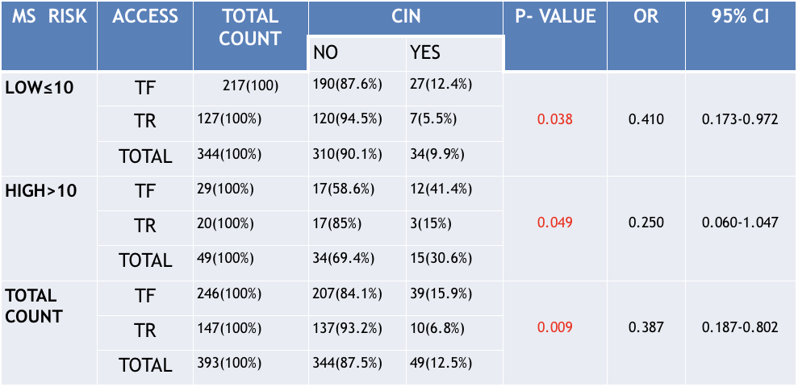
Note: adjusted P-value and 95% CI for MS-access-CIN was 0.007 (0.172-0.751) by mantel – haenszel common OR estimation test.

Discussion continue
Hydration with isotonic saline remain the only class I recommend intervention in patients at medium to high risk who are undergoing invasive management .

Yet many patients with CAD especially with ongoing MI aren't eligible for this preventive treatment due to expedite catheterization ,therefore minimization during procedure remain the most important preventive strategy in these patients,(6).

In our patients the prevalence of procedure related mean drop in HCT , highBARC score >=2 in patients who experienced more peri procedural bleeding ,had a higher incidence of CIN ,[table4 b,c].
Although increase in eosinophils plus monocytes after procedure was more in FA(66% vs 37% );respectively [table 3b].

Also there was significant relationship between the amount of drop HCT>=3G/dl BARC score with femoral access group (p=0.004&p=0.024)respectively;[table 3 a, b].
Interestingly a procedure related drop in HCT was an independent prognostic determinant of CIN regarding of baseline HCT.

The ratio of mean contrast volume ,V/eGFR,BMI,V/eGFR and increase in Scr after procedure in FA was greater than RA,[table 3 c]

The percentage of patients who had CIN was more frequent in angiography than angioplasty(12% vs11%),due to less experience of operators who have done angiography;[table 4b].

The mechanism by which drop in HCT causes AKI is likely the impairment in renal perfusion due to blood loss ,regardless of change in systemic BP.
Our present findings expand on previous observation by showing that a bleeding minimization strategy,such as RA as opposed to FA ,reduced the risk of AKI with a greater effect observed in patients at higher risk for CIN.

The mechanism by which RA reduced the incidence of CIA might be due to reduction of bleeding event or reduction in atheroemboli or both.

Also a percentage of eosinophils plus monocytes count >10% after procedure in patients who developed CIN suggest that cholesterol athaero emboli play a positive role in increasing CIN in FA,[3 b].

Hence our result confirmed previous observation that access site bleeding associated with AKI, and suggested that RA by minimizing those ,mitigated the risk of CIN,[figure 3].

The results of this study suggested that kidney protection was conferred by RA ,even at training center which the procedure is performed by operators under training.

This observations indirectly confirmed the importance of bleeding prevention as possible mechanism through which RA reduced risk of CIN
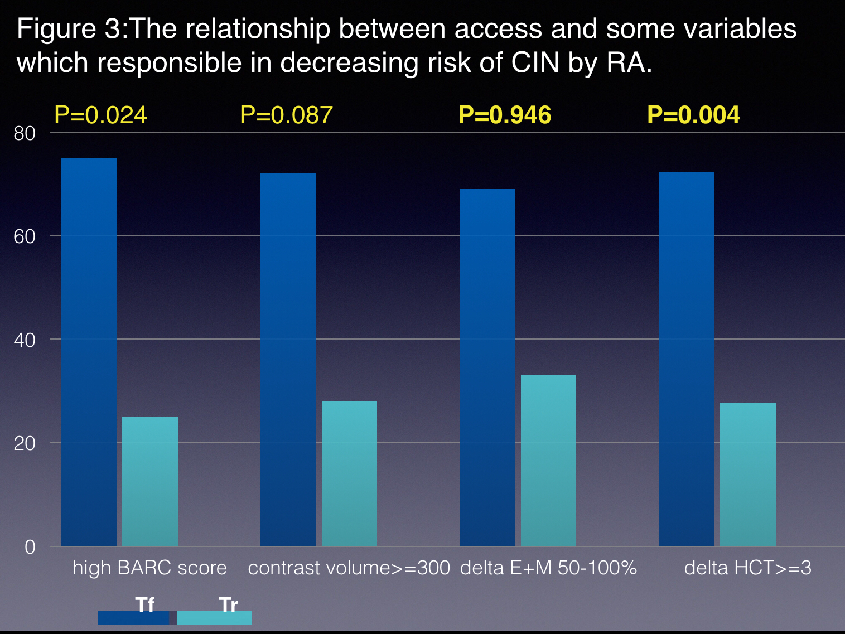

Discussion continue
It remains unclear as to whether RA,by avoiding direct passage of catheter in proximity to renal arteries ,might also contribute to lower risk of CIN .through a reduction and or avoidance of direct embolization in to renal circulation (6).

Cholesterol atheroemboli is a rare phenomena and patients undergoing diagnostic or therapeutic cardiac catheterization reveal a frequency of 0.67% associated with high mortality(16%);also a lake of significant difference between RA&FA routes may indicated that source of emboli is from aortic arch(1).
Otherwise ,recently published studies report an incidence of AKI after TAVI ranging from 7%_28% and followings variables to be associated with AKI :HTN,MI,COPD,PVD,logistics euro score system,ARDS,before Scr, blood transfusion,AI>2+. Interestingly the amount of contrast hasn't been linked to development of AKI,(1).

In our study contrast volume has a weaker relationship with CIN than others independent risk factor such as MS,BARC score ,access;(3a ,4b).

Also we know probably as a consequence of their high viscosity ,dimeric IOCA(visipaque) have been reported to causes more erythrocytes aggregation ,cessation of flow in renal micro circulation ,and greater reduction of renal blood flow than monomeric LOCA(omnipaque,ultravist),(1).”
In conclusion,the available & more recent data suggest that IOCA when compared to LOCA as a class isn't associated with reduced rate of cin(1).

This conclusion also was found in our study where CIN wasn't relationship with contrast type(p=0.589)[table 4a].
In view of the above it should again be concluded that the most important RA mechanism for reducing the risk of CIN is to reduce the risk of bleeding.

The result of our study were consistent with others previous studies

Study limitation

We were unable to equalize the population of RA and FA.
Our study population was more than 800 patients , about half of whom were excluded because discharge from hospital after 24 hr.

We weren't able to adjust the result for the volume and contrast type ,but peri procedural hydration for all patients was equal on base of same protocol .

Also request for eosinophils plus monocytes was limited to 253 patients due to operator’s opinion.

Conclution

Our result showed that in same MS risk groups both low and high risk for CIN ,the risk of AKI for RA was significantly lower than FA.

The most important mechanism for this reduction risk was limitation of bleeding in the RA group.

References

1 Digital edition of the PCR-EPACI text book of percutaneous intervention cardiovascular medicine 2014
2 Correspondence to G.M.sangiorgi,MD,university Hospital of Modena ,Department of cardiology intervention cardiology unit, via del Po220 71-41124 Modena ,Italy.
3 Mehran R ,Rao SV ,et al.standardized bleeding definitions for CV clinical trial :A consensus report from the bleeding academic research consortium.circulation:2011;123:2736-2747.
4 correspondence to Hitinders,Gurm,MD,university of Michigan CV center ,ZA 594,1500,E.medical center drive,Ann Arbor MI 48109-5853.
5 Catheterization&CV interventions,volume 72,issues,page 629-635 , 1 November 2008.
6 Andeo et al,AKI After Radial or Femoral access in ACS patients:JACC VOL. 69,NO 21,2017 MAY 30,2017;2592-603.

