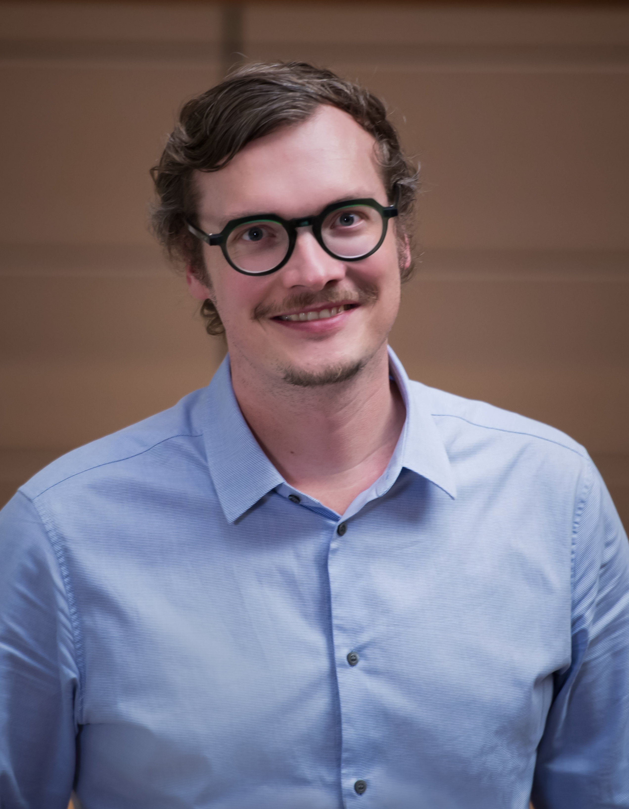
Title: Targeting IL11 to treat fibrotic disorders
Name: Sebastian Schäfer
National Heart Centre Singapore, 169609, Singapore
Duke-NUS Medical School, 169857, Singapore

We have previsouly shown how mutations in large structural proteins (titin) or modifiers thereof (RBM20) contribute to inherited cardiac diseases such as dilated cardiomyopathy. However, even though these mutations predispose to disease, they are difficult to target therapeutically. One common pathology in many cardiovascular diseases is fibrosis of the heart or kidney, which may be prevented if suitable therapeutic targets can be identified.
While TGF-beta is the exemplar target for fibrosis, its inhibition causes overwhelming toxicities and alternative approaches are needed. We modeled fibrosis using fibroblasts outgrown from atrial biopsies from 84 patients. Fibroblasts were stimulated with TGF-beta and the fibrotic response assessed by integrating RNA sequencing with high-content imaging of cell trans-differentiation, extracellular matrix (ECM) production and proliferation. This screen prioritized interleukin 11 (IL11) as a potential therapeutic target for fibrosis.
Follow-up experiments revealed that IL11 was essential for the pro-fibrotic activity of TGFB1 in fibroblasts. An autocrine loop of IL11 signalling represents a point of signaling convergence for a number of key pro-fibrotic stimuli, including angiotensin II and endothelin 1. IL11 regulates post-transcriptional gene expression in fibrosis and acts through a non-canonical, ERK-dependent pathway. In vivo experiments substantiated the pro-fibrotic nature of IL11 and its administration to mice induced severe cardiac and renal dysfunction. We then developed antibodies that neutralize IL11 signalling to inhibit fibrosis and improve organ function. These therapeutic agents may be a promising novel approach to tackle the increasing burden on human health caused by untreatable fibrotic disorders.

Biography
Sebastian Schäfer has completed his PhD at the Max Delbrück Center in Berlin and is now Assistant Professor at Duke-NUS Medical School and the National Heart Centre in Singapore. He is Co-founder of Enleofen Bio Pte Ltd, a company that develops first-in-class therapeutic antibodies to treat fibrosis. His work appeared in several high-ranking journals including first author papers in Nature, Nature Medicine, Nature Communications and Nature Genetics.

Presenting author details
Full name: Sebastian Schäfer
Contact number: +65 8233 4270
Twitter account: -
Linked In account: www.linkedin.com/in/sebastian-schafer
Session name/ number:
Category: Oral presentation

