
Title: Aorto-Coronary-Right atrial fistula
Name: Reem Laymouna
Alexandria University, Faculty of Medicine, Alexandria, Egypt

A 31-year-old male patient, non-smoker, with no medical history of hypertension nor diabetes mellitus. He started complaining of fatigue and effort intolerance in the past six months. The patient denied any previous chest trauma or surgical interventions.
Upon examination, the patient had jugular venous distension and hepatomegaly. On cardiac auscultation, a 3/6 continuous murmur was heard over the left second and third intercostal spaces. Electrocardiogram showed sinus tachycardia (normal ST segment and no pathological Q waves). Routine laboratory investigations were unremarkable.
Echocardiography revealed dilated right atrium (RA) and right ventricle (RV) with borderline RV systolic function and evidence of pulmonary hypertension. An Abnormal vascular structure was seen connected to the left coronary sinus of Valsalva with continuous systolic and diastolic flow. This structure was also observed to be connected to the right atrium. Mildly dilated left ventricular (LV) dimensions with preserved systolic function (EF=65%) were also noted.
128-MDCT showed a large vascular structure (diameter 3 cm at the beginning and 2.8 at the end) was arising from the left coronary sinus of Valsalva, passing through the left atrio-ventricular groove, draining into the right atrium (taking the course of coronary sinus but with separate draining sites into the right atrium). The left anterior descending artery (LAD) was seen arising from the proximal part of the fistula, then it continued with normal course and caliber in the anterior inter-ventricular groove. The obtuse marginal branch (OM) was also arising from this fistula. Right coronary artery (RCA) was arising normally from the right sinus of Valsalva.
So, we have a case of large aorto-right atrial fistula with LAD and OM arising from this fistula and complicated with right ventricular systolic failure. The patient was referred to a cardiac surgeon for surgical closure.
Conclusion: Aortoatrial fistulas are rare extracardiac vascular channels. These fistulous vascular communications can have an origin from any of the three sinuses of Valsalva. Although the ascending aorta is reported to be the most common site of origin for aortocameral fistulas, reports have described fistulas emanating from the descending thoracic aorta.Various treatment options are available according to the type of fistula, its caliber, tortuosity, calcification, course, and relation of the coronary ostia to the aortic orifice of the fistula.

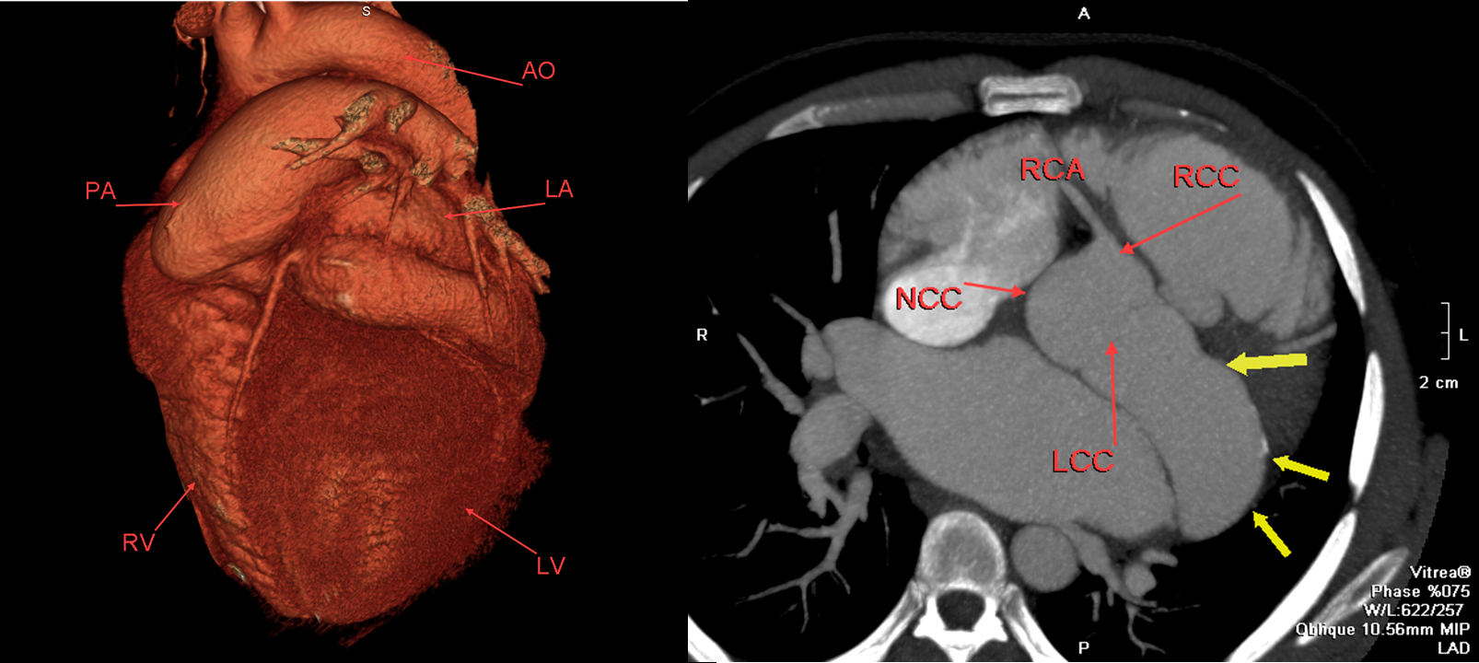

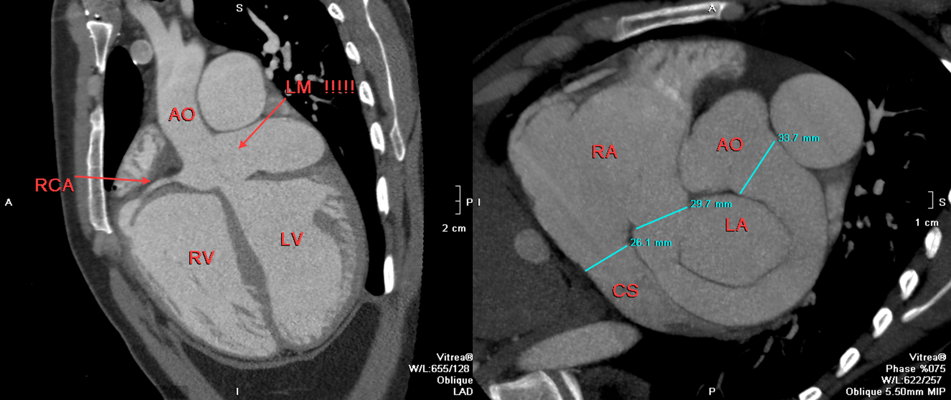

Biography

Reem Laymouna is cardiologist, specialized in cardiac imaging, Got Level 2 cardiac CT, Edinburgh University, UK 2016 (BSCI/BSCCT accredited), obtained my master degree in cardiology 2014 and started my doctorate in cardiology in 2014 till now. Five years experience in cardiac imaging and 10 years experience in clinical cardiology. Participated, presnted and awarded in multiple international cardiology conferences (Euro-Echo Imagind, ESC, CardioAlex and CardioEgypt).
Presenting author details
Full name: Reem Hamdy Laymouna
Contact number: 00201006464345
Linked In account: Reem Laymouna
Session name/ number: Case reports on cardiology
Category: Oral presentation

