Acute Myocardial Infarction (MI) following m-RNA COVID-19 Vaccination

A 44-year-old fit and well gentleman presented with chest pain and ECG showed antero-lateral ST elevation. He has no past medical history or family history of Ischaemic Heart Disease (IHD). He was rushed for Primary Percutaneous Coronary Intervention (PPCI) and his coronary angiogram showed multi-vessel occlusions with no plaque evident. Multiple thrombectomy performed in LAD and LCx and Intravascular Ultrasound (IVUS) confirmed normal vessel with no atheroma. He received his COVID-19 m-RNA booster dose 10 days back. He was started on Tirofiban infusion for 72 hours and repeat coronary angiogram confirmed that the thrombus has resolved. His Transthoracic Echocardiogram showed severely impaired LV function with EF <35% and multiple regional wall motion abnormality (RWMA). His 7 day tape showed sinus rhythm throughout with no arrhythmia and bubble ECHO was negative for cardiac shunt. He was discharged home with dual anti-platelets for 12 months.
Vaccines are considered the most effective medications in preventions of COVID-19. Kounis syndrome is an allergic reaction to various substances including excipients resulting in MI and can be a potential explanation of myocardial infarction after COVID-19 vaccine. Another possible explanation was through a prothrombotic immune thrombocytopenia induced by vaccine which has similarity to heparin-induced thrombocytopenia leading to thrombotic manifestation.

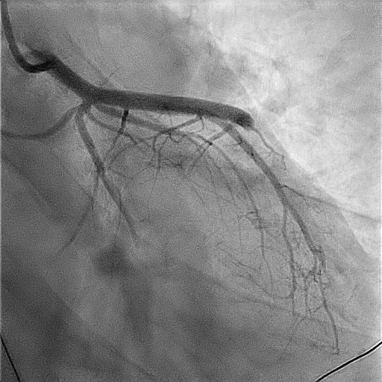
Figure 1: Coronary angiogram showing occluded LAD and LCx

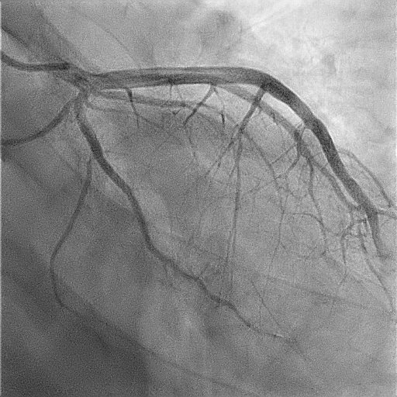
Figure 2: Repeat angiogram post thrombectomy

