

Title: Interrupted left sided inferior vena cava draining into persistent left superior vena cava- A rare association of left isomerism

Abstract:
Case presentation:
A six year female was referred to us in view of dyspnea, fatigue and central cyanosis with a provisional diagnosis of congenital cyanotic heart disease. Patient had an oxygen saturation of 78% at room air. On auscultation, she had a single first heart sound, wide and fixed split second heart sound and grade II/IV pansystolic flow murmur heard at apex. Echocardiography revealed situs ambiguous with atrioventricular canal defect seen as large ostium primum atrial septal defect with common atrium morphology and small inlet ventricular septal defect (as shown in figure 1) with moderate atrioventricular regurgitation (as shown in figure 2), a large patent ductus arteriosus (as shown in figure 3), left sided aortic arch, hepatic veins draining directly into right atrium (as shown in figure4), inferior vena cava on the left of abdominal aorta, persistent left superior vena cava (as shown in figure5).
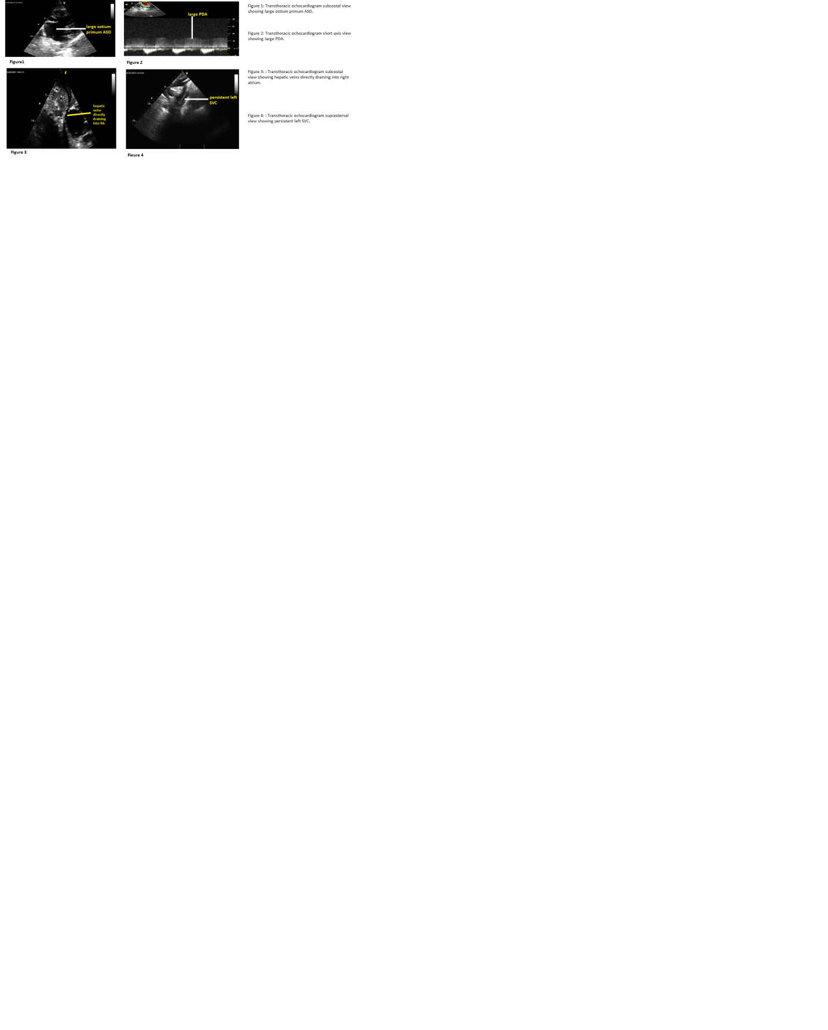

Figure 1 showing large ostium primum ASD.
Figure 2 showing large PDA.
Figure 3 showing hepatic veins directly draining into RA.
Figure 4 showing persistent left SVC.
CT scan of thorax and abdomen with contrast venography showed findings of situs ambiguous with left isomerism including trachea bifurcating into bilateral morphologically similar bronchi (as shown in figure 6) and bilateral bilobed lungs, liver in the left hypochondrium with hemangioma in segments II and IVa, polysplenia, non rotated gut, persistent left superior vena cava (as shown in figure 7), hemiazygos vein continuous with left sided inferior vena cava (as shown in figure 8).

Figure 6: CT thorax showing trachea bifurcating into bilateral morphologically similar bronchi.

 Figure 7: CT thorax showing persistent left superior vena cava.

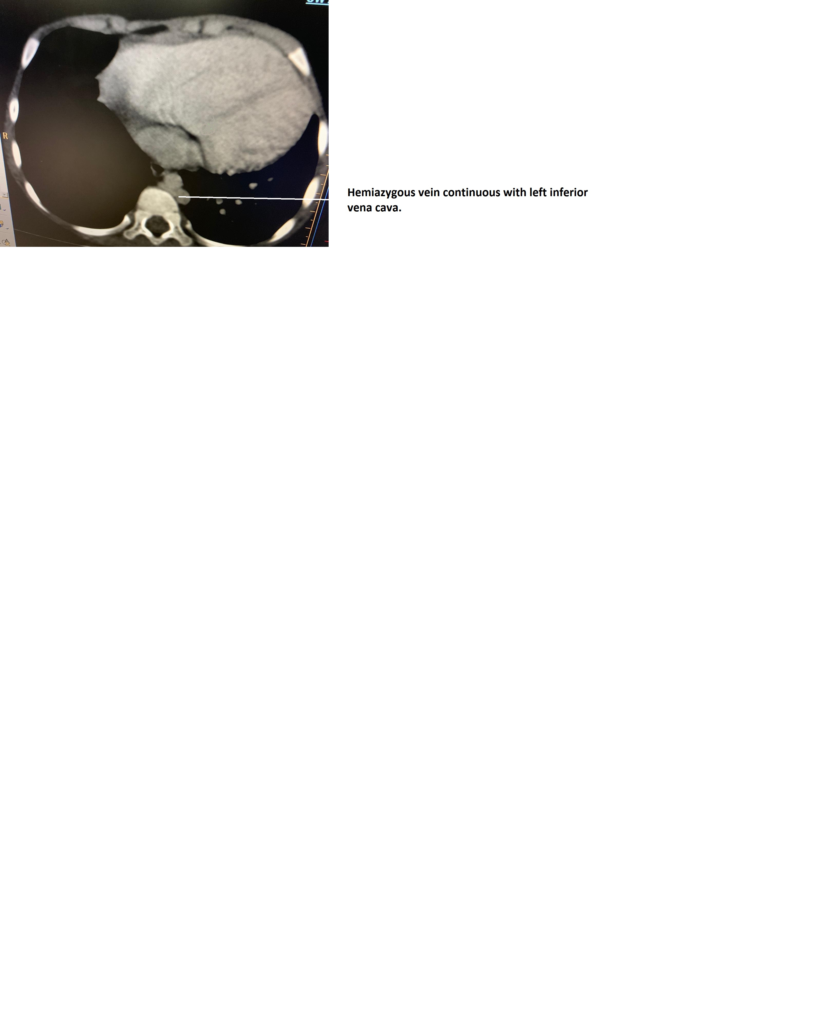
Figure 8: CT Venography showing hemiazygos vein continuous with left inferior vena cava.

The left superior vena cava was continuous with infradiaphragmatic part of inferior vena cava (as shown in figure 9) which is a very rare finding in reported cases of situs ambiguous.

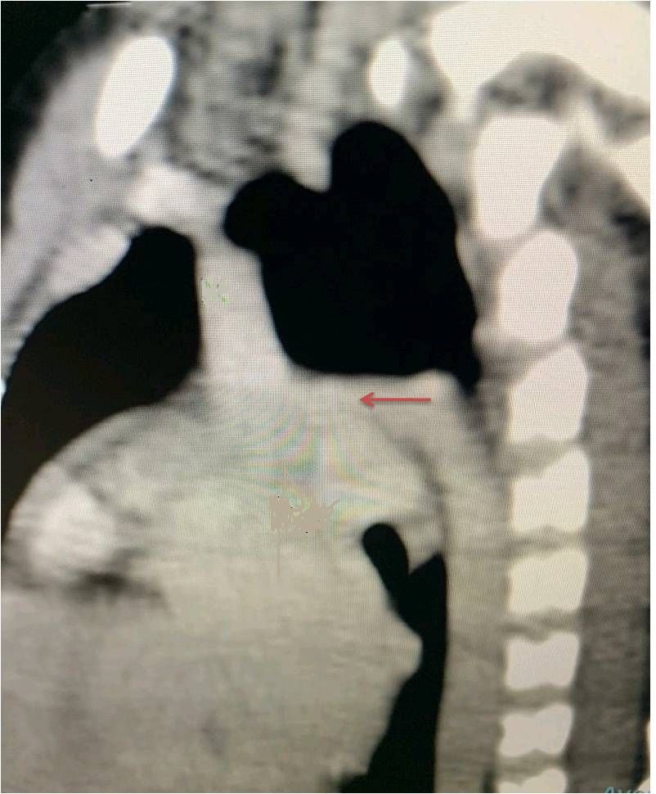

Figure 9: CT venography showing left sided inferior vena cava continuous with persistent left superior vena cava.

The patient was advised surgical correction but refused for any surgical intervention.

Biography:

Dr Shradha Satish Runwal has completed her MBBS, M.D in General Medicine from Government Medical College and Hospital, Aurangabad, India. She is currently working as 3rd D.M. Cardiology Resident under Professor Dr.Tejas M.Patel at SVP Hospital, Ahmedabad, India.

Presenting author details:
Name: DR SHRADHA SATISH RUNWAL
Mob No: 09665965002, 09265569525
Category: Poster presentation

