A brief psychosis after successfully treated inferior ST-segment elevation myocardial infarction: A case Report

Abstract
A 68-year old musician man with history of coronary artery disease (CAD), while playing fiddle presented to our cardiac emergency complaining of severe compressive retrosternal chest pain. His vital signs were as blood pressure 80/50mmHg and heart rate 40 beats/min. Initial electrocardiography (ECG) showed inferior ST-segment elevation MI as well as second-degree atrioventricular (AV) block (Wenckebach). Patient referred to catheterization laboratory (cath lab) and then discharged from cath lab by TIMI3 flow of right coronary artery and blood pressure 100/60mmHg. Three hours later he became agitated and very aggressive with nursing personnel. Twelve hours later in coronary care unit (CCU) he had delusion that the monitors are controlling his activities and some persons want to hurt him. His diagnosis was delusion of persecution and administered with Risperidone 1mg/day and the symptoms resolved after 2 weeks.
Keywords: myocardial infarction, ST elevation MI, persecutory delusion

Myocardial infarction (MI) is a common is disease. Nowadays progresses in rapid management of acute coronary syndrome (ACS) resulted in time saving and reduction of MI complications ¹. However in some patients some consequences may be occurred. In the present study we report a case of inferior ST-segment elevation MI with post angioplasty delusion of persecution.
A 68-year old musician man, while playing fiddle presented to our cardiac emergency complaining of severe compressive retrosternal chest pain. His past medical history included coronary artery disease (CAD) and 5 years ago angiography was showed left anterior descending (LAD) artery was ostially cutoff but right coronary artery (RCA) and Left circumflex artery (LCX) was patent and patient's left ventricle ejection fraction (LVEF) was 40%. The patient receives Aspirin 80mg/day and Atorvastatin 20mg/day. He had not any other medical or psychological history. He had a good family care and social relationships. His vital signs were as blood pressure 80/50mmHg and heart rate 40 beats/min.
Initial electrocardiography (ECG) showed inferior ST-segment elevation MI (figure 1) as well as second-degree atrioventricular (AV) block (Wenckebach). Patient referred to catheterization laboratory (cath lab) and temporary pace maker was applied in right ventricle (RV) apex. Then coronary angiography showed RCA proximally cutoff and either LAD. RAD directly stented by a 4mm-28mm stent (figure 2). Door-to-Device time was 60min and total ischemic time was 90min. At the end, discharged from cath lab by RCA TIMI3 flow and blood pressure 100/60mmHg. Patient's homodynamic status was stable. His consciousness was clear and he was oriented in time, place, and person. But 3 hours later he became agitated and very aggressive with nursing personnel. 12 hours later in coronary care unit (CCU) he had delusion that the monitors are controlling his activities and some persons want to hurt him. He thought we wrote his talking and checked medical orders to find any writing related to him. Some of his delusions had sexual content. He thought that his wife is treacherous (delusional jealousy). He had some auditory hallucinations (he said that some persons command him to hang). His speech was normal and had not any lateralized sign. His neurological examination was completely normal. His brain computed tomography (CT) scan and brain magnetic resonance imaging (MRI) was normal. He had no past psychiatric history. Patient was administered with Risperidone 1mg/day and the symptoms resolved after 2 weeks.
Discussion
The best diagnosis was brief psychosis. The patient had components of persecutory delusion, jealousy delusion and second person auditory hallucination. He did not have dementia. Differential diagnoses of this patient were paranoid schizophrenia and brain damage following embolic stroke and hypoxic ischemic damage to brain following hypotension and bradycardia (hypoxic-ischemic encephalopathy). Short period of symptoms (<1 month) ruled schizophrenia out. Cerebrovascular accident (CVA) grossly ruled out by normal brain CT scan and brain MRI. Relatively short period of total ischemic time and don’t cessation of circulation along with patient alertness and conscious ruled out hypoxic-ischemic encephalopathy.
Occurring psychosis following to MI has not previously reported. Response to Risperidone in delusional disorder has reported previously in some cases. Fear and Libretto (2002) a case of 50-year old women ². The other cases were for patients those who had delusional disorder along with hallucination or psychosis ³. This case was reported as the first case of brief psychosis disorder following to cardiovascular events.
Disclosure
The authors declare no conflict of interest.

References
1. George T, Ashover S, Cullen L, et al. Introduction of an accelerated diagnostic protocol in the assessment of emergency department patients with possible acute coronary syndrome: The N ambour S hort L ow‐I ntermediate C hest pain project. Emergency Medicine Australasia. 2013;25(4):340-344.
2. Fear CF, Libretto SE. Risperidone for the treatment of delusional disorder. International journal of psychiatry in clinical practice. 2002;6(2):113-116.
3. Taycan O, Ugur M, Ozmen M. Quetiapine vs. risperidone in treating psychosis in neurosyphilis: a case report. General hospital psychiatry. 2006;28(4):359-361.

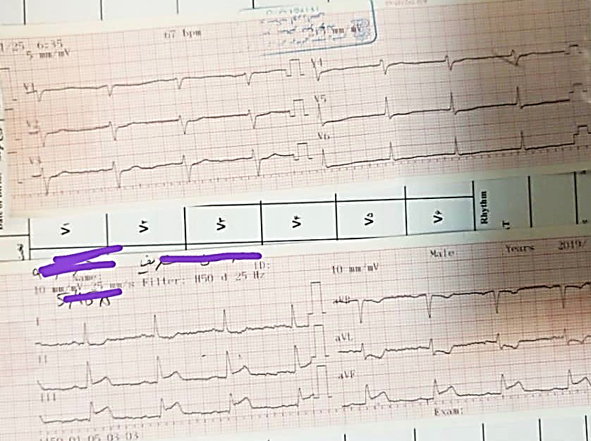
Figure 1. Initial ECG of the patient shows ST-segment elevation in leads II, III and aVF.

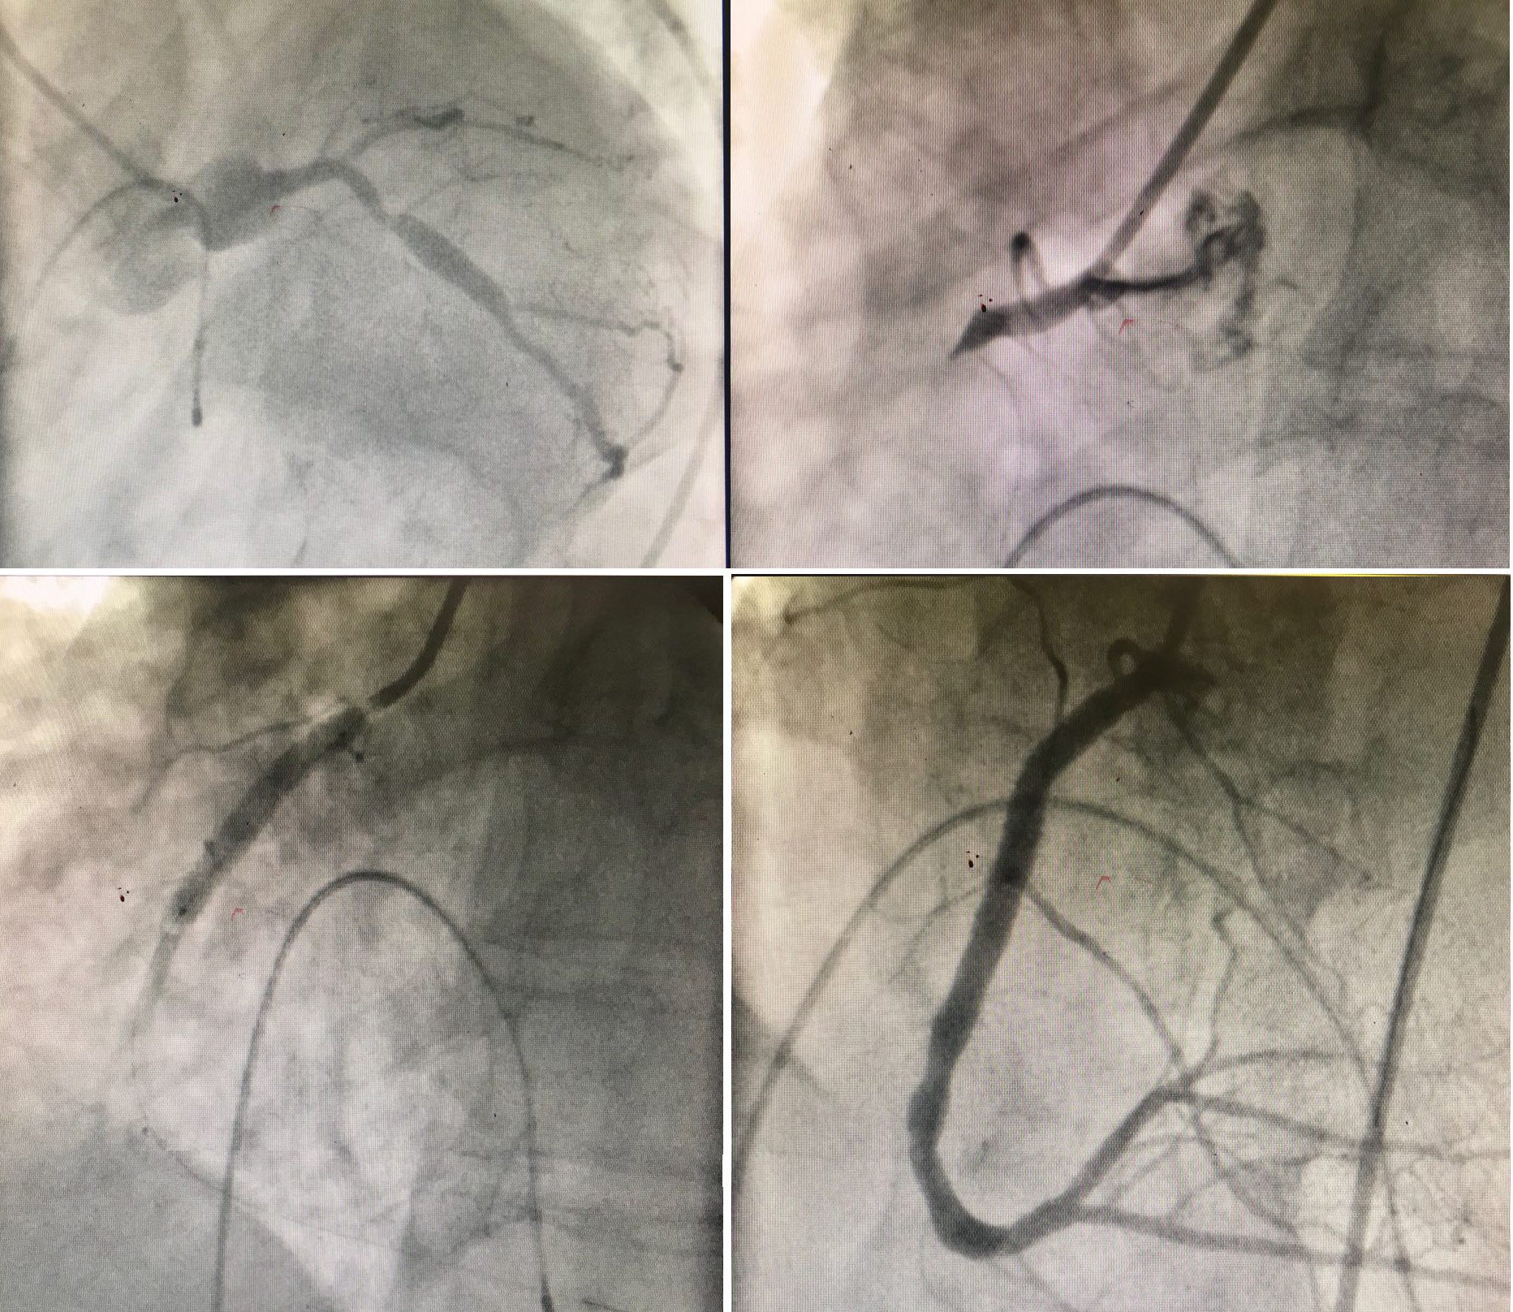
Figure 2. Coronary angiography of the patient.

