The Great Masquerader: Pulmonary Embolism
Introduction
Acute pulmonary embolism (PE) and Acute Coronary Syndrome (ACS) are considered to be potentially life threatening. Prompt identification of etiology of symptoms can significantly reduce morbidity and mortality. Both the have signs and symptoms that are common to either presentations such as dyspnea, chest discomfort and hemodynamic instability. Electrocardiography (ECG) have been traditionally used to differentiate in the initial stages of work between ACS and PE. More recently T wave inversion have been identified as possible sign of underlying PE. We would like to report a 49 year old gentleman who presented with chest pain and was initially diagnosed and treated ACS. In this case presentation we would like to present the clinical findings and briefly discuss the salient difference between the two presentations.

Case description
This is a 49 year old gentleman, with well controlled hypertension and asthma, who presented with a two weeks history of generalized fatigue along with mild exertional dyspnea, nausea and chest tightness for the past day.

On Examination,his vital signs were stable except a resting heart rate of 98 beats/minute and Oxygen saturation of 95% on room air. His ECG (Figure 1) were consistent with T wave inversions in leads V1-V4 and had elevated troponins at 227 (normal< 40). Based on the work up, patient was initially referred for urgent interventional catheterization for acute coronary syndrome (ACS). Subsequentechocardiogram (video 1) demonstrated a dilated right ventricle(RV) with elevated pressures (figure 2) and normal wall motion. Given the echocardiographic findings patient underwent a CT angiogram of the chest. He was found to have bilateral pulmonary embolism (PE) (figure 3) andhe was placed on anticoagulation.
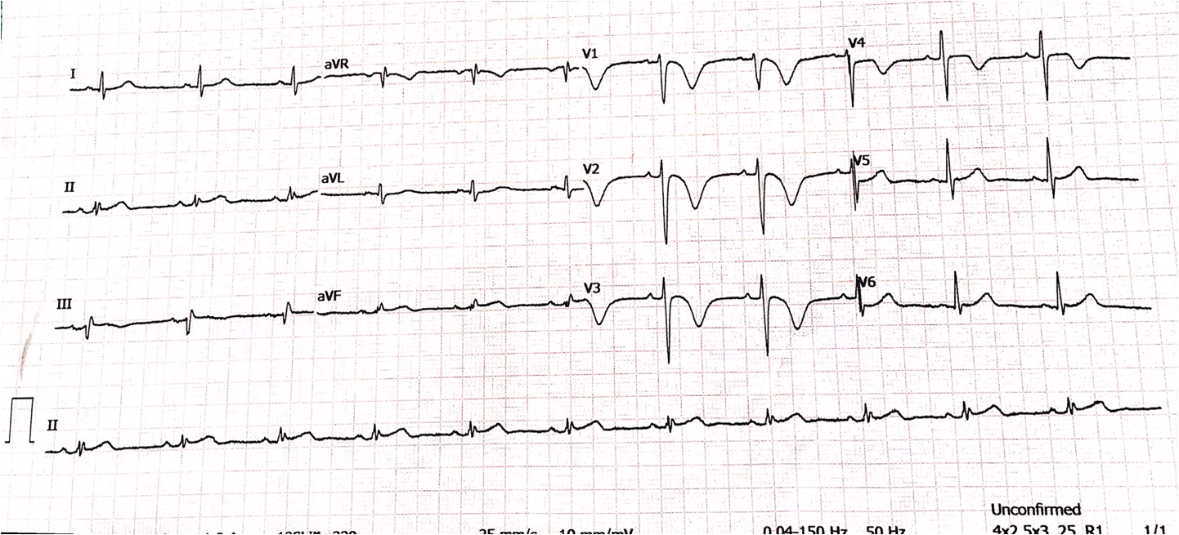
Figure 1 Admitting ECG
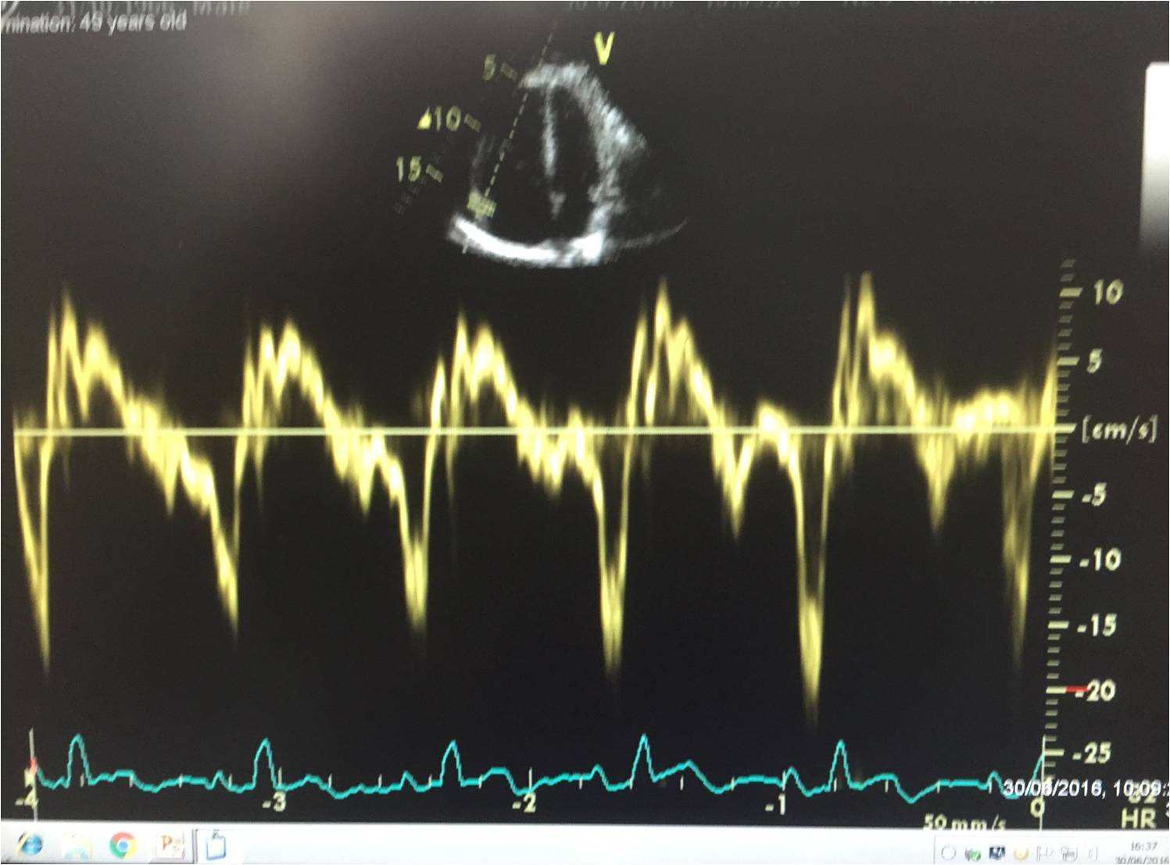
Figure 2 : Doppler study of RV
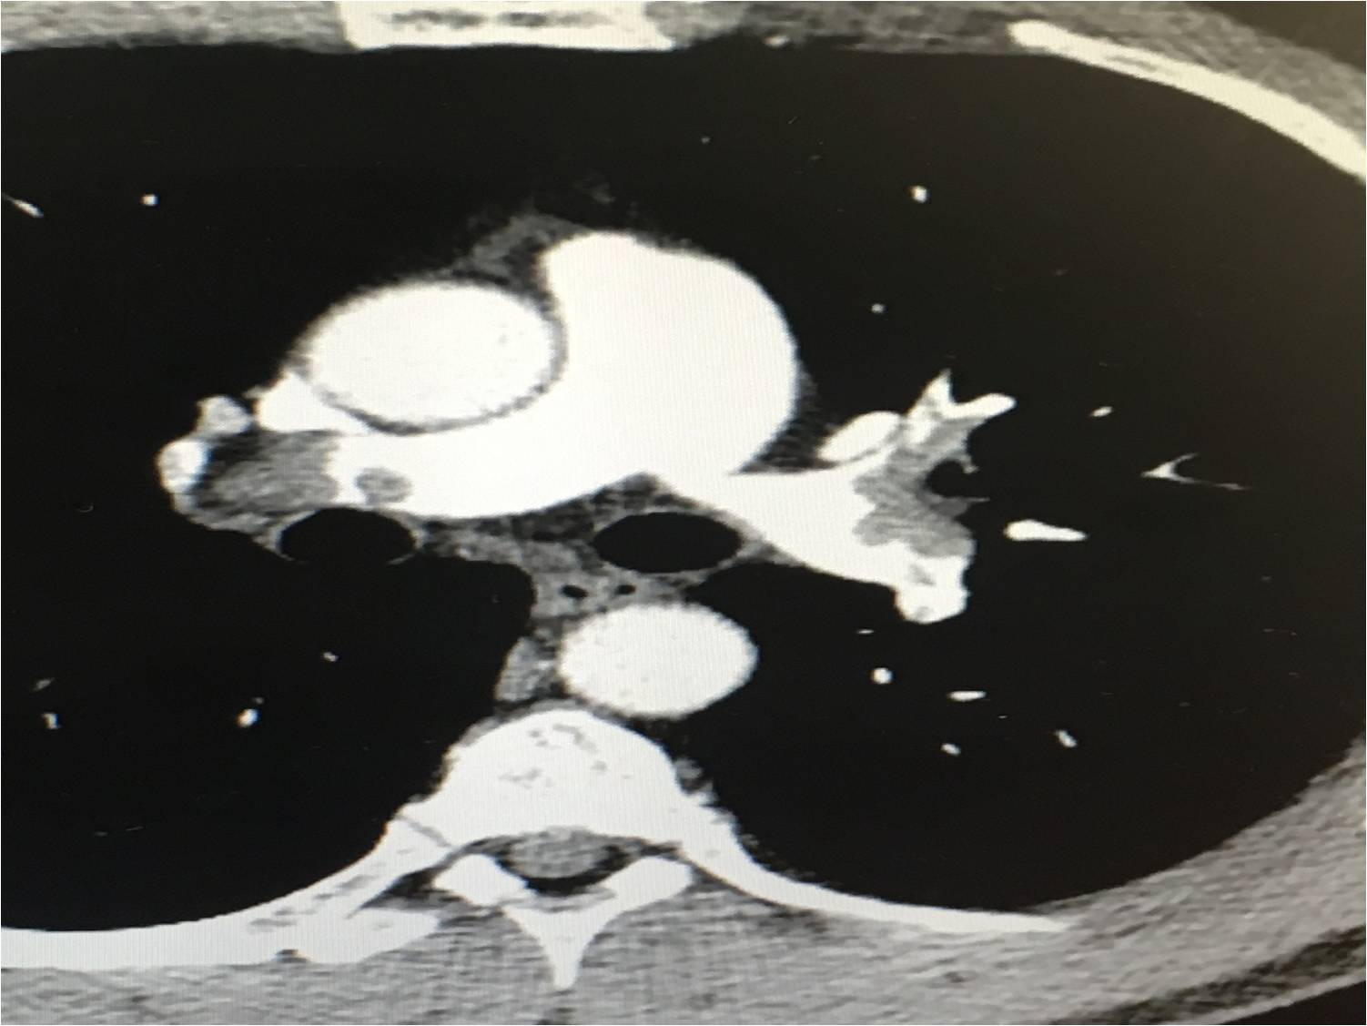
Figure 3: CTPA images of Bilateral P.E

Discussion
While both ACS and PE can present with T wave inversions and elevated troponins, it is critical to differentiate among them in early presentation. Wellens’ T waves are characterized by classic T-waves inversions either deeply inverted or biphasic, especially V2-V3 (may include V1 –V4) during pain-free periods in a patient presenting with ACS. These findings are suggestiveof a high-grade proximal stenosis of the left anterior descending artery.

Classical differences between ACS and PE findings on the ECG are as following:

- PE associated with pulmonaryP waves, S1S2S3 pattern, S1Q3T3 pattern, Low voltage and Clockwise rotation (shift in transition zone (R=S) in V5 –V6
- Negative T waves in lead III and V1 were present only in 1% of ACS
- Absence of T waves inversion in lead 1 &aVL and presence in V1 is highly suggestive of Pulmonary Embolism

