Aortic dissection: decrease blood pressure but be aware of drug toxicity !!
S. AZMOUN*; J. ELMASRIOUI*; A.GOULAHSEN*; W.FADILI** ; I. ELOUAD** ; M. ELHATTAOUI* ; S. EL KARIMI*
* Department of Cardiology, **Department of Nephrology . Mohammed VI Hospital. Marrakech. Morocco
ABSTRACT
Introduction: Aortic dissection (AD) is a diagnostic and therapeutic emergency that requires strict blood pressure targets. To achieve these objectives, the clinician is often required to prescribe a multiple and aggressive therapy exposing to a risk of drug toxicity including renal.
Case report: We report the case of a patient who presented with an AD type B of STANFORD, complicated by a drug-acute-renal-failure (ARF), requiring a hemodialysis session and a cessation of the majority of antihypertensive drugs , with very close monitoring until clinical improvement and normalization of clinical and biological parameters.
Discussion: The cornerstone of the management Type B AD is medical treatment with low blood pressure goals. However, the doctor must be alerted to side effects by respecting the rules of prescription in general, and knowing the situations with potential risk of developing adverse events. The knowledge of side effects allows their early diagnosis and appropriate care.
Conclusion: The tension equilibrium is a major objective in the treatment of the type B AD. To reach this objective, we often resort to a multiple and aggressive therapy, requiring vigilant monitoring of clinical and the paraclinical to detect its side effects early.
Iconography
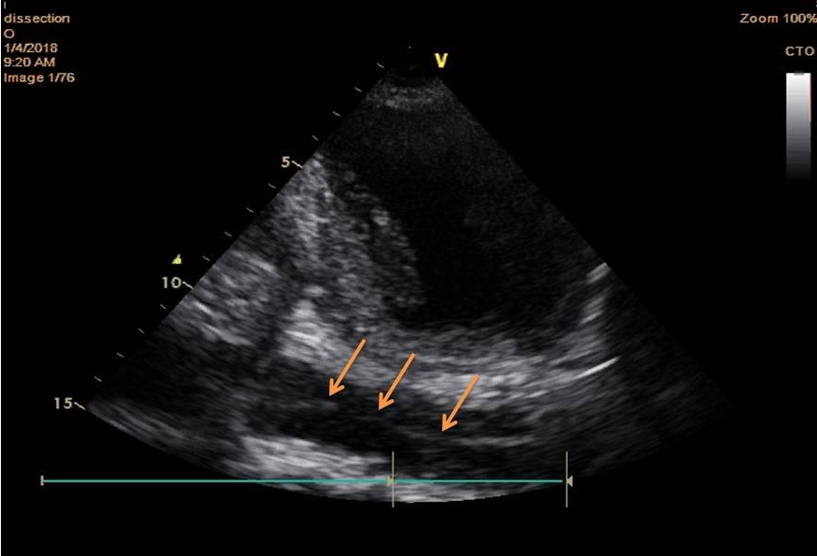
Figure1: transthoracic echocardiography in the apical two-chamber view showing an intimal flap in descending aorta
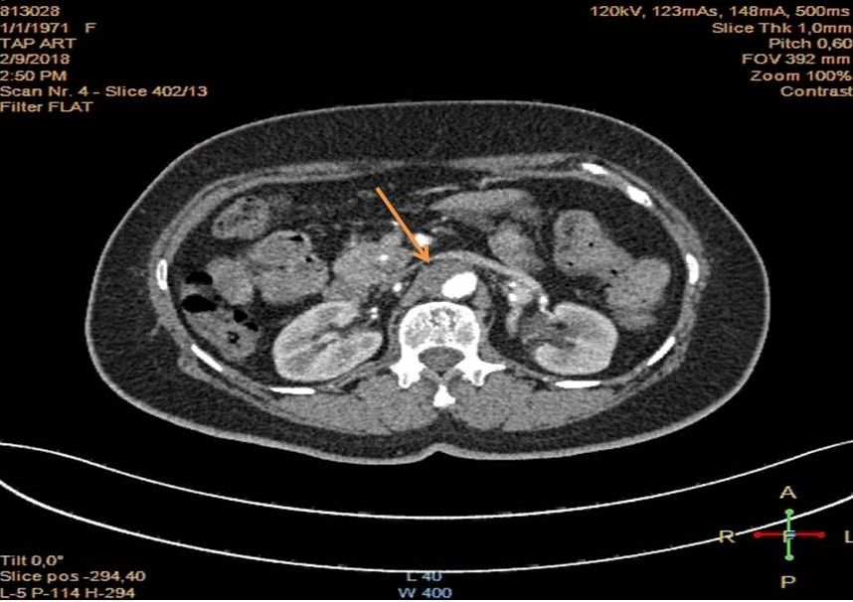
Figure 2: Transverse computed tomography scan thorax with contrast showing the dissection aorta type B
key words: Aortic Dissection - Side Effects- Antihypertensive drugs –RAA II - Acute Renal Failure
Biography:
- Chan KK, Lai P, Wright JM . Les bêta-bloquants en traitement de première ligne par rapport à d'autres médicaments antihypertenseurs dans le cadre de la dissection aortique chronique de type B. Cochrane database of systematic reviews. fevrier 2014
- Ulug P, McCaslin JE, Stansby G, Powell JT. Traitement endovasculaire versus traitement médical conventionnel pour dissection aortique chronique de type B. Cochrane database of systematic reviews . novembre 2012
- Pascal Delsart1, Gonzague Claisse1, Nadia Bouabdallaoui2, Marco Midulla3, Stephan Haulon1, Claire Mounier-Vehier . Syndromes aortiq ues aigus : organiser la prise en charge médicale à la phase aiguë et au long cours. La press medicale. Janvier 2011. tome 40 . n 81 . P 34- 42
- Erbel R et al. 2014 ESC Guidelines on the diagnosis and treatment of aortic diseases: Document covering acute and chronic aortic diseases of the thoracic and abdominal aorta of the adult. The Task Force for the Diagnosis and Treatment of Aortic Diseases of the European Society of Cardiology (ESC). Eur Heart J. Novembre 2014.
- Service de l’évaluation économique et de la santé publique Service de l’évaluation des médicaments. Évaluation par classe des médicaments antihypertenseurs. Haute autorité de santé HAS.Mars 2013.
- Collège Universitaire des Enseignants en Néphrologie. Iatrogénie en néphrologie. Diagnostic et prévention. [en ligne]. (septembre 2018) disponible sur : < http://cuen.fr/ > (consult 21/09/2019)

