Rapid progression from Aortitis to Aortic Dissection in Giant cell Arteritis (GCA)
Singh Bhavneet, MBBS, Manganas Con, MBBS, FRACS
Department of Cardiothoracic Surgery, St George Public Hospital, Kogarah, NSW, 2217, Australia.
Introduction
Anomalous left coronary artery connection to pulmonary trunk (ALCAPA) is rare. In the natural history of the disease the left ventricular ischemia is typically fatal in infancy. With rich inter-arterial collateralisation, a restrictive angulation between the left main coronary artery (LMCA) and pulmonary trunk, and a dominant right coronary circulation, a minority of patients survive into adulthood. We present an atypical adult case that underwent restoration of a two coronary system and excision of coronary artery aneurysm and saphenous vein angioplasty.
Case report
61-year-old female, with background history of obesity, diabetes, hypertension and smoking, presented with NYHA class IV dyspnoea. She was found to be in rapid atrial fibrillation with a new left bundle branch block and raised serum troponin levels.
Whilst in hospital, the patient had multiple episodes of tachy-brady syndrome requiring insertion of temporary pacing wire.
Coronary angiography (figure 1 and 2) revealed ALCAPA coupled with a large dominant right coronary artery (RCA). The RCA was found to have a proximal aneurysm, measuring 6mm by 12mm. The left coronary artery was small in calibre with insignificant circumflex branches and a small and short left anterior descending (LAD) artery. CT coronary angiogram, confirmed ALCAPA from the posterior aspect of the pulmonary trunk and a saccular aneurysm in the proximal RCA. There was no significant coronary artery stenosis or thrombosis.
The operative plan was for ligation of the LM ostium and left internal mammary (LIMA) graft to the left anterior descending (LAD), ligation of the RCA aneurysm and a reversed saphenous vein graft to the distal RCA.
Conclusion
About 10–15% of patients with ALCAPA survive to adulthood. The availability of advanced imaging modalities has resulted in increasing adult incidence. Surgical therapy is definitive, and remains the treatment of choice in patients with symptoms or left ventricular dysfunction.

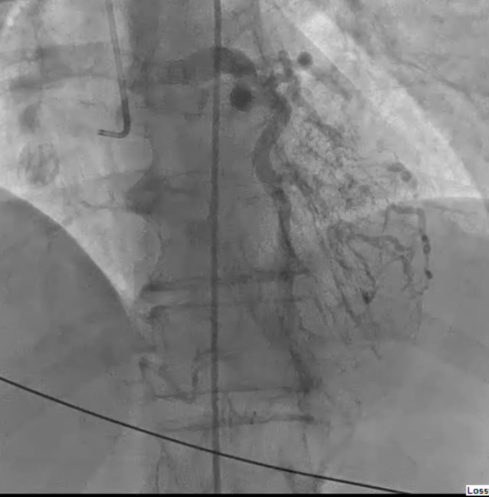
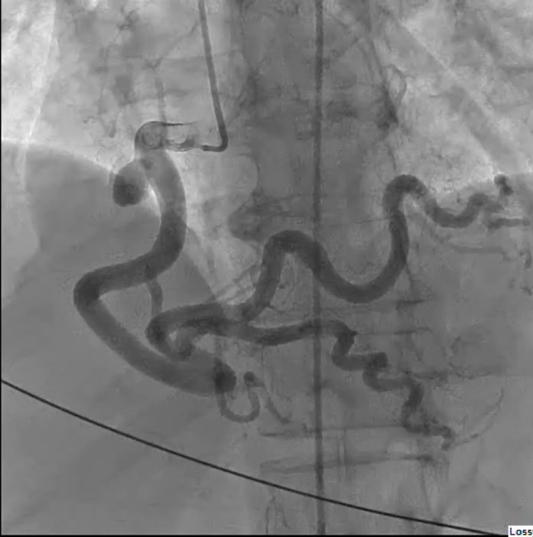
Figure 1 Figure 2
Aneurysmal and ectatic RCA LAD draining into PA
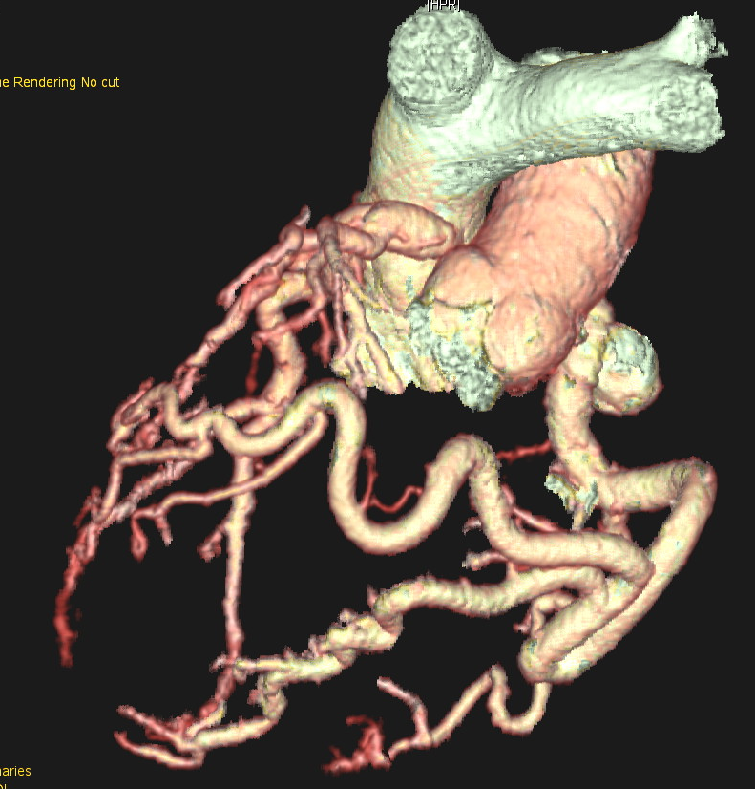
Figure 3

CTCA

Figure 4
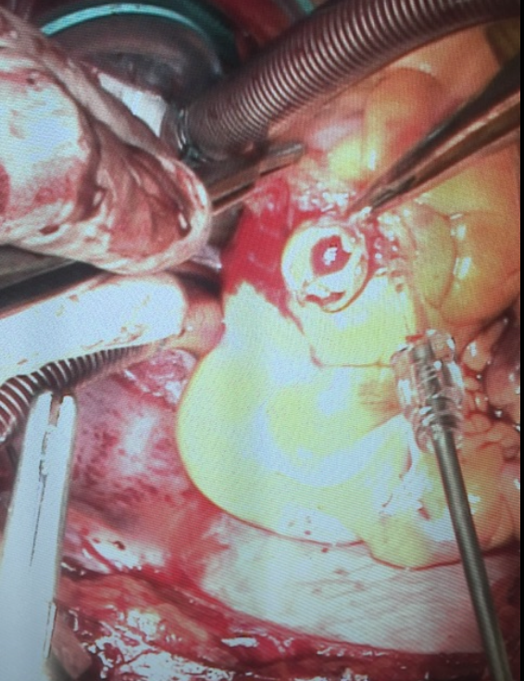
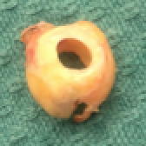

Calcific aneurysm of the RCA

