Prosthesis Eversion method improves clinical outcomes of valve-sparing aortic root replacement procedure
Zhiwei Wang PhD, Renmin hospital of Wuhan University, China
Zhipeng Hu PhD, Renmin hospital of Wuhan University, China

Abstract (300 word limit)

Subjects: To explore the advantages of prosthesis eversion method in valve-sparing aortic root replacement procedures.

Methods: We retrospectively analyzed the data of a total of 283 Standford type A acute aortic dissection patients who accepted valve-sparing aortic root repair in Renmin hospital of Wuhan university during March 2006 to April 2014. 88 of them were treated using traditional continuous suture method and 195 patients were treated using prosthesis eversion method. Baseline data, intra-operative data and data about early stage clinical results were collected and statistically analyzed.

Results: Baseline data and surgical methods were similar except for age，incidence of hyperlipidemia and cases of taking ACEI/ARB drugs (P<0.05). But cardiopulmonary bypass time, crossclamp time, circulation arrest time, hemostasis time and total operation time patients in the traditional anastomosis group were far longer than patients in sleeve anastomosis group (P<0.01). Patients in traditional method group also accepted far more red blood cells and plasma transfusion than patients in prosthesis eversion method (P<0.01). The operation mortality is similar (P>0.01). Post-operatively, the ventilation time, cases of reexploration, cases of tracheostomy, postoperative mortality, cases of paraplegia, cases of long term coma and stroke of patients in two groups were similar (P>0.05). Patients in traditional method group stayed longer in ICU and hospital than patients in prosthesis eversion method (P<0.05). Patients in traditional method group accepted more red blood cells (P<0.01), plasma (P<0.05) and human albumin (P<0.05) transfusion than patients in prosthesis eversion method group.

Conclusions: Our experience and statistical analysis showed prosthesis eversion method method have some advantage in reducing blood loss and improve clinical results. This method seems to be simple and reproducible.

Image

Fig1.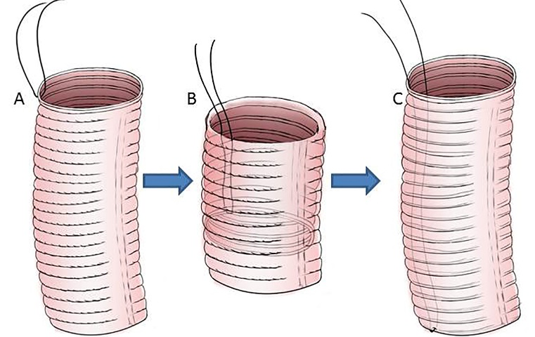

Fig2.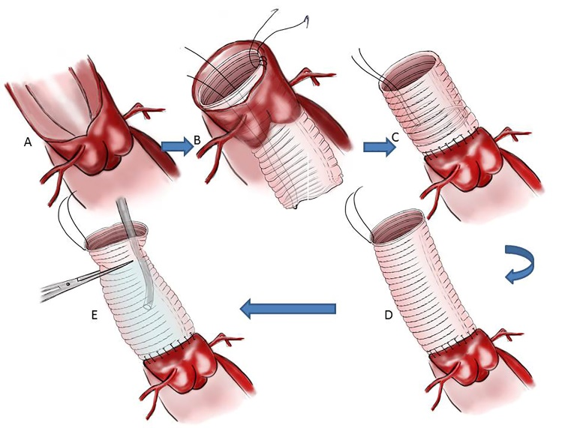

Fig3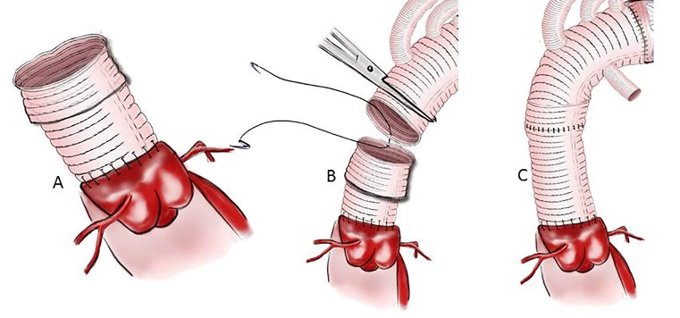

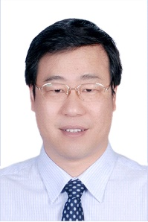
Biography
Professor wang zhiwei is a well-known cardiovascular surgeon in China. He is good at aortic surgery, off-pump coronary artery bypass grafting, heart transplantation. By now, he has performed over a thousand of total aortic arch replacement and has made several improvements to aortic surgery. Professor wang has also achieved fruitful results in the pathogenesis research of aortic disease
.Email:wangzhiwei@whu.edu.cn

