Retrograde Type A Dissection following Complex Hybrid Endovascular Surgery

YC Chan, Law Y, SW Cheng.
Division of Vascular & Endovascular Surgery,
Department of Surgery,
University of Hong Kong Medical Centre,
Hong Kong.

Abstract (300 word limit)
Introduction: Hybrid procedures with combined open extra-anatomical supra-aortic bypasses and endovascular surgery are less invasive for patients with complex aortic arch pathology. The aim of this paper is to report patients who developed retrograde Type A aortic dissection following initially successful hybrid endovascular treatment.
Methods: Retrospective review of prospectively collected computerised departmental database. All patients with supra-aortic hybrid endovascular surgery and post-procedure retrograde Type A dissection were identified. Patient demographics, comorbid conditions, perioperative parameters, procedural details and post-operative complications were collected.
Results: We report 6 patients who developed retrograde Type A aortic dissection. All were elective cases, with 3 chronic dissecting aneurysms and 3 atherosclerotic aneurysms. All had one stage hybrid procedures: 2 patients had carotid-carotid bypass grafts, 1 had carotid-carotid-left subclavian bypass graft, and 3 had bypass grafts from ascending aorta to innominate artery and left carotid artery. Five patients had Cook Zenith thoracic stentgrafts (Cook®, Bloomington, USA), and 1 had Medtronic® Valiant stentgrafts (Medtronic Vascular Inc, Santa Rosa, USA). The retrograde Type A dissection occurred with sudden symptoms at day 5, 6, 10, 20, 105 and 128 respectively. There were 3 immediate fatalities and 2 patients treated conservatively deemed unfit for reintervention (one died at 9 month of pneumonia, and one remained alive at 7 months post-complication). One patient underwent successful emergency open surgery and survived.
Conclusion: Supra-aortic hybrid procedures in treating aortic arch pathology are not protective of retrograde Type A dissection, and patients with this post-operative complication inevitably have poor outcome, even with early diagnosis or treatment is delayed.

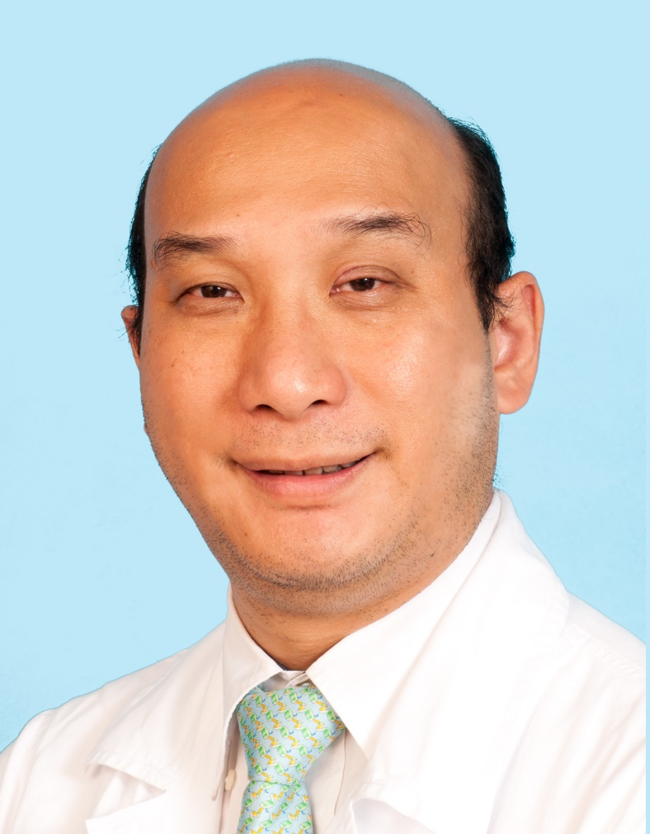Biography (150 word limit)
Associate Professor Yiu Che CHAN
MB BS BSc MD FRCS FRCS(General Surgery) FCSHK

Graduate of Charing Cross & Westminster Medical School, London University, and trained at St. Mary’s Hospital, Guy’s & St. Thomas’ Hospital, Yiu Che CHAN returned to Hong Kong in 2007 and now works as Associate Professor in Division of Vascular Surgery at the University of Hong Kong. He was UCLA Travelling Scholarship to University of California, Los Angeles in 2012, and he is the Director of Surgical Admissions at University of Hong Kong, and the Secretary General for the Asian Surgical Association. He is a vascular surgeon specialising in open and minimally invasive endovascular surgery involving the aorta, peripheral arteries and veins. He is a holder of multiple international and local research grants, and has published over 100 papers.

Email: ycchan667@gmail.com or ycchan88@hkucc.hku.hk

Notes/Comments:
Please kindly consider the enclosed abstract as an oral presentation in main session or free paper session (aortic/ endovascular aortic session).

