A novel study on SARS-COV-2 virus associated bradycardia as a predictor of mortality-retrospective multicenter analysis
Sabina Kumar DO MS, Umeh Chukwuemeka DrPhd, Christina Arcuri MD, Sumanta Chaudhuri MD, Rahul Gupta MD, Mahendra Aseri MS, Shivang Shah MS MD, and Pranav Barve MD, MPH

SARS-CoV2 has affected more than 73.8 million individuals. While SARS-CoV2 is considered a predominantly respiratory virus, we report a trend of bradycardia among hospitalized patients, particularly in association with mortality.
The multi-center retrospective analysis consisted of 1053 COVID-19 positive patients from March to August 2020. A trend of bradycardia was noted in the study population. Absolute bradycardia and profound bradycardia was defined as a sustained heart rate < 60 BPM and < 50 BPM, respectively, on two separate occasions, a minimum of 4 h apart during hospitalization. Each bradycardic event was confirmed by two physicians and exclusion criteria included: less than 18 years old, end of life bradycardia, left AMA, or taking AV Nodal blockers. Data was fetched using a SQL program through the EMR and data was analyzed using SPSS 27.0. A logistic regression was done to study the effect of bradycardia, age, gender, and BMI on mortality in the study group.
24.9% patients had absolute bradycardia while 13.0% had profound bradycardia. Patients with absolute bradycardia had an odds ratio of 6.59 (95% CI [2.83–15.36]) for mortality compared with individuals with a normal HR response. The logistic regression model explained 19.6% (Nagelkerke R²) of variance in the mortality, correctly classified 88.6% of cases, and was statistically significant X² (5)=47.10, p < .001. For each year of age > 18, the odds of dying increased 1.048 times (95% CI [1.25–5.27]).
The incidence of absolute bradycardia was found in 24.9% of the study cohort and these individuals were found to have a significant increase in mortality.

Image:

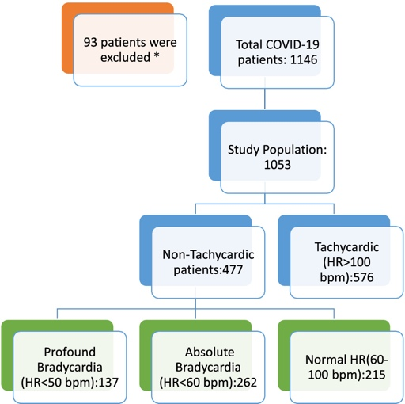

Figure: Study Design
Recent Publications:
- Kumar S, Arcuri C, Chaudhuri S, et al. A novel study on SARS-COV-2 virus associated bradycardia as a predictor of mortality-retrospective multicenter analysis. Clin Cardiol. 2021;44(6):857-862. doi:10.1002/clc.23622
- Umeh C, Giberson C, Kumar S, et al. (January 16, 2022) A Multicenter Retrospective Analysis on the Etiology of Bradycardia in COVID-19 Patients. Cureus 14(1): e21294. doi:10.7759/cureus.21294
- Kumar S, Arcuri C, Chaudhuri S, et al. Remdesivir therapy associated with Bradycardia in SARS‐CoV2 . Clin Cardiol. 2021;44(9):1190-1191. 10.1002/clc.23700
- Kumar S, Arcuri C, Chaudhuri S, et al. Response to Dr. Masaya Miyauchi and Dr. Teruhiko Imamura, Clinical implication of COVID-19 associated bradycardia. Clin Cardiol. 2021;44(8):1070-1071. doi:10.1002/clc.23675
- Sabina Kumar, John Carvalho, Chukwuemeka Umeh, Pranav Barve, Jose Penaherrera, Ratan Tiwari and Shivang Shah. Recurrent Marijuana Induced Myocarditis: A Case Report. American Journal of Medical Case Reports. 2021; 9(10):519-521. doi: 10.12691/ajmcr-9-10-11
- Chukwuemeka A. Umeh, Sabina Kumar, John Carvalho, Christina Arcuri, Hycienth Ahaneku, Krishna Pulumati, Shivang Shah, Austin Ma and Rakesh Gupta. Vancomycin Induced Thrombocytopenia Complicating Permanent Pacemaker Placement: A Case Report. American Journal of Medical Case Reports. 2021; 9(7):360-362. doi: 10.12691/ajmcr-9-7-5
- Peter Flores, Sabina Kumar, Umeh Chukwuemeka, Jose Penaherrera, Pranav Barve and Shivang Shah. Takotsubo Syndrome Associated with Benzodiazepine Withdrawal: A Case Report. American Journal of Medical Case Reports. 2021; 9(12):672-674. doi: 10.12691/ajmcr-9-12-2



Biography
Dr. Sabina Kumar has a BS and MS in Biomedical Engineering from Case Western Reserve University and is currently a 3rd year internal medicine resident at Hemet Global Medical Center in Southern California. She will be starting her cardiology fellowship at McLaren Macomb/Michigan State University Program this July. Her interest include the intersection of biomedical engineering and cardiology as well women’s cardiovascular health. Dr. Pranav Barve is the director of research and outpatient clinic at KPC Global and assistant program director of the residency program at Hemet Global Medical Center. He went to residency at Yale University and has his MPH from John’s Hopkins. His interest includes: cardiovascular disease, women’s health, pulmonary fibrosis, and pancreatitic cancer. Email: sxk730@case.edu and barveMD@sevenstar.health

