Clopidogrel, prasugrel, and ticagrelor for all-comers with ST-segment elevation myocardial Infarction
Mia R Jacobsen, MD, The Heart Center, Copenhagen University Hospital, Rigshospitalet, Denmark

Abstract (300 word limit)

Statement of the Problem: The recommendations for antiplatelet therapy in patients with ST-segment elevation myocardial infarction (STEMI) have been extrapolated from randomized controlled trials (RCTs) on patients with acute coronary syndromes. These cohorts may not be generalizable to all-comers with STEMI, as patients with STEMI accounted for one-third, the elderly was represented in minority, and high bleeding risk patients were excluded.

Aim: To compare the effectiveness and safety of clopidogrel, prasugrel, and ticagrelor among all-comers with STEMI to extend the knowledge from RCTs to broader populations.

Methodology & Theoretical Orientation: All consecutive patients with STEMI admitted to Copenhagen University Hospital, Rigshospitalet, from 2009 to 2016 were identified via the Eastern Danish Heart Registry. By individual linkage to Danish nationwide registries, claimed drugs and endpoints were obtained. Patients alive a week post-discharge were included, stratified according to clopidogrel, prasugrel, or ticagrelor, and followed for a year. The effectiveness (composite of all-cause mortality, myocardial infarction, and stroke) and safety endpoints (composite of bleedings leading to hospitalization) were assessed by multivariate Cox proportional hazards models.

Findings: In total, 5123 patients were included (clopidogrel [n=1245], prasugrel [n=1902], ticagrelor [n=1976]) with ≥95% treatment persistency. Concomitant aspirin use was ≥95%. Females accounted for 24% and elderly for 17%. Compared with clopidogrel, the effectiveness endpoint occurred less often for ticagrelor (HR 0.50, 95% CI 0.35–0.70) and prasugrel treatment (HR 0.48, 95% CI 0.33–0.68) without more bleedings. No differences in comparative effectiveness or safety were found between prasugrel and ticagrelor.

Conclusion & Significance: Both ticagrelor and prasugrel were associated with reduced all-cause mortality and prasugrel with fewer ischemic events compared with clopidogrel. No differences were found in comparative safety between all treatments or comparative effectiveness between prasugrel and ticagrelor. The possible merits of prasugrel over ticagrelor in all-comers with STEMI were questioned, despite the observational design.

Image

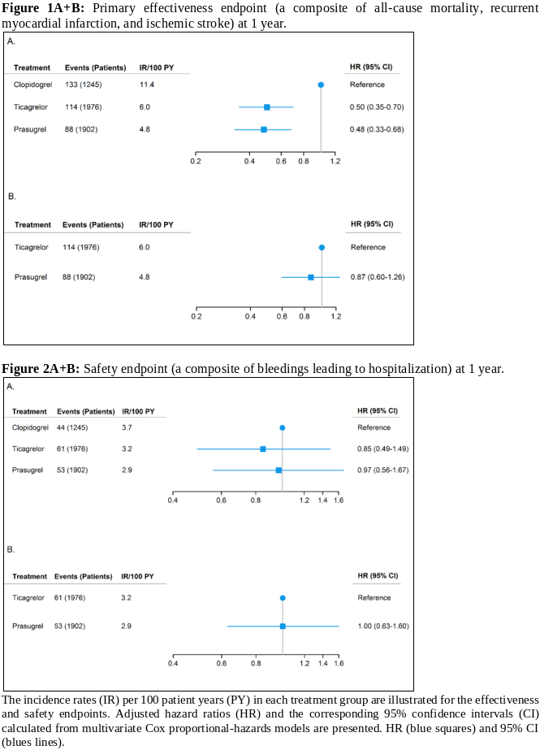
Recent Publications (minimum 5)
1. Steg PG, James S, Harrington RA, et al. (2010) Ticagrelor versus clopidogrel in patients with ST-elevation acute coronary syndromes intended for reperfusion with primary percutaneous coronary intervention: A Platelet Inhibition and Patient Outcomes (PLATO) trial subgroup analysis. Circulation. 122(21):2131–41.
2. Montalescot G, Wiviott SD, Braunwald E, et al. (2009) Prasugrel compared with clopidogrel in patients undergoing percutaneous coronary intervention for ST-elevation myocardial infarction (TRITON-TIMI 38): double-blind, randomised controlled trial. Lancet Lond Engl. 373(9665):723–31.
3. Schüpke S, Neumann F-J, Menichelli M, et al. (2019) Ticagrelor or Prasugrel in Patients with Acute Coronary Syndromes. N Engl J Med. 381(16):1524–34.
4. De Filippo O, Cortese M, D Ascenzo F, et al. (2019) Real-World Data of Prasugrel vs. Ticagrelor in Acute Myocardial Infarction: Results from the RENAMI Registry. Am J Cardiovasc Drugs Drugs Devices Interv.19(4):381–91.
5. Rafique AM, Nayyar P, Wang TY, et al. (2016) Optimal P2Y12 Inhibitor in Patients With ST-Segment Elevation Myocardial Infarction Undergoing Primary Percutaneous Coronary Intervention: A Network Meta-Analysis. JACC Cardiovasc Interv. 9(10):1036–46.



Biography (150 word limit)
Dr. Mia Ravn Jacobsen began her research career as a medical student and continued her projects alongside working as a doctor in training. She has 5 years of research experience already. By utilizing a large data material from a local hospital registry with consecutive patient enrollment and by individual linkage to the unique Danish nationwide registries, she has focused her research on ways to assess the effectiveness, safety, and use of antiplatelet therapy in patients with myocardial infarction. Further, she is working on risk stratification of patients with myocardial infarction for bleeding complications while preparing a larger, randomized trial for her PhD thesis, which aims to assess an individualized, de-escalated strategy for antiplatelet therapy among high bleeding risk patients with myocardial infarction. By optimizing dual antiplatelet therapy, there is a great potential for future prevention of bleeding in numerous patients, for whom the continuous improvement of DAPT strategies is crucial.

Email: miaravnjacobsen@gmail.com

Notes/Comments:

