Potentials of community-based early detection of cardiovascular disease risk during the COVID-19 pandemic
Kemal N. Siregar, PhD, Health Informatics Research Cluster, Faculty of Public Health, Universitas Indonesia
Rico Kurniawan, Faculty of Public Health, Universitas Indonesia
Ryza Jazid B.N., Research Center of Biostatistics and Health Informatics, Faculty of Public Health, Universitas Indonesia
Dion Zein Nuridzin, Research Center of Biostatistics and Health Informatics, Faculty of Public Health, Universitas Indonesia
Yolanda Handayani, Health Informatics Research Cluster, Faculty of Public Health, Universitas Indonesia
Retnowati, Universitas Indonesia Hospital
Rohjayanti, NCD Control Program, District Health Office, Bogor District, Indonesia
Lindawati Halim, Health Centers, Babakan Madang Sub-district, Bogor District, Indonesia

Abstract (300 word limit)
Statement of the Problem: The COVID-19 pandemic has led to a significant reduction in activities for early detection and screening for Non-Communicable Diseases (NCD), especially cardiovascular disease (CVD). This study aims to evaluate the potential of community-based CVD risk self-screening through the mHealth application. Research by Tremblay et al. (2018), the use of Community Based Participatory Research can demonstrate important processes and outcomes such as raising awareness; shifting norms and beliefs about NCD in the community; fostering community mobilization, collaboration, and advocacy; building community capacity, skills, and expertise in NCD prevention; creating a culture of collaboration and resource sharing among community organizations and infiltrating the NCD prevention agenda into community. Methodology & Theoretical Orientation: This study is an operational research by engaging the community to conduct self-screening through the use of mHealth. Community health workers (cadres) were recruited as facilitators who encourage the community to conduct the self-screening. To assess the potential of community-based CVD risk self-screening, we used several indicators: responses rate, CVD risk level, and community acceptance. Findings: Among the 846 individuals reached by cadres, 53% or 442 individuals completed self-screening. Based on the results of self-screening of CVD risk, it is predicted that 21.3% of people will have a high risk of CVD in the next 10 years. Respondents reported that 48% of people had positive opinions, 22% believe that the self-screening could increase awareness and provide information, 3% recommend improving the self-screening tools. Conclusion & Significance: The cadres play an important role in reaching the communities and facilitating their understanding of their health through CVD risk self-screening. The availability of the mHealth, which is easily accessible to the public, can simplify CVD risk prediction and expand screening coverage, especially during the COVID-19 pandemic where there are social restrictions policies and community activities.

Image

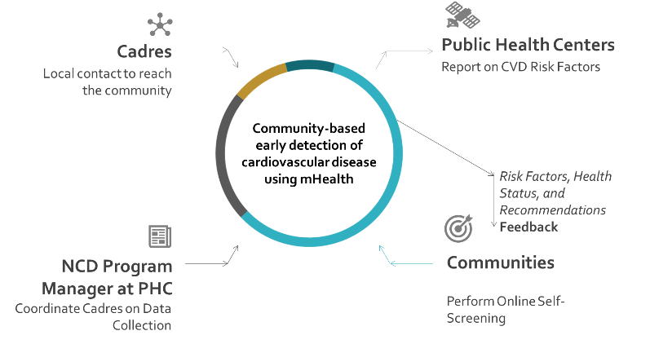
Figure 1. External entities of community-based early detection of CVD
Recent Publications (minimum 5)
- Mansoor, H., Elgendy, I. Y., Williams, R. S., Joseph, V. W., Hong, Y.-R., & Mainous, A. G. (2018). A risk score assessment tool for peripheral arterial disease in women: From the National Health and Nutrition Examination Survey. Clinical Cardiology, 41(8), 1084–1090.
- Chow, E. J., Doody, D. R., Di, C., Armenian, S. H., Baker, K. S., Bricker, J. B., Gopal, A. K., Hagen, A. M., Ketterl, T. G., Lee, S. J., Reding, K. W., Schenk, J. M., Syrjala, K. L., Taylor, S. A., Wang, G., Neuhouser, M. L., & Mendoza, J. A. (2020). Feasibility of a behavioral intervention using mobile health applications to reduce cardiovascular risk factors in cancer survivors: a pilot randomized controlled trial. Journal of Cancer Survivorship.
- Springer, M. V., & Skolarus, L. E. (2019). Community-based participatory research: Partnering with communities. Stroke, 50(3), e48-e50.
- Tremblay, M. C., Martin, D. H., McComber, A. M., McGregor, A., & Macaulay, A. C. (2018). Understanding community-based participatory research through a social movement framework: a case study of the Kahnawake Schools Diabetes Prevention Project. BMC Public Health, 18(1), 1-17.
- Chang, A. Y., Cullen, M. R., Harrington, R. A., & Barry, M. (2020). The impact of novel coronavirus COVID-19 on noncommunicable disease patients and health systems: A review. Journal of Internal Medicine, 1–13.

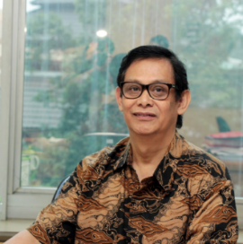

Biography (150 word limit)
Kemal N. Siregar has his expertise in public health for more than 40 years, after graduating as medical doctor from the University of Indonesia in 1975. He started his carrier as an academician at the Faculty of Public Health, University of Indonesia in 1976. He is working on Biostatistics, Health Informatics and Population Research. He has research experiences involving quite a broad area. He completed works from micro level operational research such as studying on recording and reporting in the ‘Posyandu’ activities, until wider study with a macro level approach such as structuring of a national policy. Some of the consultation works for a national policy were on development plan for health information system, the prevention of HIV/AIDS and for the tobacco control in Indonesia.
Email: nazarudin.kemal51@gmail.com

Notes/Comments: This research has been published in BMC Public Health Journal.
Siregar, K.N., Kurniawan, R., BaharuddinNur, R.J., Nuridzin, D.Z., Handayani, Y. Rohjayanti, and Halim, L., (2021). Potentials of community-based early detection of cardiovascular disease risk during the COVID-19 pandemic. BMC Public Health, 21(1), pp.1. https://doi.org/10.1186/s12889-021-11384-6

